Executive Summary: Blue marlin

Status of the Indian Ocean blue marlin (BUM: Makaira nigricans) resource

TABLE 1. Blue marlin: Status of blue marlin (Makaira nigricans) in the Indian Ocean.
Area¹ | Indicators |  | 2015 stock status determination
Indian Ocean | Catch 2016²:  Average catch 2012–2016: | 16,353 t  15,859 t | 46.8%*
 | MSY (1,000 t) (80% CI):  F_{MSY} (80% CI):  B_{MSY} (1,000 t) (80% CI):  F_{2015/}F_{MSY} (80% CI):  B_{2015/}B_{MSY} (80% CI):  B₂₀₁₅/B₁₉₅₀ (80% CI): | 11.93 (9.23–16.15)  0.109 (0.076 –0.160)  113.0 (71.7 – 161.95)  1.18 (0.80–1.71)  1.11 (0.90–1.35)  0.56 (0.44 – 0.71)

¹ Boundaries for the Indian Ocean = IOTC area of competence; n.a. = not available

² Proportion of catch estimated or partially estimated by IOTC Secretariat in 2016: 41%

* Estimated probability that the stock is in the respective quadrant of the Kobe plot (shown below), derived from the confidence intervals associated with the current stock status.

Colour key | Stock overfished(B_{year}/B_{MSY}< 1) | Stock not overfished (B_{year}/B_{MSY}≥ 1)
Stock subject to overfishing(F_{year}/F_{MSY}> 1) | 24.6% | 46.8%
Stock not subject to overfishing (F_{year}/F_{MSY}≤ 1) | 1.0% | 27.6%
Not assessed/Uncertain
Indian Ocean stock – Management Advice
Stock status. Stock status based on BSP-SS stock assessment suggests that the stock in 2015 is in the orange zone in the Kobe plot and both F and B are close to their MSYs, i.e., F/F_{MSY}=1.18 and B/B_{MSY}=1.11. Two other approaches examined in 2016 came to similar conclusions, namely ASPIC and SS3. The Kobe plot (Fig. 2) from the BSP-SS model indicated that the stock has been subject to overfishing but not overfished in recent years, while the stock biomass is slightly above the BMSY level (Table 1; Fig. 2).

Outlook. The uncertainty in the data available for assessment purposes and the CPUE series suggests that the advice should be interpreted with caution. The recent rapid increase of catch may bring the status of stock to the red zone (Kobe plot) in the near future if such high levels of catch continue. There is a high probability (70-80%) to exceed MSY-based reference points in next 10 years if the current catch level is continued. But if the catch level is reduced by 20%, then the risk will be reduced to close to or less than 50% (Table 2).
Management advice. The current catches of BUM (average of 15,859 t in the last 5 years, 2012-2016) (Fig.1) are higher than MSY (11,926 t) and the stock is currently subject to overfishing (F₂₀₁₅ > F_{MSY}). In order to achieve the Commission objectives of being in the green zone of the Kobe Plot by 2025 (F₂₀₂₅ < F_{MSY} and B₂₀₂₅ > B_{MSY}) with at least a 50% probability, the catches of blue marlin would have to be reduced to a maximum value of 11,643 t.
The following key points should be noted:
- Maximum Sustainable Yield (MSY): estimate for the whole Indian Ocean is 11,926 t (estimated range 9,232–16,149 t).
- Provisional reference points: Although the Commission adopted reference points for swordfish in Resolution 15/10 on target and limit reference points and a decision framework, no such interim reference points, nor harvest control rules have been established for blue marlin.

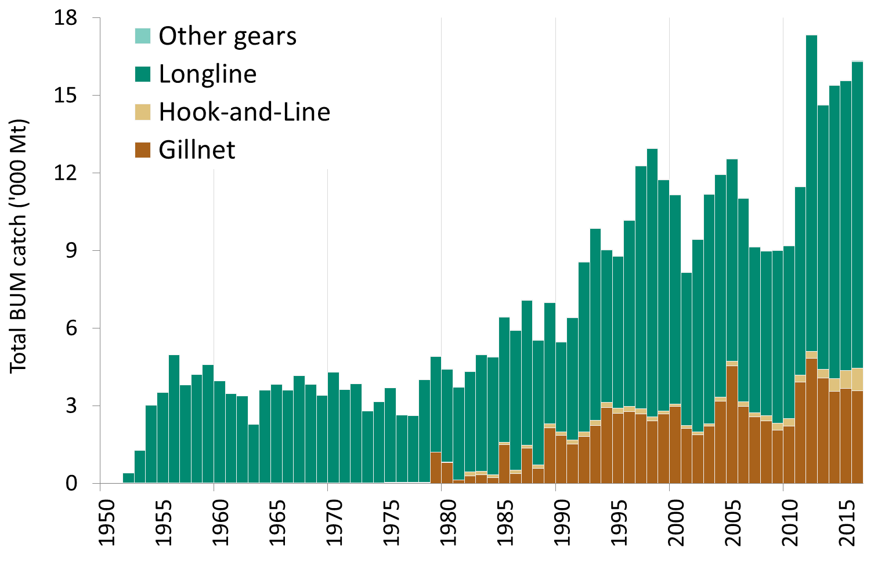
Fig. 1. Blue marlin: catches by gear and year recorded in the IOTC Database (1950–2016).
Note: Other gears includes: coastal purse seine, Danish purse seine, beach seine and purse seine.

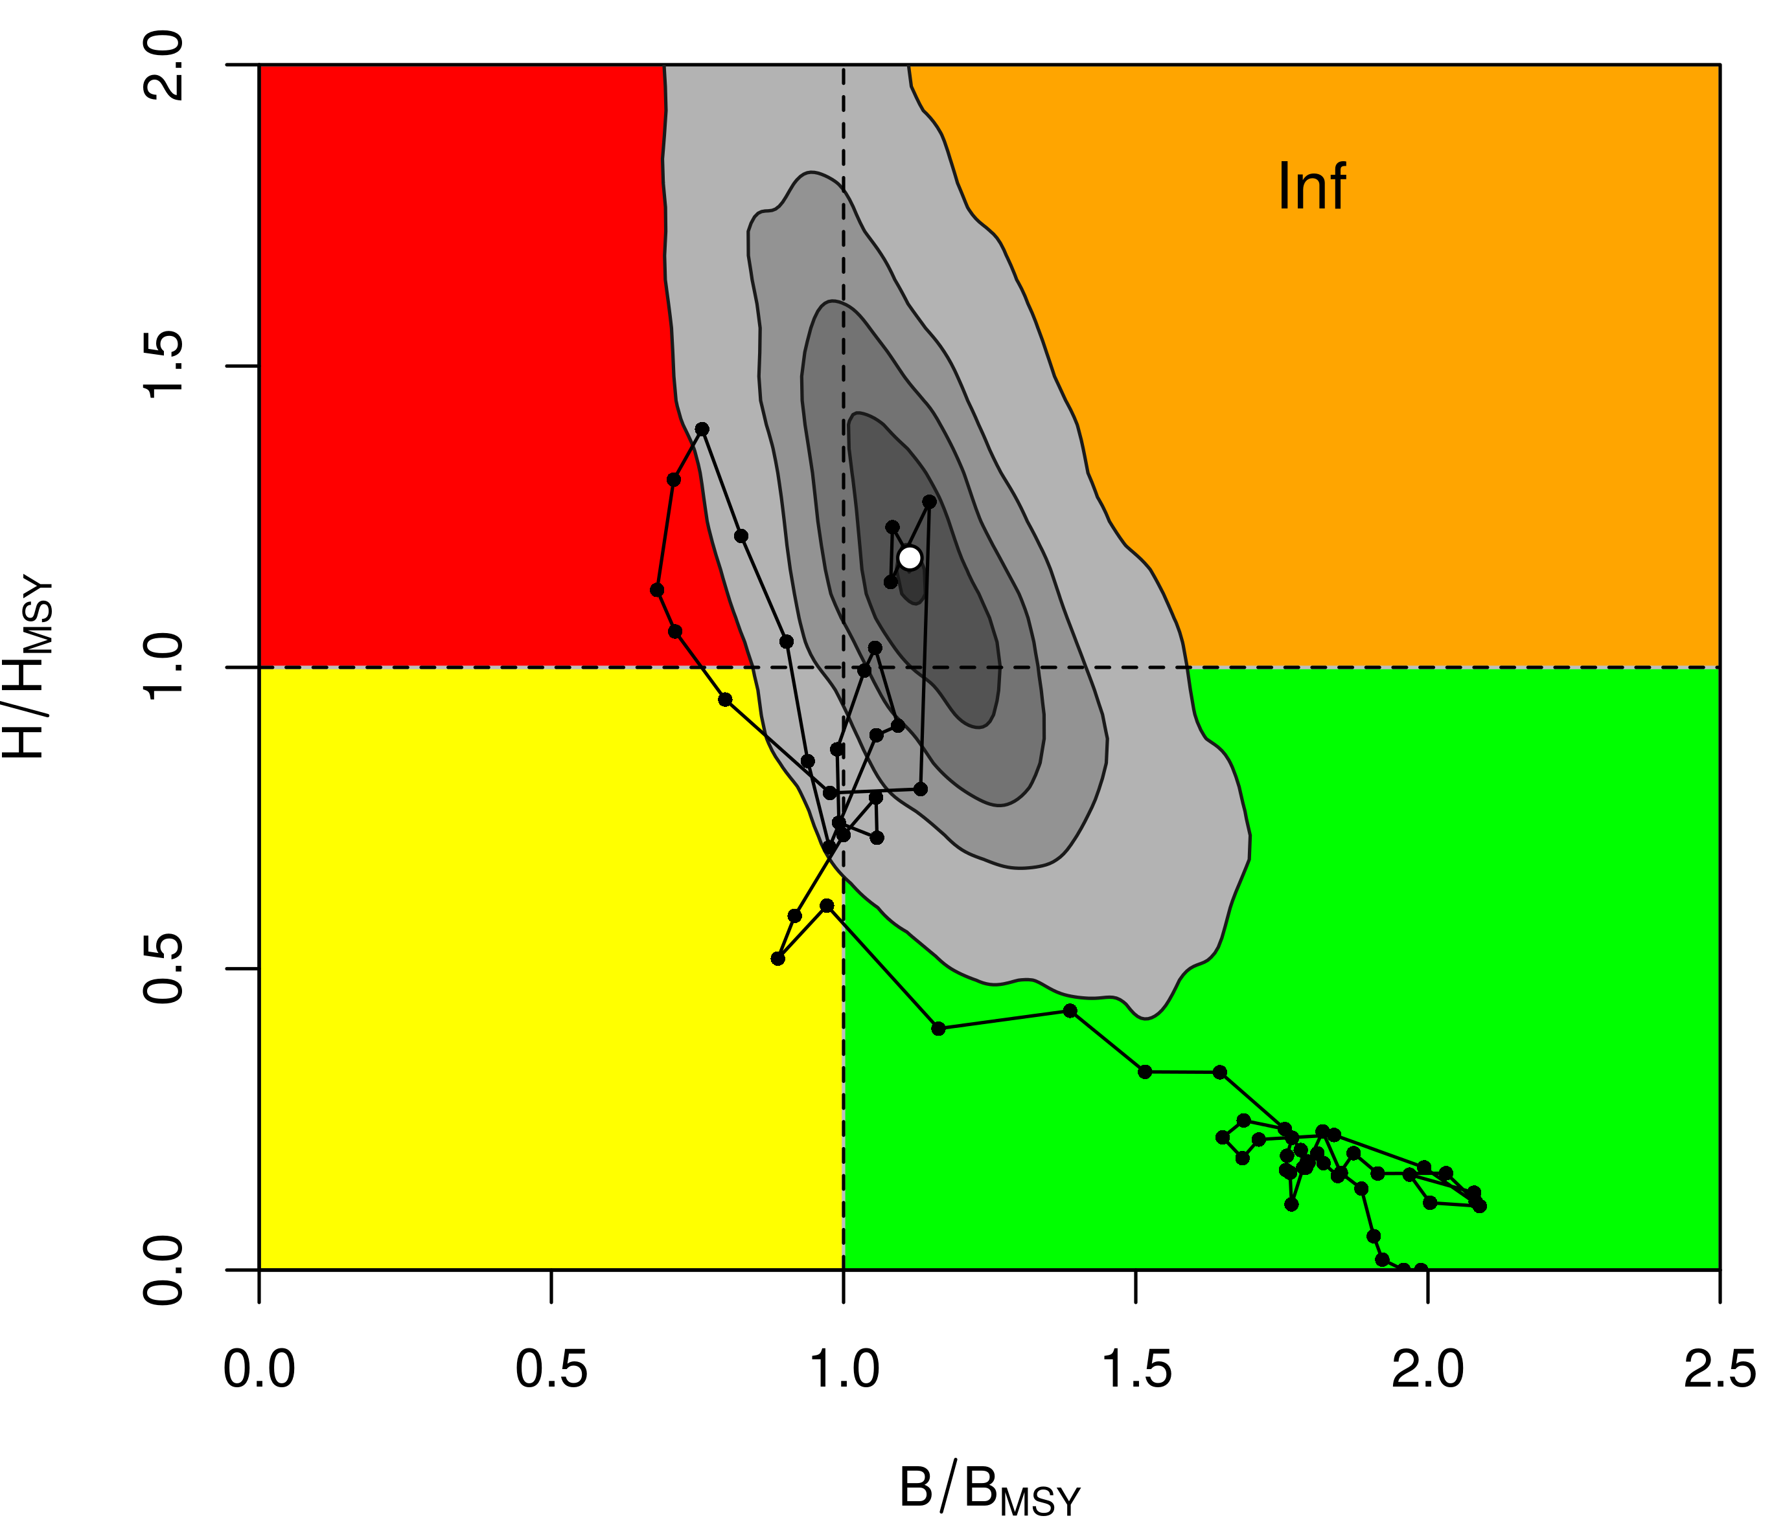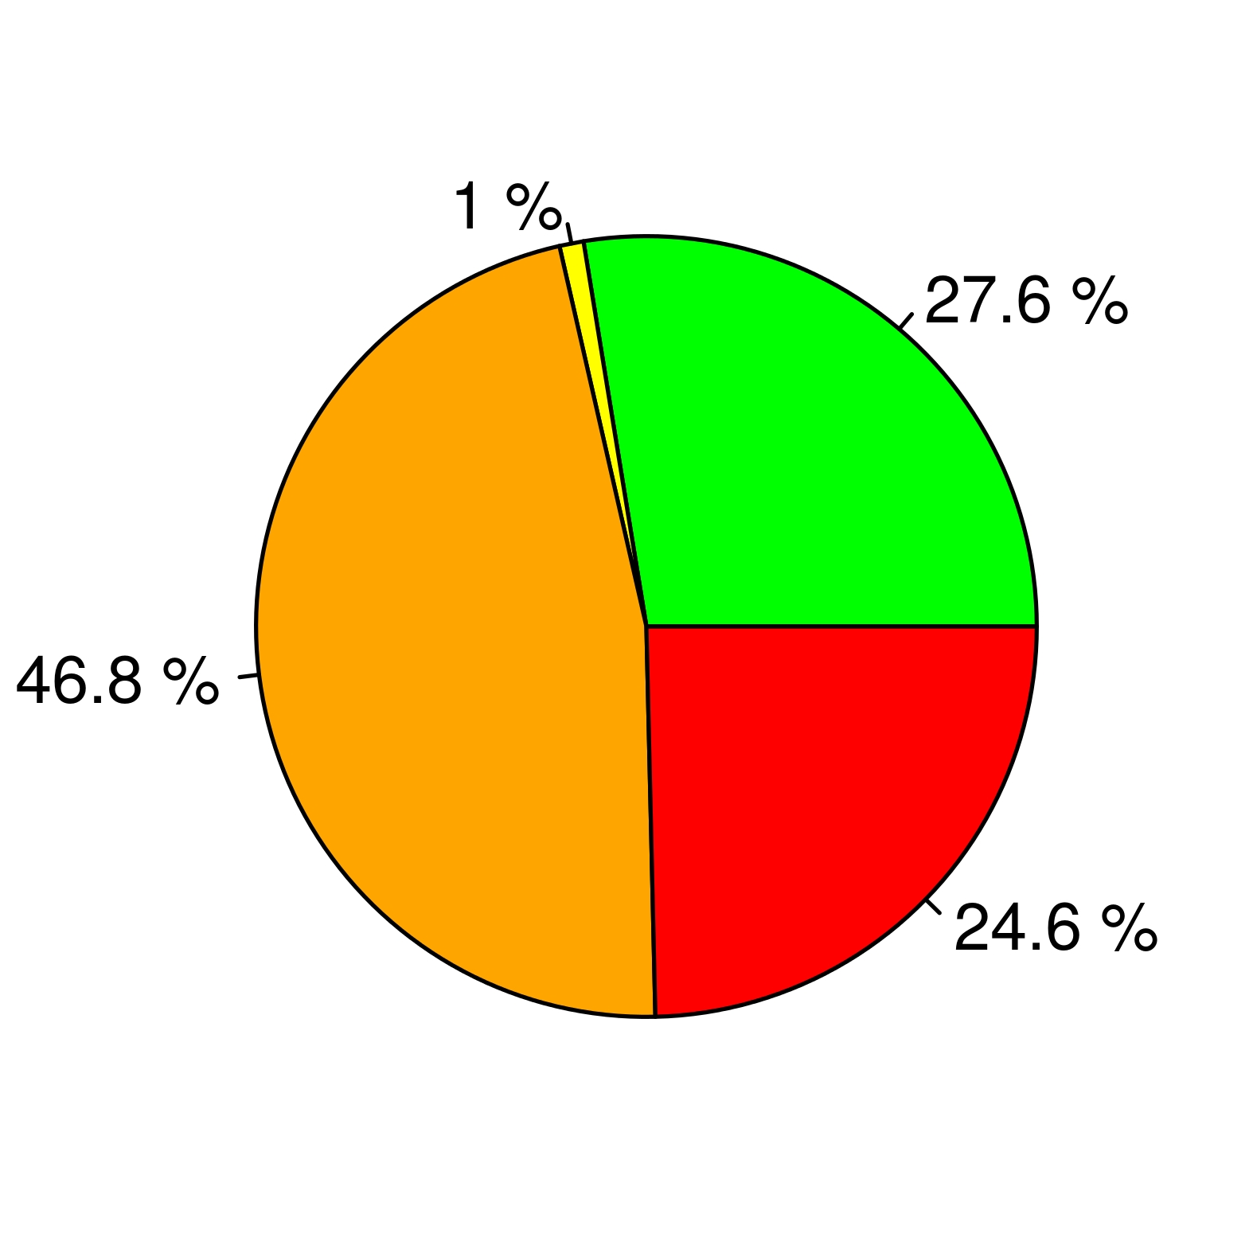

Fig. 2. Blue marlin: BSP-SS Aggregated Indian Ocean assessment Kobe plot for blue marlin (90% bootstrap confidence surfaces shown around 2015 estimate). Black line indicates the trajectory of the point estimates for the biomass (B) ratio and F ratio for each year 1950–2015.

Table 2. Blue Marlin: Indian Ocean BSP-SS Kobe II Strategy Matrix. Probability (percentage) violating the MSY-based target reference points for nine constant catch projections (average catch level 15,401 t ± 10%, ± 20%, ± 30% ± 40%) projected for 3 and 10 years.
Reference point and projection timeframe | Alternative catch projections (relative to the average catch level 15,401 t and probability (%) of violating MSY-based target reference points  (B_{targ} = B_{MSY}; F_{targ} = F_{MSY})
 | 60% | 70% | 80% | 90% | 100% | 110% | 120% | 130% | 140%
 | 9,240 t | 10,780 t | 12,321t | 13,861 t | 15,401 t | 16,941 t | 18,481 t | 20,021 t | 21,561 t
B₂₀₁₈<B_{MSY} | 26 | 31 | 37 | 43 | 48 | 54 | 59 | 64 | 69
F₂₀₁₈> F_{MSY} | 14 | 30 | 47 | 63 | 75 | 84 | 90 | 94 | 96
B₂₀₂₅<B_{MSY} | 16 | 30 | 46 | 60 | 73 | 82 | 88 | 93 | 95
F₂₀₂₅> F_{MSY} | 12 | 30 | 51 | 68 | 80 | 89 | 93 | 96 | 98

