Executive Summary: Seabirds
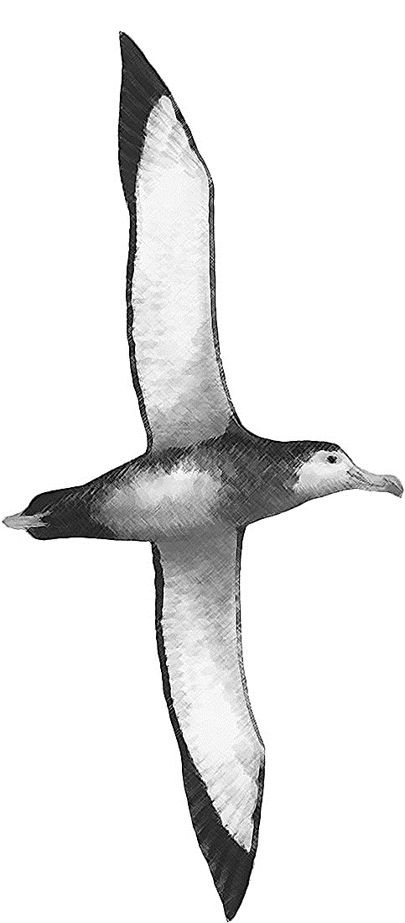

Status of seabirds in the Indian Ocean

TABLE 1. IUCN threat status for all seabird species reported as caught in fisheries within the IOTC area of competence.
Common name | Scientific name | IUCN threat status
Albatross
Atlantic Yellow-nosed Albatross | Thalassarche chlororynchos | Endangered
Black-browed albatross | Thalassarche melanophris | Near Threatened
Indian yellow-nosed albatross | Thalassarche carteri | Endangered
Shy albatross | Thalassarche cauta | Near Threatened
Sooty albatross | Phoebetria fusca | Endangered
Light-mantled albatross | Phoebetria palpebrata | Near Threatened
Amsterdam albatross | Diomedea amsterdamensis | Critically Endangered
Tristan albatross | Diomedea dabbenena | Critically Endangered
Wandering albatross | Diomedia exulans | Vulnerable
White-capped albatross | Thalassarche steadi | Near Threatened
Grey-headed albatross | Thalassarche chrysostoma | Endangered
Petrels
Cape/Pintado petrel | Daption capense | Least Concern
Great-winged petrel | Pterodroma macroptera | Least Concern
Grey petrel | Procellaria cinerea | Near Threatened
Southern giant petrel | Macronectes giganteus | Least Concern
Northern giant-petrel | Macronectes halli | Least Concern
White-chinned petrel | Procellaria aequinoctialis | Vulnerable
Others
Cape gannet | Morus capensis | Vulnerable
Flesh-footed shearwater | Puffinus carneipes | Least Concern

Indian Ocean stock – Management Advice
Stock status. Following a data call in 2016, the IOTC Secretariat received seabird bycatch data from 6 CPCs, out of the 15 with reported or expected longline effort South of 25ºS (IOTC-2016-SC19-INF02). Due to the lack of data submissions from other CPCs, and the limited information provided on the use of seabird bycatch mitigations, it has not yet been possible to undertake an assessment for seabirds. The current International Union for Conservation of Nature (IUCN) threat status for each of the seabird species reported as caught in IOTC fisheries to date is provided in Table 1. It is important to note that the IUCN threat status for all birds is currently being re-assessed; this process is expected to be completed by the end of 2016. A number of international global environmental accords (e.g. Convention on Migratory Species (CMS), the Agreement on the Conservation of Albatrosses and Petrels (ACAP), Convention on Biological Diversity (CBD)), as well as numerous fisheries agreements obligate States to provide protection for these species. While the status of seabirds is affected by a range of factors such as degradation of nesting habitats and targeted harvesting of eggs, for albatrosses and large petrels, fisheries bycatch is generally considered to be the primary threat. The level of mortality of seabirds due to fishing gear in the Indian Ocean is poorly known, although where there has been rigorous assessment of impacts in areas south of 25 degrees (e.g. in South Africa), very high seabird incidental catches rates have been recorded in the absence of a suite of proven incidental catches mitigation measures.
Outlook. Resolution 12/06 On Reducing the Incidental Bycatch of Seabirds in Longline Fisheries includes an evaluation requirement (para. 8) by the Scientific Committee in time for the 2016 meeting of the Commission. The level of compliance with Resolution 12/06 and the frequency of use of each of the 3 measures (because vessels can chose two out of three possible options) are still poorly known.. Observer reports and logbook data should be analysed to support assessments of the effectiveness of mitigation measures used and relative impacts on seabird mortality rates. Information regarding seabird interactions reported in National Reports should be stratified by season, broad area, and in the form of catch per unit effort. Following the data call in 2016 it was possible to carry out a preliminary and qualitative analysis. The information provided suggests higher sea bird catch rates at higher latitudes, even within the area south of 25°S, and higher catch rates in the coastal areas in the eastern and western parts of the southern Indian Ocean. In terms of mitigation measures, the preliminary information available suggests that those currently in use (Resolution 12/06) may be proving effective in some cases, but there are also some conflicting aspects that need to be explored further. Unless IOTC CPCs become compliant with the data collection, Regional Observer Scheme and reporting requirements for seabirds, the WPEB will continue to be unable to fully address this issue. The following should be noted:
- The available evidence indicates considerable risk from longline fishing to the status of seabirds in the Indian Ocean, where the best practice seabird incidental catches mitigation measures outlined in Resolution 12/06 are not implemented.
- CPCs that have not fully implemented the provisions of the IOTC Regional Observer Scheme outlined in paragraph 2 of Resolution 11/04 shall report seabird incidental catches through logbooks, including details of species, if possible.
- Appropriate mechanisms should be developed by the Compliance Committee to assess levels of compliance by CPCs with the Regional Observer Scheme requirements and the mandatory measures described in Res 12/06.

The process of the threat assessment from IUCN is independent from the IOTC and is presented for information purpose only

