**Executive Summary: Albacore**



**Status of the Indian Ocean albacore (ALB: *Thunnus alalunga*) resource**

**TABLE 1**. Albacore: Status of albacore (*Thunnus alalunga*) in the Indian Ocean.

|  |  |  |  |
| --- | --- | --- | --- |
| **Area1** | **Indicators – 2016 assessment** | | **2018 stock status3 determination** |
| Indian Ocean |  | SS3 |  |
| Catch 20172:  Average catch 2013–2017:  MSY (1000 t) (80% CI):  FMSY (80% CI):  SBMSY (1000 t) (80% CI):  F2014/FMSY (80% CI):  SB2014/SBMSY (80% CI):  SB2014/SB1950 (80% CI): | 38,347 t  36,004 t  38.8 (33.9–43.6)  -  30.0 (26.1–34.0)  0.85 (0.57–1.12)  1.80 (1.38–2.23)  0.37 (0.28–0.46) |

1 Boundaries for the Indian Ocean stock assessment are defined as the IOTC area of competence.

2 Proportion of catch estimated or partially estimated by IOTC Secretariat in 2017: 17%

3 The stock status refers to the most recent years’ data used in the last assessment conducted in 2016.

|  |  |  |
| --- | --- | --- |
| **Colour key** | **Stock overfished(SByear/SBMSY< 1)** | **Stock not overfished (SByear/SBMSY≥ 1)** |
| Stock subject to overfishing(Fyear/FMSY> 1) |  |  |
| Stock not subject to overfishing (Fyear/FMSY≤ 1) |  |  |

**Indian Ocean stock – Management Advice**

***Stock status.*** No new stock assessment was carried out for albacore in 2018, thus, the stock status is determined on the basis of the 2016 assessment and other indicators presented in 2018.

Trends in the CPUE series suggest that the longline vulnerable biomass has declined to around 65% of the levels observed in 1980–82. Prior to 1980 there was 20 years of moderate fishing, after which total catches of albacore tuna in the Indian Ocean have more than doubled in subsequent years (**Fig. 1**). Catches have also increased substantially since 2007 for some fleets (i.e., Indonesian and Taiwan,China longline fisheries), although there is substantial uncertainty regarding the reliability of the catch estimates. Catches in 2017 were marginally below the MSY level of the SS3 model. Fishing mortality represented as F2014/FMSY is 0.85 (0.57–1.12). Biomass is considered to be above the SBMSY level (SB2014/SBMSY = 1.80 (1.38–2.23)) from the SS3 model (**Table 1**, **Fig. 2**). The results from the other model options were also generally consistent with these estimates of stock status. Thus, the stock status in relation to the Commission’s BMSY and FMSY target reference points indicates that the stock is **not overfished** and **not** **subject to overfishing** (**Table 1**).

***Outlook.*** Maintaining or increasing effort in the core albacore fishing grounds is likely to result in further decline in the albacore tuna biomass, productivity and CPUE. The impacts of piracy in the western Indian Ocean have resulted in the displacement of a substantial portion of longline fishing effort into the traditional albacore fishing areas in the southern and eastern Indian Ocean. With the decline in the threat of piracy in recent years – and the presumption that longline fishing effort in the western Indian Ocean may return to levels similar to years pre-piracy – it is unlikely that catch and effort on albacore will increase in the near future. There is a moderate probability of exceeding MSY-based reference points by 2017 if catches are maintained at 2014 levels (14% probability that SB2017<SBMSY, and 33% probability that F2017>FMSY) (**Table 2**).

***Management advice.*** Although considerable uncertainty remains in the SS3 assessment conducted in 2016, particularly due to the lack of biological information on Indian Ocean albacore tuna stocks, a precautionary approach to the management of albacore tuna should be applied by capping total catch levels to MSY levels (38,800 t; **Table 2**).

The following should be noted:

* The two primary sources of data that drive the assessment, total catches and CPUE, are highly uncertain and should be developed further as a priority.
* Catches in 2014 (39,507 t) marginally exceeded MSY levels.
* The catch estimates for 2017 (38,347 t) are marginally below the current estimated MSY levels (**Table 1**).
* A Kobe 2 Strategy matrix was calculated to quantify the risk of different future catch scenarios, using the projections from the SS3 model (**Table 2**).
* Provisional reference points: noting that the Commission in 2015 adopted Resolution 15/10 *On interim target and limit reference points and a decision framework*, the following should be noted:
  + **Fishing mortality**: Current fishing mortality is considered to be below the provisional target reference point of FMSY, and the provisional limit reference point of 1.4*FMSY (**Fig. 2**).
  + **Biomass**: Current spawning biomass is considered to be above the target reference point of SBMSY, and therefore above the limit reference point of 0.4*SBMSY (**Fig. 2**).
* **Main fishing gear (average catches 2013–17)**: Albacore tuna are currently caught almost exclusively using drifting longliners, with the remaining catches recorded using purse seines and other gears. Catches from the longline fisheries are split between deep-freezing longliners, and fresh-tuna longliners (Fig. 1).
* **Main fleets (average catches 2013–17)**: The majority of albacore catches are attributed to vessels flagged to distant water fishing nations (i.e., Taiwan,China and Japan), followed by coastal countries such as Indonesia and Malaysia.

|  |
| --- |
|  |
| **Fig. 1.** Albacore: Catches of albacore by gear (1950-2017)[1]. |

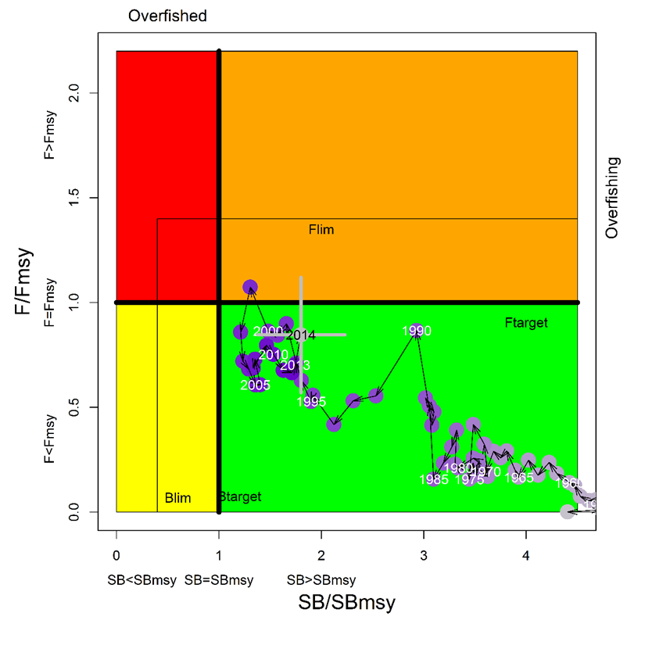

**Fig. 2.** Albacore: SS3 Aggregated Indian Ocean assessment Kobe plot. Blue circles indicate the trajectory of the point estimates for the SB ratio and F ratio for each year 1950–2014 (the grey lines represent the 80 percentiles of the 2014 estimate). Target (Ftarg and SBtarg) and limit (Flim and SBlim) reference points are shown.

**TABLE 2.** Albacore: SS3 aggregated Indian Ocean assessment Kobe II Strategy Matrix.Probability (percentage) of violating the MSY-based target (top) and limit (bottom) reference points for constant catch projections (2014 catch levels*, ± 10%, ± 20%, ± 30%, and ± 40%) projected for 3 and 10 years.

|  |  |  |  |  |  |  |  |  |  |  |  |
| --- | --- | --- | --- | --- | --- | --- | --- | --- | --- | --- | --- |
| **Reference point and projection timeframe** | | **Alternative catch projections (relative to the catch level for 2014*) and probability (%) of violating MSY-based target reference points**  **(SBtarg = SBMSY; Ftarg = FMSY)** | | | | | | | | | |
|  | | **60%** | **70%** | **80%** | **90%** | **100%** | **110%** | **120%** | **130%** | **140%** |
|  | | **(23,821)** | **(27,791)** | **(31,761)** | **(35,731)** | **(39,701)** | **(43,671)** | **(47,641)** | **(51,611)** | **(55,581)** |
| SB2017 < SBMSY | | 1 | 2 | 4 | 7 | 14 | 19 | 24 | 33 | 44 |
| F2017 > FMSY | | 0 | 1 | 5 | 18 | 33 | 47 | 59 | 71 | 77 |
|  | |  |  |  |  |  |  |  |  |  |
| SB2024 < SBMSY | | 4 | 8 | 9 | 31 | 42 | 50 | 62 | NA | 92 |
| F2024 > FMSY | | 0 | 0 | 3 | NA | 39 | 56 | 66 | 70 | 100 |
| **Reference point and projection timeframe** | **Alternative catch projections (relative to the catch level for 2014*) and probability (%) of violating MSY-based limit reference points**  **(SBlim = 0.4 SBMSY; FLim = 1.4 FMSY)** | | | | | | | | | |
|  | **60%** | | **70%** | **80%** | **90%** | **100%** | **110%** | **120%** | **130%** | **140%** |
|  | **(23,821)** | | **(27,791)** | **(31,761)** | **(35,731)** | **(39,701)** | **(43,671)** | **(47,641)** | **(51,611)** | **(55,581)** |
| SB2017 < SBLim | 0 | | 0 | 0 | 0 | 0 | 0 | 1 | 1 | 4 |
| F2017 > FLim | 0 | | 0 | 0 | 0 | 2 | 10 | 20 | 34 | 46 |
|  |  | |  |  |  |  |  |  |  |  |
| SB2024 < SBLim | 0 | | 0 | 1 | 13 | 20 | 24 | 30 | NA | 65 |
| F2024 > FLim | 0 | | 0 | 0 | NA | 10 | 27 | 48 | 60 | 100 |

*\* Catches for 2014, at the time of the last albacore assessment conducted in 2016.*

1. **Definition of fisheries**: Driftnet (**DN; Taiwan,China**); Freezing-longline (**LL**); Fresh-tuna longline (**FLL**); Purse seine (**PS**); Other gears nei (**OT**).