Appendix VIII
Executive Summary: Frigate Tuna

Status of the Indian Ocean frigate tuna (FRI: Auxis thazard) resource

TABLE 1. Frigate tuna: Status of frigate tuna (Auxis thazard) in the Indian Ocean.
Area¹ | Indicators |  | 2018 stock status determination
Indian Ocean | Catch 2017²:  Average catch 2013–2017: | 74,886 t  86,157 t
 | MSY (1,000 t) (80% CI):  F_{MSY} (80% CI):  B_{MSY} (1,000 t) (80% CI):  F_{current/}F_{MSY} (80% CI):  B_{current/}B_{MSY} (80% CI):  B_{current}/B₀ (80% CI): | unknown  unknown  unknown  unknown  unknown  unknown

¹ Boundaries for the Indian Ocean stock assessment are defined as the IOTC area of competence.
² Proportion of catch estimated or partially estimated by IOTC Secretariat in 2018: 80%

Nominal catches represent those estimated by the IOTC Secretariat. If these data are not reported by CPCs, the IOTC Secretariat estimates total catch from a range of sources including: partial catch and effort data; data in the FAO FishStat database; catches estimated by the IOTC from data collected through port sampling; data published through web pages or other means; data reported by other parties on the activity of vessels; and data collected through sampling at the landing place or at sea by scientific observers.

Colour key | Stock overfished(SB_{year}/SB_{MSY}< 1) | Stock not overfished (SB_{year}/SB_{MSY}≥ 1)
Stock subject to overfishing(F_{year}/F_{MSY}> 1)
Stock not subject to overfishing (F_{year}/F_{MSY}≤ 1)
Not assessed/Uncertain

Indian Ocean stock – Management Advice
Stock status. No quantitative stock assessment is currently available for frigate tuna in the Indian Ocean, and due to a lack of fishery data for several gears, only preliminary stock status indicators can be used. Aspects of the fisheries for frigate tuna combined with the lack of data on which to base an assessment of the stock are a cause for considerable concern. Stock status in relation to the Commission’s B_{MSY} and F_{MSY} reference points remains unknown (Table 1).
Outlook. Total annual catches for frigate tuna have increased substantially in recent years with peak catches taken in 2010 (~100,000 t) which have been maintained at that level until 2014 after which they declined to <80,000 t (Fig.1). There is insufficient information to evaluate the effect that this level of catch or a further increase in catches may have on the resource. Research emphasis on collating catch per unit effort (CPUE) time series for the main fleets, size compositions and life trait history parameters (e.g. estimates of growth, natural mortality, maturity, etc.) should be considered of high priority for the Commission.
Management advice. For assessed species of neritic tunas in Indian Ocean (longtail tuna, kawakawa and narrow barred Spanish mackerel), the MSY was estimated to have been reached between 2009 and 2011 and both F_{MSY} and B_{MSY} were breached thereafter. Therefore, in the absence of a stock assessment of frigate tuna a limit to the catches should be considered by the Commission, by ensuring that future catches do not exceed the average catches estimated between 2009 and 2011 (94,921 t). The reference period (2009-2011) was chosen based on the most recent assessments of those neritic species in the Indian Ocean for which an assessment is available under the assumption that also for bullet tuna MSY was reached between 2009 and 2011. This catch advice should be maintained until an assessment of frigate tuna is available. Considering that MSY-based reference points for assessed species can change over time, the stock should be closely monitored. Mechanisms need to be developed by the Commission to improve current statistics by encouraging CPCs to comply with their recording and reporting requirements, so as to better inform scientific advice.
The following should be also noted:
- The Maximum Sustainable Yield estimate for the Indian Ocean stock is unknown.
- Limit reference points: The Commission has not adopted limit reference points for any of the neritic tunas under its mandate.
- Further work is needed to improve the reliability of the catch series, such as verification or estimation based on expert knowledge of the history of the various fisheries or through statistical extrapolation methods.
- Research emphasis on collating catch per unit effort (CPUE) time series for the main fleets, size compositions and life trait history parameters (e.g. estimates of growth, natural mortality, maturity, etc.) should be considered of high priority for the Commission.
- Species identification, data collection and reporting urgently need to be improved.
- There is limited information submitted by CPCs on total catches, catch and effort and size data for neritic tunas, despite their mandatory reporting status. In the case of 2017 catches, 80% of the total catches were either fully or partially estimated by the IOTC Secretariat, which increases the uncertainty of the stock assessments using these data. Therefore the management advice to the Commission includes the need for CPCs to comply with IOTC data requirements per Resolution 15/01 and 15/02.
- Main fishing gear (average catches 2013-17): frigate tuna is mainly caught using gillnets (≈35%), coastal longline and trolling, handlines and trolling (≈37%), and to a lesser extent coastal purse seine nets (Table 3; Fig.12). The species is also a bycatch for industrial purse seine vessels and is the target of some ring net fisheries.
- Main fleets (average catches 2013–17): Catches of frigate tuna are highly concentrated: Indonesia accounts for around two-thirds of catches, while over 90% of catches are accounted for by four countries (Indonesia, India, Sri Lanka and I.R. Iran).

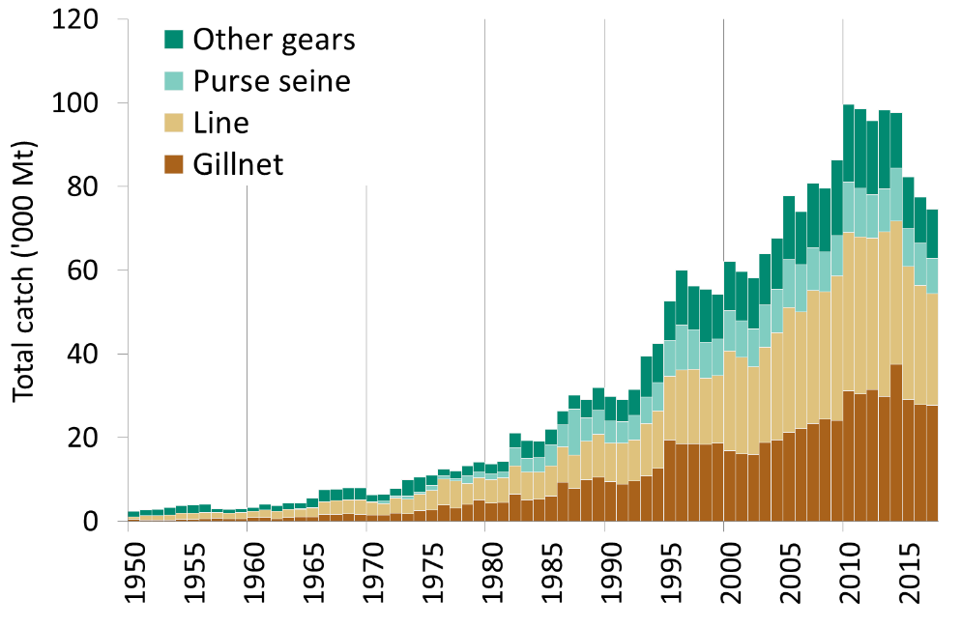
Fig. 1. Frigate tuna: Annual catches of frigate tuna by gear recorded in the IOTC Database (1950–2017).

Definition of fishery: Gillnet: gillnet, including offshore gillnet; Line: coastal longline, hand line, troll line; Purse seine: coastal purse seine, purse seine, ring net; Other gears: baitboat, Danish seine, liftnet, longline, longline fresh, trawling.

