Appendix XI
Executive Summary: Scalloped Hammerhead Shark
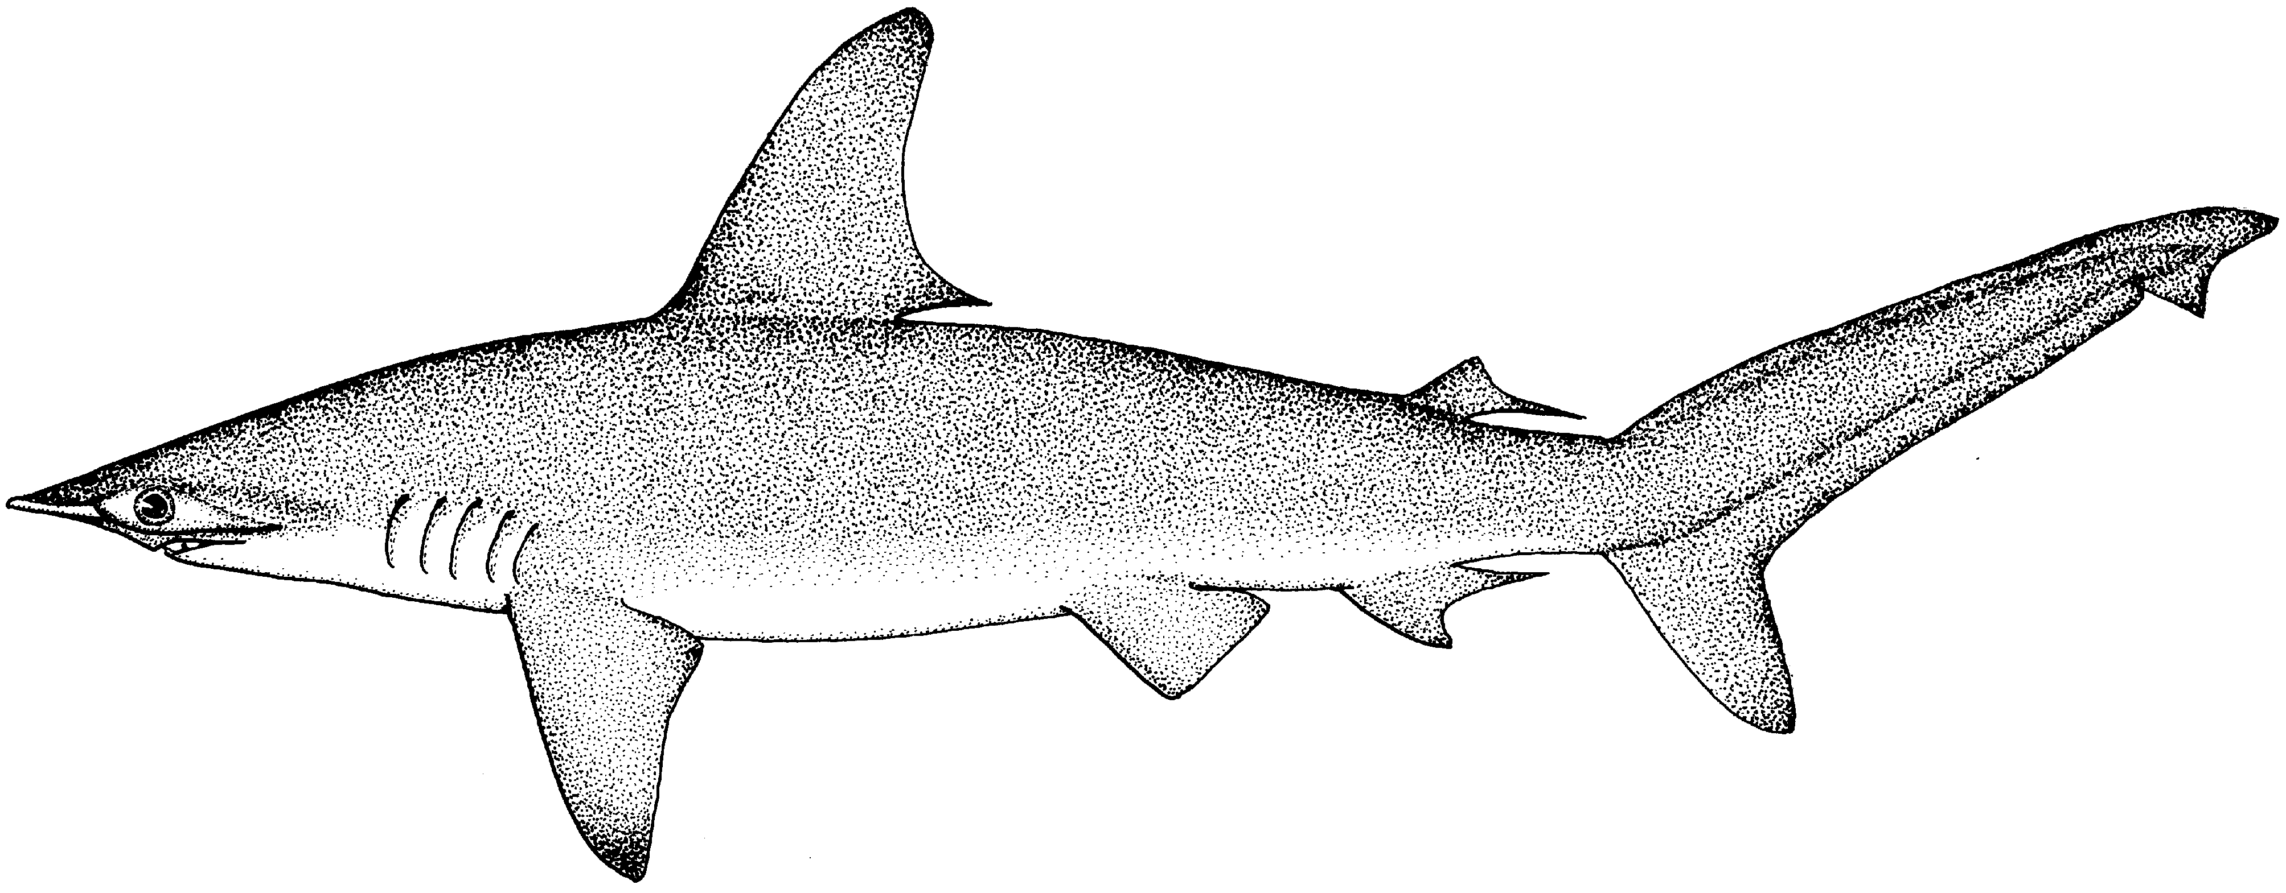
Status of the Indian Ocean Scalloped Hammerhead Shark (SPL: Sphyrna lewini)

CITES APPENDIX II species

TABLE 1. Status of scalloped hammerhead shark (Sphyrna lewini) in the Indian Ocean.
Area¹ | Indicators |  | 2018 stock status determination
Indian Ocean | Reported catch 2017:  Not elsewhere included (nei) sharks²2017:  Average reported catch 2013-17:  Av. not elsewhere included (nei) sharks² 2013-2017: | 118 t  56,883 t  76 t  51,712 t
 | MSY (1,000 t) (80% CI):  F_{MSY} (80% CI):  SB_{MSY} (1,000 t) (80% CI):  F _{current /}F_{MSY} (80% CI):  SB _{current /}SB_{MSY} (80% CI):  SB _{current} /SB₀ (80% CI): | unknown
¹Boundaries for the Indian Ocean = IOTC area of competence
²Includes all other shark catches reported to the IOTC Secretariat, which may contain this species (i.e., SHK: sharks various nei; RSK: requiem sharks nei).
Colour key | Stock overfished(SB_{year}/SB_{MSY}< 1) | Stock not overfished (SB_{year}/SB_{MSY}≥ 1)
Stock subject to overfishing(F_{year}/F_{MSY}> 1)
Stock not subject to overfishing (F_{year}/F_{MSY}≤ 1)
Not assessed/Uncertain

TABLE 2.IUCN threat status of scalloped hammerhead shark (Sphyrna lewini) in the Indian Ocean.
Common name | Scientific name | IUCN threat status³
 |  | Global status | WIO | EIO
Scalloped hammerhead shark | Sphyrna lewini | Endangered | Endangered | –
IUCN = International Union for Conservation of Nature; WIO = Western Indian Ocean; EIO = Eastern Indian Ocean
³The process of the threat assessment from IUCN is independent from the IOTC and is presented for information purpose only
Sources: IUCN 2007, Baum 2007
Indian Ocean stock – Management Advice
Stock status. The current IUCN threat status of ‘Endangered’ applies to scalloped hammerhead sharks globally and specifically for the western Indian Ocean (Table 2). The ecological risk assessment (ERA) conducted for the Indian Ocean by the WPEB and SC in 2018 consisted of a semi-quantitative risk assessment analysis to evaluate the resilience of shark species to the impact of a given fishery, by combining the biological productivity of the species and its susceptibility to each fishing gear type. Scalloped hammerhead shark received a low vulnerability ranking (No. 17) in the ERA rank for longline gear because it was estimated to be one of the least productive shark species, but was also characterised by a lower susceptibility to longline gear. Scalloped hammerhead shark was estimated as the twelfth most vulnerable shark species in the ERA ranking for purse seine gear, but with lower levels of vulnerability compared to longline gear, because the susceptibility was lower for purse seine gear. There is a paucity of information available on this species and this situation is not expected to improve in the short to medium term. Scalloped hammerhead sharks are commonly taken by a range of fisheries in the Indian Ocean. They are extremely vulnerable to gillnet fisheries. Furthermore, pups occupy shallow coastal nursery grounds, often heavily exploited by inshore fisheries. Because of their life history characteristics – they are relatively long lived (over 30 years), and have relativity few offspring (<31 pups each year), the scalloped hammerhead shark is vulnerable to overfishing. There is no quantitative stock assessment or basic fishery indicators currently available for scalloped hammerhead shark in the Indian Ocean therefore the stock status is unknown (Table 1).
Outlook. Maintaining or increasing effort can result in declines in biomass and productivity. Piracy in the western Indian Ocean has resulted in the displacement and subsequent concentration of a substantial portion of longline fishing effort into certain areas in the southern and eastern Indian Ocean. Some longline vessels have returned to their traditional fishing areas in the northwest Indian Ocean, due to the increased security onboard vessels, with the exception of the Japanese fleet which has still not returned to the levels seen before the start of the piracy threat. It is therefore unlikely that catch and effort on scalloped hammerhead shark declined in the southern and eastern areas during this time period, and may have resulted in localised depletion there.
Management advice. Despite the absence of stock assessment information, the Commission should consider taking a cautious approach by implementing some management actions for scalloped hammerhead sharks. While mechanisms exist for encouraging CPCs to comply with their recording and reporting requirements (Resolution 16/06), these need to be further implemented by the Commission so as to better inform scientific advice.

The following key points should be noted:
- Maximum Sustainable Yield (MSY): Unknown.
- Reference points: Not applicable.
- Main fishing gear (2013-2017): Ringnet, Gillnet, longline (fresh), longline-coastal.
- Main fleets (2013-17): Sri Lanka; Seychelles; NEI-Fresh (report as released alive/discarded by EU-France, South Africa, Indonesia, Japan).
Literature Cited
Murua H, Santiago, J, Coelho, R, Zudaire I, Neves C, Rosa D, Semba Y, Geng Z, Bach P, Arrizabalaga, H., Baez JC, Ramos ML, Zhu JF and Ruiz J. (2018). Updated Ecological Risk Assessment (ERA) for shark species caught in fisheries managed by the Indian Ocean Tuna Commission (IOTC). IOTC–2018–SC21–14_Rev_1.

