Information on the 3rd Working Party on Neritic Tunas
Bali – Indonesia,
2 – 5 July 2013

1. Meeting dates and venue

The 3rd Working Party on Neritic Tunas will meet from the 2nd to the 5th July 2013, from 9am to 5pm daily.

The venue of the meeting will be :
Hotel Santika (Premiere Beach Resort Bali)
Jalan Kartika Plaza
Tuban, Kuta
Bali – Indonesia
[P] +62.361.751267
[F] +62.361.751760, 761889
santika@santikabali.com
www.santikabali.com

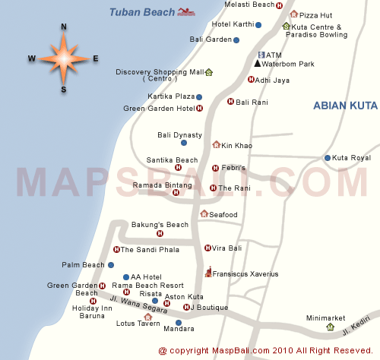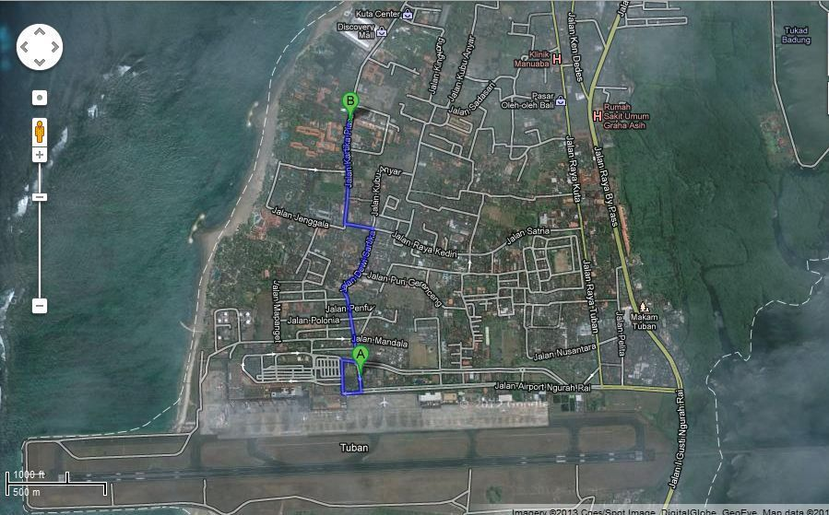
Location of the Working Party in Bali, Indonesia

2. Contact
Research Institute for Tuna Fisheries (RITF) are :

Budi Nugraha : budinug03@yahoo.com
Ririk Kartika Sulistyaningsih : ririkkartika_s@yahoo.com
Anung Widodo : anungwd@yahoo.com.id
Fayakun Satria : fsatria_2@yahoo.com

3. Travel arrangements and accomodations
Participants are requested to make their own travel arrangements and fund the expenses incurred.

Information on possible accomodation on Bali is provided bellow. All rates are on a bed and breakfast basis in single ocupancy.

Hotels | Rates | Contact | Notes
Hotel Santika Premiere Beach Resort  http://www.santika.com | USD 120  Deluxe room | Sri Sitti  santika@santikabali.com | Special RITF rate provided.  Meeting venue.
Bali Dynasty Resort  http://www.balidynasty.com | USD 140  Deluxe room | Edwin  se@balidynasty.com | Special RITF rate provided.
Bintang Kuta Hotel  http://www.bintangkutahotelbali.com | USD 90  Deluxe room | Dwi Wasiathi  sm@bintangkutahotelbali.com | Special RITF rate provided.
Ramada Bintang Bali Resort  http://www.bintang-bali-hotel.com | USD 135  Deluxe room | info@bintang-bali-hotel.com | Special RITF rate provided.
Febris Hotel & Spa  http://www.greenbali.com | USD 90  Deluxe room | info@greenbali.com | Special RITF rate provided.
Bali Rani Hotel  http://www.baliranihotel.com | USD 85  Deluxe room | salesmanager@baliranihotel.com | Special RITF rate provided.
Rama Beach Resort & Villas  http://www.ramabeach.com | USD 85  Deluxe room | I Made Dana  sales@ramabeachhotel.com  md_dana.bali@yahoo.com | Special RITF rate provided.

Participants are advised to make their reservations in the hotel of their choice as early as possible. NOTE: Recipients of the IOTC Meeting Participation Fund should NOT book their own accommodation. This is will booked by the IOTC Secretariat.

4. Arrival and entry formalities
Participants should make their own arrangements for their entry visa in Indonesia and it is recommended to do so as soon as possible.

What are the requirements for entering Indonesia?

Visa-Free Short Visit
11 countries and territories are eligible for a "Visa Free" facility. Those holding valid passports from the following countries will be granted a non-extendable 30-day Visa-Free Short Visit Permit upon arrival at an Indonesian international gateway without charge:

- Brunei Darussalam
- Chile
- Hong Kong SAR
- Macau SAR
- Malaysia
- Morocco
- Peru
- Philippines
- Thailand
- Vietnam
- Singapore

The official entry requirements for the issuance of a visa-free short visit permit:
- Passport must be from one of the eleven countries listed above.
- Passport must be valid for a minimum of 6 (six) months from the date of entry into Indonesia.
- Onward or return tickets are compulsory.
- Visitors must enter and exit through one of the 15 airports, 21 seaports or 1 overland border post officially approved as an "international gateway" by the Indonesian Immigration department.

Visa on Arrival Facility (VOA)
Effective Jan 26, 2010, visitors holding valid passports from certain countries can now only obtain a 30-days visa on arrival (VOA). The previous 7-day visa at US$10 has been abolished, hence this 30-days US$25 visa (renewable for an additional 30 days, cost for this extension has not been revealed yet) being the only visa that can be issued to eligible tourists. This VOA can be obtained at any of the 15 airports and 21 seaports designated as "international gateways" by the Indonesian Immigration department.
Nationals of the following countries are eligible to purchase a VOA (Updated Feb 17, 2010):

- Algeria
- Argentina
- Australia
- Austria
- Bahrain
- Belgium
- Brazil
- Bulgaria
- Cambodia
- Canada
- Cyprus
- Czech Republic
- Denmark
- Egypt
- Estonia
- Fiji
- Finland
- France
- Germany
- Greece
- Hungary
- Iceland
- India
- Iran
- Ireland
- Italy
- Japan
- Kuwait
- Laos
- Latvia
- Libya
- Liechtenstein
- Lithuania
- Luxembourg
- Maldives
- Malta
- Mexico
- Monaco
- New Zealand
- Norway
- Oman
- Panama
- People's Republic of China
- Poland
- Portugal
- Qatar
- Romania
- Russia
- Saudi Arabia
- Slovakia
- Slovenia
- South Africa
- South Korea
- Spain
- Suriname
- Switzerland
- Sweden
- Taiwan
- The Netherlands
- Tunisia
- United Arab Emirates
- United Kingdom
- United States of America

The official entry requirements for the issuance of this 30-days visa-on arrival:
- Passport must be from one of the countries listed above.
- Passport must be valid for a minimum of 6 (six) months from the expected date of departure from Indonesia.
- Payment of US$25 must be paid at the gateway.
- Onward or return tickets are compulsory.
- Visitors must enter and exit through one of the 15 airports or 21 seaports officially approved as an "international gateway" by the Indonesian Immigration department.
- Please make sure that you have one (1) entire blank page for the placement of your visa. If there is no page available, you run the risk of being turned away from Indonesia.

Tourist Visa
Individuals not holding a passport from among those nations listed above and eligible either for a visa-free short visit or a purchasable visa-on-arrival (VOA) can apply for a tourist visa at an Indonesian Embassy aboard. Tourist visa are normally granted for a 60 day stay in Indonesia.
Visa Issued on Approval.
All visa applications for Business, Tourist and Social Visits from nationals of the following countries need prior approval from an Immigration Office in Indonesia before traveling. The requirements vary depending on the propose visit to Indonesia.

- Afghanistan
- Albania
- Angola
- Bangladesh
- Cameroon
- Cuba
- Ethiopia
- Ghana
- Iraq
- Israel
- Nigeria
- North Korea
- Pakistan
- Somalia
- Sri Lanka
- Tanzania

Other Classes of Visas for Temporary Visitors
There are several other classes of visas available to visitors to Indonesia. If you are making your travel arrangements with www.balidiscovery.com we will be happy to provide you additional information and assistance regarding the following visa classes.
Business Visa - This visa is given by an Indonesian Embassies abroad to applicants visiting Indonesia for normal business activities (including attending a conference/seminar) which do not involve taking up employment or receiving any payments whilst in Indonesia. This visa, valid for a stay of 60 days, can be for a single or multiple visits. This visa is obtainable after application by a sponsoring party in Indonesia to the Department of Immigration.
Limited Stay Permit (KITAS) - This visa is a Temporary Stay Permit (KITAS) and is issued to applicants whose purpose of visit is to stay in Indonesia for a limited period.

http://www.manadosafaris.com/before_traveling.php
5. Transportation
Participants should make their own airport transfer and other transport arrangements between their hotel and the meeting venue.

Taxis are readily at the airport and the cost of transportation from the airport to the meeting venue should be around IDR 50.000 or USD 6.

6. General information about Bali
Among 17,500 islands across the Indonesian archipelago, Bali is one of the 33 provinces of the Republic of Indonesia, the largest archipelagic country in the world, made up of 2,000,000 km2 of land with a chain of islands stretching over 500,000 km from Sumatra to Papua, and covers territorial waters of more than 5,000,000 km2. Situated between Java and Lombok, the island of Bali is located 8 to 9 degrees south of the equator with the Java Sea to the north, the Indian Ocean to the south. Bali’s covers an area of 5,636 km2 or 0.29% of Indonesia, measuring just 90km long the north-south axis and less than about 140km from west to east. Divided into three areas of water, the North Bali Sea is about 3,168km2, the East about 3.350km2, and the West about 2,982km2. Bali Sea covers an area of 9,500km2. The North Bali sea runs along the coastline of Buleleng, the East Bali Sea runs along the coastline of Karangasem, Klungkung and Gianyar, and the West Bali Sea include the coastline of Badung Tabanan and Jembrana.

With sunshine shining throughout the year, Bali has a tropical monsoon climate, with pleasant day temperatures between 20 to 33 degrees Celsius or 68 to 93 degrees Fahrenheit. Rainy season starts from October to March, when the West monsoon brings heavy showers and high humidity. June to September is considered the driest season, with low humidity and it can be fairly cold in the evenings, the best time for any outdoor activities. Something unique can be found about climate in Bali. Even when it rains most times in the most parts of Bali you can often enjoy sunny days on the “Bukit”, the hill south of Jimbaran. On the other hand, you may expect cloudy skies and drips throughout the year in Ubud and the mountainous areas. Most interestingly perhaps, the international weather reports for “Denpasar” or “Bali” mention showers and rain storms all times of the year. In higher regions such as in Bedugul or Kintamani you’ll expect to wear either a sweater or jacket when evening falls.

One of the most popular tourist destinations in the world, Bali for few years awarded as the world best island by The International Travel Magazine. There, however, are still many people who do not know in depth about the uniqueness of Balinese culture. Life in Bali is always related to Tri Hita Karana or tripartite concept that include the spiritual relationship between human and God, and there environment.

The rapid growth of development in tourism has had a big impact and influences to Bali tradition and lifestyle. Interestingly, Balinese culture is still as what it was, growing along with the of globalization. It is the Balinese civilization what makes the island different from other destination.

The Rupiah is the currency of Indonesia. At the moment (11/01/2013) the rate is USD 1 = Indonesia Rupiah (IDR) 9625. All major currencies are exchangeable at banks, hotels, airport, and several money changers in Bali.

Balinese Food

Main Course
- Satay Lilit : It is made out of snapper filet, prawns, coconut and different kinds of herbs. A lot of restaurants serve this dish so when you see it on the menu it is surely worth a try.
- Nasi Campur : It is a famous Balinese food and it is easy to find. It contains a bowl of steamed rice, mixed with steamed vegetables with shredded spicy coconut, fried nuts, coconut milk, few shreds of fried/dry curry chicken, chopped seasoning, meat or fish, and hot traditional chili sauce.
- Ayam/Bebek Betutu: It is made from chicken or duck, chopped or not, and filled up with spices such as salam leaf, turmeric, ginger, galangal, kencur, garlic, onion, and chilies inside. Many restaurants have this on their menu but it takes hours to prepare, so it is better to order it a day in advance.
- Lawar : It is different from any other local food in Bali. It is a blend of vegetables, meat and various tropical spices. These ingredients are blended together and then mixed with raw pig blood. Usually served during popular festivals or occasions, lawar is well-known to the locals. If there is one thing you should add to your bucket list it is to experience exquisite Balinese food.

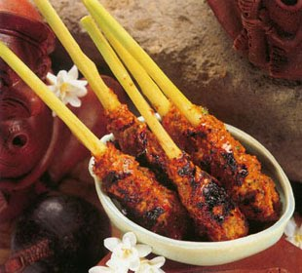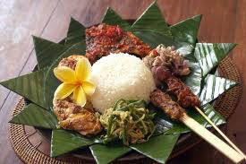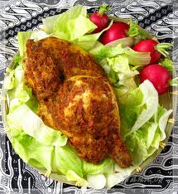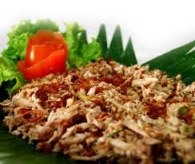
Satay Lilit Nasi Campur Ayam Betutu Lawar

- Dessert
- Jajan Bantal : Jajan bantal could prepared as a dish or just for offerings in ceremonies. Main ingredients of Jajan bantal is white sticky rice mixed with grated coconut and sugar, wrapped in coconut leaf tied with square shaped with a rope and steamed. Jajan bantal also can be found in restaurants in Kuta, Sanur , or Nusa Dua.
- Bubuh Injin : Very simple, made from black rice, coconut milk, mixed with Brown sugar, and sometimes add with small slices of jack fruit. Served hot or cold (with ice)
- Bubuh Sumsum : I eat this when I was a baby, and usually it is good for children digestion. Made from rice floured flavored with liquid produce from palm leaf (pandan) to make greenish tone and tempting smell served with liquid brown sugar.
- Batun Bedil : Batun bedil is not only can found in Bali, but in Java as well. It is made from rice flour mixed with coconut milk, shaped like a small bullet ( bedil ) then boiled. Served with melting brown sugar and taste very sweet. It could be find in traditional market or supermarket and Batun Bedil usually wrapped with banana leaf.
- Klepon : If you travelling to Bali, and visited Tanah Lot, Tabanan before watching sunset, in entrance area, a lot of seller will offer you to taste ”Klepon”. Klepon it self is a traditional cake made from rice flour, and inside there is liquid brown sugar, with grated coconut as topping and shaped like small ball.
- Jaja Uli : This is ” a must have” cake when Balinese have ceremonies. In every offering won’t be complete without Jaje Uli. Made from white sticky rice , grated coconut, and white sugar, then steamed to make an easier for the shape, it could triangle, square, circle.
- Laklak : Traditional cake, very famous, almost favorite for every Balinese. Easy to find in traditional market, and quite delicious. It is made from rice flour, served with grated coconut and brown sugar, usually shaped of Laklak is small circle similar with pancake, best served when is hot. Yummy….
- Cerorot : Looks like a dodol, but it isn't. So the cake consists of two main ingredients: brown sugar and rice. They are then steamed. To eat it, simply push the cerorot to your mouth and let the gooey cake melts into your mouth. Nice.

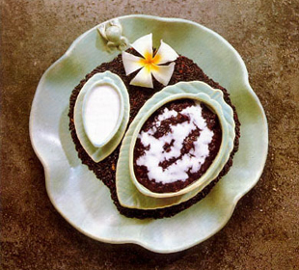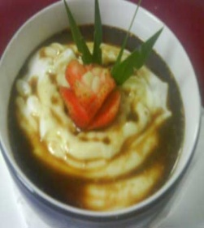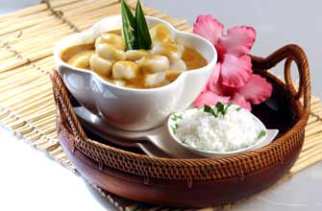
Jajan Bantal Bubuh Injin Bubuh Sumsum Batun Bedil

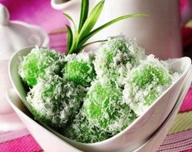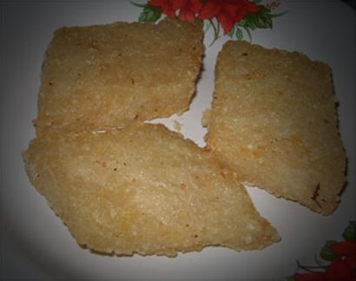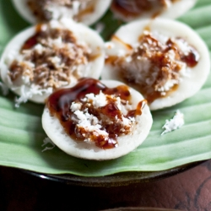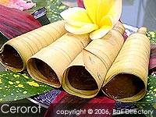
Klepon Jaja Uli Laklak Cerorot

- Tropical Fruit
- Jackfruit : the big fruit is easily found everywhere at the island with sweet taste of the fruit meat and big stone inside the meat. Jackfruit also release particular odor when they ripened. People use the jackfruit as additional fruit to give some smell and taste in local dessert dishes like Es Buah (Fruits assorted ice with coconut milk and sugar), Es Campur (assorted jelly, fruits and young coconut meat with coconut milk, milk (cream) and sugar with ices), or jackfruit chips and fried jackfruit.
The unripe jackfruit also use for traditional dishes, like gulai nangka (jackfruit curry) and Balinese used unripe jackfruit for lawar (chopped jackfruit, grated coconut, chopped meat and young bones and spicy seasonings)
- Lime : typically round, green to yellow in color. Limes are often used to accent the flavors of foods and beverages. The leaves also can be used as spicy seasonings for fresh or dried leaves.
- Keffir Lime : a rough, bumpy green fruit that grows on very thorny bush with aromatic leaves known commonly as jeruk limo, jeruk purut or jeruk lima , used as seasonings especially for sambal. The leaves also used as seasonings.
- Guava : known as Jambu Batu or Jambu biji is a pear shaped fruit green to yellow with white or red in the meat. Full of Vitamin A and C and easily found everywhere at the island, and sometimes found at the street without pruning. The leaves also used for herbal medicine, especially to cure diarrhea and diabetes.
- Mango : known locally as Mangga with flavor vary from sweet to sour fruit. The fruit is juicy and high water content which makes people so refresh after consume the fruit in the hot days.
- Mangosteen : a deep reddish purple fruit when ripe with white meat inside the shell. It is famous fruit in the island. To open the fruit, you may use knife or just squeeze between both hands and have the sweet juicy inside the shell..
- Durian : Durian is derived of duri (thorn) and suffix an which meant thorny fruit. Widely known as the king of fruits, durian is Bali native fruit and seasonal fruits available June to August. Ripe durian always spread strong odor that can be recognized from 1 kilometer with sweet and a splash of alcoholic and high sugar and fat content. You may find durian offered at the street side or supermarkets to have imported durian or local durian when they ripen due.
- Starfruit : or Carambola fruit known locally as Belimbing. A slightly tart and sweet juicy fruit with high vitamin C content. The leaves also can be used as herbal medicine to cure mild headache.
- Papaya : easily found in the island and all season fruit. A very sweet fruit and the meat so soft. The fruit skin also so vulnerable with green with orange hues or yellowish. High sugar content and also vitamin C.
- Rambutan : literally means as hairy fruit. Rambutan is easily found in Bali at every household yard. The fruit is in the loosely cluster, red and round with pliable spikes which people calling it hairs (rambut). The fruit flesh is white with tart and juicy sweet flavor.
- Salak : or snakeskin fruit due to the reddish-brown scaly skin is native fruit of Bali. It is the most popular fruit of the island among locals and tourists. The fruit is rather large, yellowish flesh and crunchy and mild tart and sweet flavors.
- Soursop : locally known as Sirsak or Nangka Cina or Nangka Belanda a thorny green round fruit with white flesh and scattered black seed between. The fruit is mixed of tart and sweet. Rather difficult to eat and usually used as ice sorbet, juice, and sweetmeat candies.
- Pineapple : a thorny fruit with yellow flesh and tartly sweet flavor. Famous in Bali as favored fruit for Rujak (like fruit salad with sambal sauce) for the flavor is not very sweet by tartly sweet. The fruit also used for jam spread.
- Water apple : locally known as Jambu Air is a bell-shaped fruit with colors ranging from white, pale green, green, red, purple, crimson, to deep purple. The fruit is crunchy with a lot of water content. The flavors also range from juicy bland to very juicy sweet. Commonly used by local people as fruit for Rujak.
- Banana : is very popular and important fruit in Bali, not only serve as food but also as offering ingredients in Bali. The banana sells in cluster (or hand) with green to yellow skin and white to yellow flesh. Banana is seedless fruit with sweet flavor. Banana can be fried and served with honey or coconut sugar or just boiled or steamed and sold at many food stall at traditional market. Banana leaves also used for cover or food wrapping which left good smells for the food. Balinese also use the stem (plant) for meal. The food name is ares or jukut ares, the young stem is finely chopped added spicy seasoning and some chicken meat or pork.
- Pomelo : or Chinese grapefruit or locally known as jeruk Bali. A citrus fruit larger than grapefruit with green to yellowish fruit. The peel is very thick and can be used for candy or marmalade. The jeruk Bali is bitter sweet flavor with juicy water.
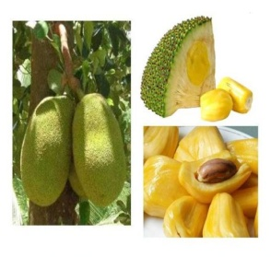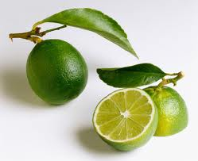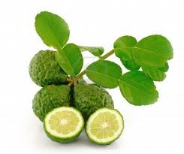
Jackfruit Lime Keffir Lime Guava

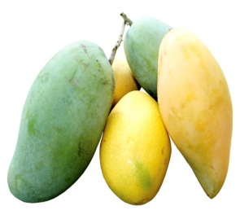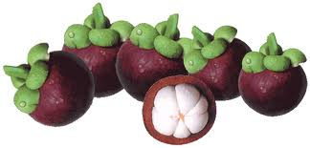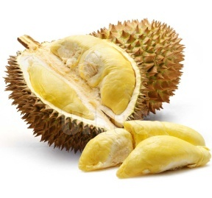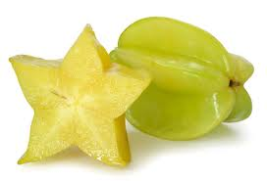
Mango Mangosteen Durian Starfruit

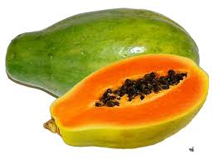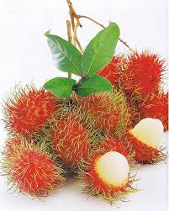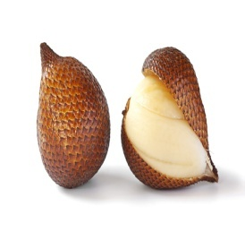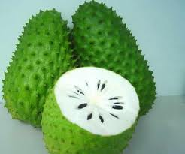
Papaya Rambutan Salak Soursop

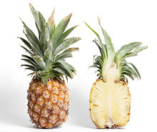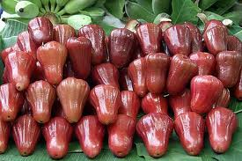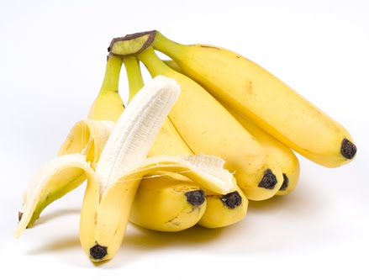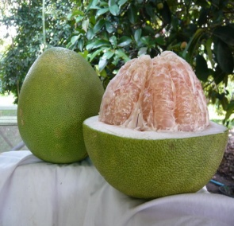
Pinapple Water Apple Banana Pomelo

Ngurah Rai Airport
Ngurah Rai International Airport (IATA: DPS, ICAO: WADD), also known as Denpasar International Airport, is located in southern Bali, 13 km south of Denpasar. Ngurah Rai is Indonesia's second-busiest international airport, after Jakarta's Soekarno-Hatta International Airport, but currently (pending the construction of new terminal facilities) is the second most crowded airport in the country after Soekarno-Hatta International Airport.
The airport is named after I Gusti Ngurah Rai, an Indonesian National Hero an Indonesian republican who died on 20 November 1946 in a puputan (fight to the death) against the Dutch at Marga in Tabanan where the Dutch defeated them with the aid of aircraft, killing Rai and 95 others during the Indonesian Revolution in 1946.
The airport is located in Tuban on the Island of Bali between Kuta and Jimbaran and is close to the tourist locations of southern Bali; the resort center of Kuta is 2.5 km north of the airport. The capital of Bali Denpasar is located nearby.

7. Electricity
Indonesia uses 220 Volt for its electricity. The electrical outlet has two round holes, similar to those in continental Europe.

8. Telephone services
International dialing code:
The International dialing code for Bali, Indonesia is +62 361

Mobile services:
Three operators (Telkomsel, Indosat, XL) are offering SIM card and prepaid recharge for mobile phones.

9. Internet
Wi-Fi facility will be available only in the conference area and internet service at hotels will be at participants own expense.

10. Tourism
Information on tourism and other information can also found at the following website:
http://www.balitourismboard.org/

