Executive Summary: Kawakawa

Status of the Indian Ocean kawakawa (KAW: Euthynnus affinis) resource

TABLE 1. Kawakawa: Status of kawakawa (Euthynnus affinis) in the Indian Ocean.
Area¹ | Indicators |  | 2017 stock status determination
Indian Ocean | Catch 2016²:  Average catch 2012-2016: | 156,831 t  158,990 t
 | MSY (1,000 t) [*]  F_{MSY} [*]  B_{MSY} (1,000 t) [*]  F_{2013/}F_{MSY} [*]  B_{2013/}B_{MSY} [*]  B₂₀₁₃/B₀ [*] | 152 [125 –188]  0.56 [0.42–0.69]  202 [151–315]  0.98 [0.85–1.11]  1.15 [0.97–1.38]  0.58 [0.33–0.86]

¹ Boundaries for the Indian Ocean stock assessment are defined as the IOTC area of competence.
² Proportion of catch estimated or partially estimated by IOTC Secretariat in 2016: 63%

Nominal catches represent those estimated by the IOTC Secretariat. If these data are not reported by CPCs, the IOTC Secretariat estimates total catch from a range of sources including: partial catch and effort data; data in the FAO FishStat database; catches estimated by the IOTC from data collected through port sampling; data published through web pages or other means; data reported by other parties on the activity of vessels; and data collected through sampling at the landing place or at sea by scientific observers.

*Range of plausible values
Colour key | Stock overfished(SB_{year}/SB_{MSY}< 1) | Stock not overfished (SB_{year}/SB_{MSY}≥ 1)
Stock subject to overfishing(F_{year}/F_{MSY}> 1)
Stock not subject to overfishing (F_{year}/F_{MSY}≤ 1)
Not assessed/Uncertain

Indian Ocean stock – Management Advice
Stock status. A stock assessment was not undertaken for kawakawa in 2017 and the status is determined on the basis of the 2015 assessment, which used catch data from 1950 to 2013. Analysis using an Optimised Catch Only Method (OCOM) approach in 2015 indicates that the stock is near optimal levels of F_{MSY}, and stock biomass is near the level that would produce MSY (B_{MSY}). Due to the quality of the data being used, the simple modelling approach employed in 2015, and the large increase in kawakawa catches over the last decade (Fig. 1), measures need to be taken in order to slow the rate of increasing catch, though catches between 2014 and 2016 are lower than those estimated in 2013. Based on the weight-of-evidence available, the kawakawa stock for the whole Indian Ocean is classified as not overfished and not subject to overfishing (Table 1, Fig. 2).
Outlook. There is considerable uncertainty about stock structure and the estimate of total catches. Due to the uncertainty associated with catch data (e.g.,63% of catches partially or fully estimated by the IOTC Secretariat in 2016) and the limited number of CPUE series available for fleets representing a small proportion of total catches, only data poor assessment approaches can currently be used. Aspects of the fisheries for this species, combined with the lack of data on which to base a more complex assessment (e.g. integrated models) are a cause for considerable concern. In the interim, until more traditional approaches are developed, data-poor approaches will be used to assess stock status. The continued increase in annual catches for kawakawa is likely to have further increased the pressure on the Indian Ocean stock as a whole resource. Research emphasis on collating catch per unit effort (CPUE) time series for the main fleets, size compositions and life trait history parameters (e.g. estimates of growth, natural mortality, maturity, etc.) should be considered a high priority for the Commission. There is a high risk of exceeding MSY-based reference points if catches are maintained at 2013 levels (96% risk that B₂₀₁₆<B_{MSY}, and 100% risk that F₂₀₁₆>F_{MSY}) or an even higher high risk if catches are increased further (120% of 2013 levels) (100% risk that SB₂₀₁₆<SB_{MSY}, and 100% risk that F₂₀₁₆>F_{MSY}) (Table 2).
Management Advice. Although the stock status is classified as not overfished and not subject to overfishing, the Kobe strategy II matrix developed in 2015 showed that there is a 96% probability that biomass is below MSY levels and 100% probability that F>F_{MSY} by 2016 and 2023 if catches are maintained at the 2013 levels. The modelled probabilities of the stock achieving levels consistent with the MSY reference points (e.g. SB > SB_{MSY} and F<F_{MSY}) in 2023 are 100% for a future constant catch at 80% of 2013 catch levels, thus if the Commission wishes to recover the stock to levels above the MSY reference points with a 50% probability by 2023, the Scientific Committee recommends that catches should be reduced by 20% based on 2013 levels (170,181 t).
The following should be noted:
- The Maximum Sustainable Yield estimate for the whole Indian Ocean is estimated to be between 125,000 and 188,000 t and so catch levels should be stabilised or reduced in future to prevent the stock becoming overfished.
- Further work is needed to improve the reliability of the catch series. Reported catches should be verified or estimated, where they are believed to be gaps, based on expert knowledge of the history of the various fisheries or through statistical extrapolation methods.
- Improvement in data collection and reporting is required if the stock is to be assessed using integrated stock assessment models.
- Limit reference points: The Commission has not adopted limit reference points for any of the neritic tunas under its mandate
- Research emphasis on collating catch per unit effort (CPUE) time series for the main fleets, size compositions and life trait history parameters (e.g. estimates of growth, natural mortality, maturity, etc.) should be considered of high priority for the Commission.
- Given the limited information submitted by CPCs on total catches, catch and effort and size data for neritic tunas, despite their mandatory reporting status, the IOTC Secretariat was required to estimate 63% of the catches (in 2016), which increases the uncertainty of the stock assessments using these data. Therefore the management advice to the Commission includes the need for CPCs need to comply with IOTC data requirements per Resolution 15/01 and 15/02.

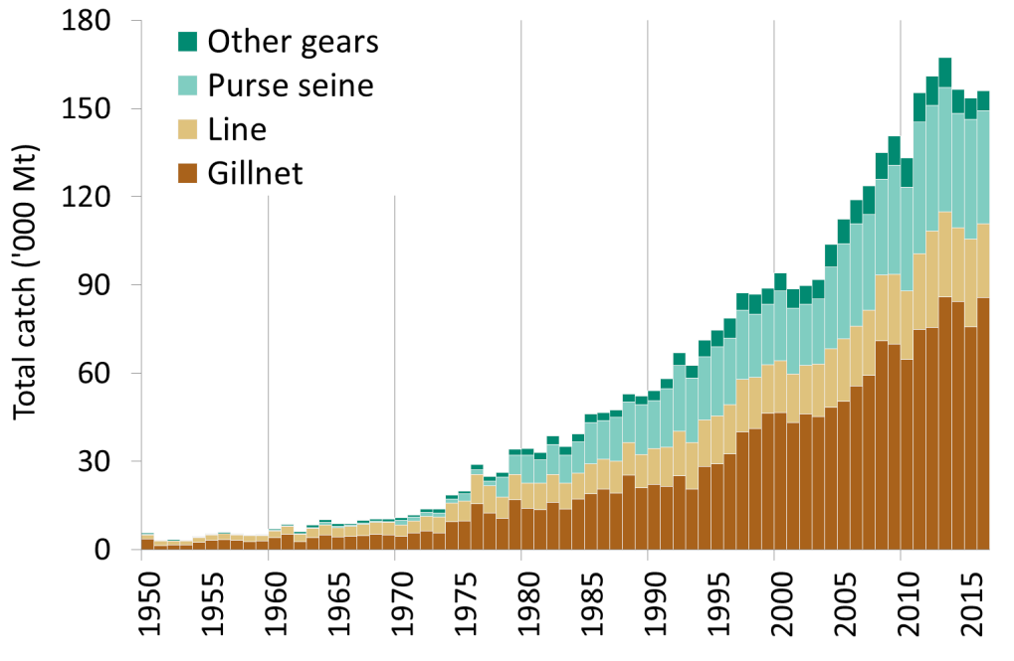
Fig.1. Kawakawa: Annual catches of kawakawa by gear recorded in the IOTC database (1950–2016).
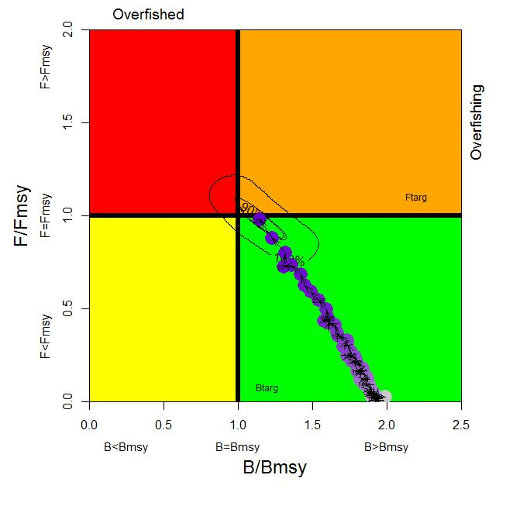
Fig.2. Kawakawa. OCOM aggregated Indian Ocean assessment. Blue circles indicate the trajectory of the point estimates for the B ratio and F ratio for each year between 1950 and 2013 (the black lines represent all plausible model runs shown around 2015 estimate). Target reference points (B_{targ} and F_{targ}) are shown as B_{MSY} and F_{MSY}.

Table 2. Kawakawa: OCOM Aggregated Indian Ocean assessment Kobe II Management Strategy Matrix. Probability (percentage) of plausible models violating the MSY-based reference points for five constant catch projections (2013 catch level, -10%, -20%, -30%, +10% and +20%) projected for 3 and 10 years. Note: from the 2015 stock assessment using catch estimates (i.e. 1950-2013) at that time.
Reference point and projection timeframe | Alternative catch projections (relative to 2013) and weighted probability (%) scenarios that violate reference point
 | 70%  (119,126 t) | 80%  (136,144 t) | 90%  (153,162 t) | 100%  (170,181 t) | 110%  (187,199 t) | 120%  (204,216 t)
B₂₀₁₆ < B_{MSY} | 0 | 1 | 37 | 96 | n.a. | 100
F₂₀₁₆ > F_{MSY} | 0 | 18 | 87 | 100 | 100 | 100
B₂₀₂₃ < B_{MSY} | 0 | 0 | 55 | 100 | 100 | 100
F₂₀₂₃ > F_{MSY} | 0 | 0 | 91 | 100 | 100 | 100

as estimated in 2015

