Executive Summary – Yellowfin tuna

Status of the Indian Ocean yellowfin tuna (YFT: Thunnus albacares) resource

TABLE 1. Yellowfin tuna: Status of yellowfin tuna (Thunnus albacares) in the Indian Ocean.
Area¹ | Indicators |  | 2017 stock status³ determination
Indian Ocean | Catch 2016²:  Average catch 2012–2016: | 412,679 t  407,985 t | 67.6%*
 | MSY (1000 t) (80% CI):  F_{MSY} (80% CI):  SB_{MSY} (1,000 t) (80% CI):  F_{2015/}F_{MSY} (80% CI):  SB_{2015/}SB_{MSY} (80% CI):  SB₂₀₁₅/SB₀ (80% CI): | 422 (406-444)  0.151 (0.148-0.154)  947 (900-983)  1.11 (0.86-1.36)  0.89 (0.79-0.99)  0.29 (n.a.-n.a.)
¹Boundaries for the Indian Ocean stock assessment are defined as the IOTC area of competence.
² Proportion of catch estimated or partially estimated by IOTC Secretariat in 2016: 22%
³ The stock status refers to the most recent years’ data used in the last assessment conducted in 2016.
* Estimated probability that the stock is in the respective quadrant of the Kobe plot (shown below), derived from the confidence intervals associated with the current stock status. The confidence intervals for SB₂₀₁₅/SB₀ were not estimated for the models used.

Colour key | Stock overfished (SB_{year}/SB_{MSY}< 1) | Stock not overfished (SB_{year}/SB_{MSY}≥ 1)
Stock subject to overfishing(F_{year}/F_{MSY}> 1) | 67.6% | 3.7%
Stock not subject to overfishing (F_{year}/F_{MSY}≤ 1) | 27.3% | 1.4%
Not assessed/Uncertain

Indian Ocean stock – Management Advice
Stock status. No new stock assessment was carried out for skipjack tuna in 2017, thus, stock status is determined on the basis of the 2016 assessment and other indicators presented in 2017. In 2016, two models were applied to the yellowfin tuna stock in the IOTC area of competence to update the stock status undertaken in 2015: a Biomass Dynamic Model (BDM) and Stock Synthesis III (SS3) model, which gave qualitatively similar results. Stock status and management advice was based on the SS3 model formulation. Spawning stock biomass in 2015 was estimated to be 28.9% of the unfished levels (Table 1) and 89% (79–99%) of the level which can support MSY. The assessment is somewhat more optimistic than the stock assessment undertaken in 2015 mainly due to the use of a new composite LL CPUE series, which results in a lower estimate of fishing mortality in the NE Indian Ocean. In addition, the catch series revised in 2016 reduced the catch data for 2014 by 5.1% (from 430,327 to 408,497, although the impact of this revision on status determination was minor. According to the information available for the stock assessment, the total catch has remained relatively stable at levels somewhat lower than the estimated MSY since 2012 (412,659 t in 2016, 402,384 t in 2015, 408,097 in 2014, 405,048 in 2013 and 400,502 in 2012). The inclusion of revised and new data into the updated assessment using the model structure applied in the 2015 assessment resulted in a higher estimated biomass in 2014 and lower estimated F/F_{MSY} than the corresponding estimates from the 2015 stock assessment. Nonetheless, the updated assessment estimates SB₂₀₁₅/SB_{MSY} at 0.89 (0.79-0.99) and F₂₀₁₅/F_{MSY} at 1.11 (0.86-1.36). The quantified uncertainty in these estimates is an underestimate of the underlying uncertainty of the assessment. On the weight-of-evidence available in 2017, the yellowfin tuna stock is determined to remain overfished and subject to overfishing (Table 1 and Fig. 1).
Outlook. The increase in longline, gillnet, handline and purse seine effort and associated catches in recent years has substantially increased the pressure on the Indian Ocean stock as a whole, with recent fishing mortality exceeding the MSY-related levels. There is a risk of continuing to exceed the MSY-based biomass reference point if catches increase or remain at current levels (2016) until 2018 (88% risk that SB < SB_{MSY}) (Table 2). The modelled probabilities of the stock attaining levels consistent with the Commission’s current management objective (e.g. SB > SB_{MSY}) are shown in the K2MSM, which provides a range of options for reducing catches and the probabilities of the yellowfin tuna stock recovering to the MSY target levels (Table 2).
Management advice. As no stock assessment was conducted in 2017, the stock status determination has not changed since 2016, and gives a somewhat more optimistic estimate of stock status than the 2015 assessment as a result of the use of more reliable information on catch rates of longline fisheries and catches updated to 2016. The stock status is driven by unsustainable catches of yellowfin tuna taken over the last five (5) years, and the relatively low recruitment levels estimated by the model in recent years. The Commission has an interim plan for the rebuilding of this stock (Resolution 17/01, which is yet to be evaluated and superseded Resolution 16/01) to achieve the recovery of yellowfin stock, with catch limitations based on 2014/2015 levels. The projections produced to advise on future catches are, in the short term, driven by the below average recruitment estimated for in recent years since these year classes have yet to reach maturity and contribute to the spawning biomass (see Table 2).
The following key points should also be noted:
- Maximum Sustainable Yield (MSY): estimate for the whole Indian Ocean is estimated at 422,000 t with a range between 406,000-444,000 t (Table 1). The 2012-2016 average catches (407,985 t) were below the estimated MSY level.
- Interim reference points: Noting that the Commission in 2015 agreed to Resolution 15/10 on target and limit reference points and a decision framework, the following should be noted:
  - Fishing mortality: Current fishing mortality is considered to be 11% above the interim target reference point of F_{MSY}, and below the interim limit reference point of 1.4*F_{MSY} (Fig. 2).
  - Biomass: Current spawning biomass is considered to be 11% below the interim target reference point of SB_{MSY}, however above the interim limit reference point of 0.4*SB_{MSY} (Fig. 2).

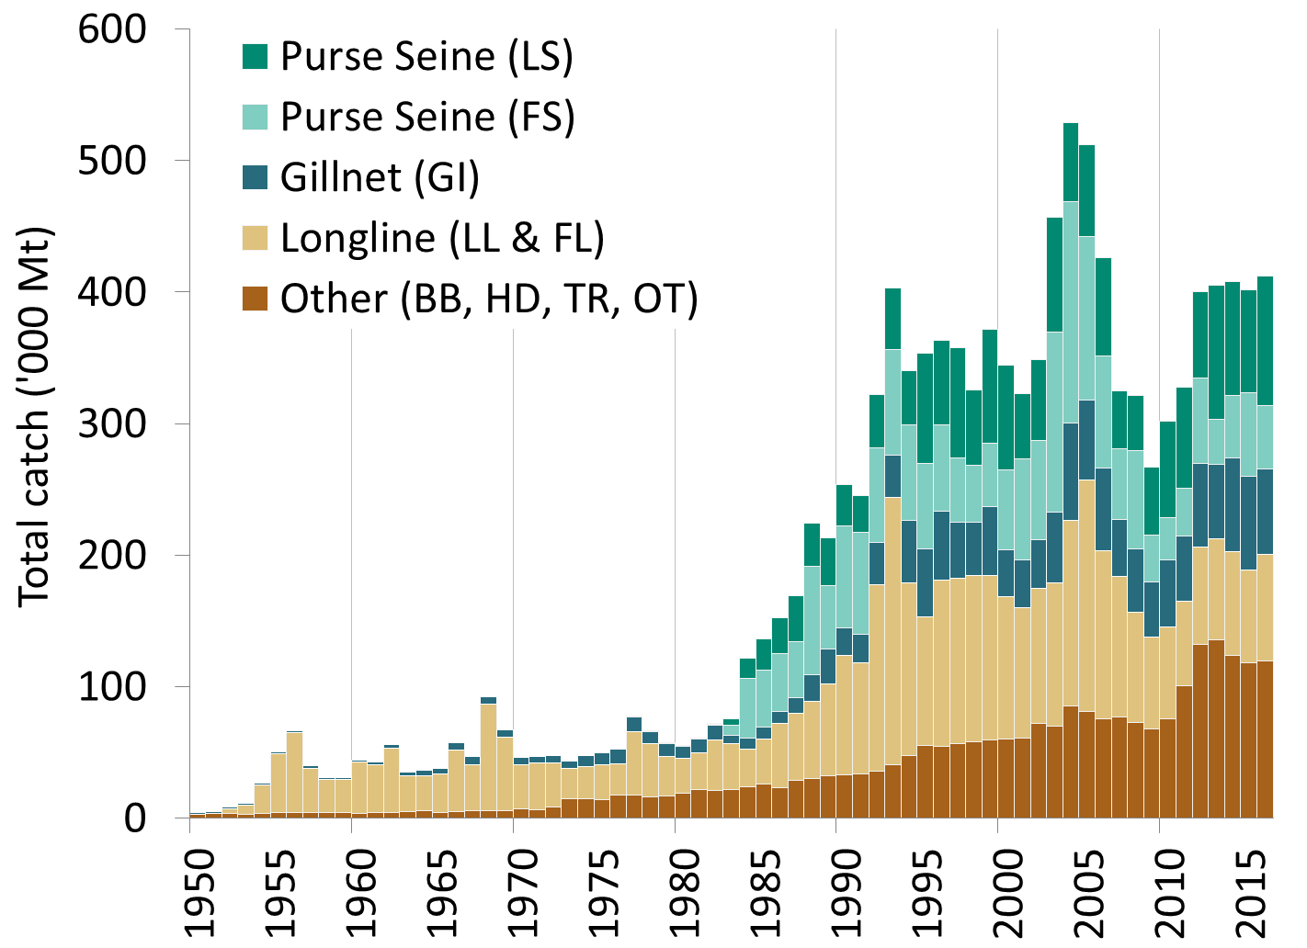

Fig. 1. Annual catches of yellowfin tuna by gear (1950–2016).

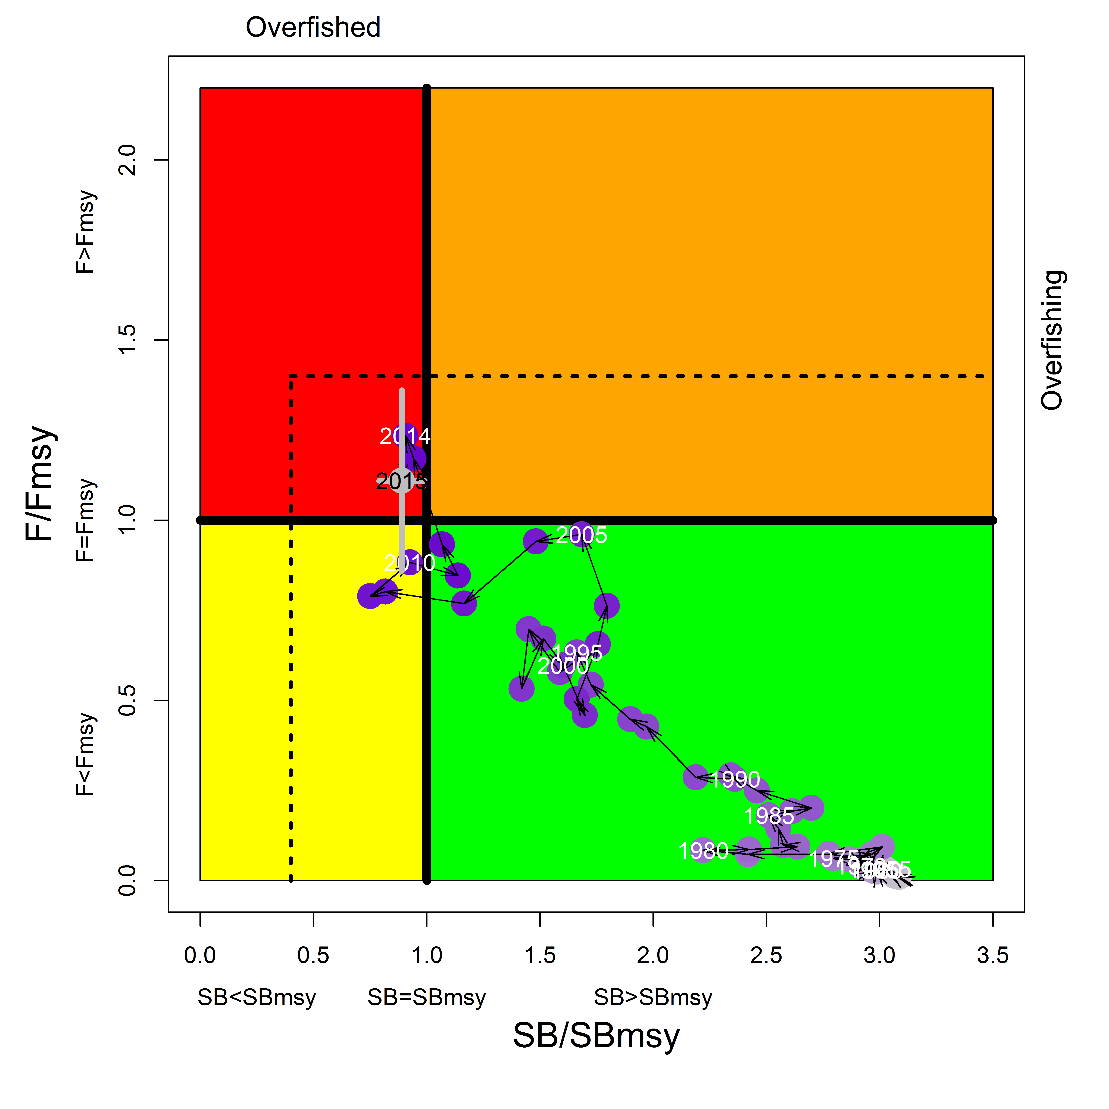
Fig. 2. Yellowfin tuna: Stock synthesis Kobe plot. Blue dots indicate the trajectory of the point estimates for the B/B_{MSY} ratio and F_{MSY} proxy ratio for each year 1950–2015. The grey line represents the 80% confidence interval associated with the 2015 stock status. Dotted black lines are the interim limit reference points adopted by the Commission via Resolution 15/10.
TABLE 2. Yellowfin tuna: Stock synthesis assessment Kobe II Strategy Matrix. Probability (percentage) of violating the MSY-based target (top) and limit (bottom) reference points for constant catch projections (relative to the catch level from 2015* levels (407,575t), -30%, - 25%, ± 20%, -15%,± 10%, -5% ), projected for 3 and 10 years), projected for 3 and 10 years.

Reference point and projection timeframe | Alternative catch projections (relative to the catch level from 2015*) and probability (%) of  violating MSY-based target reference points  (B_{targ} = B_{MSY}; F_{targ} = F_{MSY})
 | 70%  (285,302t) | 75%  (305,680t) | 80%  (326,059t) | 85%  (346,438t) | 90%  (366,816t) | 95%  (387,195t) | 100%  (407,574t) | 110%  (448,331t) | 120%  (489,089t)
B₂₀₁₈ < B_{MSY} | 53 | 61 | 67 | 77 | 80 | 88 | 88 | 97 | 99
F₂₀₁₈ > F_{MSY} | 2 | 7 | 23 | 47 | 65 | 73 | 100 | 100 | 100
B₂₀₂₅ < B_{MSY} | 6 | n.a. | 20 | 37 | 60 | 100 | 100 | 100 | 100
F₂₀₂₅ > F_{MSY} | 0 | n.a. | 10 | 40 | 57 | 100 | 100 | 100 | 100
Reference point and projection timeframe | Alternative catch projections (relative to the catch level from 2015*) and probability (%) of  violating MSY-based limit reference points  (B_{lim} = 0.4 B_{MSY}; F_{Lim} = 1.4 F_{MSY})
 | 70%  (285,302t) | 75%  (305,680t) | 80%  (326,059t) | 85%  (346,438t) | 90%  (366,816t) | 95%  (387,195t) | 100%  (407,574t) | 110%  (448,331t) | 120%  (489,089t)
B₂₀₁₈ < B_{Lim} | 2 | 1 | 2 | 4 | 6 | 6 | 12 | 21 | 38
F₂₀₁₈ > F_{Lim} | 0 | 0 | 1 | 10 | 32 | 52 | 100 | 100 | 100
B₂₀₂₅ < B_{Lim} | 0 | n.a. | 1 | 7 | 30 | >30** | >30** | >30** | >30**
F₂₀₂₅ > F_{Lim} | 0 | n.a. | 0 | 11 | 53 | >30** | >30** | >30** | >30**
* Catches for 2015, at the time of the last yellowfin tuna assessment conducted in 2016.
** At least one fishery not able to take the catch due to absence of vulnerable fish in the projection period. The probability levels are not well determined, but likely progressively exceed 30% as the catch level increases beyond 90%.

