Appendix XI
Executive Summary: Indo-Pacific King Mackerel

Status of the Indian Ocean Indo-Pacific king mackerel (GUT: Scomberomorus guttatus) resource

TABLE 1. Indo-Pacific king mackerel: Status of Indo-Pacific king mackerel (Scomberomorus guttatus) in the Indian Ocean.
Area¹ | Indicators |  | 2018 stock status determination
Indian Ocean | Catch 2017²:  Average catch 2013-2017: | 49,905 t  46,814 t
 | MSY (1,000 t):  F_{MSY}:  B_{MSY} (1,000 t) :  F_{current/}F_{MSY}:  B_{current}/B_{MSY}:  B_{current}/B₀: | Unknown  Unknown  Unknown  Unknown  Unknown  Unknown

¹ Boundaries for the Indian Ocean stock assessment are defined as the IOTC area of competence.
² Proportion of catch estimated or partially estimated by IOTC Secretariat in 2017: 68%

Nominal catches represent those estimated by the IOTC Secretariat. If these data are not reported by CPCs, the IOTC Secretariat estimates total catch from a range of sources including: partial catch and effort data; data in the FAO FishStat database; catches estimated by the IOTC from data collected through port sampling; data published through web pages or other means; data reported by other parties on the activity of vessels; and data collected through sampling at the landing place or at sea by scientific observers.

Colour key | Stock overfished(SB_{year}/SB_{MSY}< 1) | Stock not overfished (SB_{year}/SB_{MSY}≥ 1)
Stock subject to overfishing(F_{year}/F_{MSY}> 1)
Stock not subject to overfishing (F_{year}/F_{MSY}≤ 1)
Not assessed/Uncertain

Indian Ocean stock – Management Advice
Stock status. A preliminary assessment was undertaken for Indo-Pacific king mackerel using catch-only methods techniques (Catch-MSY and OCOM) in 2016. The OCOM model, which was considered the more robust of the two catch-only models in terms of assumptions and treatment of priors, indicated that overfishing was not occurring and the stock was not overfished. The continuing uncertainty in catches (68% estimated) for this species, coupled with the highly variable and uncertain estimates of growth parameters used to estimate model priors, warrant caution in interpreting model results for Indo-Pacific king mackerel. Given that no new assessment was undertaken in 2017, the WPNT considered that stock status in relation to the Commission’s B_{MSY} and F_{MSY} target reference points remains unknown (Table1).
Outlook. Total annual catches for Indo-Pacific king mackerel have increased over time, reaching a peak of 53,000 t in 2009 and have since fluctuated between 42,000 and 52000 t. There is considerable uncertainty about stock structure and total catches. Aspects of the fisheries for this species, combined with the limited data on which to base a more complex assessment (e.g. integrated models), are a cause for concern. Although data-poor methods are yet to be used to provide stock status advice, further refinements to the catch-only methods and application of additional data-poor approaches may improve confidence in the results. Research emphasis on collating catch per unit effort (CPUE) time series for the main fleets, size compositions and life trait history parameters (e.g. estimates of growth, natural mortality, maturity, etc.) should be considered a high priority for the Commission.

Management advice. For assessed species of neritic tunas in Indian Ocean (longtail tuna, kawakawa and narrow barred Spanish mackerel), the MSY was estimated to have been reached between 2009 and 2011 and both F_{MSY} and B_{MSY} were breached thereafter. Therefore, in the absence of a stock assessment of Indo-Pacific king mackerel a limit to the catches should be considered by the Commission, by ensuring that future catches do not exceed the average catches estimated between 2009 and 2011 (46,787 t). The reference period (2009-2011) was chosen based on the most recent assessments of those neritic species in the Indian Ocean for which an assessment is available under the assumption that also for Indo-Pacific king mackerel MSY was reached between 2009 and 2011. This catch advice should be maintained until an assessment of Indo-Pacific king mackerel is available. Considering that MSY-based reference points for assessed species can change over time, the stock should be closely monitored. Mechanisms need to be developed by the Commission to improve current statistics by encouraging CPCs to comply with their recording and reporting requirements, so as to better inform scientific advice.
The following should be also noted:
- Limit reference points: The Commission has not adopted limit reference points for any of the neritic tunas under its mandate.
- Research emphasis on collating catch per unit effort (CPUE) time series for the main fleets, size compositions and life trait history parameters (e.g. estimates of growth, natural mortality, maturity, etc.) should be considered of high priority for the Commission.
- Further work is needed to improve the reliability of the catch series. Reported catches should be verified or estimated, based on expert knowledge of the history of the various fisheries or through statistical extrapolation methods.
- Data collection and reporting urgently need to be improved.
- There is limited information submitted by CPCs on total catches, catch and effort and size data for neritic tunas, despite their mandatory reporting status. In the case of 2017 catches 68% of the total catches were either fully or partially estimated by the IOTC Secretariat, which increases the uncertainty of the stock assessments using these data. Therefore the management advice to the Commission includes the need for CPCs to comply with IOTC data requirements per Resolution 15/01 and 15/02.
- Main fishing gear (average catches 2013-17): Indo-Pacific King mackerel are caught mainly by gillnets (≈66%), however significant numbers are also caught trolling (Fig. 1).
- Main fleets (average catches 2013–17): Almost two-thirds of catches are accounted for by fisheries in India and Indonesia; with important catches also reported by I.R. Iran.
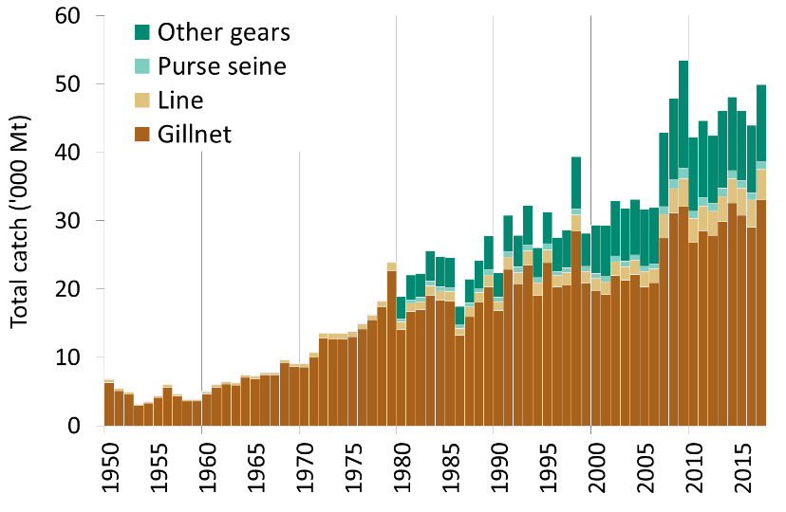
Fig. 1. Indo-Pacific king mackerel: Annual catches of Indo-Pacific king mackerel by gear recorded in the IOTC database (1950–2017)

Definition of fishery: Gillnet: gillnet, including offshore gillnet; Line: coastal longline, hand line, troll line; Purse seine: coastal purse seine, purse seine, ring net; Other gears: baitboat, Danish seine, liftnet, longline, longline fresh, trawling.

