Appendix IX
Executive Summary: Blue Shark
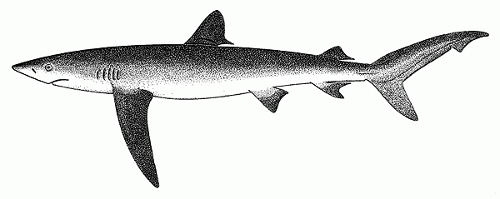
Status of the Indian Ocean blue shark (BSH: Prionace glauca)

TABLE 1. Blue shark: Status of blue shark (Prionace glauca) in the Indian Ocean.
Area | Indicators |  | 2018 stock status determination
Indian Ocean | Reported catch 2017:  Estimated catch 2015:  Not elsewhere included (nei) sharks 2017:  Average reported catch 2013-17:  Average estimated catch 2011–15:  Ave. not elsewhere included (nei) sharks² 2012-16: | 27,259 t  54,735 t  56,883 t  29,790 t  54,993 t  51,712 t | 72.6%
 | MSY (1,000 t) (80% CI)³:  F_{MSY} (80% CI) ³:  SB_{MSY} (1,000 t) (80% CI) ^{3,4}:  F_{2015/}F_{MSY} (80% CI) ³:  SB_{2015/}SB_{MSY} (80% CI) ³:  SB₂₀₁₅/SB₀ (80% CI) ³: | 33.0 (29.5 - 36.6)  0.30 (0.30 - 0.31)  39.7 (35.5 - 45.4)  0.86 (0.67 - 1.09)  1.54 (1.37 - 1.72)  0.52 (0.46 - 0.56)
Boundaries for the Indian Ocean = IOTC area of competence
²Includes all other shark catches reported to the IOTC Secretariat, which may contain this species (i.e., SHK: sharks various nei; RSK: requiem sharks nei).
³Estimates refer to the base case model using estimated catches.
⁴ Refers to fecund stock biomass

Colour key | Stock overfished  (SB₂₀₁₅/SB_{MSY}< 1) | Stock not overfished (SB₂₀₁₅/SB_{MSY}≥ 1)
Stock subject to overfishing(F₂₀₁₅/F_{MSY}> 1) | 0% | 27.4%
Stock not subject to overfishing (F₂₀₁₅/F_{MSY}≤ 1) | 0% | 72.6%
Not assessed/Uncertain

TABLE 2. Blue shark: IUCN threat status of blue shark (Prionace glauca) in the Indian Ocean.
Common name | Scientific name | IUCN threat status³
 |  | Global status | WIO | EIO
Blue shark | Prionace glauca | Near Threatened | – | –
IUCN = International Union for Conservation of Nature; WIO = Western Indian Ocean; EIO = Eastern Indian Ocean
³The process of the threat assessment from IUCN is independent from the IOTC and is presented for information purpose only
Sources: IUCN 2007, Stevens 2009

Indian Ocean stock – Management Advice
Stock status. Considerable progress was made since the last Indian Ocean blue shark assessment on the integration of new data sources and modelling approaches. Uncertainty in data inputs and model configuration were explored through sensitivity analysis. Four stock assessment models were applied to the blue shark in 2017, specifically a data-limited catch only model (SRA), two Bayesian biomass dynamic models (JABBA with process error and a Pella-Tomlinson production model without process error) and an integrated age-structured model (SS3) (Fig. 1). All models produced similar results suggesting the stock is currently not overfished nor subject to overfishing, but with the trajectories showing consistent trends towards the overfished and subject to overfishing quadrant of the Kobe plot (Fig 1). A base case model was selected based on the best Indian Ocean biological data, consistency of CPUE standardized relative abundance series, model fits and spatial extent of the data (Fig. 1, Table 1). The major change in biological parameters since the previous stock assessment is the stock recruitment relationship, i.e., steepness = 0.79 due to the update of the key biological parameters calculated specific to the Indian Ocean. The major axes of uncertainties identified in the current model are catches and CPUE indices of abundance. Model results were explored with respect to their sensitivity to the major axes of uncertainty identified. If the alternative CPUE groupings were used then the stock status was somewhat more positive (B>>Bmsy and F<<Fmsy), while if the alternative catch series (trade and EUPOA) were used then the estimated stock status resulted in F>Fmsy. The ecological risk assessment (ERA) conducted for the Indian Ocean by the WPEB and SC in 2018 consisted of a semi-quantitative risk assessment analysis to evaluate the resilience of shark species to the impact of a given fishery by combining the biological productivity of the species and its susceptibility to each fishing gear type. Blue sharks received a medium vulnerability ranking (No. 6) in the ERA rank for longline gear because it was estimated as the most productive shark species, but was also characterised by the third highest susceptibility to longline gear. Blue shark was estimated as not being susceptible thus not vulnerable to purse seine gear. The current IUCN threat status of ‘Near Threatened’ applies to blue sharks globally (Table 2). Information available on this species has been improving in recent years. Blue sharks are commonly taken by a range of fisheries in the Indian Ocean and in some areas they are fished in their nursery grounds. Because of their life history characteristics – they live until at least 25 years, mature at 4–6 years, and have 25–50 pups every year – they are considered to be the most productive of the pelagic sharks. On the weight-of-evidence available in 2017, the stock status is determined to be not overfished and not subject to overfishing (Table 1).
Outlook. Increasing effort could result in declines in biomass. The Kobe II Strategy Matrix (Table 3) provides the probability of exceeding reference levels in the short (3 years) and long term (10 years) given a range of percentage changes in catch.
Management advice. Even though the blue shark in 2017 was assessed to be not overfished nor subject to overfishing, maintaining current catches is likely to result in decreasing biomass and the stock becoming overfished and subject to overfishing in the near future (Table 3). If the catches are reduced at least 10%, the probability of maintaining stock biomass above MSY reference levels (B>B_{MSY}) over the next 8 years will be increased (Table 3). The stock should be closely monitored. While mechanisms exist for encouraging CPCs to comply with their recording and reporting requirements (Resolution 16/06), these need to be further implemented by the Commission, so as to better inform scientific advice in the future.

The following key points should also be noted:
- Maximum Sustainable Yield (MSY): estimate for the Indian Ocean stock is 33,000 t.
- Reference points: The Commission has not adopted reference points or harvest control rules for any shark species.
- Main fishing gear (2013–17): Coastal longline; longline targeting swordfish; longline (deep-freezing).
- Main fleets (2013–17): Indonesia; EU,Spain; Taiwan, China; Japan; EU,Portugal.

Literature Cited
Murua H, Santiago, J, Coelho, R, Zudaire I, Neves C, Rosa D, Semba Y, Geng Z, Bach P, Arrizabalaga, H., Baez JC, Ramos ML, Zhu JF and Ruiz J. (2018). Updated Ecological Risk Assessment (ERA) for shark species caught in fisheries managed by the Indian Ocean Tuna Commission (IOTC). IOTC–2018–SC21–14_Rev_1.
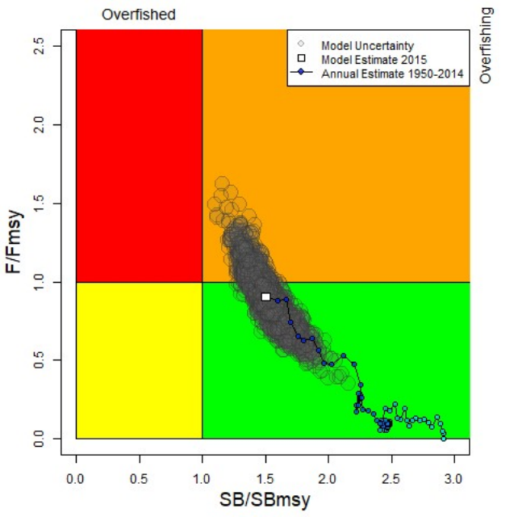 | 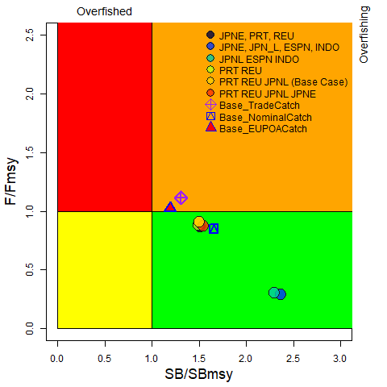
Fig. 1. Blue shark: Aggregated Indian Ocean stock assessment Kobe plot for the 2017 estimate based on the base case model and a range of sensitivity models explored with several catch reconstructions and fits to CPUE series. (Left panel: base case model with trajectory and MCMC uncertainties in the terminal year; Right panel: terminal year estimates of the sensitivity model runs). All models shown are run using SS3 - Stock Synthesis III.

TABLE 3. Blue shark: Aggregated Indian Ocean assessment Kobe II Strategy Matrix. Probability (percentage) of violating the MSY-based reference points for nine constant catch projections using the base case model (catch level from 2015* (54,735t), ± 10%, ± 20%, ± 30% and ± 40%) projected for 3 and 10 years.
Reference point and projection time frame | Alternative catch projections (relative to the catch level* from 2015) and probability (%) of violating MSY-based reference points
Catch Relative to 2015 | 60% | 70% | 80% | 90% | 100% | 110% | 120% | 130% | 140%
Catch (t) | (32,841) | (38,315) | (43,788) | (49,262) | (54,735) | (60,209) | (65,682) | (71,156) | (76,629)
B₂₀₁₈ < B_{MSY} | 0% | 0% | 0% | 0% | 0% | 0% | 1% | 1% | 3%
F₂₀₁₈ > F_{MSY} | 0% | 1% | 7% | 25% | 49% | 69% | 83% | 91% | 95%
B₂₀₂₅ < B_{MSY} | 0% | 1% | 8% | 25% | 48% | 68% | 82% | 89% | 92%
F₂₀₂₅ > F_{MSY} | 0% | 7% | 35% | 67% | 87% | 95% | 97% | 94% | 90%
*: average catch level and respective % changes refer to the estimated catch series used in the final base case model (IOTC-2017-WPEB13-23)

