Report of the 23rd Session of the IOTC Working Party on Billfish

Distribution: | Bibliographic entry
Participants in the Session  Members of the Commission  Other interested Nations and International Organizations  FAO Fisheries Department  FAO Regional Fishery Officers | IOTC–WPB23 2025. Report of the 23rd Session of the IOTC Working Party on Billfish, IRD, Sete, France, 2025.  IOTC–2025–WPB23–R[E]: 65 pp.
IRD, Sète, France, 15–18 September 2025

The designations employed and the presentation of material in this publication and its lists do not imply the expression of any opinion whatsoever on the part of the Indian Ocean Tuna Commission (IOTC) or the Food and Agriculture Organization (FAO) of the United Nations concerning the legal or development status of any country, territory, city or area or of its authorities, or concerning the delimitation of its frontiers or boundaries.
This work is copyright. Fair dealing for study, research, news reporting, criticism or review is permitted. Selected passages, tables or diagrams may be reproduced for such purposes provided acknowledgment of the source is included. Major extracts or the entire document may not be reproduced by any process without the written permission of the Executive Secretary, IOTC.
The Indian Ocean Tuna Commission has exercised due care and skill in the preparation and compilation of the information and data set out in this publication. Notwithstanding, the Indian Ocean Tuna Commission, employees and advisers disclaim all liability, including liability for negligence, for any loss, damage, injury, expense or cost incurred by any person as a result of accessing, using or relying upon any of the information or data set out in this publication to the maximum extent permitted by law.

Contact details:
Indian Ocean Tuna Commission
Blend Seychelles
PO Box 1011
Providence, Mahé, Seychelles
Ph: +248 4225 494
Fax: +248 4224 364
Email: IOTC-secretariat@fao.org
Website: http://www.iotc.org

The designations employed and the presentation of material in this publication do not imply the expression of any opinion whatsoever on the part of the Indian Ocean Tuna Commission or the Food and Agriculture Organization of the United Nations concerning the legal status of any country, territory, city or area or of its authorities, or concerning the delimitation of its frontiers or boundaries.

Acronyms

ABF African Billfish Foundation
ASPIC A Stock-Production Model Incorporating Covariates
B Biomass (total)
B_{MSY} Biomass which produces MSY
BLM Black marlin (FAO code)
BSP-SS Bayesian Surplus Production Model – State-Space
BUM Blue marlin (FAO code)
CE Catch and effort
CI Confidence Interval
CMM Conservation and Management Measure (of the IOTC; Resolutions and Recommendations)
CPCs Contracting parties and cooperating non-contracting parties
CPUE Catch per unit of effort
current Current period/time, i.e. F_{current} means fishing mortality for the current assessment year.
EU European Union
EEZ Exclusive Economic Zone
F Fishing mortality; F₂₀₁₀ is the fishing mortality estimated in the year 2010
FAO Food and Agriculture Organization of the United Nations
F_{MSY} Fishing mortality at MSY
GLM Generalized linear model
HBF Hooks between floats
IO Indian Ocean
IOTC Indian Ocean Tuna Commission
JABBA Just Another Bayesian Biomass Assessment (a generalized Bayesian State-Space Surplus Production Model)
LL Longline
M Natural Mortality
MLS Striped marlin (FAO code)
MSY Maximum sustainable yield
n.a. Not applicable
NGO Non-governmental organization
PS Purse-seine
q Catchability
r Intrinsic rate of population increase
ROS Regional Observer Scheme
SC Scientific Committee of the IOTC
SB Spawning biomass (sometimes expressed as SSB)
SB_{MSY} Spawning stock biomass which produces MSY
SFA Indo-Pacific sailfish (FAO code)
SS3 Stock Synthesis III
SWO Swordfish (FAO code)
Taiwan,China Taiwan, Province of China
WPB Working Party on Billfish of the IOTC
WPEB Working Party on Ecosystems and Bycatch of the IOTC

Standardisation of IOTC Working Party and Scientific Committee report terminology
SC16.07 (para. 23) The SC ADOPTED the reporting terminology contained in Appendix IV and RECOMMENDED that the Commission considers adopting the standardised IOTC Report terminology, to further improve the clarity of information sharing from, and among its subsidiary bodies.
How to interpret terminology contained in this report
Level 1: From a subsidiary body of the Commission to the next level in the structure of the Commission:
RECOMMENDED, RECOMMENDATION: Any conclusion or request for an action to be undertaken, from a subsidiary body of the Commission (Committee or Working Party), which is to be formally provided to the next level in the structure of the Commission for its consideration/endorsement (e.g. from a Working Party to the Scientific Committee; from a Committee to the Commission). The intention is that the higher body will consider the recommended action for endorsement under its own mandate, if the subsidiary body does not already have the required mandate. Ideally this should be task specific and contain a timeframe for completion.

Level 2: From a subsidiary body of the Commission to a CPC, the IOTC Secretariat, or other body (not the Commission) to carry out a specified task:
REQUESTED: This term should only be used by a subsidiary body of the Commission if it does not wish to have the request formally adopted/endorsed by the next level in the structure of the Commission. For example, if a Committee wishes to seek additional input from a CPC on a particular topic, but does not wish to formalize the request beyond the mandate of the Committee, it may request that a set action be undertaken. Ideally this should be task specific and contain a timeframe for the completion.

Level 3: General terms to be used for consistency:
AGREED: Any point of discussion from a meeting which the IOTC body considers to be an agreed course of action covered by its mandate, which has not already been dealt with under Level 1 or level 2 above; a general point of agreement among delegations/participants of a meeting which does not need to be considered/adopted by the next level in the Commission’s structure.
NOTED/NOTING: Any point of discussion from a meeting which the IOTC body considers to be important enough to record in a meeting report for future reference.

Any other term: Any other term may be used in addition to the Level 3 terms to highlight to the reader of and IOTC report, the importance of the relevant paragraph. However, other terms used are considered for explanatory/informational purposes only and shall have no higher rating within the reporting terminology hierarchy than Level 3, described above (e.g. CONSIDERED; URGED; ACKNOWLEDGED).
Table of Contents
1. Opening of the session 13
2. Adoption of the agenda and arrangements for the session 13
3. The IOTC process: Outcomes, updates and progress 13
4. New information on fisheries and associated environmental data for billfish 15
5. Marlins (Priority species for 2025: Blue marlin and Indo Pacific sailfish) 18
6. Progress MANAGEMENT Procedure (Resolution 24/08) 29
7. Other Billfishes 30
8. WPB PROGRAM OF WORK 32
9. Other business 32
Appendix I - List of participants 34
Appendix II - Agenda for the 23rd Working Party on Billfish 35
Appendix III - List of documents for the 23st Working Party on Billfish 36
Appendix IV - [ Draft ] resource stock status summary – Swordfish 37
Appendix V - [ Draft ] resource stock status summaries – Black marlin 41
Appendix VI - [ Draft ] resource stock status summaries – Blue marlin 45
Appendix VII - [ Draft ] resource stock status summaries – Striped marlin 49
Appendix VIII - [ Draft ] resource stock status summary – Indo-Pacific sailfish 53
Appendix IX drafted Guidelines for Longline CPUE Standardization 57
Appendix X Working Party on Billfish Program of Work (2026–2030) 59
Appendix XI Consolidated recommendations of the 23rd Session of the Working Party on Billfish 63

Executive summary
The 23rd Session of the Indian Ocean Tuna Commission’s (IOTC) Working Party on Billfish (WPB) was held in IRD, Sète, France, using a hybrid format from the 15 to 18 September 2024. A total of 36 participants (47, in 2024, 97 in 2023, 51 in 2022, and 55 in 2021) attended the Session (of which 25 attended in person). The list of participants is provided at Appendix I. The meeting was opened by the Chairperson, Dr Jie Cao (China), who welcomed participants.
The following are the complete recommendations from the WPB23 to the Scientific Committee, which are also provided at Appendix XI:
Review of new information on the status of blue marlin and Indo Pacific sailfish

WPB23.01 (para 90): The WPB NOTED that, for several years, joint analyses combining catch and effort data from major longline fleets have been proposed to improve the CPUE index for billfish species, and that the WPEB recommended investigating methods to compare CPUE indices across fleets and to develop joint CPUE indices for bycatch species. The WPB also NOTED that these suggestions are based on a methodological perspective that such analyses could harmonize standardization methods, reconcile conflicts between indices developed from different fleets, and potentially produce more robust indices with broader spatial and temporal coverage. The WPB further NOTED that it is at the discretion of CPCs to determine the feasibility of such collaboration, considering data confidentiality agreements and other logistical arrangements. The WPB AGREED on the importance of establishing a process to discuss how to move forward. Noting that joint CPUE analysis arrangements already exist for the standardization of tropical and temperate tuna, the WPB RECOMMENDED that the SC advise the Commission to urge CPCs to explore ways to extend joint analyses to bycatch species, such as marlins.
WPB23.02 (para 92): Following these discussions, the author of document IOTC-2025-WPB23-16 tentatively drafted Guidelines for Longline CPUE Standardization (Appendix IX). The WPB RECOMMENDED that the SC review and further develop these guidelines for potential adoption in the future.

Indo Pacific sailfish
WPB23.03 (para 138): NOTING that the methodology was not reviewed prior to the 2025 assessment, and NOTING concern from the WPB, the WPB RECOMMENDED that simulation testing be carried out prior to the next WPB in 2026 to understand whether the SPR index can be used as an abundance index in the JABBA model.
WPB23.04 (para 139): The WPB RECOMMENDED that the stock assessment be revisited at the next WPB after simulation testing has been completed, and an updated stock status be presented to the SC in 2026.
Resolution 18/05 Catch Limits
WPB23.05 (para 166): NOTING the necessity to gather information to enable the development of advice relating to a range of potential management measures to complement the commonly used CPC based catch advice, the WPB RECOMMENDED that the Scientific Committee REQUEST:
- That the IOTC Secretariat (or alternately CPCs, where the Secretariat does not hold a CPCs relevant data or information) provide summaries of observer data (or logbook data or other relevant information) to WPB pertaining to the following data types for the following fishery types:
  - All gear/fishery types – discarding/retention rates and at-haul mortality (%) for each marlin and sailfish species, by fishery/gear type.
  - Longline – proportion of each fleet using different hook types and sizes (Japanese tuna, J hook, Circle hook, other)
  - Gillnet – estimate of the proportion of the gillnet fleet using subsurface setting, and if possible, preferred depths used in fishery, and whether the fishery predominantly sets/soaks the gear overnight or through the day (or other)
- CPCs to consider undertaking analyses (e.g., model-based) of at-haul mortality, at a longline fleet level (and if possible for troll/handline), to help identify key factors driving at-haul mortality and subsequently, possibly help identify additional options to reduce at haul mortality.
- CPCs individually or collaboratively conduct gillnet experimental fishing trials that:
  - Aim to test different setting depths and times of setting/soaking (e.g. day/night), on catch rates and mortality of interacting species
  - Collect data on all interacting species including billfish bycatch, target tuna and vulnerable species (e.g. cetaceans, turtles), in order to provide the Commission a quantified understanding of likely effects and possible trade-offs of various subsurface setting options, on each species.
  - Prioritise accurate species identification.
WPB23.06 (para 167): In addition, the WPB RECOMMENDED that the Scientific Committee advise the Commission to give consideration to how such a trial (point (3) above) might be supported financially and logistically.
Revision of the WPB Program of work (2026–2030)
WPB23.07 (para 171): The WPB RECOMMENDED that the SC consider and endorse the WPB Program of Work (2026–2030), as provided in Appendix X.
Date and place of the 24rd and 25th Sessions of the Working Party on Billfish
WPB23.08 (para 181): The WPB RECOMMENDED the SC consider early September as a preferred time period to hold the WPB24 in 2026. As usual it was also AGREED that this meeting should continue to be held back-to-back with the WPEB and that in 2026 WPB will be held in the week before the WPEB.
Review of the draft, and adoption of the Report of the 23rd Session of the Working Party on Billfish
WPB23.09 (para 183): The WPB RECOMMENDED that the Scientific Committee consider the consolidated set of recommendations arising from WPB22, provided at Appendix XI, as well as the management advice provided in the draft resource stock status summary for each of the five billfish species under the IOTC mandate, and the combined Kobe plot for the five species assigned a stock status in 2024 (Fig. 3):
  - Swordfish (Xiphias gladius)– Appendix IV
  - Black marlin (Istiompax indica) – Appendix V
  - Blue marlin (Makaira nigricans) – Appendix VI
  - Striped marlin (Kajikia audax) – Appendix VII
  - Indo-Pacific sailfish (Istiophorus platypterus) – Appendix VIII

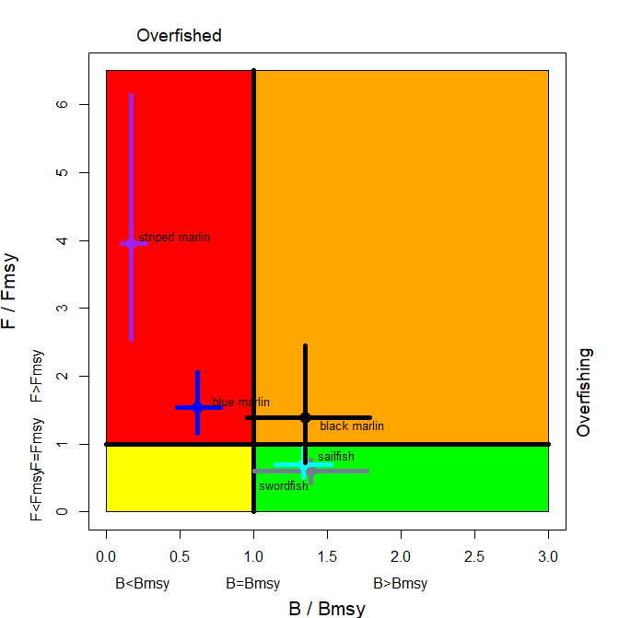
Fig. 3. Combined Kobe plot for swordfish (grey), Indo-pacific sailfish (cyan), black marlin (black), blue marlin (blue) and striped marlin (purple) showing the 2023, 2024, and 2025 estimates of current stock size (SB or B, species assessment dependent) and current fishing mortality (F) in relation to optimal spawning stock size and optimal fishing mortality. Cross bars illustrate the range of uncertainty from the model runs.

Table 1. Status summary for billfish species under the IOTC mandate.
Stock | Indicators | 2021 | 2022 | 2023 | 2024 | 2025 | Advice to the Scientific Committee
Swordfish  Xiphias gladius | Catch 2023 (t): 24,115  Average catch 2019-2023 (t): 27,651  MSY (1,000 t) (80% CI): 30 (26–33)  F_{MSY} (80% CI): 0.16 (0.12–0.20)  SB_{MSY} (1,000 t) (80% CI): 55(40–70)  F₂₀₂₁/F_{MSY} (80% CI): 0.60 (0.43–0.77)  SB₂₀₂₁/SB_{MSY} (80% CI): 1.39 (1.01–1.77)  SB₂₀₂₁/SB₁₉₅₀ (80% CI): 0.35 (0.32–0.37) |  |  |  | 97% |  | Stock status. No new stock assessment was carried out for Swordfish in 2025, thus, the stock status estimates are based on the assessment carried out in 2023. Two models were applied to the swordfish stock (ASPIC and Stock Synthesis (SS3)), with the SS3 stock assessment selected to provide scientific advice (as done previously). An update of the JABBA model was also conducted during the WPB meeting. The reported SS3 stock status is based on a grid of 48 model configurations designed to capture the uncertainty relating to steepness of the stock recruitment relationship (0.7, 0.8, and 0.9), recruitment variability (two levels), CPUE series (2 options), growth (2 options) and weighting of length composition data (two options). A number of the options included in the final grid were selected from a range of additional sensitivity runs that were conducted to explore uncertainties. Median spawning biomass in 2021 was estimated to be 35% (80% CI: 32-37%) of the unfished levels in 2021 and 1.39 (80% CI: 1.01-1.77) times higher than the level required to support MSY. Median fishing mortality in 2021 was estimated to be 60% (80% CI 43%-77%) of the FMSY level, and catch in 2021 (23,237 t) was well below the estimated MSY level of 29,856 t (80% CI: 26,319-33,393t). Taking into account the characterized uncertainty, and on the weight-of-evidence available in 2023, the swordfish stock is determined to be not overfished and not subject to overfishing.  Management advice. The 2021 catches (23,237 t at the time of the assessment) were significantly lower than the estimated MSY level (29,856 t). Under those levels of catches, the spawning biomass was projected to likely increase, with a high probability of maintaining at or above the SBMSY for the longer term. There is a very low risk of exceeding MSY-based reference points by 2031 if catches are maintained at 2021 levels (<1% risk that SB₂₀₃₁< SB_{MSY}, and <1% risk that F₂₀₂₁> F_{MSY}). The projections indicate that an increase of 40% or more from 2021 catch levels will not likely result in the biomass dropping below the SBMSY level for the longer term (with a 15% probability). Catches in 2022 (23,597t) were still lower than the estimated MSY. Nevertheless, the Commission should consider monitoring the catches to ensure that the probability of exceeding the SBMSY target reference points in the long term remains minimal. Taking into account the differential CPUE and biomass trends between regions, the WPB noted that there is recurring evidence for localised depletion in the South Western region (which appears to be more depleted than other regions) and suggests this should be further monitored.  Click here for full stock status summary: Appendix IV
Black marlin  Istiompax indica | Catch 2023: 27,881 t  Average catch 2019–2023: 20,509 t  MSY (1000 t) (80% CI): 13.90 (8.73–28.51)  FMSY (80% CI): 0.21 (0.15–0.30)  BMSY (1,000 t) (80% CI):65.23 (46.43–101.84)  F2022/FMSY (80% CI):1.39 (0.72–2.45)  B2022BMSY (80% CI):1.35 (0.96–1.79)  B2022/B0 (80% CI):0.49 (0.35–0.66) |  |  |  | 62% |  | Stock status. No new stock assessment was carried out for black marlin in 2025, thus, the stock status estimates are based on the stock assessment in 2024 using JABBA, a Bayesian state-space production model (using data up to 2022). The relative point estimates for this assessment are F/FMSY=1.39 (0.72-2.45) and B/BMSY=1.35 (0.96 -1.79). The Kobe plot indicated that the stock is currently not overfished but is subject overfishing (Table 1; Fig. 3). In 2022, the catch of black marlin surged to 26,320 t. Until 2024, fish stock status was characterised as “uncertain” due to significant uncertainties in past assessments (like those from 2018 and 2021). These uncertainties were attributed to both historical catch reporting from key fishing states and poor assessment diagnostics. However, there has been progress recently with black marlin catch data, particularly from coastal countries in the northern Indian Ocean, and the latest JABBA assessment shows it is now more reliable (with improved model fitting to the abundance indices and acceptable level of retrospective patterns). The assessment relied on CPUE indices from longline fisheries in which the black marlin is a bycatch species. On the weight-of-evidence available in 2024, the stock status of black marlin is determined to be not overfished but subject to overfishing.  Management advice. The catch limits (9,932 t) as stipulated in Resolution 18/05 have been exceeded for three consecutive years since 2020, which as per resolution 18/05, requires a review of the resolution. Furthermore, these limits are not based on estimates of most recent stock assessment. Thus, it is recommended that the Commission urgently revise Res. 18/05 to incorporate limits that reflect the most recent stock assessment and projections, and review, and where necessary, revise the implementation and effectiveness of the measures contained in this Resolution. The stock is now subject to overfishing. If the Commission wishes to recover the stock to the green quadrant of the Kobe plot with a probability ranging from 60% to 90% by 2026 as per Resolution 18/05, it needs to provide mechanisms to ensure the maximum annual catches remain less than 9, 932 t.  Click here for full stock status summary: Appendix V
Blue marlin  Makaira nigricans | Catch 2023: 7,905 t  Average catch 2019–2023: 7,964 t  MSY (1000 t) (80% CI): 8.35 (7.52 –9.23)  F_{MSY} (80% CI): 0.30 (0.21 – 0.38)  B_{MSY} (1,000 t) (80% CI): 27.9 (22.3 – 39.9)  F₂₀₂₃/FMSY (80% CI): 1.54 (1.16 – 2.06)  B₂₀₂₃/BMSY (80% CI) : 0.62 (0.48 – 0.78)  B₂₀₂₃/B0 (80% CI): 0.23 (0.18 – 0.29) |  | 100% |  |  | 97.4% | Stock status. A new stock assessment was carried out for blue marlin in 2025 using two different models: JABBA, a Bayesian state-space production model (age-aggregated); and SS3, an integrated model (age-structured) (using data up to 2023). Uncertainty in the biological parameters and the parameterisation of the SS3 model is still evident and as such the JABBA model (B2023/BMSY = 0.62, F2023/FMSY =1.54) was selected as the base case. Both models were consistent with regards to stock status, although the SS3 model was less pessimistic. On the weight-of-evidence available in 2025, the stock is determined to be overfished and subject to overfishing.  Management advice. The current catches of blue marlin (average of 7,262 t in the last 3 years, 2021-2023) are lower than MSY (8,351 t). The stock is currently overfished and subject to overfishing, and according to the KOBE plot (Fig. 3), has been in this state since 2001 (with ~ 80 % CI). According to K2SM calculated (Table 2), a reduction of 20% of catches (5,809 t) compared to the mean of catches from 2021-2023 (7,262 t) would recover the stock to the green quadrant by 2035 with a probability of 64 % and if the catches are reduced by 40 % (4,357 t) the probability would be 86 %. The Commission should note that the current catch limit for blue marlin in Resolution 18/05 (11,930 t, which was established as the MSY value estimated in 2016 stock assessment) is 30 % more (3,579 t) than the new MSY estimated by the latest stock assessment in 2025 (8,351 t). Thus, it is recommended that the Commission urgently revise Resolution 18/05 to incorporate limits that reflect the most recent stock assessment and projections and review and strengthen the implementation and effectiveness of the measures contained in this Resolution.  Click here for full stock status summary: Appendix VI
Striped marlin  Kajikia audax | Catch 2023: 3,556  Average catch 2019–2023: 3,017 t  MSY (1,000 t) (JABBA): 4.73 (4.22–5.24)  MSY (1,000 t) (SS3): 4.89 (4.48 – 5.30)  F_{MSY} (JABBA): 0.26 (0.20–0.35)  F_{MSY} (SS3): 0.22 (0.21–0.24)  F_{2022/}F_{MSY} (JABBA): 3.95 (2.54–6.14)  F_{2022/}F_{MSY} (SS3): 9.26 (5.38–13.14)  B_{2022/}B_{MSY} (JABBA): 0.17 (0.11–0.27)  SB₂₀₂₂/SB_{MSY} (SS3): 0.27 (0.19–0.35)  B2022/B0(JABBA): 0.06 (0.04–0.10)  SB₂₀₂₂/SB₀ (SS3): 0.036 (0.03–0.04) |  |  |  | 100% |  | Stock status: No new stock assessment was carried out for Striped marlinin 2025, thus, the stock status estimates are based on two different assessment models carried out in 2024: JABBA, a Bayesian state-space production model (age-aggregated); and SS3, an integrated model (age-structured) (using data up to 2022). Both models were generally consistent with regards to stock status and confirmed the results from 2012, 2013, 2015, 2017, 2018, and 2021 assessments, indicating that the stock is subject to overfishing (F>FMSY) and is overfished, with the biomass being below the level which would produce MSY (B<BMSY) for over a decade. Both SS3 and JABBA assessments rely on CPUE indices from the longline fisheries in which the striped marlin are not the main target species. On the weight-of-evidence available in 2024, the stock status of striped marlin is determined to be overfished and subject to overfishing.  Management advice. Current or increasing catches have a very high risk of further decline in the stock status. The 2022 catches (3,225 t) are lower than MSY (4,730 t) but are very close the limit set by Resolution 18/05 (3, 260 t) which may be a concern if this trend continues. However, the limit is not based on estimates of most recent stock assessment. Thus, it is recommended that the Commission urgently revise Resolution 18/05 to incorporate limits that reflect the most recent stock assessment and projections and review and where necessary revise the implementation and effectiveness of the measures contained in this Resolution.  The stock has been overfished for more than a decade and is now in a highly depleted state. If the Commission wishes to recover the stock to the green quadrant of the Kobe plot with a probability ranging from 60% to 90% between 2027 and 2032 (as per Resolution 18/05), it needs to provide mechanisms to ensure the maximum annual catches to be below 30% of the current level (Table 3). [SC to revise the advice].  Click here for full stock status summary: Appendix VII
Indo-Pacific Sailfish  Istiophorus platypterus | Catch 2023: 31,898t  Average catch 2019–2023: 33,888t  MSY (1,000 t) (80% CI): 34.3 (28.7-42.2)⁴  F_{MSY} (80% CI) : 0.20 (0.17-0.23) ⁴  SB_{MSY} (1,000 t) (80% CI) : 174 (145-212) ⁴  F_{2023/}F_{MSY} (80% CI) : 0.69 (0.51 - 0.94) ⁴  SB_{2023/}SB_{MSY} (80% CI) : 1.34 (1.15 - 1.53) ⁴  SB₂₀₂₃/SB₀ (80% CI) : 0.67 (0.58 - 0.76) ⁴  ⁴These figures are outputs from the 2025 stock assessment and are not endorsed for management advice. Please see the section on management advice for further explanations on these estimates. |  |  |  |  | 92% | Stock status: A new iteration of a Bayesian state-space production model (age-aggregated) JABBA stock assessment was carried out for Indo-Pacific Sailfish in 2025, using data up to 2023. Prior to this, in 2015 and 2019, data poor methods (Catch-MSY) were utilised to provide stock status for Indo-Pacific sailfish. These methods rely on catch data only, which is highly uncertain for this species, and resulted in an undefined stock status.  To overcome the lack of standardised CPUE indices or alternative abundance indices for this species, this assessment followed the methods of the previous assessment in 2022 (Parker et. al. (2022)) where length-frequency data were used to estimate the annual Spawning Potential Ratio (SPR) using the length-based spawning potential ratio (LBSPR) method. Annual estimates of SPR were then normalised in the JARA (Just Another Red List Assessment) model to provide an index that was assumed to be proportional to spawning biomass. This index was then incorporated as an index of relative abundance in a JABBA model.  This is a novel technique applied to overcome the paucity of abundance data for Indo-Pacific sailfish and it had not been thoroughly tested with rigorous simulation-evaluation. This method has key assumptions that raised concerns within members of the WPB23. These three equilibrium assumptions that are likely to be violated are: 1) annual recruitment is assumed to be constant over time without directional trends; 2) length-frequency data used to derive the SPR trends is representative of the population; 3) selectivity is non-varying, and follows a logistic form.  The previous iteration of the Indo-Pacific sailfish assessment also noted the same concerns, and it was agreed by the SC in 2022 that the methodology of converting the length data into an index of relative abundance required further review. At the time of the assessment in 2025, there was uncertainty regarding how much the current assessment results are impacted by the violation of the assumptions listed above. It was discussed that it was possible that if assumptions are violated, the index of abundance could be showing trends that are diametrically opposed to the true population trend. It was recommended by the WPB23 that the extent of the potential bias must be evaluated with a simulation study which will inform whether this index is acceptable for use in the Indo-Pacific sailfish stock assessment.  The results of the LBSPR portion of the assessment indicate that there has been a 45.5 % decline in SPR since 1970. The latest (2023) estimate of B/B_{MSY} was 1.34, while the F/F_{MSY} estimate was 0.69. Additionally, concern was raised regarding the high levels of current catches (31,898 t in 2023), that are above the previous MSY estimate of 25,905 t, and close to the current, higher estimate of MSY of 34,300 t.  On the weight-of-evidence available in 2025, the stock status of Indo-Pacific sailfish is determined to be not overfished nor subject to overfishing  Management advice: Considerable uncertainty remains in the JABBA assessment conducted in 2025, however the trends in key model outputs align relatively well with the 2022 assessment. For this year, due to the uncertainty in the model outputs, the management advice from 2022 would be carried over for one year (1 year) to allow time to complete the simulation studies and provide updated management advice in 2026. It is anticipated that, once the underlying uncertainty in the JABBA assessment is understood and presented at the proposed WPB meeting next year, management advice can be updated.  The catch limits as stipulated in Resolution 18/05 have been exceeded since 2020, which as per resolution 18/05, requires a review of the resolution. Furthermore, these limits are not based on estimates of most recent stock assessment. it is recommended that the Commission review the implementation and effectiveness of the measures contained in this Resolution and consider the adoption of additional conservation and management measures. The Commission should provide mechanisms to ensure that catch limits are not exceeded by all concerned fisheries. Research emphasis on further developing possible CPUE indicators from coastal gillnet and longline fisheries, and further exploration of stock assessment approaches for data poor fisheries are warranted. Given the limited data being reported for coastal fisheries, and the importance of sports fisheries for this species, efforts must be made to rectify these information gaps.  Click here for full stock status summary: Appendix VIII

Colour key | Stock overfished (SB_{year}/SB_{MSY}< 1) | Stock not overfished (SB_{year}/SB_{MSY}≥ 1)
Stock subject to overfishing (F_{year}/F_{MSY}> 1)
Stock not subject to overfishing (F_{year}/F_{MSY}≤ 1)
Not assessed/Uncertain

- Opening of the session
- The 23rd Session of the Indian Ocean Tuna Commission’s (IOTC) Working Party on Billfish (WPB) was held in IRD, Sète, France, using a hybrid format from the 15 to 18 September 2025. A total of 36 participants (47, in 2024, 97 in 2023, 51 in 2022, and 55 in 2021) attended the Session (of which 25 attended in person). The list of participants is provided at Appendix I. The meeting was opened by the Chairperson, Dr Jie Cao (China), who welcomed participants.
- Adoption of the agenda and arrangements for the session
- The WPB ADOPTED the Agenda provided in Appendix II. The documents presented to the WPB23 are listed in Appendix III.
- The IOTC process: Outcomes, updates and progress
  - Outcomes of the 27th Session of the Scientific Committee
- The WPB NOTED paper IOTC–2025–WPB23–03 which describes the main outcomes of the 27th Session of the Scientific Committee (SC27), specifically related to the work of the WPB:
“Report of the 22nd Session of the Working Party on Billfish (WPB22)”
- The SC NOTED the report of the 22nd Session of the Working Party on Billfish (IOTC–2024–WPB22–R), including the consolidated list of recommendations provided as an appendix to the report. The meeting was attended by 47 participants (cf. 97 in 2023). Five participants received funding through the MPF.
- The SC THANKED and CONGRATULATED the Chair and the WPB for their efforts and accomplishments during the 22nd session of the WPB.
- The SC NOTED that, according to the FAO Global Capture Production Database, the Indian Ocean has accounted for more than 40% of the global billfish catch in recent years.
- The SC NOTED that annual Indian Ocean billfish catches increased from approximately 5,500 tonnes in the 1950s to around 90,000 tonnes in the 2010s, representing less than 5% of the total catch of IOTC species in recent years.
- The SC further NOTED that the contribution of gillnets has increased over the years, accounting for nearly 50% of the total billfish catch in the Indian Ocean in recent years.
Billfish reproductive biology workshop
- The SC NOTED that a portion of the 22nd session of the WPB was dedicated to billfish reproductive biology, ACKNOWLEDGING the contribution of an invited expert, Dr. Robert Humphreys, who presented a comprehensive review of past and recent studies utilising gonad histology to define reproductive phases and maturity status in billfish species.
Striped marlin stock assessment
- The SC NOTED with concern the status of the striped marlin stock in the Indian Ocean, despite the agreement to catch limits established in late 2018 through Resolution 18/05. Both a surplus production model using JABBA and an age-structured model using SS3 indicated that the stock was overfished and subject to overfishing in 2022 with a probability of 100%.
- The SC NOTED that the stock status determination in the stock-specific tables of the report refers to the year 2024, despite the input data being available only up to 2022. The SC AGREED that the year of assessment could serve as the reference year in the management advice but ACKNOWLEDGED the importance of ensuring this approach is consistent across all assessments conducted by the IOTC for harmonisation purposes.
- NOTING that information on stock abundance is derived from the longline fisheries of Japan and Taiwan, China, which have caught relatively small amounts of striped marlin in recent years, the SC NOTED the importance of better emphasising the major fishing nations targeting striped marlin.
- The SC ACKNOWLEDGED that the fishing mortality levels (F₂₀₂₂/F_{MSY}) estimated by the models were exceptionally high, with values of 9.26 and 3.95 according to SS3 and JABBA, respectively. The SC NOTED that the intensity of the depletion level has be primarily driven by the Japanese longline CPUE in a specific area historically, while the recent increase in catch contributed to the elevated fishing mortality levels.
- The SC AGREED that the abundance indices derived from longline CPUE analyses will be critical for future assessments and ENCOURAGED all concerned CPCs to allocate adequate time and resources to support this work.
Black marlin stock assessment
- The SC ACKNOWLEDGED the progress made on the assessment of black marlin, which could not be determined previously due to substantial uncertainties, primarily arising from conflicting information between CPUE and catch data.
- The SC NOTED that the assessment model applied to the stock of black marlin indicated that the stock was not overfished but subject to overfishing in 2022 with a probability of 62.2%.
- NOTING that a joint analysis of fleet specific CPUE based on a consistent statistical framework which accounts for differences in catchability between fleets could be useful for assessing species under the mandate of WPB, the SC RECOMMENDED that the Commission urge the CPCs to dedicate effort to harmonising the standardised methods for different fleets and to develop a joint analysis combining catch effort data from key fleets for major billfish species where feasible.
Revision of catch levels of marlins under Resolution 18/05
- The SC NOTED that the catch levels of black marlin and Indo-Pacific sailfish have exceeded the catch limits established under Resolution 18/05, while the catches of blue marlin have remained well below the limit in recent years (Fig. 1).
- For striped marlin, the SC ACKNOWLEDGED that the stock has remained subject to overfishing and overfished. While reported catches remained below the Resolution 18/05 limit of 3,260 t during 2018-2022, they have been above levels required to recover the stock to BMSY, as indicated by the most recent assessment based projections.
- The SC RECALLED that the Resolution 18/05 catch limits were based on previous stock assessments and emphasised the need for their revision and update in light of the most recent data and stock status information.
- The SC RECOMMENDED that the Commission reassess the effectiveness of the current measures within this resolution and to revise Resolution 18/05 to update the catch limits based on the latest stock assessments and projections for the billfish species.

  - Outcomes of the 29th Session of the Commission
- The WPB NOTED paper IOTC–2025–WPB23–04 which provided the main outcomes of the 29th Session of the Commission specifically related to the work of the WPB.
- Participants to WPB23 were ENCOURAGED to familiarise themselves with the previously adopted Resolutions, especially those most relevant to the WPB and AGREED to consider how best to provide the Scientific Committee with the information it needs, in order to satisfy the Commission’s requests, throughout the course of the current WPB meeting.
- The WPB NOTED that there was very little discussion related to the WPB and that the main items were the endorsement by the Commission of the SC information on stock status and Work Plan.
- The WPB AGREED that any advice to the Commission would be provided in the Management Advice section of each stock status summary.
  - Review of Conservation and Management Measures relevant to billfish
- The WPB NOTED paper IOTC–2025–WPB23–05 which aimed to encourage participants at the WPB23 to review some of the existing CMMs relevant to billfish, noting the CMMs referred to in document IOTC–2025–WPB23–05, and - as necessary - to 1) provide recommendations to the SC on whether modifications may be required and 2) recommend whether other CMMs may be required.
- The WPB NOTED that Resolution 25/07 provides a revision to one of the parameters of the swordfish MP, due to an error identified in the MSE. The WPB further NOTED that this revision did not change the catch advice from running the MP in 2024. It was also NOTED that the assessment and MP schedule are outlined in the resolution, and that following the adoption of the MP, the role of assessment will shift from providing catch advice to monitoring the status of the stock and supporting the examination of exceptional circumstances that may invalidate the conditions of the MP.
  - Progress on the recommendations of WPB22
- The WPB NOTED paper IOTC–2025–WPB23–06 which provided an update on the progress made in implementing the recommendations from the previous WPB meeting which were endorsed by the Scientific Committee and AGREED to provide alternative recommendations for the consideration and potential endorsement by participants as appropriate given any progress.
- The WPB NOTED that good progress had been made on these Recommendations, and that several of these, would be directly addressed by the scientists when presenting the results for 2025.
- The WPB NOTED its recommendation to the SC in 2024 to dedicate efforts toward harmonizing standardized methods for different fleets and to develop a joint analysis that combines catch and effort data from key fleets for major billfish species. It was also NOTED that other working parties have made similar recommendations, as they are facing very similar issues. The WPB was informed that a joint tRFMO longline CPUE workshop is planned for 2026, focusing on standardization methods for longline data.
- The WPB participants were ENCOURAGED to review IOTC-2025-WPB23-06 during the meeting and report back on any progress in relation to requests or actions by CPCs that have not been captured by the report, and to note any pending actions for attention before the next meeting (WPB24).
- The WPB REQUESTED that the IOTC Secretariat continue to annually prepare a paper on the progress of the recommendations arising from the previous WPB, incorporating the final recommendations adopted by the Scientific Committee and endorsed by the Commission.
- New information on fisheries and associated environmental data for billfish
  - Review of the statistical data available for billfish at the Secretariat
- The WPB NOTED paper IOTC–2025–WPB23–07 on a review of the statistical data available for Indian Ocean billfish (1951-2023) and subsequent papers (IOTC-2025-WPB23-07_2, IOTC-2025-WPB23-07_3, IOTC-2025-WPB23-07_4, IOTC-2025-WPB23-07_5, IOTC-2025-WPB23-07_6 ) of detailed reviews for individual billfish species statistical data available, with the following abstract provided by the authors:
“Billfish species are among the lease captured pelagic species globally. With only 3% of total tuna and tuna-like species, and most of the catches coming from the Indian Ocean in recent years (40%). Five billfish species remain under the IOTC management mandate, although there are discussion to include other commonly caught billfish species. Swordfish is the main billfish species, and longline (rods and reels) fisheries are the principal fisheries catching billfish species. In recent years however, substantial catches of billfish are coming from gillnet fisheries.”
- The WPB THANKED the Secretariat for the overview of billfish data available from the 1950 to 2023, NOTING the continuous increase in the catch of billfish species, particularly from the coastal fisheries, despite the low quality of some datasets.
- The WPB NOTED that the paper covers the period until 2023 but that preliminary data for 2024 have been used to update the time series of catches used in paper IOTC-2025-WPB23-INF01 focusing on Res. 18/05.
- The WPB NOTED that catches of billfish species from the IOTC region have accounted for approximately 40% of global billfish catches in recent years, with a particular increase observed in black marlin catches over the past few years.
- The WPB also HIGHLIGHTED the lack of size data, especially from the main fleets targeting billfish species. ACKNOWLEDGING the challenges in collecting billfish samples and took note of pilot projects initiated by CPCs to enhance sample collection efforts.
- The WPB NOTED the difficulties in collecting samples of billfish species from Iranian gillnet vessels. These challenges were attributed to the landing of already-processed billfish, which are cut into pieces onboard for storage purposes. NOTING that, as billfish are considered bycatch species, they are not prioritized, further complicating data collection. The processing of billfish at sea makes it unfeasible for data collectors at landing sites to accurately record size measurements by species.
- The WPB also NOTED that not all ports where gillnet vessels offload are equipped with inspectors, and the conditions onboard make it difficult for observers to be present and collect information.
- The WPB ACKNOWLEDGED that the Islamic Republic of Iran is conducting training for fishers in fishing cooperatives to improve species identification and onboard size-frequency data collection.
- The WPB NOTED that the pilot project launched by Sri Lanka to identify billfish pieces and assign them to species is ongoing and has been successful so far.
- The WPB NOTED a decrease in the total catch of billfish species in 2003, which could have implications for catch data used in stock assessments.
- The WPB NOTED that the revision of Indonesia’s historical catch data resulted in a decrease in reported blue marlin catches compared to previous estimates. This revision primarily affected catches from the longline fishery, as updated data for Indonesia’s longline fleet led to lower catch figures for blue marlin.
- The WPB further NOTED an increase in blue marlin catches from industrial purse seine fisheries. NOTING that the estimation process used by EU-France for billfish species, was based on the same methodology used for tropical tunas, the primary target species, which led to the high estimated catch of billfish. The WPB ACKNOWLEDGED that EU-France is currently revising this methodology.
- The WPB also NOTED that the historical revision of Indonesia’s catch data led to an increase in reported catches of Indo-Pacific sailfish. NOTING that the re-estimation process is described in document IOTC-2024-WPDCS20-16_Rev1, and that the methodology used was endorsed by the Scientific Committee.
- The WPB SUGGESTED that presenting percentage changes in catch data could provide a clearer understanding of the differences resulting from data revisions.
- The WPB NOTED that it is complex to combine coastal longline catches with industrial longline data, given the differences between the two fisheries. Specifically, industrial longline catch data refer to operations beyond national jurisdiction, whereas coastal longline data are derived from nearshore fishing activities within national waters.
- The WPB NOTED the increasing contribution of billfish catches from gillnet fisheries in recent years and highlighted the potential for species misidentification.
- The WPB further NOTED that the Secretariat is conducting regional workshops on species identification, which includes billfish species. In December 2024, the workshop was held in Sri Lanka for western region countries. For eastern region countries, the workshop will be held in India in late September. The WPB NOTED that the workshop on species identification could be conducted again in the future.
- The WPB NOTED paper IOTC-2025-WPB23-10, which summarises billfish resources of India with special reference to the fishery and biology of blue marlin landed caught from the Eastern Arabian Sea. The following abstract is provided by the authors:
“Billfish, comprising sailfishes, marlins, spearfishes, and swordfishes, are highly migratory and large pelagic predators distributed globally across tropical and subtropical oceans. Along the Indian coast, the estimated landings of billfishes have shown a rising trend, reaching 21,321 tonnes in 2024”. see the paper for the full abstract.
- The WPB ACKNOWLEDGED the research presented by the authors, outlining the biology of blue marlin caught in the Eastern Arabian Sea, CONSIDERNG the various scientific parameters analysed to better understand the species' distribution.
- The WPB NOTED the increasing catches of billfish species reported by India, which include five species caught in the Indian and Arabian Seas. NOTING that these areas are characterized by high oceanographic productivity and are favourable for billfish spawning activity.
- The WPB ACKNOWLEDGED the research which also use of genomic DNA to identify species and classify them using COI and CR-based phylogenetic trees.
- The WPB NOTED that the study did not identify spatial differences in fecundity, and suggested that future research should consider analysing regional variation in movement patterns
- The WPB further NOTED that the spawning season for blue marlin, likely associated with a decline in GSI (gonadosomatic index), is estimated to occur between August and September.
- The WPB also NOTED that the gonad and stomach samples analysed in the study were collected from coastal areas, primarily from longline and gillnet fisheries.
- The WPB NOTED that the results of this analysis are broadly consistent with findings from similar research conducted in the Pacific.
- The WPB NOTED paper IOTC-2025-WPB23-11, which summarises billfish landing by foreign IOTC fishing vessels at Thai fishing ports during 2020 – 2024, with the following abstract provided by the authors:
“This study analyzed billfish landing data from foreign fishing vessels at the Thai designated fishing ports in 2020 - 2024. The total of 62,118 tons of fish catching in the IOTC area were landed in Thailand. Most of the catch was skipjack tuna, yellowfin tuna, and bigeye tuna, which made up 99% of all landings. Billfish were accounted for 0.63% of the total landing and only reported in three years: 2020, 2021, and 2023. The highest landing was in 2020 with 244 tons, then it decreased each year. Six billfish species were found: swordfish, Indo-Pacific sailfish, blue marlin, black marlin, striped marlin, and white marlin. Swordfish was the most common in billfish landing, followed by Indo-Pacific sailfish and blue marlin. Most billfish landing in 2020-2021 were whole fish, but they were mostly processed with gills and guts removed in 2023. The results show that billfish landings from foreign vessels have been declining over time”
- The WPB THANKED the author for the analysis presented, which outline the trend of billfish catch data from foreign vessels landing in Thailand.
- The WPB NOTED that it is not currently possible to determine the exact fisheries of origin for these catches, as such information is not recorded, although catch data are documented during inspections.
- The WPB SUGGESTED that incorporating size measurements could be considered in future studies to enhance knowledge on the fish landed.
- The WPB also NOTED that the observed decrease in billfish catches from vessels landing in Thailand may be related to changes in the demand and supply dynamics of fish for Thai canneries.
- The WPB NOTED paper IOTC-2025-WPB23-12, which summarises spatial temporal distribution of swordfish catches and catch rates from the Kenyan industrial longline fishery, with the following abstract provided by the authors:
“This study aimed to assess their catches in a spatio-temporal distribution perspective by employing combined approach for longline industrial fishing catch logbooks, fishery-independent data from the national observer scheme between 2022 and December 2024. The annual swordfish landed by Kenyan industrial longliners were 16MT, 261MT, 217MT and 131.5 MT in 2021, 2022, 2023 and 2024 respectively. There was a typical annual cycle in the catch quantities landed, with high values from May to December, and displacement of the fishing operation Southward 39° E to 45° E and 2° S to 5°S. The pattern of the spatial-temporal distribution of fishing and catch rates of swordfish (Xiphias gladius) from the Kenyan industrial longline fleet to be assessed using comparative analysis. The generalized analysis to include variables such as latitude, longitude, date, depth, number of hooks and catches to depict spatial and temporal distribution of catches and catch rates of swordfish”
- The WPB THANKED the authors for the paper analysing the spatial-temporal distribution of swordfish catch from Kenya longline fishery, NOTING the combined data approach of the logbook data and observer data of the longline vessels.
- The WPB NOTED that the study should also consider changes in target species, in addition to environmental factors, that may be influencing swordfish catches by longline vessels.
- The WPB further NOTED that the sex of the fish was not considered in the analysis, which limits understanding of the size distribution between males and females.
- The WPB NOTED that there were certain seasons during which vessels did not operate, and further NOTED that swordfish hotspots were identified into some specific seasons.
- The WPB ACKNOWLEDGED that the study has the potential to provide useful information to fishers, including: optimal fishing seasons; identified hotspots for swordfish; and guidance on vessel deployment to minimize environmental impact.
- Additionally, the WPB NOTED that targeting fishing activities based on knowledge of fishing grounds could help reduce search time and improve operational efficiency, with less environmental impact.
- The WPB NOTED paper IOTC-2025-WPB23-13, which summarises spatial-temporal Trends of Sailfish catch Rates in the Sri Lankan Tuna Longline Fishery, with the following abstract provided by the authors:
“Sailfish (Istiophorus platypterus) is an apex predator inhabiting pelagic waters above thermocline are often caught as by-catch in tuna longline fisheries. Spatial and temporal trends of sailfish catch rates of tuna longline fishery of Sri Lanka in relation to environmental variables were investigated using general linear models (GLM), generalized additive models (GAM) and machine learning algorithms such as Random Forest (RF) and Gradient Boosted Trees (GRF). This analysis utilise logbook data consists of 17625 non-zero catch fishing operations from January 2016 to December 2019 in the northern and central Indian ocean”. see the paper for the full abstract.
- The WPB THANKED the authors for the paper highlighting how the spatio-temporal and environmental factors are essential drivers of sailfish catch rates, providing vital information for the sustainable management of the incidental sailfish fishery.
- The WPB NOTED that several models were compared in the study, incorporating environmental variables and multiple parameters to identify the best-fitting model. NOTING however, that SSD (Size Structure Data) were not considered in the analysis.
- The WPB NOTED that each model produced different outputs, with the Generalized Additive Model (GAM) providing the best explanatory power.
- The WPB NOTED that the pre-filtered dataset contained a large number of zero-catch observations, which was attributed to Indo-Pacific sailfish being a bycatch species in tuna fisheries.
- The WPB NOTED the spatial-temporal distribution patterns of sailfish, highlighting a peak in CPUE between June and July, followed by a decline in catch rates between August and September, coinciding with the end of the southwest monsoon.
- The WPB ACKNOWLEDGED the need to improve standardized methodologies for CPUE estimation.
- The WPB further NOTED that the joint indices data presented were highly informative and SUGGESTED that similar data might be available from other countries.
- Finally, the WPB ACKNOWLEDGED that multiple parameters are needed to detect fish abandon, CONSIDERING the importance of incorporating fishing strategies into such analyses.
- Marlins (Priority species for 2025: Blue marlin and Indo Pacific sailfish)
  - Review new information on marlin biology, stock structure, fisheries and associated environmental data (all)
- The WPB NOTED paper IOTC-2025-WPB23-24, which analysed the on-deck condition and mortality of Indo-Pacific Sailfish, in Indian Ocean tuna longline fisheries, with the following abstract provided by the authors:
“The Indo-Pacific sailfish (Istiophorus platypterus), an oceanic pelagic migratory fish species, has been increasingly at risk of overfishing in recent years due to rising fishing pressure. In the Indian Ocean, mandatory release for billfish below specific body lengths has become one of the key conservation management strategies. Nevertheless, current research paradigms largely overlook the physiological condition of individuals upon deck retrieval—a critical factor influencing post-release survival. This study analyzes observer data from the Chinese tuna longline fishery collected between 2012 and 2019. A total of 516 Indo-Pacific sailfish captured in the Indian Ocean were assessed for on-deck condition (A1: healthy; A2: lightly injured; A3: severely injured; D: dead), alongside associated environmental factors and operational parameters. Statistical modeling was applied to identify key drivers of individual condition and mortality”. see the paper for the full abstract.
- The WPB NOTED that the study found mortality was higher when mackerel and other bait types were used, while the likelihood of fish being landed in good condition was much greater with sardine bait, likely due to gentler biting behavior. The WPB also NOTED that results indicated circle hooks were associated with slightly lower mortality rates compared to other hook types, and further NOTED that condition analysis provided a more informative indicator of post-release survival potential.
- The WPB SUGGESTED that, given the focus on longline fisheries and the bycatch nature of Indo-Pacific sailfish, soak time should be incorporated in future analyses. However, The WPB NOTED that soak time is not necessarily indicative of how long an animal has remained on the line.
- The WPB QUERIED why temperature had not been included as an explanatory variable. The authors explained that latitude had been used instead since these are highly correlated, and that latitude provided a better fit. The WPB considered it may be useful to test temperature directly to examine its potential effects.
- The WPB also SUGGESTED that the analysis should test the effect of including the number of hooks per basket in the model.
- The WPB AGREED that this type of study is important for highlighting the influence of bait type, which is often excluded from similar analyses, and welcomed the inclusion of both hook type and bait type in the assessment. The WPB also ENCOURAGED the authors to conduct similar analyses on billfish species, including blue marlin.

  - Review of new information on the status of blue marlin and Indo Pacific sailfish

Blue Marlin
- Nominal and standardised CPUE indices
- The WPB NOTED paper IOTC-2025-WPB23-15: Update on CPUE Standardization of Blue Marlin (Makaira nigricans) from Indonesian Tuna Longline Fleets 2006-2023, with the following abstract provided by the authors:
“Blue marlin (Makaira nigricans) is commonly caught as bycatch by Indonesian tuna longline fleets targeting albacore, yellowfin, and bigeye tunas, contributing approximately 600 tons annually. Indices of relative abundance, derived from commercial catch data, are essential inputs for stock assessment models that inform fisheries management and decision-making processes. In this study, a delta-lognormal generalized linear model (GLM) was used to standardize catch per unit effort (CPUE) and estimate relative abundance indices for blue marlin, based on data collected by the Indonesian scientific observer program from August 2005 to September 2023. Most observed vessels operated out of Benoa Port, Bali. The results indicated that year, quarter, latitude, and longitude were statistically significant predictors and were retained in the lognormal component of the model, while moon phase and fishing cluster were excluded. Notably, fishing cluster (representing targeting practices) and longitude had no significant effect on the probability of blue marlin catch occurrence. In contrast, year, quarter, longitude, and moon phase appeared to influence catch rates. Overall, the standardized CPUE trend remained relatively stable during the first five years, then approximately doubled in 2012 before returning to a stable level in the subsequent years. However, high uncertainties seemed as lingering issue, which inevitable due to low coverage of scientific observer data.”
- The WPB ACKNOWLEDGED the CPUE standardization based on observer data presented by the authors and NOTED that the overall standardized CPUE trend remained relatively stable during the initial five years, approximately doubled in 2012, and subsequently returned to a stable level in the following years. The WPB further NOTED that low observer coverage continues to represent a concern nevertheless
- The WPB also NOTED the following observations: there is an increase in trip days and total hooks deployed in 2023; the lowest CPUE was recorded in 2018, while the highest occurred in 2012; the proportion of zero catches was relatively high; unlike the nominal CPUE, the standardized trend varied annually; current catches appeared sporadic and were influenced by temporal factors (year and quarter), spatial distribution (latitude and longitude), environmental conditions (e.g., lunar phase), and operational aspects (e.g., number of hooks between floats).
- The WPB SUGGESTED that an alternative distribution (e.g., zero-inflated) may be more appropriate, or that a delta model be used, given the large proportion of zero catches (around 90%). The authors pointed out that they attempted to use zero-inflated distributions, but this approach did not improve the results.
- The WPB NOTED that, although some filtering had been applied by removing trips without blue marlin catches, a high proportion of zeros remained, and suggested investigating whether focusing on specific areas or subsets of vessels could potentially remove some of these zeros.
- The WPB SUGGESTED that the latitude and longitude should be included as 5° x 5° squares (categorical) rather than continuous linear variables. The WPB further SUGGESTED that the spatial effects should be included as random effects given the large interannual spatial variability.
- The WPB also REQUESTED that more information on the effect of variables, as well as model diagnostics, be provided, and suggested that the authors use the R package DHARMa to visualize and interpret residuals.
- The WPB NOTED paper IOTC-2025-WPB23-16, which describes spatial-temporal model for CPUE standardization of blue marlin caught by Japanese tuna longline fishery in the Indian ocean from 1979 to 2023, with the following abstract provided by the authors:
“Abundance indices of blue marlin caught by Japanese tuna-longline fishery in the Indian Ocean were estimated using logbook data from 1979 to 2023. The nominal CPUEs were standardized using the spatio-temporal generalized linear mixed model (GLMM, sdmTMB) to update the annual changes in the abundance indices and to account for spatiotemporal changes in fishing locations resulting from shifts in target species, including tuna and tuna-like species. Since blue marlins are mainly distributed in the tropical and subtropical areas in the Indian Ocean, only data north of 30 °S was used. Due to the shrinkage of operational areas of Japanese longline fleets after 2010, calculations were performed separately for the periods 1979-2010 and 2011-2023. The predicted annual CPUEs between 1979 and 2010 revealed a declining trend from 1979 to 2001. Since then, the annual CPUEs have remained relatively stable, with no substantial fluctuations. The predicted annual CPUEs between 2011 and 2023 showed a decline until 2021 and exhibited an increasing trend from 2021 onward. The predicted CPUE using the spatiotemporal model with a large amount of data collected in the wide area in the Indian Ocean is very useful information about the spatiotemporal changes in the abundance. However, for estimates after 2010, due to reduced area coverage, careful consideration is required in cases where there are conflicts with annual CPUE trends in major fleets such as Chinese Taipei”
- The WPB NOTED that during the 1980s and 1990s the Japanese fleets did not target blue marlin and, in most cases, discarded individuals (especially large individuals). As a result, very few catch records exist for this period. Additionally, fleets may have operated in areas without blue marlin, used gear configurations that did not interact with the species, or simply failed to report catches.
- The WPB NOTED that while the initial model applied was a zero-inflated Poisson, the present analysis utilized a negative binomial model. Given that the filtered dataset exhibited a moderate proportion of zero catches and variance substantially greater than the mean, the negative binomial model was considered appropriate.
- The WPB NOTED that the previous CPUE standardization was based on three core areas whereas the present study covers north of 30°S. The WPB further NOTED that the issue of not being able to estimate CPUE after 2011 for the NWIO was addressed by dividing the data into two time blocks: 1979–2010 and 2011–2023 The authors confirmed that that year was included as a fixed effect with no temporal structure imposed.
- NOTING the wide spatial range of Japanese longline fishing operations and the shift since 2011 toward targeting more temperate tuna rather than tropical tunas—resulting in operations moving further south and reducing pressure on blue marlin— the WPB DISCUSSED the treatment of variables in spatial and spatio-temporal models, and the circumstances under which each approach should be applied. It was NOTED that a spatial random effect model may be appropriate when important factors influencing fish distribution are not explicitly included in the model, rather than relying solely on latitude and longitude as explanatory variables.
- Further, the use of spatio-temporal random effects is warranted when it is believed that fish distribution, or the probability of observing fish, changes spatially over time. These random variables are intended to capture effects that may influence the change of spatial distribution of the stock, as well as changes in fleet efficiency in capturing or retaining the species in particular locations. However, whenever spatio-temporal effects are included, it is important to clearly consider the rationale for doing so. One concern is that such effects may “explain away” true biomass trends, potentially flattening the index relative to the underlying abundance signal.
- For the current study, the author explained that the spatio-temporal effects could account for changes in targeting over time. NOTING that the cluster variable already included in the model may account for some of the targeting effect, the WPB SUGGESTED investigating both the inclusion of a cluster fixed effect together with the spatial random effects, and the inclusion of spatio-temporal effects while excluding the cluster variable.
- The WPB also NOTED that variations in hooks per basket is associated with species targeting and that this should also be considered in the model.
- The WPB DISCUSSED the use of hooks between floats (HBF) as a proxy for fishing depth, NOTING that this parameter may be unreliable for blue marlin and for other species as well. Despite these limitations, it remains the only available metric to approximate gear depth in the data. Assessments in the Pacific raised some concerns that this method may not adequately capture this characteristic for marlin species primarily caught near the surface. The WPB cautioned that apparent depletion patterns may reflect artifacts of the standardization process, though they may also represent real trends, and SUGGESTED that the effect of HBF on the standardized results should be carefully examined.
- The WPB NOTED paper IOTC-2025-WPB23-17, which describes a CPUE standardization of blue marlin caught by the Taiwanese large-scale longline fishery in the Indian Ocean using GLM and sdmTMB, with the following abstract provided by the authors:
“This study presents the standardization of catch-per-unit-effort (CPUE) indices for blue marlin (Makaira nigricans) caught by the Taiwanese large-scale longline fishery in the Indian Ocean from 2005 to 2023. Daily logbook data were analyzed for the northwestern (NW) and northeastern (NE) regions, where blue marlin catches are most prevalent. Species targeting clusters were identified using hierarchical cluster analysis, and two CPUE standardization approaches were applied: delta-GLM with various distributions for positive catches, and the spatio-temporal mixed-effects model sdmTMB. Throughout the study period, a high proportion of zero-catch observations was recorded in both areas, highlighting the challenges of standardizing CPUE for bycatch species in this fishery. Both methods produced similar general trends in standardized CPUE, with a pronounced peak in the NW region during 2010–2015 and a subsequent decline, while the NE region showed more stable indices over time. The sdmTMB model provided smoother CPUE trajectories and better accounted for spatial and temporal heterogeneity”
- The WPB NOTED that hooks between floats (HBF) is not a commonly used variable in the standardization analysis of the Taiwanese fishery; instead, cluster analysis is applied for tropical tunas to identify different fishing strategies across regions, which in turn may provide an indirect means of accounting for depth effects.
- The WPB NOTED that use of the sdTMB model resulted in flattened trends in both the NWIO and NEIO, with a slight increase in the terminal period compared to the delta-GLM results; it was further NOTED that the dataset was divided into two areas to maintain continuity with previous standardization analyses. The WPB SUGGESTED that combining the regions might be more appropriate, since the spatio-temporal model already accounts for uncertainties due to spatial stratification, and REQUESTED testing a spatial model against a spatio-temporal model to assess whether changes are attributable to temporal or spatial effects. The WPB also NOTED that sdTMB should be able to address spatio-temporal variability across the fishing grounds.
- NOTING that residuals analysis method is not consistent across models, limiting direct comparability, the WPB SUGGESTED using the R package DHARMa for residuals analysis for both models.
- The WPB further QUERIED the historical definition of areas in the Indian Ocean, RECALLING that it had originally been separated into four regions as defined by Wang and Nishida (2011) using Taiwanese and Japanese datasets; it was considered that this area definition may now be outdated given the availability of spatio-temporal models. The WPB also NOTED that there have been large changes in targeting in the northeast and northwest Indian Ocean, with the author confirming that targeting in the northeast by Taiwanese fisheries has declined markedly, as progressively fewer vessels have operated there in recent years compared to earlier periods. The WPB DISCUSSED the issue of area stratification and NOTED support for combining areas in future analyses.
- The WPB REQUESTED clarification on the relative performance of the two models and a clear recommendation as to which approach is preferable. In particular, the WPB DISCUSSED whether a CV of 0.2 is too low and whether the reported values are close to, or substantially different from, this threshold. It was AGREED that further explanation is required to interpret the uncertainty estimates and to provide guidance on how these should be weighed in the assessment model.
- The WPB REQUESTED that this paper include a figure presenting both the combined standardized and nominal CPUE series for comparison.
- The WPB NOTED that, for several years, joint analyses combining catch and effort data from major longline fleets have been proposed to improve the CPUE index for billfish species, and that the WPEB recommended investigating methods to compare CPUE indices across fleets and to develop joint CPUE indices for bycatch species. The WPB also NOTED that these suggestions are based on a methodological perspective that such analyses could harmonize standardization methods, reconcile conflicts between indices developed from different fleets, and potentially produce more robust indices with broader spatial and temporal coverage. The WPB further NOTED that it is at the discretion of CPCs to determine the feasibility of such collaboration, considering data confidentiality agreements and other logistical arrangements. The WPB AGREED on the importance of establishing a process to discuss how to move forward. Noting that joint CPUE analysis arrangements already exist for the standardization of tropical and temperate tuna, the WPB RECOMMENDED that the SC advise the Commission to urge CPCs to explore ways to extend joint analyses to bycatch species, such as marlins.
- The WPB AGREED that the CPUE standardization process could be made more consistent and transparent by adopting common protocols and guidelines endorsed by the SC, and encouraged developing standard code through the WPM which could improve transparency and facilitate comparable models at species working parties. The WPB RECALLED that the Scientific Committee, at its 17th Session, adopted guidelines for presenting the standardized CPUE index (IOTC–2014–SC17–06); however, standardization methods have since evolved, with many new methods now prevalent. Therefore, revising or developing new guidelines is important to guide the standardization analyses conducted by IOTC species working parties, including the WPB.
- Following these discussions, the author of document IOTC-2025-WPB23-16 tentatively drafted Guidelines for Longline CPUE Standardization (Appendix IX). The WPB RECOMMENDED that the SC review and further develop these guidelines for potential adoption in the future.
- Stock assessments
Stock Synthesis
- The WPB NOTED paper IOTC-2025-WPB23-19, which summarises the stock assessment of blue marlin in the Indian Ocean using Stock Synthesis, with the following abstract provided by the authors:
“In this study, Stock Synthesis (SS) was applied to evaluate the stock status of blue marlin (Makaira nigricans) in the Indian Ocean, using a combination of historical catch records, standardized CPUE indices, and length-frequency data. Notably, compared with the previous assessment conducted in 2022, the recent upward trends in CPUE observed for most fleets have contributed to a more optimistic perception of the current stock status. While the SS model provides a comprehensive framework for integrating available data, the resulting management advice should be interpreted with caution and viewed in the context of these underlying uncertainties. The assessment results demonstrated that estimates of current stock status were influenced by model assumptions, particularly those related to natural mortality and stock-recruitment steepness. Furthermore, most life-history parameters used in this assessment were derived from studies of blue marlin in the Pacific Ocean, and this reliance on external parameter values introduces additional uncertainty into the evaluation of stock status in the Indian Ocean.”
- The WPB NOTED the model structure that was presented, where the IO is separated into two areas – west and east, based on fleet dynamics.
- The WPB NOTED the differences in length-frequency data from the JPN fleet through time (comparison from the previous assessment to now).
- The WPB NOTED the life history parameters included in the model – a Lorenzen age-specific M, and fixed M, the BH relationship for population dynamics, with a steepness of h = 0.87 (along with sensitivity runs at 0.7, 0.8, and 0.9).
- The WPB NOTED the comparison between the included maturity ogive, and the one presented by IND during the meeting, NOTING the differences, and ENCOURAGED the provision of data to estimate updated maturity ogives for inclusion in future stock assessment models.
- The WPB NOTED the scenarios that were run, and the fits to the CPUE indices which were sub-optimal for the TWN,China indices prior to 2000, and post-2000.
- The WPB NOTED the stock status was less pessimistic than that from JABBA, but NOTED that the model was unable to fit the main abundance indices sufficiently for model outputs to be reliable.
- The WPB DISCUSSED the results from the SS3 model, in particular, the value of steepness was thought to be quite high at 0.87, noting also this value was from work conducted in the Pacific Ocean.
- The WPB DISCUSSED the fact that both M and h were fixed within the model with no time-varying M. When this is done, the population dynamics are essentially fixed, so it was REQUESTED that the next time the SS3 model is run for blue marlin, that a range of M was used, and that likelihood profiles were presented to check whether the estimates of these parameters were correct. Additionally, the WPB REQUESTED that retrospective analyses, and other diagnostics be provided to allow for data-driven model selection.
- The WPB NOTED that there was no Francis-weighting of the length data in the model, and SUGGESTED that this be included in the next iteration of the assessment. Additionally it was suggested that at least one fleet should have logistic selectivity, to avoid the model assuming cryptic biomass (and therefore a more optimistic stock status).
- The WPB NOTED the outputs from the base scenario model, particularly the Fmsy value which is very high (~ 9).
- The WPB NOTED that most biological parameters were from the previous assessment with no significant new information on species biology. The maximum age in the model was 40 years old, but the M schedule may cause the fish to only live to 20 years old in the model.
- The WPB AGREED that the SS3 model should be further developed in the future, but at the moment there were considerable doubts as to the suitability of the models provided, and whether they sufficiently reproduced the blue marlin stock dynamics.
- The WPB AGREED that the JABBA model should be used for stock status, and management advice. The WPB THANKED the modeller for developing two stock assessment models for this meeting, under time constraints.
Bayesian Surplus Production Model (JABBA)
- The WPB NOTED paper IOTC-2025-WPB23-18, which summaries the stock assessment of blue marlin in the Indian Ocean using JABBA, with the following abstract provided by the authors:
“This study assessed the stock status of blue marlin (Makaira nigricans) in the Indian Ocean using the Bayesian state–space biomass dynamic model JABBA. Updated catch data (1950–2023) and standardized CPUE indices from Taiwanese, Japanese, and Indonesian longline fleets were analyzed under ten scenarios combining alternative CPUE series, production model types (Schaefer or Fox), and treatments of process error variance. Posterior diagnostics and residual analyses indicated that the Fox model with the Taiwanese sdmTMB index and process error standard deviation (σ.proc) fixed at 0.15 (S10) provided the most robust and internally consistent fit. Biomass declined across scenarios since the mid-1980s, with depletion falling below BMSY and fishing mortality exceeding FMSY in recent decades. Kobe plots indicated probabilities exceeding 95% that the stock is both overfished and subject to overfishing, although the Fox model with fixed process error variance produced slightly less pessimistic outcomes compared to the Schaefer alternatives. Projections under constant catch levels further confirmed that rebuilding prospects depend on reducing catches. Overall, the assessment concludes that the Indian Ocean blue marlin stock is overfished and undergoing overfishing, with findings intended to inform future IOTC WPB discussions and management advice”
- The WPB NOTED the key assessment results for Bayesian State Space Surplus-Production Model (JABBA) for blue marlin from the base case (S10) as shown below (Table 2; Figure 1).
Table 2. Stock status summary table for the blue marlin assessment (JABBA) reference model (scenario 10). CI = Confidence interval
Management quantity | JABBA (scenario 10)
Current catch (t) | 7,905
Mean catch 2019–2023 (t) | 7,964
MSY (1,000 t) (80% CI) | 8.35 (7.52-9.23)
F_{MSY} (80% CI) | 0.30 (0.21 - 0.38)
Data period (catch) | 1950–2023
F₂₀₂₃/F_{MSY} | 1.54 (1.16 – 2.06)
B₂₀₂₃/B_{MSY} (80% CI) | 0.62 (0.48 – 0.78)
SB₂₀₂₃/SB_{MSY} | N/A
B₂₀₂₃/B₀ (80% CI) | 0.23 (0.18 – 0.29)
SB₂₀₂₃/SB₀ | N/A

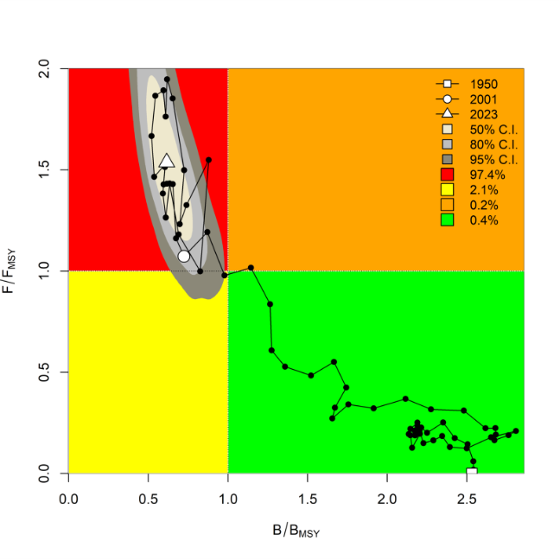
Fig. 1. JABBA Indian Ocean assessment Kobe plots for blue marlin (contours are the 50, 80 and 95 percentiles of the 2023 estimate). Black line indicates the trajectory of the point estimates for the total biomass ratio (B/BMSY) and fishing mortality ratio (F/FMSY) for each year 1950–2023

- The WPB NOTED the presentation of several scenarios by the modeller and DISCUSSED them with regards to the abundance indices included in the model. There were 10 scenarios presented to the WPB, but none investigated removing any of the individual CPUE indices. The JPN early index was NOTED as being particularly important to include as it is the only abundance index that provides information prior to 2010, however the JPN late index may not be representative of the abundance index as the fleet has reduced significantly in recent years, and the subsequent increase in CPUE may not be representative of an abundance change, but a change in fleet dynamics.
- The WPB NOTED that the scenarios presented to the group also included testing two production functions (Fox vs. Schaefer models), but not the Pella-Tomlinson function. It was SUGGESTED that further scenarios were run that included this additional production function, along with testing of removal of CPUEs.
- The WPB DISCUSSED the ‘wiggliness’ of the posterior distribution of the carrying capacity parameter (K) suggesting that this may be due to lack of information in the data to inform the capacity parameter. It was suggested to use alternative priors for this parameter. The WPB also DISCUSSED the process error and REQUESTED that diagnostic plots be provided to the group to determine whether there were any trends in the process error, and how these differed between models, to assist with choosing a base case.
- The WPB REQUESTED further model diagnostics to allow full comparisons, including retrospective analyses, process error trends (as JABBA compensates by using process error to reconcile catch and abundance trajectories), DIC for model selection, and plots of the relative fit of Fox vs. Schaefer production models.
- The WPB NOTED that CPUE indices were weighted equally within the model, and it was AGREED that if uncertainty estimates are available, that they should be incorporated into the model, rather than treating all indies as equal.
- The WPB AGREED that model selection for the base case scenario should be based on appropriate diagnostics.
- The WPB NOTED the diagnostics presented to the group, and DISCUSSED the different TWN,China CPUE indices to be included in the model (using sdmTMB or GLM for model fitting), and AGREED that the models should use sdmTMB.
- The WPB AGREED that scenario S10 (Fox model; fixed process error at 0.15; all CPUE indices included) would be a good candidate to develop a base case.
- The WPB NOTED the additional scenarios that were tested overnight, including ones that excluded TWN,China CPUE index, excluded JPN late and IDN indices, applied CV weighting, raised phi to 0.99, and tested the Pella–Tomlinson production function.
- The WPB NOTED that Scenarios 10b and 10c had the best statistical fits (lowest RMSE) and improved MSY estimates, but overall S10c (applied CV weighting) remained the most balanced scenario, although for all models, process error is trending upwards, making the possible outlook from the model relatively more optimistic. The WPB REQUESTED that this be investigated in the future, as the current estimation of stock status is likely still overly optimistic.
- The WPB AGREED to use model scenario S10c as the base case, and REQUESTED that projections were completed using this model. Projections started in 2026, while catches in 2024 and 2025 were held constant. Catches for projections were based on the average catch for the final three years of data in the model (2021-2023 inclusive), and included 10 years of projections, with values of B/Bmsy and F/Fmsy at 3 years (2028) and 10 years (2035) used for management advice.

Indo Pacific sailfish
- Stock assessments
Bayesian Surplus Production Model (JABBA)
- The WPB NOTED document IOTC-2025-WPB23-20 assesses Indo-Pacific sailfish stock using JABBA, including the following abstract as provided by the author:
“Assessing the status of the Indo-Pacific (IP) sailfish (Istiophorus platypterus) in the Indian Ocean remains challenging due to limited data availability. There is lack of reliable information on stock structure, abundance and biological parameters. This report details the ongoing stock assessment for IP sailfish in the Indian Ocean, building upon the methodological framework established in the 2022 assessment. Given the persistent data constraints for this highly migratory species, this assessment employs alternative approaches suitable for data-limited scenarios. The primary objective is to evaluate stock status relative to sustainability reference points to provide science-based management advice.” See the paper for the full abstract.
- The WPB NOTED the key assessment results for the reference case (S6) of the Bayesian State Space Surplus-Production Model (JABBA) for Indo-Pacific sailfish as shown below (Table 3; Figure 2).

Table 3. Stock status summary table for the Indo Pacific sailfish assessment (JABBA). CI = Confidence interval from the model run
Management quantity | JABBA
Current catch in assessment (t) | 31,898
Mean catch 2019–2023 (t) | 33,888
MSY (1,000 t) (80% CI) | 34.3 (28.7 - 42.2)
F_{MSY} (80% CI) | 0.20 (0.17-0.23)
B_{MSY} (1,000 t) (80 % CI) | 174 (145-212)
Data period (catch) | 1950 – 2023
F₂₀₂₃/F_{MSY} | 0.69 (0.51-0.94)
B₂₀₂₃/B_{MSY} (80% CI) | 1.34 (1.15-1.53)
B₂₀₂₃/B_{MSY} | N/A
B₂₀₂₃/B₀ (80% CI) | N/A
B₂₀₂₃/B₀ (80% CI) | 0.67 (0.58-0.76)

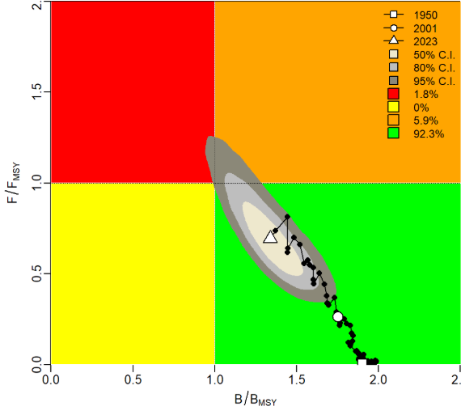
Figure 2: JABBA: Kobe plot showing estimated trajectories (1950-2023) of B/B_{MSY} and F/F_{MSY} for JABBA model of Indian Ocean IP sailfish. Different grey shaded areas denote the 50%, 80%, and 95% credibility interval for the terminal assessment year. The probability of terminal year points falling within each quadrant is indicated in the figure legend.

- The WPB COMMENDED the analysts for their first stock assessment for the IOTC. The WPB NOTED that this assessment was the second time that a formal assessment had been completed for the Indo-Pacific sailfish in the IOTC Area of Competence.
- The WPB NOTED that the assessment used length-based spawning potential ratio (LBSPR) outputs as a proxy for an abundance index, as the previous assessment had done (IOTC-2022-WPB20-15).
- The WPB NOTED that the LBSPR-derived spawning potential ratio (SPR) was provided as a biomass input index into a secondary model – the Just Another Redlist Assessment model (JARA) that then provided a normalised SPR for input into the Just Another Bayesian Biomass Assessment (JABBA) model.
- The WPB NOTED that the authors provided ten scenarios that differed in their priors, and process error assumptions, as there were no alternative abundance indices available for this species. Indeed, the WPB NOTED that in previous assessments, catch-only methods had been used due to the lack of CPUE indices to provide any additional biomass information.
- The WPB NOTED that the scenarios presented all suggested the stock was in the ‘green’ quadrant of the Kobe plot (not overfished and not subject to overfishing), however some scenarios indicated that the trajectory of the stock status was moving closer to the threshold for being subject to overfishing. The WPB NOTED the caveats presented by the authors, and the novelty of the approach.
- The WPB CONGRATULATED the assessors for tackling a challenging species and NOTED the significance of attempting this assessment in a very data poor situation.
- The WPB DISCUSSED at length the reliance on length-frequency data as an input into the LBSPR method, and it was NOTED that most of the length data were from longline fleets, when most of the reported catch was from gillnet fisheries. These fisheries catch substantially different portions of the size distribution of sailfish (gillnet would have dome-shaped selectivity, while longline would have logistic / asymptotic selectivity).
- The WPB NOTED that, due to the issues in the point above relating to the representativeness of the length data, it was possible that the B/BMSY values are likely overly optimistic.
- The WPB DISCUSSED at length a number of major concerns with the assessment and it was AGREED that using the normalised SPR as an abundance index was un-tested and not used elsewhere in fisheries stock assessments. The WPB NOTED that significant biases may exist in the method if recruitment varies (as this method assumes constant recruitment through time).
- The WPB NOTED some strong criticism of the use of SPR in this way: SPR assumes constant recruitment, which is not realistic for a stock that is subject to environmental variability and potentially fluctuating recruitment. Under variable recruitment, the resulting index is likely to be biased and could be diametrically opposed to the one currently used in the JABBA model. This criticism also included a suggestion to pause the use of this method until simulation studies have been conducted to test its robustness to a variety of likely scenarios in the IO.
- The WPB NOTED, however there were differing opinions over whether the assessment could be used for management advice, with some participants noting that it was the current best available science on the stock, and did represent an improvement on catch-only based methods.
- The WPB NOTED other improvements for the next iteration of this model, in particular:
  - Exploration of alternative priors (e.g. less informative prior for k (carrying capacity)
  - Consider weighting the length data by the catch to better reflect fishery removals
  - Re-examine reliance on longline data, and investigate the incorporation of gillnet length-frequency data, which the Secretariat does hold
- The WPB AGREED that the stock status for SFA would remain unchanged from the previous assessment in 2022. This was based on a weight-of-evidence approach, using both the results of the 2025 JABBA assessment (stock is not overfished and not subject to overfishing, with an estimated likelihood of 92.3 %), and the results of the LBSPR which indicates that the SPR has declined to 45.5 % since 1970.
- The WPB AGREED that there was no evidence to suggest that the stock status had moved to a different quadrant of the Kobe plot but NOTED that there was concern regarding the consistently high level of catches, that have been above or close to the estimated MSY for several years.
- The WPB NOTED that the methods used in the 2025 assessment had been used in the 2022 assessment, but that there were substantial concerns regarding the utilisation of the annual trend in SPR as an abundance index within the JABBA model. These issues were identified in 2022, and were presented to the SC.
- In 2022, “The SC NOTED that the new assessment used the Just Another Red-List Assessment(JARA) model to link the LB-SPR and the JABBA model. It was NOTED that the JARA model was incorporated as an additional modelling step that acts as a smoother over the time series obtained from the LB-SPR and normalizes the time series with respect to the initial state, in order to calculate an estimate of depletion. However, the inclusion of the “JARA” model has a negligible influence on the outcomes of the JABBA assessment. The SC also AGREED that the methodology of converting the length data into an index of relative abundance, requires further review.”
- NOTING concern from the WPB that the methodology was not reviewed prior to the 2025 assessment, the WPB RECOMMENDED that simulation testing be carried out prior to the next WPB in 2026 to understand whether the SPR index can be used as an abundance index in the JABBA model.
- The WPB RECOMMENDED that the stock assessment be revisited at the next WPB after simulation testing has been completed, and an updated stock status be presented to the SC in 2026.

  - Development of management advice for blue marlin and Indo Pacific sailfish and update of species Executive Summaries for the consideration of the Scientific Committee, including discussion on current catch limits as per standing IOTC Resolutions
Blue marlin
- The WPB ADOPTED the management advice developed for blue marlin, as provided in the draft status summary and REQUESTED that the IOTC Secretariat update the draft stock status summary with the latest 2025 interaction data and the JABBA to be provided to the SC as part of the draft Executive Summary, for its consideration.
  - Blue marlin (Makaira nigricans) – Appendix VII
Indo-Pacific sailfish
- The WPB ADOPTED the management advice developed for Indo-Pacific sailfish, as provided in the draft status summary and REQUESTED that the IOTC Secretariat update the draft stock status summary with the latest 2025 interaction data to be provided to the SC as part of the draft Executive Summary, for its consideration:
  - Indo Pacific sailfish (Istiophorus platypterus) – Appendix V

- Progress MANAGEMENT Procedure (Resolution 24/08)
- The WPB NOTED information document IOTC-2025-WPB23-INF02, which investigates the population structure of the swordfish across the Indian Ocean using next generation sequencing with the following abstract provided by the authors.
“Swordfish ( Xiphias gladius ) is of significant economic importance as it is the second most exploited billfish in the Indian Ocean. While the Indian Ocean Tuna Commission (IOTC) considers swordfish to be a single panmictic population in the Indian Ocean, several studies have examined the potential for spatial variations within this highly migratory species with conflicting results, including emerging evidence that population structuring does indeed exist within swordfish. These findings therefore raise questions about the current guidelines for management adopted by the IOTC. In the present study, we address questions about the genetic structuring of swordfish in the Indian Ocean through the analysis of three datasets: (i) neutral SNPs, (ii) with, and (iii) only SNPs under potential selection identified from 1694 swordfish originating from 24 distinct locations across the Indian Ocean. A discriminant analysis of principal components showed the presence of two swordfish subpopulations in the Indian Ocean in the north and the south and was confirmed by admixture methods. This genetic differentiation may be explained by a chromosomal inversion, indicating that both populations could be demographically connected but remain differentiated by this structural variant”
- The WPB sought further clarification regarding the issue of chromosomal inversion that was identified in the study and NOTED that this was still requiring further investigation. The authors stated that regardless of that issue the result suggest that there are two different subpopulations and that this will likely have implications for the assessment and MSE OMs going forward, although the urgency may be lower due to the healthy status of the stock. The WPB NOTED that the assessment is already spatially structured and so may be well set up to account for the new research but that the lack of information on mixing between subregions is still problematic and adds uncertainty.
- The WPB NOTED that the research indicating two subpopulations likely identifies a potential Exceptional Circumstance with respect to the swordfish MP and REQUESTED that:
- The authors of the Swordfish EC paper (IOTC-2025-WPB23-21) include discussion of this issue in the revised paper to the WPM, and
- The WPM consider and discuss the implications of this new research for the future operation of the MP, and develop advice on this issue to the SC.
- The WPM NOTED it will be very important, if possible, that the authors of the new research attend the WPM and participate in the discussions of this issue to ensure that the WPM understand the research fully and could discuss its implications for the MP.
- The WPB NOTED document IOTC-2025-WPB23-21, which synthesizes the consideration of exceptional circumstances for the Swordfish Management Procedure 2025, NOTED the following points from the paper abstract :
“This paper summarises the outcomes from a review of a wide range of information, in considering if there is evidence of exceptional circumstances. It is important to note that this current review paper may not yet take account of all new information presented to the WPB23 (September 2025). However, any new and relevant information can be included in a revised paper for consideration by the Working Party on Methods (October 2025). The key conclusions of the current review are:.
  - TAC implementing measure – At it’s meeting in April 2025, the IOTC Commission failed to propose and agree a measure to implement (and allocate) the TAC recommended by the MP. As such, there is no measure in place to ensure TAC adherence in the 2026-2028 period, increasing the risk of catches increasing above the recommended level. This needs to be urgently addressed by the Commission at its 2026 meeting.
  - Stock status, population dynamics or biology - The 2023 stock assessment estimates of SB/SBMSY and F/FMSY were shown to be within the 90% probability interval of the estimates from the operating models used to test the performance and tune the MP. No EC relating to biology or population dynamics were identified, but noting that new recent research on stock structure has yet to be reviewed by WPB and SC.
  - Fishery or fishing operations - There are no identified changes in recent fishery operations (e.g. methods/approaches). Shifts in relative catch proportions by the fishery over time (noted by WPB22 in 2024) have been incorporated into the MSE operating models (OMs), and the subsequent MP performance tested and demonstrated to be acceptable. Fishery catch levels and proportions from the 2 most recent years of data are not substantially different to the most recent levels considered by the OMs, albeit total catch levels continue to show a declining trend in recent years.
  - Catch data inputs – There have been no significant recent changes in the quality and representativeness of swordfish catch data to be utilised by the MP.
  - CPUE data inputs – StdCPUE time series estimates from the 2023 standardisation process (for period to 2022) and the 2024 standardisation process (for period to 2023) are very similar. Prediction skill of the NWIO Japanese longline CPUE remains acceptable but Japanese longline effort trends should continue to be monitored and considered in annual EC reviews and as part of the larger MP review in 2031.
See the paper for the full abstract.
- The WPB NOTED again that the Japanese fishing effort and catch in the NWIO area for which the MP CPUE index is derived continues to be low relative to levels prior to a decade ago, and raised concerns again over the potential for this to increase the risk that the index is no longer representative and fit for use in the MP, or can even be produced in future. However, the WPB NOTED that the low effort in that area has existed now for a significant time and the use of the Japanese index from that area, under low effort conditions, has been tested and validated as suitable under the MSE testing process, and that a subsequent and more recent examination of the prediction skill of the NW JPN CPUE from the 2023 assessment model indicates that the prediction skill remains acceptable. However, the WPB REQUESTED that the WPM continue to monitor and explore alternate abundance indices as part of the next review of the MP.
- The WPB also NOTED information provided by participants on the potential future emergence of a new longline fishing gear, meka-ring or loop gear, that is aimed at catching swordfish, and the potential for this to impact on CPUE indices in future. It was NOTED that Japan has started collecting information on the use of this gear already and will provide an update to the WPB in future.
- The WPB NOTED the discussion on recently published new information on stock structure suggesting that there may be two sub populations in the IOTC (contrasting current assumptions of one stock) and that the request from that discussion by WPB to WPM is directly relevant to the consideration of Exceptional Circumstances for the Swordfish MP.
- The WPB NOTED the range of other criteria examined under the Exceptional Circumstances guidelines and that with the exception of the issue pertaining to new information on stock structure, no other potential exceptional circumstances were identified for this MP in 2025. The WPB NOTED that this paper will be revised and resubmitted to WPM to take account of WPB discussions.
- Other Billfishes
  - Review of new information on other billfishes (other marlins, I.P. sailfish) biology, stock structure, fisheries and associated environmental data

- The WPB NOTED document IOTC-2025-WPB23-22, which summarises the standardization of the catch per unit effort for Swordfish for the South African longline fishery, with the following abstract provided by the authors:
“Swordfish, Xiphias gladius, is a target species in the South African pelagic longline fleet operating along the
west and east coast of South Africa. A standardization of the CPUE of the South African swordfish directed
longline fleet for the time series 2004-2024 was carried out with a Generalized Additive Mixed Model (GAMM)
with a Tweedie distributed error. Explanatory variables of the final model included Year, Month, geographic
position (Lat, Long) and a targeting factor (Fishing Tactic) with two levels, derived by clustering of PCA scores
of the root-root transformed, normalized catch composition. Vessel was included as a random effect.
Swordfish CPUE had a definitive seasonal trend, with catch rates higher in winter (July - October) than in the
rest of the year. Standardized (normalized) CPUE has been relatively stable over the 20-year period, ranging
from a low 0.60 in 2014 to a peak of 1.36 in 2023. The CPUE has shown a general increasing trend since
2021”

- The WPB NOTED that South Africa straddles both the IOTC and ICCAT Convention areas, and genetic studies have well established the stock separation between Indian Ocean and Atlantic swordfish stocks; it was further NOTED that about half of the catch in 2022 came from the IOTC region. The WPB also NOTED that the fishery is composed of traditional vessels targeting pelagic sharks, local fishermen fishing for swordfish in shallow waters, and vessels venturing further offshore to target tuna in deep waters.
- The WPB THANKED South Africa for resuming the CPUE standardization work for swordfish and noted that this work could not be conducted in 2023 due to staff shortages. Additionally, the WPB NOTED there is a long-term plan to continue work supporting the swordfish stock assessment, to explore a wide range of statistical models, and that variables related to gear configuration, such as HBF, will be considered once the model becomes more stable.

  - Resolution 18/05 Catch Limits
- The WPB NOTED information document IOTC-2025-WPB23-INF01, which summarises the status of marlins and sailfish catches- resolution 18/05 (IOTC Secretariat), with the following abstract provided by the authors
“There have been significant revisions in the historical catch data for billfish species overall, with some species experiencing an increase in catches, while others have seen a decline. These changes could influence the catch limits set for certain species”
- The WPB NOTED a decline in catches of blue marlin, resulting from the historical revision by Indonesia, which has led to an overall reduction in catches from longline fisheries
- Additionally, the WPB NOTED an increase in catches of black marlin and Indo-Pacific sailfish due to the historical revision, with both species continuing to see increased catches, particularly from gillnet fisheries in recent years.
- The WPB NOTED that catches of black marlin and Indo-Pacific sailfish have remained above the catch limit set, beyond 2020. NOTING that catches of blue marlin have remained below the limit for the entire period, due to changes in the historical catch.
- The WPB NOTED that more recent assessments of the species in question are available and should be used to update the catch limits. Furthermore, it was NOTED that recent revisions of historical catch data have led to changes in the average catches for the period used to establish those limits.
- The WPB REQUESTED that this information be relayed to the Commission for advice on how the catch limits should be revised. NOTING that the group should propose methodology on how to revise the limits set forth in 18/05 to the Scientific Committee.
- The WPB NOTED document IOTC-2025-WPB23-23, which provides a review of potential management options for IOTC marlin and sailfish, and NOTED the following key points in the abstract provided by the authors:
  - The most recent assessments of marlin and sailfish stocks in the Indian Ocean have identified that striped marlin, black marlin and blue marlin are all subject to overfishing and striped marlin and blue marlin are currently overfished. The SC has advised that a) reductions in catch, relative to recent levels, are required for each of these stocks, to ensure or return biomass to MSY levels, and; b) Resolution 18/05 should be revised to reflect recommended catch limits and implement strengthened measures to reduce fishing mortality on these stocks.
  - This paper aims to provide a preliminary review of relevant data and scientific research to support the Working Party on Billfish (WPB) develop advice to the Scientific Committee (SC) relating to: (a) the potential effectiveness of a range of different management tools (specifically catch limits, non-retention, and gear/method-based options) for reducing fishing mortality, and (b) the need to address any gaps and uncertainties in available data and research to assist further consideration of these and other potential management options.
  - On the basis of catch proportions alone, effective measures applied to reduce fishing mortality by gillnet and longline are likely to have the greatest impact on overall fishing mortality on these stocks.”
  - See the paper for the full abstract.
- The WPB NOTED that the paper discussed a range of potential management options for reducing fishing mortality on marlin stocks overfished or subject to overfishing including CPC based catch limits (within overall fishery TACs), non-retention options and fishing gear or method-based options/mitigation (that considered predominantly gillnet and longline based approaches).
- In relation to CPC catch limits, the WPB NOTED that this approach had been applied in a number of other RFMO’s and at least one participant expressed the view that this should be the Commissions preferred approach to reducing fishing mortality. The WPB NOTED the authors comment that the paper at this stage was not attempting to recommend any specific approach, but rather review and assess information pertaining to the potential efficacy of a range of different potential management approaches, as well as identify information and data gaps for further consideration.
- In relation to non-retention options, the WPB NOTED that the paper provided a preliminary review of existing data and research on at-haul mortality and post-release mortality for these species, with the authors concluding that non-retention approaches in longline fisheries may have potential to contribute to reductions in overall fishing mortality for the three marlin species (especially blue marlin) but will likely be much less effective in other fisheries for which at-haul mortality is very high.
- In relation to fishing gear depth-related measures (particularly for gillnet setting depth), the paper reviewed research on vertical habitat use by each species, and on the basis of this, the WPB NOTED that the authors had recommended that there be further at sea fishing trials of a range of different gillnet setting depths to determine if that approach offers a feasible option for reducing fishing mortality of these species by gillnet.
- The WPB NOTED that the authors considered a range of elements of the review paper to be preliminary reviews and that further work would be undertaken to revise and strengthen the paper in future, including the need to obtain additional data from CPCs to further assess some of the management options considered.
- NOTING the necessity to gather information to enable the development of advice relating to a range of potential management measures to complement the commonly used CPC based catch advice, the WPB RECOMMENDED that the Scientific Committee REQUEST:
- That the IOTC Secretariat (or alternately CPCs, where the Secretariat does not hold a CPCs relevant data or information) provide summaries of observer data (or logbook data or other relevant information) to WPB pertaining to the following data types for the following fishery types:
  - All gear/fishery types – discarding/retention rates and at-haul mortality (%) for each marlin and sailfish species, by fishery/gear type.
  - Longline – proportion of each fleet using different hook types and sizes (Japanese tuna, J hook, Circle hook, other)
  - Gillnet – estimate of the proportion of the gillnet fleet using subsurface setting, and if possible, preferred depths used in fishery, and whether the fishery predominantly sets/soaks the gear overnight or through the day (or other)
- CPCs to consider undertaking analyses (e.g., model-based) of at-haul mortality, at a longline fleet level (and if possible for troll/handline), to help identify key factors driving at-haul mortality and subsequently, possibly help identify additional options to reduce at haul mortality.
- CPCs individually or collaboratively conduct gillnet experimental fishing trials that:
  - Aim to test different setting depths and times of setting/soaking (e.g. day/night), on catch rates and mortality of interacting species
  - Collect data on all interacting species including billfish bycatch, target tuna and vulnerable species (e.g. cetaceans, turtles), in order to provide the Commission a quantified understanding of likely effects and possible trade-offs of various subsurface setting options, on each species.
  - Prioritise accurate species identification.
- In addition, the WPB RECOMMENDED that the Scientific Committee advise the Commission to give consideration to how such a trial (point (3) above) might be supported financially and logistically.

- WPB PROGRAM OF WORK
  - Revision of the WPB Program of Work (2026–2030) (Chairperson and IOTC Secretariat)
- The WPB NOTED document IOTC-2025-WPB23-08, which provides a revision of the WPB Program of Work for 2026–2030)
- The WPB NOTED paper IOTC–2025–WPB23–08 which provided an opportunity to consider and revise the WPB Program of Work (2026–2030), by taking into account the specific requests of the Commission, Scientific Committee, and the resources available to the IOTC Secretariat and CPCs.
- The WPB RECALLED that the SC, at its 18th Session, made the following request to its Working Parties:
“The SC REQUESTED that during the 2016 Working Party meetings, each group not only develop a Draft Program of Work for the next five years containing low, medium and high priority projects, but that all High Priority projects are ranked. The intention is that the SC would then be able to review the rankings and develop a consolidated list of the highest priority projects to meet the needs of the Commission. Where possible, budget estimates should be determined, as well as the identification of potential funding sources.” (SC18. Para 154).
- The WPB RECOMMENDED that the SC consider and endorse the WPB Program of Work (2026–2030), as provided in Appendix X.
  - Development of priorities for an Invited Expert at the next WPB meeting (Chairperson)
- The WPB THANKED the invited expert, Catalina Wor, for her valuable contributions to enhance the technical capacity of the meeting. Her critical and constructive review greatly enriched the discussion on CPUE standardization and the assessment of blue marlin and Indo-Pacific fish.
- The WPB NOTED that an Invited Expert may be required to support the next WPB meeting and AGREED that the decision for the selection of the candidate for the WPB24 be considered inter-sessionally. Once decided, the selection will be performed by advertising the position through the IOTC science list (as a priority channel) and finalized after receipt and assessment of supporting information for potential candidates, according to the deadlines set forth by the rules and procedures of the Commission.
- The WPB AGREED to the following core areas of expertise and priority areas for contribution that need to be enhanced for the next meeting of the WPB in 2025 by an Invited Expert:
- Expertise: Stock assessment, CPUE standardisation.
- Priority areas for contribution: Providing expert input into swordfish stock assessment work.

- Other business
  - Election of the Chairperson and Vice-Chairperson of the WPB for the next biennium (Secretariat)
Chairperson
- The WPB NOTED that the first term of the current Chairperson, Dr Jie Cao (CHN) expired at the close of the WPB23 meeting and, as per the IOTC Rules of Procedure (2014), participants are required to elect a new Chairperson of the WPB for the next biennium.
- NOTING the Rules of Procedure (2014), the WPB CALLED for nominations for the position of Chairperson of the IOTC WPB for the next biennium. Dr Cao (CHN) was nominated, seconded and re-elected as Chairperson of the WPB for the next biennium.
Vice-Chairperson
- The WPB NOTED that the second term of the current Vice-Chairperson, Dr Sylvain Bonhommeau (EU. France) expired at the close of the WPB23 meeting. As per the IOTC Rules of Procedure (2014), participants are required to elect a new Vice-Chairperson of the WPB for the next biennium.
- NOTING the Rules of Procedure (2014), the WPB CALLED for nominations for the positions of Vice-Chairperson of the IOTC WPB for the next biennium. Dr Bonhommeau was nominated, seconded and elected as Vice-Chairperson of the WPB for the next biennium.

  - Date and place of the 24th and 25th Sessions of the Working Party on Billfish
- The WPB REQUESTED that CPCs that may be interested in hosting the 24th and 25th Working Party on Billfish meetings contact the Secretariat.
- The WPB NOTED that the SC emphasized the importance of holding working party meetings in a hybrid format whenever feasible. However, the WPB further NOTED that this should not discourage CPCs from offering to host the meetings, even if they are unable to accommodate a hybrid format.
- The WPB RECOMMENDED the SC consider early September as a preferred time period to hold the WPB24 in 2026. As usual it was also AGREED that this meeting should continue to be held back-to-back with the WPEB and that in 2026 WPB will be held in the week before the WPEB.
- The WPB NOTED that EU. France tentatively offered to host the next WPB and WPEB) meetings in Reunion, with confirmation to be provided at the SC meeting in December. The WPB THANKED EU. France for this offer.
  - Review of the draft, and adoption of the Report of the 23rd Session of the Working Party on Billfish
- The WPB RECOMMENDED that the Scientific Committee consider the consolidated set of recommendations arising from WPB23, provided at Appendix XI, as well as the management advice provided in the draft resource stock status summary for each of the five billfish species under the IOTC mandate, and the combined Kobe plot for the five species assigned a stock status in 2025 (Fig. 3):
  - Swordfish (Xiphias gladius)– Appendix IV
  - Black marlin (Istiompax indica) – Appendix V
  - Blue marlin (Makaira nigricans) – Appendix VI
  - Striped marlin (Kajikia audax) – Appendix VII
  - Indo-Pacific sailfish (Istiophorus platypterus) – Appendix VIII

Fig. 3. Combined Kobe plot for swordfish (grey), indo-pacific sailfish (cyan), black marlin (black), blue marlin (blue) and striped marlin (purple) showing the 2023, 2004, and 2025 estimates of current stock size (SB or B, species assessment dependent) and current fishing mortality (F) in relation to optimal spawning stock size and optimal fishing mortality. Cross bars illustrate the range of uncertainty from the model runs.
- The report of the 23rd Session of the Working Party on Billfish (IOTC–2025–WPB23–R) was ADOPTED by correspondence.

Appendix I - List of participants

Chairpersons WPB23
Title | First name | Last name | Organisation | E-mail
Mr. | Jie | Cao | North Carolina State University | jcao22@ncsu.edu
Mr. | Sylvain | Bonhommeau | IFREMER | sylvain.bonhommeau@ifremer.fr
Title | First name | Last name | Organisation | E-mail
Ms. | Pia | Bessell-Browne | CSIRO | pia.bessell-browne@csiro.au
Mr. | Don | Bromhead | ABARES | Don.Bromhead@aff.gov.au
Mr. | Emmanuel | Chassot | IOTC Secretariat | Emmanel.Chassot@fao.org
Mr. | Yong | Chen | Shanghai Ocean University, P. R. China | ychen@maine.edu
Ms. | Sophia | Chrico | IOTC Secretariat | Sphia.Chirico@fao.org
Mr. | Conor | Clayton | ABARES | conor.clayton@aff.gov.au
Ms. | Charlene | da Silva | DFFE South Africa | CDaSilva@dffe.gov.za
Mr. | Jose | Fernández Costa | IEO-CSIC | jose.costa@ieo.csic.es
Mr. | Laurent | Floch | IRD | laurent.floch@ird.fr
Mr. | Dan | Fukugama | IOTC Secretariat | Dan.Fu@fao.org
Mr. | Pradeep | HD | FISHERY SURVEY OF INDIA | hdpradeep@gmail.com
Mr. | Prabath | Jayasinghe | NARA, Sri Lanka | prabath_jayasinghe@yahoo.com
Mr. | Mikihiko | Kai | Fisheries Resources Institute | kai_mikihiko61@fra.go.jp
Mr. | Wasantha Sanjeewa | Kumara | DFAR Sri lanka | sanjemk@gmail.com
Ms. | Yanan | Li | Shanghai Ocean University | liyananxiada@yeah.net
Ms. | Yujiao | Liu | Shanghai Ocean University | 3309243742@qq.com
Mr. | Paul | Lukhwenda | Kenya Fisheries Service | alexasdsp@gmail.com
Ms. | Lauren | Nelson | IOTC Secretariat | Lauren.Nelson@fao.org
Mr. | David | Nordlund | MAPA | dpnordlund@mapa.es
Mr. | Reza | Nouri | Iran Fisheries Organization | nouri.ifo@gmail.com
Ms. | Aintzina | Oihenarte Zubiaga | FIP BLues Spanish longline surface | departamentotecnico@fipblues.com
Mr. | Teodoro | Patrocinio Ibarrola | IEO-CSIC | teo.ibarrola@ieo.csic.es
Mr. | Toby | Patterson | CSIRO | toby.patterson@csiro.au
Ms. | Genevieve | Philipps | IOTC Secretariat | Genevieve.Philipps@fao.org
Ms. | Lucia | Pierre | IOTC Secretariat | Lucia.Pierre@fao.org
Ms. | María Lourdes | Ramos Alonso | Instituto Español de Oceanografía (IEO-CSIC) | mlourdes.ramos@ieo.csic.es
Mr. | SURYA | S | CMFRI | revandasurya@gmail.com
Mr. | Philippe | Sabarros | IRD | philippe.sabarros@ird.fr
Mr. | Bram | Setyadji | National Research and Innovation Agency (BRIN) | bram.setyadji@gmail.com
Ms. | Chloé | TELLIER | IRD | chloe.tellier@ird.fr
Mr. | Weerapol | Thitipongtrakul | DOF Thailand | weerapol.t@gmail.com
Mr. | Sheng-Ping | Wang | National Taiwan Ocean University | wsp@mail.ntou.edu.tw
Ms. | Catarina | Wor | Fisheries and oceans Canada | Catarina.Wor@dfo-mpo.gc.ca
Ms. | Na | Zhang | Shanghai Ocean University | 18473271095@163.com
Mr. | Jizhang | Zhu | Shanghai Ocean University | jizhangzhu_shou@163.com

Appendix II - Agenda for the 23rd Working Party on Billfish

Date: 15–18 September 2025
Location: IRD, Sète, France
Time: 09:00 – 17:00 daily (French time)
Chair: Dr Jie Cao (China); Vice-Chair Dr Sylvain Bonhommeau (France):

- OPENING OF THE MEETING (Chairperson)

- ADOPTION OF THE AGENDA AND ARRANGEMENTS FOR THE SESSION (Chairperson)
I
- THE IOTC PROCESS: OUTCOMES, UPDATES AND PROGRESS
  - Outcomes of the 27th Session of the Scientific Committee (IOTC Secretariat)
  - Outcomes of the 29th Session of the Commission (IOTC Secretariat)
  - Review of Conservation and Management Measures relevant to billfish (IOTC Secretariat)
  - Progress on the recommendations of WPB22 (IOTC Secretariat)
- NEW INFORMATION ON FISHERIES AND ASSOCIATED ENVIRONMENTAL DATA FOR BILLFISH
  - Review of the statistical data available for billfish at the Secretariat (IOTC Secretariat)
  - Climate change (all)
- MARLINS (Priority species for 2025: Blue marlin and Indo Pacific Sailfish)
  - Review new information on marlin biology, stock structure, fisheries and associated environmental data (all)
  - Review of new information on the status of blue marlin and Indo Pacific sailfish (all)
      - Nominal and standardised CPUE indices
      - Stock assessments
      - Selection of Stock Status indicators
  - Development of management advice for blue marlin and Indo Pacific sailfish and update of species Executive Summaries for the consideration of the Scientific Committee, including discussion on current catch limits as per standing IOTC Resolutions (all)
- THE SWORDFISH MANAGEMENT Procedure (Resolution 24/08)
  - Review of exceptional circumstances
- OTHER BILLFISHES (new information for informing future assessments)
  - Review of new information on other billfishes (biology, stock structure, fisheries and associated environmental data (all)
  - Resolution 18/05 Catch Limits

- WPB PROGRAM OF WORK
  - Revision of the WPB Program of Work (2026–2030) (Chairperson and IOTC Secretariat)
  - Development of priorities for an Invited Expert at the next WPB meeting (Chairperson)
- OTHER BUSINESS
  - Date and place of the 24th and 25th Sessions of the Working Party on Billfish (Chairperson and IOTC Secretariat)
  - Review of the draft, and adoption of the Report of the 23rd Session of the Working Party on Billfish (Chairperson)

Appendix III - List of documents for the 23nd Working Party on Billfish
Document | Title
IOTC-2025-WPB23-01a | Agenda of the 23rd Working Party on Billfish
IOTC-2025-WPB23-01b | Annotated agenda of the 23rd Working Party on Billfish
IOTC-2025-WPB23-02 | List of documents of the 23rd Working Party on Billfish
IOTC-2025-WPB23-03 | Outcomes of the 27th Session of the Scientific Committee (IOTC Secretariat)
IOTC-2025-WPB23-04 | Outcomes of the 29th Session of the Commission (IOTC Secretariat)
IOTC-2025-WPB23-05 | Review of Conservation and Management Measures relevant to billfish (IOTC Secretariat)
IOTC-2025-WPB23-06 | Progress made on the recommendations and requests of WPB22 and SC27 (IOTC Secretariat)
IOTC-2025-WPB23-07 | Review of the statistical data and fishery trends for billfish species (IOTC Secretariat)
IOTC-2025-WPB23-08 | Revision of the WPB Program of Work (2026-2030) (IOTC Secretariat)
IOTC-2025-WPB23-10 | Billfish resources of India with special reference to the fishery and biology of blue marlin (Makaira nigricans) landed caught from the Eastern Arabian Sea (Surya S, Abdusamad E, Mini K, Rajesh K, Manas H, Abdul A, Anulekshmi C, Vinothkumar R, Santhosh B, Shoba J, Grinson G)
IOTC-2025-WPB23-11 | Billfish landing by foreign IOTC fishing vessels at Thai fishing ports during 2020 – 2024 (Thitipongtrakul W, Kumyoo C)
IOTC-2025-WPB23-12 | Spatial temporal distribution of for Swordfish (Xiphias Gladius) catches and catch rates from the Kenyan industrial longline fishery (Lukhwenda P)
IOTC-2025-WPB23-13 | Spatio-temporal Trends of Sailfish (Istiophorus platypterus) Catch Rates in the Sri Lankan Tuna Longline Fishery (Gunasekara S, Jayasinghe R)
IOTC-2025-WPB23-15 | Update on CPUE Standardization of Blue Marlin (Makaira nigricans) from Indonesian Tuna Longline Fleets 2006-2023 (Setyadji B, Spencer M, Kell L, Wright S, Ferson S)
IOTC-2025-WPB23-16 | Spatio-temporal model for CPUE standardization: application  to blue marlin caught by Japanese tuna longline fishery in  the Indian ocean from 1979 to 2023 (Kai M)
IOTC-2025-WPB23-17 | CPUE standardization of blue marlin (Makaira nigricans) caught by the Taiwanese large-scale longline fishery in the Indian Ocean using GLM and sdmTMB (Xu W, Lin C, Wang S)
IOTC-2025-WPB23-18 | Stock assessment of blue marlin (Makaira nigricans) in the Indian Ocean using JABBA (Lin C, Xu W, Wang S )
IOTC-2025-WPB23-19 | Stock assessment of blue marlin (Makaira nigricans) in the Indian Ocean using Stock Synthesis (Xu W, Lin C, Wang S )
IOTC-2025-WPB23-20 | Stock assessment for Indo-Pacific sailfish (Istiophorus platypterus) in Indian Ocean using Bayesian surplus production model (JABBA) (Li Y)
IOTC-2025-WPB23-21 | Consideration of exceptional circumstances for the Swordfish Management Procedure 2025 (Bromhead D, Preece A, Brunel T, Mosqueira I)
IOTC-2025-WPB23-22 | Standardization of the catch per unit effort for Swordfish (Xiphias Gladius) for the South African longline fishery (Da silva C, West W, Kerwath S)
IOTC-2025-WPB23-23 | A preliminary review of scientific data and research relevant to potential management options for marlin and sailfish in the IOTC (Bromhead D. Clayton C, Emery T)
IOTC-2025-WPB23-24 | On-deck condition and mortality of Indo-Pacific Sailfish (Istiophorus platypterus) in Indian Ocean tuna longline fisheries (Zhang N)
IOTC-2025-WPB23-INF01: | Status of marlins and sailfish catches- resolution 18/05 (IOTC Secretariat)
IOTC-2025-WPB23-INF02: | Population structure of the swordfish, Xiphias gladius, across the Indian Ocean using next generation sequencing (Chevrier T, Cowart D, Nieblas A, Charrier G, Bernard S, Evano H, Brisset B, Chanut J, Bonhommeau S)

Appendix IV - [ Draft ] resource stock status summary – Swordfish

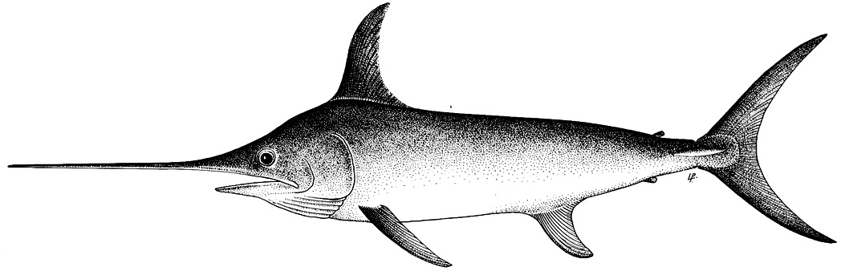

TABLE 1. Status of swordfish (Xiphias gladius) in the Indian Ocean.
Area¹ | Indicators |  | 2023 stock status determination
Indian Ocean | Catch 2023² (t)  Average catch 2019-2023 (t) | 24,115  27,651 | 97%
Indian Ocean | MSY (1,000 t) (80% CI)  F_{MSY} (80% CI)  SB_{MSY} (1,000 t) (80% CI)  F_{2021/}F_{MSY} (80% CI)  SB_{2021/}SB_{MSY} (80% CI)  SB₂₀₂₁/SB₁₉₅₀ (80% CI) | 30 (26–33)  0.16 (0.12–0.20)  55 (40–70)  0.60 (0.43–0.77)  1.39 (1.01–1.77)  0.35 (0.32–0.37) | 97%
¹ Boundaries for the Indian Ocean stock assessment are defined as the IOTC area of competence
² Proportion of 2022 catch estimated or partially estimated by IOTC Secretariat: 19.3%
³2021 is the final year that data were available for this assessment

Colour key | Stock overfished (SB_{year}/SB_{MSY}< 1) | Stock not overfished (SB_{year}/SB_{MSY}≥ 1)
Stock subject to overfishing (F_{year}/F_{MSY}> 1) | 0.2% | 0
Stock not subject to overfishing (F_{year}/F_{MSY}≤ 1) | 3% | 97%
Not assessed/Uncertain/Unknown
Indian Ocean stock – Management Advice
Stock status. No new stock assessment was conducted for swordfish in 2025 thus the stock status estimates are based on the assessment carried out in 2023. Two models were applied to the swordfish stock (ASPIC and Stock Synthesis (SS3)), with the SS3 stock assessment selected to provide scientific advice (as done previously). An update of the JABBA model was also conducted during the WPB meeting. The reported SS3 stock status is based on a grid of 48 model configurations designed to capture the uncertainty relating to steepness of the stock recruitment relationship (0.7, 0.8, and 0.9), recruitment variability (two levels), CPUE series (2 options), growth (2 options) and weighting of length composition data (two options). A number of the options included in the final grid were selected from a range of additional sensitivity runs that were conducted to explore uncertainties. Median spawning biomass in 2021 was estimated to be 35% (80% CI: 32-37%) of the unfished levels (Table 1) and 1.39 times (80% CI: 1.01-1.77) the level required to support MSY. Median fishing mortality in 2021 was estimated to be 60% (80% CI 43%-77%) of the FMSY level, and catch in 2021 (23,237 t) was well below the estimated MSY level of 29,856 t (80% CI: 26,319-33,393t). Taking into account the characterized uncertainty, and on the weight-of-evidence available in 2023, the swordfish stock is determined to be not overfished and not subject to overfishing (Table 1, Fig. 3).

Outlook. The significant decrease in recent longline catch and effort from 2019 to 2022 (a 33% reduction from 35,256t to 23,597t) substantially lowered the pressure on the Indian Ocean stock as a whole, and current fishing mortality is not expected to reduce the population to an overfished state over the next decade. (Table 1). The estimated recent recruitment (2010-2020) was above the long-term average although this appears to be mainly driven by the sharp increase in the Japanese longline CPUE in the northern region. The WPB expressed concern over whether that CPUE index accurately represents the change of abundance in that region which may require further investigation. Further, the South-western region, which is one of the sub-regions used in the model, exhibit a declining biomass trend which indicate higher depletion in this region, compared to other regions.

Management advice. The 2021 catches (23,237t at the time of the assessment) were significantly lower than the estimated MSY level (29,856 t). Under those levels of catches, the spawning biomass was projected to likely increase, with a high probability of maintaining at or above the SB_{MSY} for the longer term. There is a very low risk of exceeding MSY-based reference points by 2031 if catches are maintained at 2021 levels (<1% risk that SB₂₀₃₁< SB_{MSY}, and <1% risk that F₂₀₂₁> F_{MSY}). The projections indicate that an increase of 40% or more from 2021 catch levels will not likely result in the biomass dropping below the SB_{MSY} level for the longer term (with a 15% probability). Catches in 2022 (23,597t) were still lower than the estimated MSY. Nevertheless, the Commission should consider monitoring the catches to ensure that the probability of exceeding the SB_{MSY} target reference points in the long term remains minimal. Taking into account the differential CPUE and biomass trends between regions, the WPB noted that there is recurring evidence for localised depletion in the South Western region (which appears to be more depleted than other regions) and suggests this should be further monitored.
The following key points should also be noted:
- Maximum Sustainable Yield (MSY): estimate for the Indian Ocean is 29,856 t.
- Provisional reference points: noting that the Commission in 2015 agreed to Resolution 15/10 on target and limit reference points and a decision framework, the following should be noted:
  - Fishing mortality: current fishing mortality is considered to be below the provisional target reference point of F_{MSY} and below the provisional limit reference point of 1.4*F_{MSY} (Fig. 2).
  - Biomass: current spawning biomass is considered to be above the target reference point of SB_{MSY}, and therefore above the limit reference point of 0.4*SB_{MSY} (Fig. 2).
- Main fisheries (mean annual catch 2018-2022): swordfish are caught using longline (53.6%), followed by line (30.1%) and gillnet (15.8%). The remaining catches taken with other gears contributed to 0.5% of the total catches in recent years (Fig. 1).
- Main fleets (mean annual catch 2018-2022): the majority of swordfish catches are attributed to vessels flagged to Sri Lanka (27.4%) followed by Taiwan,China (17%) and Yemen (6.2%). The 25 other fleets catching swordfish contributed to 49.5% of the total catch in recent years (Fig. 2).

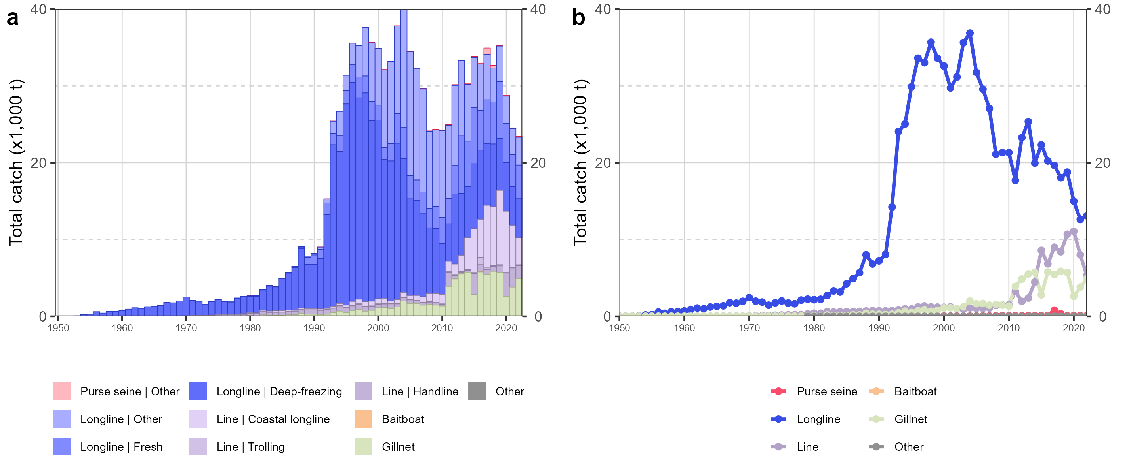

Fig. 1. Annual time series of (a) cumulative nominal catches (metric tons; t) by fishery and (b) individual nominal catches (metric tons; t) by fishery group for swordfish during 1950–2022. Longline|Other: swordfish and sharks-targeting longlines; Other: all remaining fishing gears

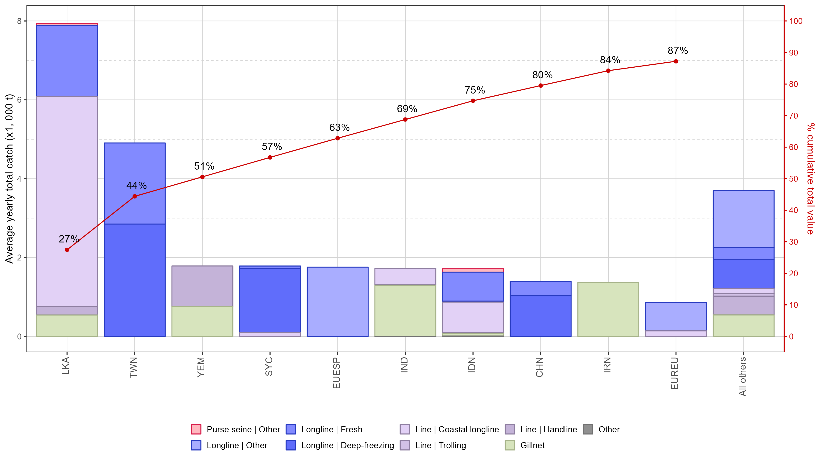

Fig. 2. Mean annual catches (metric tons; t) of swordfish by fleet and fishery between 2018 and 2022, with indication of cumulative catches by fleet. Longline | Other: swordfish and sharks-targeted longlines; Other: all remaining fishing gears

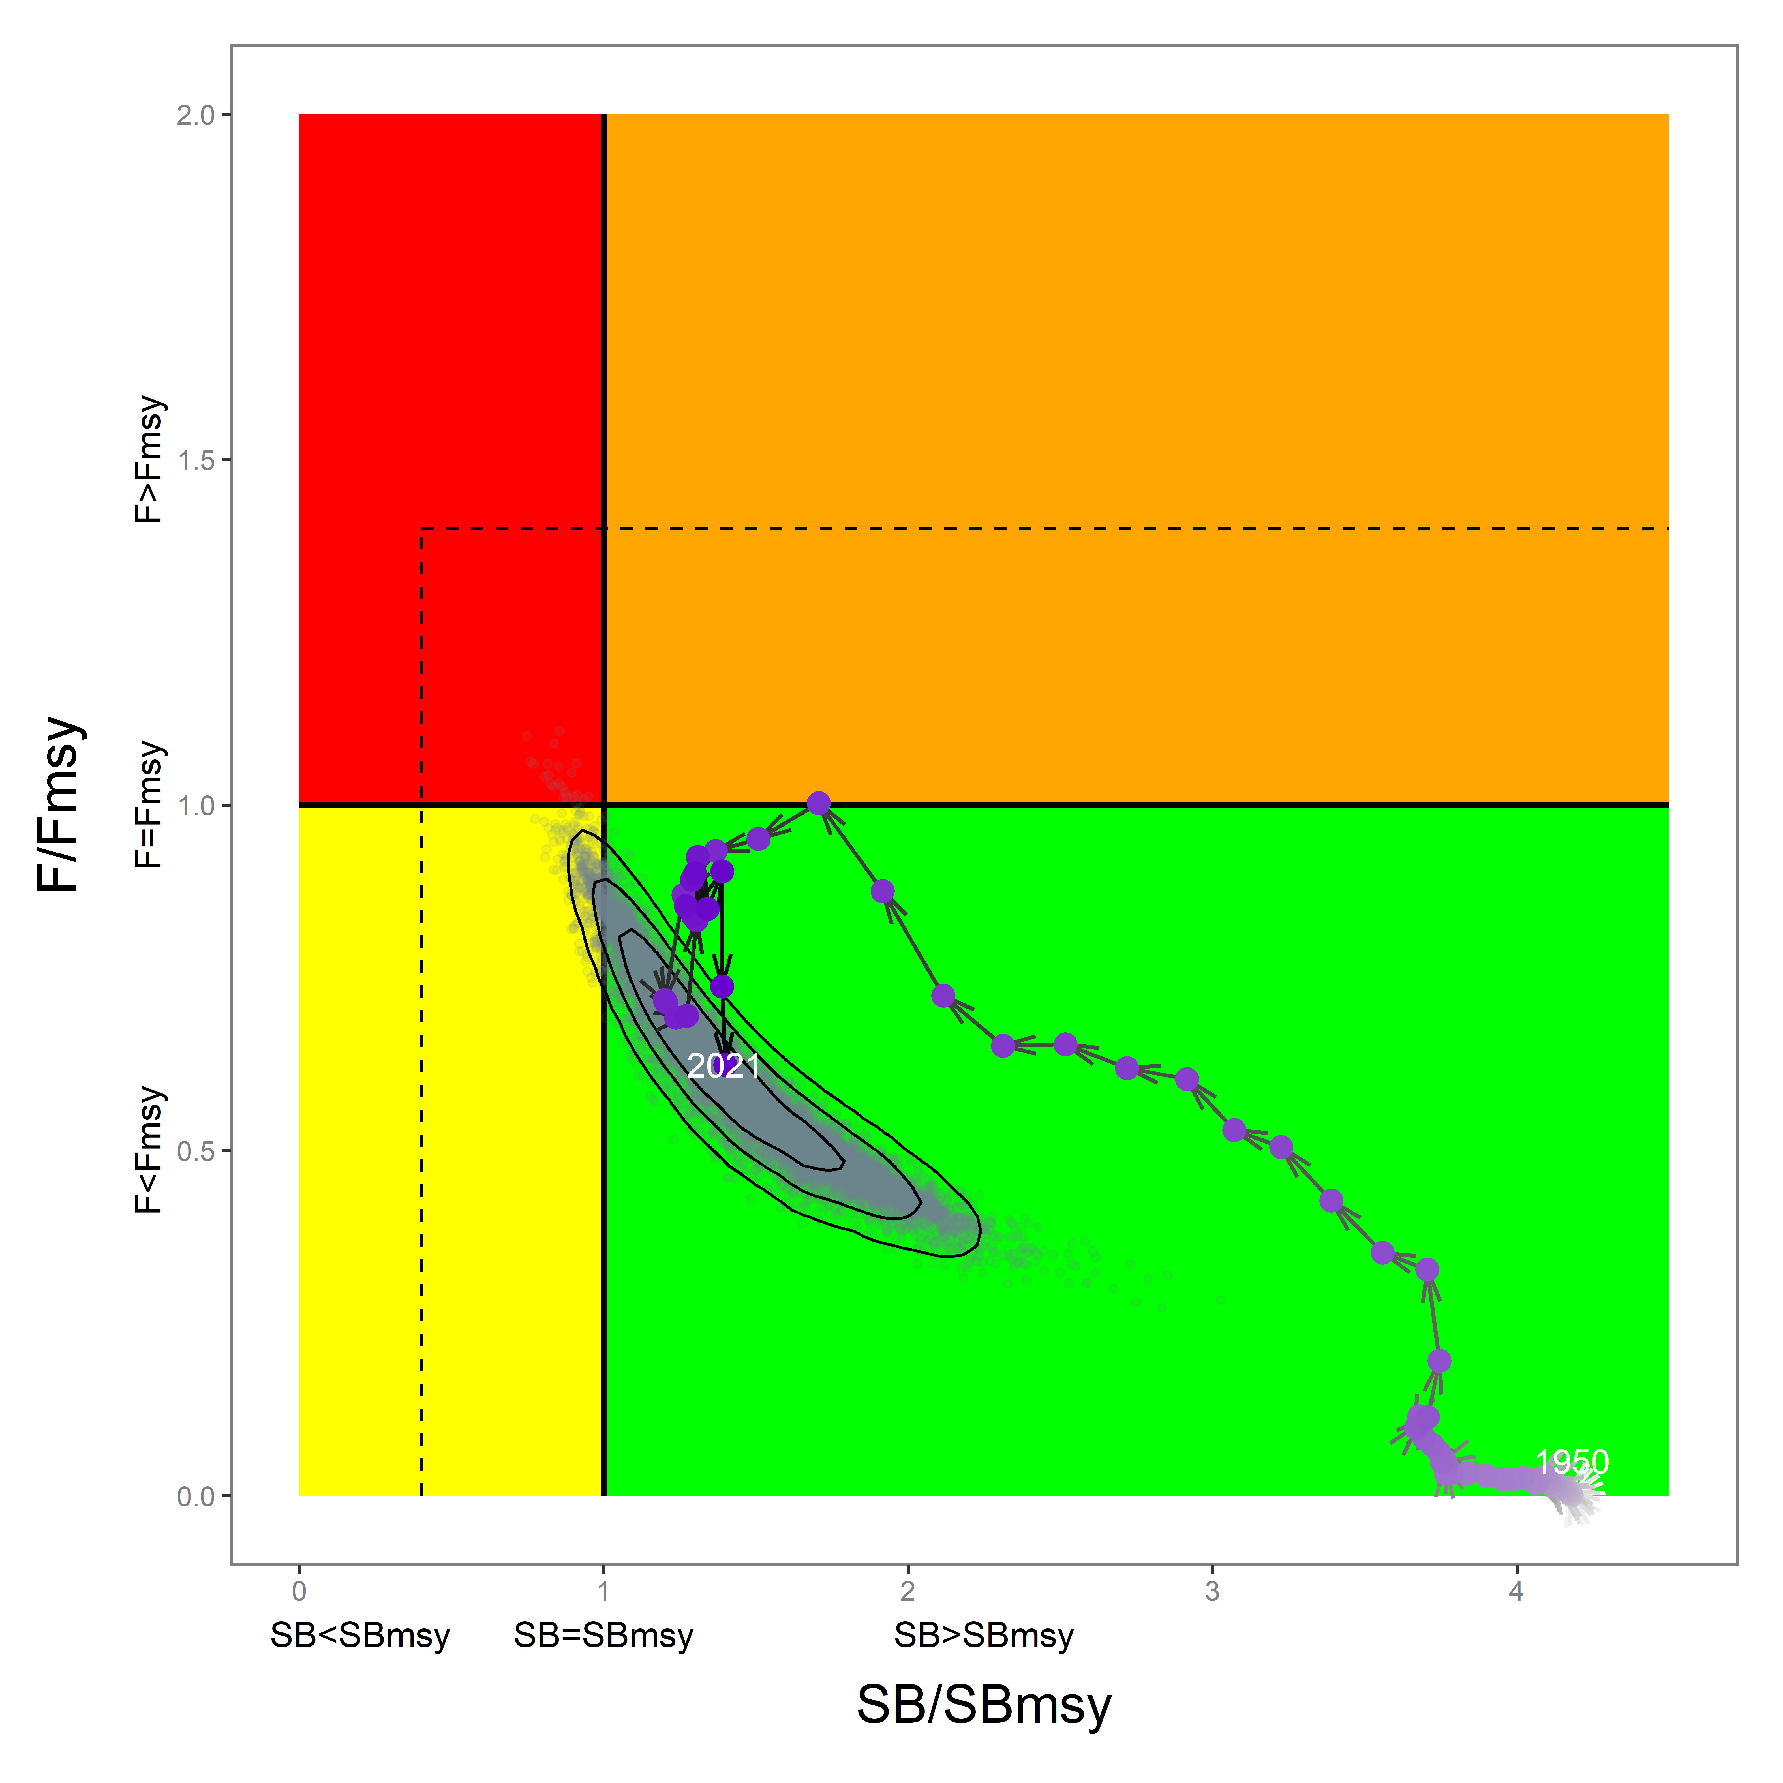

Fig. 3. Swordfish: 2021 stock status, relative to SB_{MSY} (x-axis) and F_{MSY} (y-axis) reference points for the final model grid. Grey dots represent uncertainty from individual models with 50%, 80% and 95% contours lines. The arrowed line represents the time series of stock trajectory from the reference model. The dashed lines represent limit reference points for Indian Ocean swordfish (SB_{lim} = 0.4 SB_{MSY} and F_{lim} = 1.4*FMSY)

Table 2. Swordfish: SS3 Indian Ocean assessment Kobe II Strategy Matrix. Probability (percentage) of violating the MSY-based target reference points for nine constant catch projections relative to the 2021 catch level (23 237 t)*, 0%, ± 20%, ± 40%) projected for 3 and 10 years.
Reference point and projection timeframe | Alternative catch projections (relative to the 2019 catch of 3,001 t)  and probability (%) of violating MSY-based target reference points (Btarg = B_{MSY}; Ftarg = F_{MSY})
 | 60%  (13 942 t) |  | 80%  (18 590 t) |  | 100%  (23 237 t) |  | 120%  (27 884 t) |  | 140%  (32 532 t)
B₂₀₂₄ < B_{MSY} | 0 |  | 0 |  | 1 |  | 1 |  | 2
F₂₀₂₄ > F_{MSY} | 0 |  | 0 |  | 0 |  | 5 |  | 24
B₂₀₃₁ < B_{MSY} | 0 |  | 0 |  | 0 |  | 3 |  | 15
F₂₀₃₁ > F_{MSY} | 0 |  | 0 |  | 0 |  | 8 |  | 30

Appendix V - [ Draft ] resource stock status summaries – Black marlin
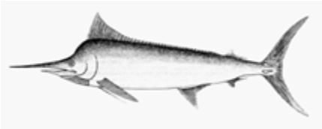

TABLE 1. Status of black marlin (Istiompax indica) in the Indian Ocean.

Area¹ | Indicators |  | 2024  stock status determination³
Indian Ocean | Catch 2023 (t)²  Average catch 2019–2023 (t) | 27,881  20,509 | 62.2%
Indian Ocean | MSY (1,000 t) (80% CI)  F_{MSY} (80% CI)  B_{MSY} (1,000 t) (80% CI)  F_{2022/}F_{MSY} (80% CI)  B_{2022/}B_{MSY} (80% CI)  B₂₀₂₂/B₀ (80% CI) | 13.90 (8.73 – 28.51)  0.21 (0.15 - 0.30)  65.23 (46.43-101.84)  1.39 (0.72 – 2.45)  1.35 (0.96 – 1.79)  0.49 (0.35 – 0.66) | 62.2%
¹ Boundaries for the Indian Ocean stock assessment are defined as the IOTC area of competence
² Proportion of 2023 catch fully or partially estimated by the IOTC Secretariat: 21.7%
³2020 is the final year that data were available for this assessment

Colour key | Stock overfished (B_{year}/B_{MSY}< 1) | Stock not overfished (B_{year}/B_{MSY}≥ 1)
Stock subject to overfishing (F_{year}/F_{MSY}> 1) | 12.5% | 62.2%
Stock not subject to overfishing (F_{year}/F_{MSY}≤ 1) | 0 | 25.3%
Not assessed/Uncertain/Unknown
Indian Ocean stock – Management Advice
Stock status. No new stock assessment was carried out for black marlin in 2025, thus, the stock status estimates are based on the stock assessment in 2024 using JABBA, a Bayesian state-space production model (using data up to 2022). The relative point estimates for this assessment are F/FMSY=1.39 (0.72-2.45) and B/BMSY=1.35 (0.96 -1.79). The Kobe plot indicated that the stock is currently not overfished but is subject overfishing (Table 1; Fig. 3). In 2022, the catch of black marlin surged to 26,320 tons. Until 2024, fish stock status was characterised as “uncertain” due to significant uncertainties in past assessments (like those from 2018 and 2021). These uncertainties were attributed to both historical catch reporting from key fishing state and poor assessment diagnostics. However, there's been progress recently with black marlin catch data, particularly from coastal countries in the northern Indian Ocean, and the latest JABBA assessment shows it's now more reliable (with improved model fitting to the abundance indices and acceptable level of retrospective patterns). The assessment relied on CPUE indices from longline fisheries in which the black marlin is a bycatch species. On the weight-of-evidence available in 2024, the stock status of black marlin is determined to be not overfished but subject to overfishing (Table 1; Fig. 3).
Outlook. While the recent high catches seem to be mainly due to developing coastal fisheries operating in the core habitat of the species (mainly IR.Iran, India and Sri Lanka), the CPUE indicators are from industrial fleets with lower catches of black marlin operating mostly offshore. There has been a substantial increase of catches of black marlin from coastal countries. The outlook is likely to remain uncertain in the absence of CPUE indices from gillnet and coastal longline fleets to inform stock assessment models. Moreover, catches remain substantially higher than the limits stipulated in Res 18/05 and are a cause for concern as this will likely continue to drive the population towards overfished status.
Management advice. The catch limits (9932 t) as stipulated in Resolution 18/05 have been exceeded for three consecutive years since 2020, which as per resolution 18/05, requires a review of the resolution. Furthermore, these limits are not based on estimates of most recent stock assessment. Thus, it is recommended that the Commission urgently revise 18/05 to incorporate limits that reflect the most recent stock assessment and projections and review and where necessary revise the implementation and effectiveness of the measures contained in this Resolution. The stock is now subject to overfishing. If the Commission wishes to recover the stock to the green quadrant of the Kobe plot with a probability ranging from 60% to 90% by 2026 as per Resolution 18/05, it needs to provide mechanisms to ensure the maximum annual catches remain less than 10 626 t (Table 3).
.
The following key points should be noted:
- Maximum Sustainable Yield (MSY): estimate for the whole Indian Ocean is 13,900 t.
- Provisional reference points: Although the Commission adopted reference points for swordfish in Resolution 15/10 on target and limit reference points and a decision framework, no such interim reference points nor harvest control rules have been established for black marlin.
- Main fisheries (mean annual catch 2018-2022): black marlin are caught using gillnet (63.3%), followed by line (25%) and longline (7%). The remaining catches taken with other gears contributed to 4.7% of the total catches in recent years (Fig. 1).
- Main fleets (mean annual catch 2018-2022): the majority of black marlin catches are attributed to flagged to I. R. Iran (42.7%) followed by India (19.4%) and Sri Lanka (12.2%). The 27 other fleets catching black marlin contributed to 25.4% of the total catch in recent years (Fig. 2).

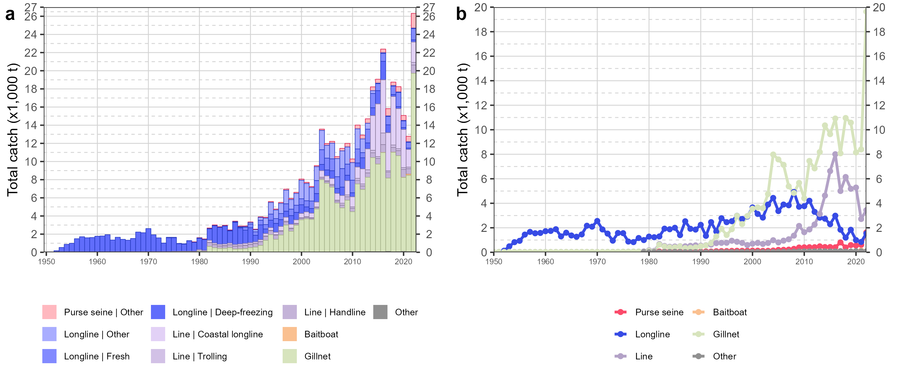

Fig. 1. Annual time series of (a) cumulative nominal catches (metric tons; t) by fishery and (b) individual nominal catches (metric tons; t) by fishery group for black marlin during 1950-2022. Longline | Other: swordfish and sharks-targeted longlines; Other: all remaining fishing gears

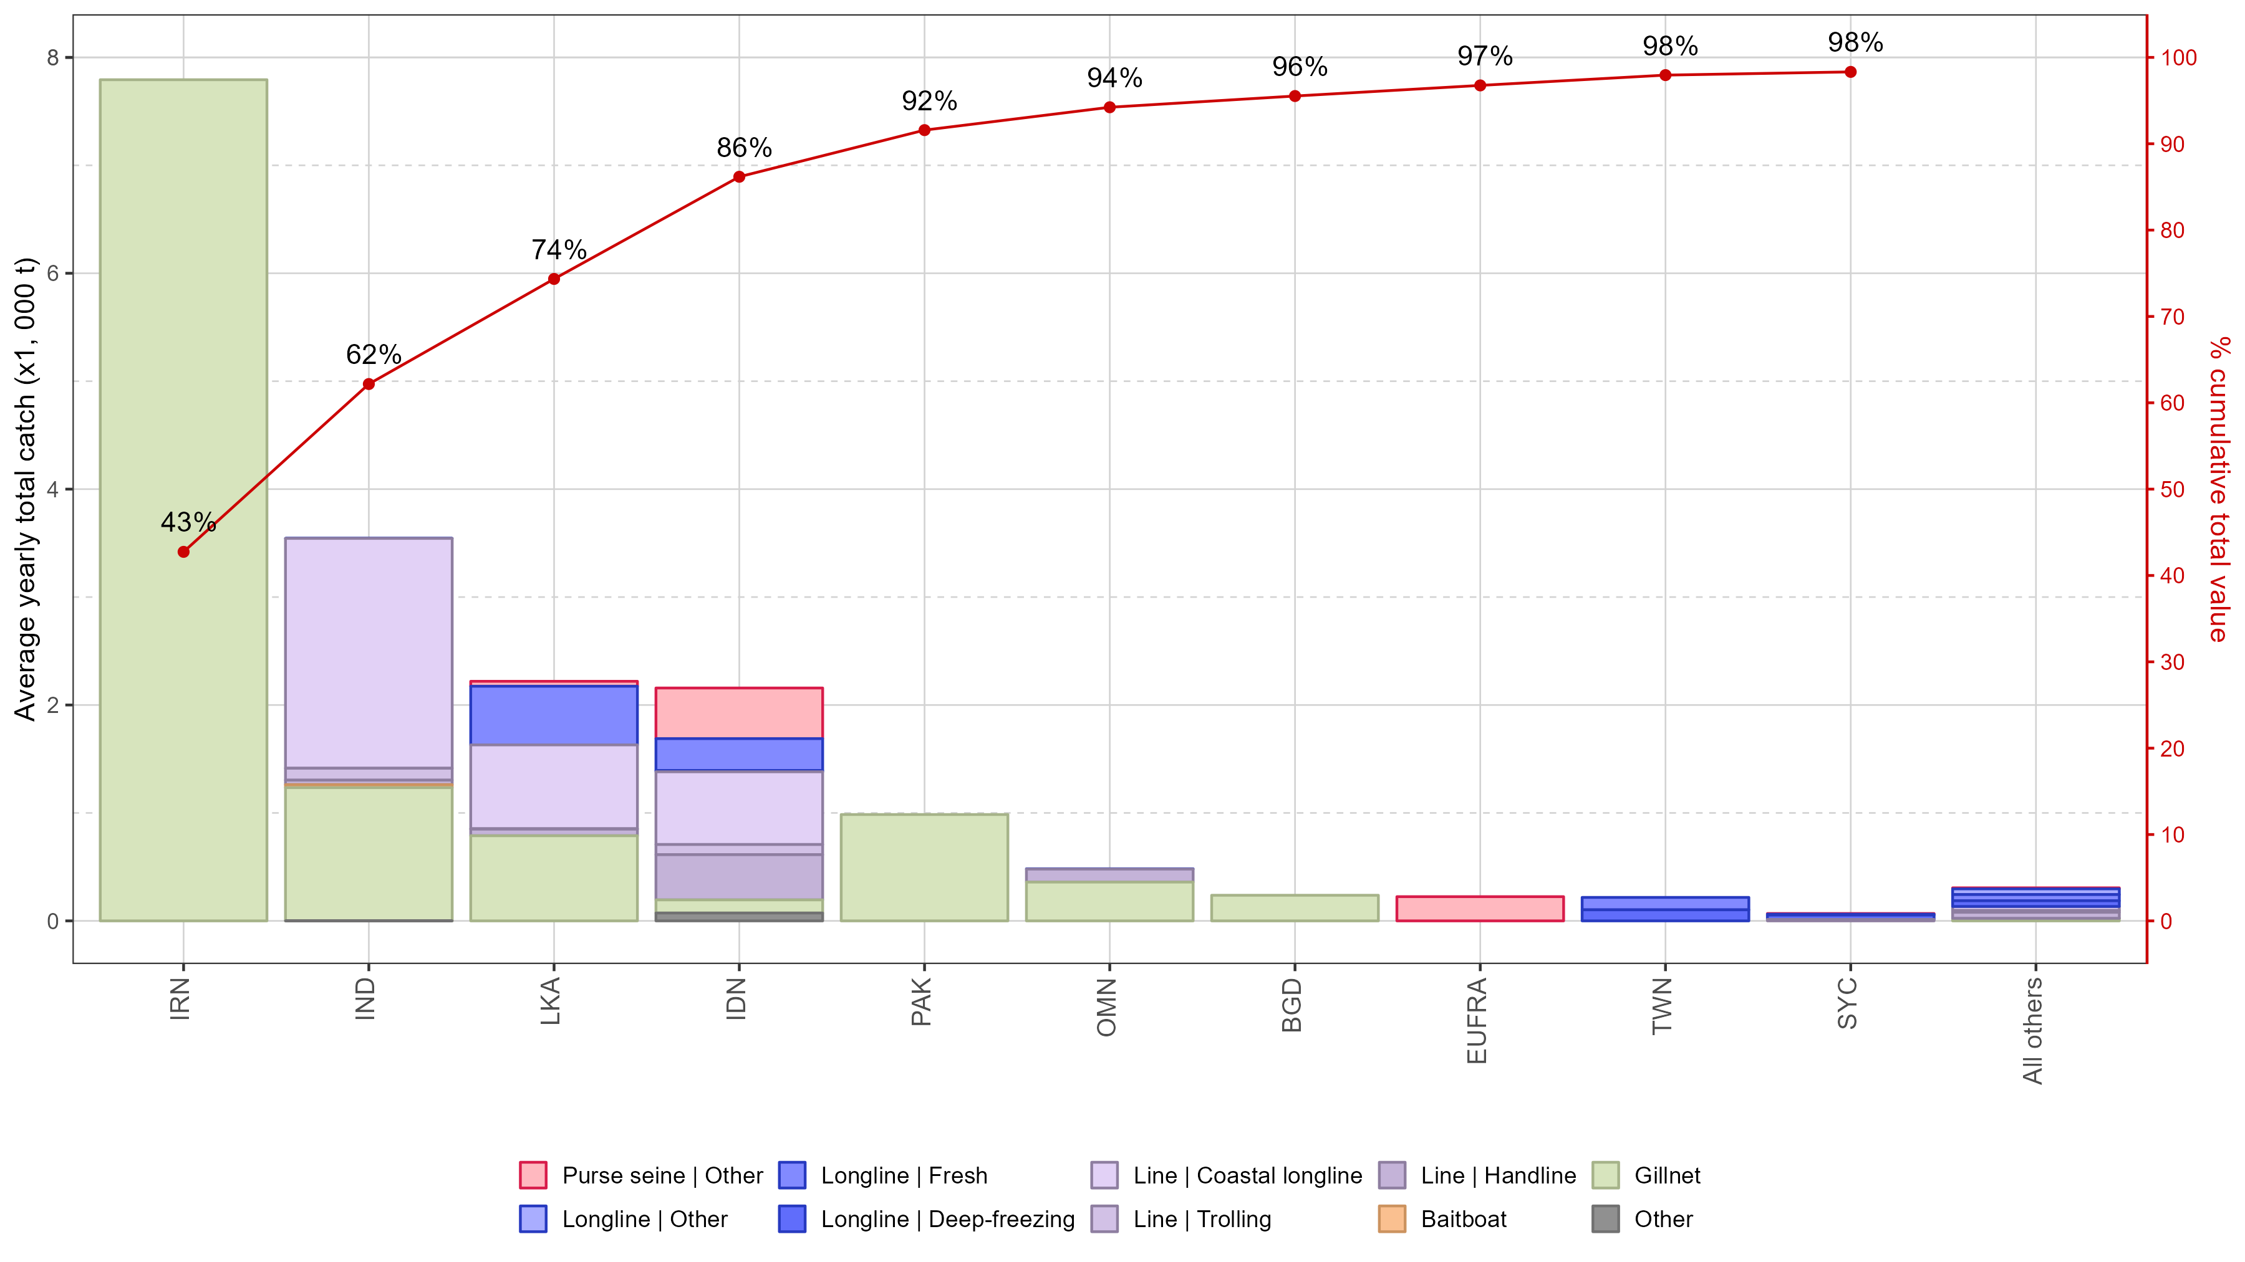

Fig. 2. Mean annual catches (metric tons; t) of black marlin by fleet and fishery between 2018 and 2022, with indication of cumulative catches by fleet. Longline | Other: swordfish and sharks-targeted longlines; Other: all remaining fishing gears

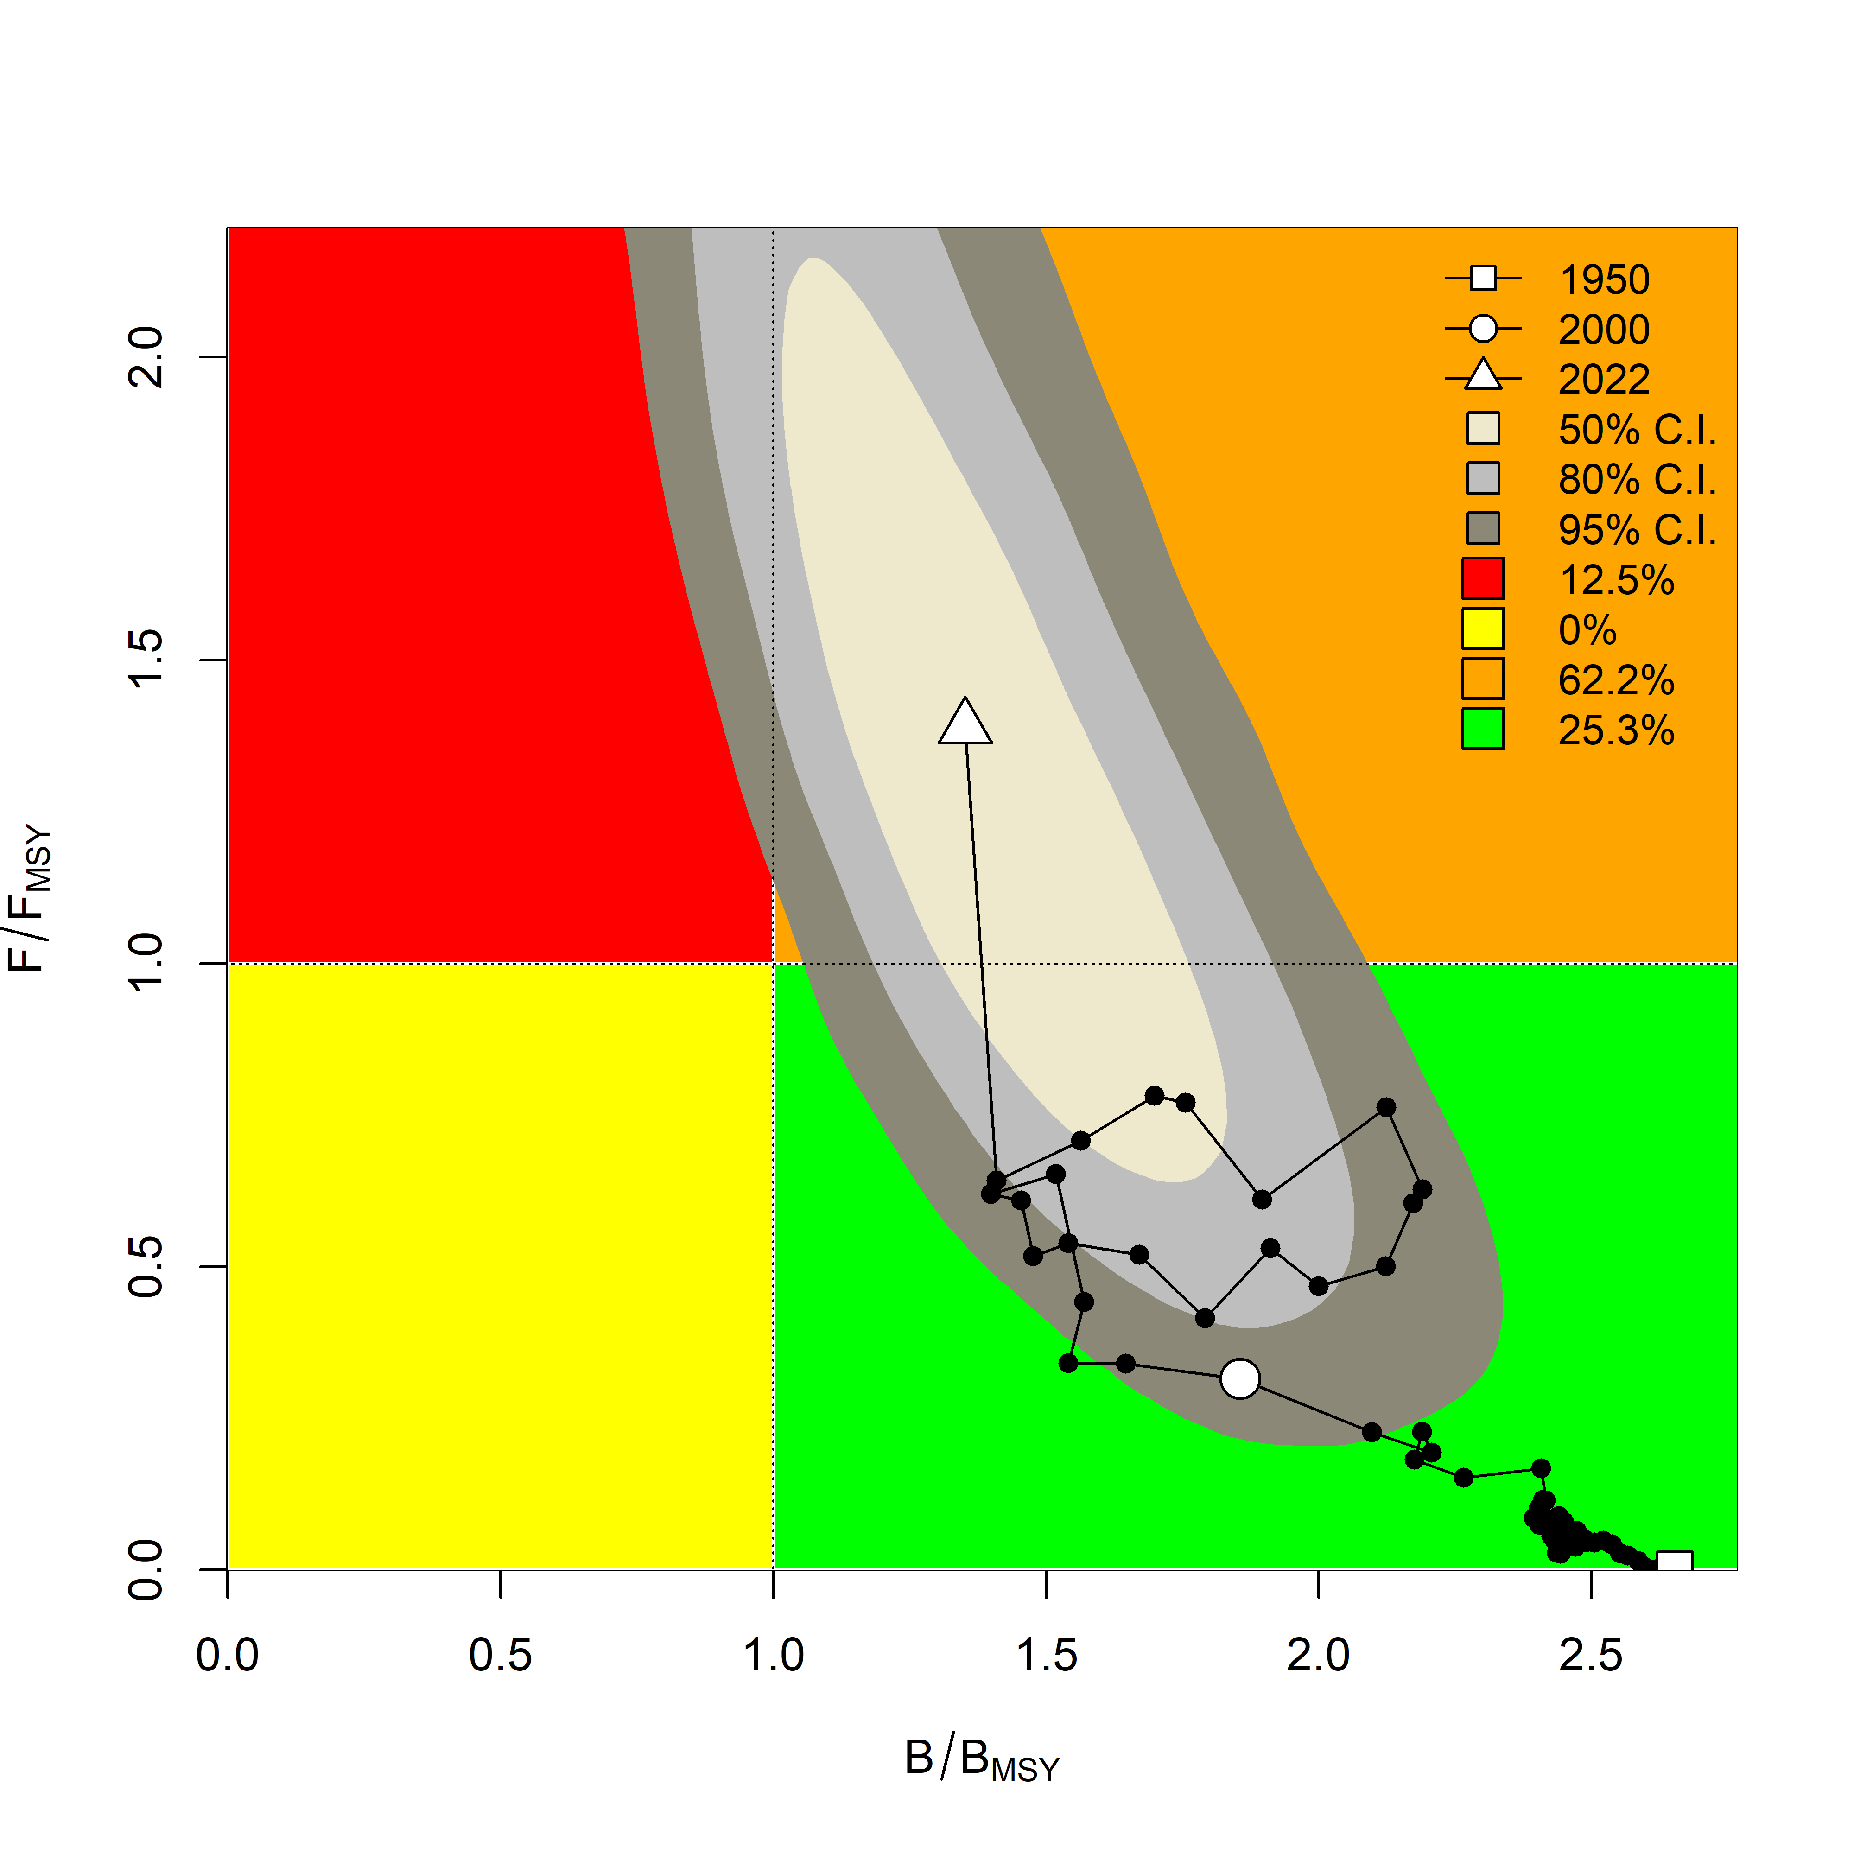

Fig. 3. JABBA Indian Ocean assessment Kobe plots for black marlin (contours are the 50, 80 and 95 percentiles of the 2022 estimate). Black line indicates the trajectory of the point estimates for the total biomass ratio (B/B_{MSY}) and fishing mortality ratio (F/F_{MSY}) for each year 1950–2022.
Table 2. Black marlin: JABBA Indian Ocean assessment Kobe II Strategy Matrix. Probability (percentage) of violating the MSY-based target reference points for nine constant catch projections relative to the average catch level of 2020 – 2022 (17710 t) * ± 20%, ± 40%,± 60%) projected for 3 and 10 years.
Reference point and projection timeframe | Alternative catch projections (relative to the average catch level of 2020–2022 of 17710 t)  and probability (%) of violating MSY-based target reference points (Btarg = B_{MSY}; Ftarg = F_{MSY})
 | 40%  (7084 t) | 60%  (10626 t) | 80%  (14168 t) | 100%  (17710 t) | 120%  (21252 t) | 140%  (24794 t) | 160%  (28336 t)
B₂₀₂₅ < B_{MSY} | 23 | 31 | 40 | 49 | 57 | 64 | 70
F₂₀₂₅ > F_{MSY} | 6 | 23 | 45 | 63 | 76 | 84 | 89
B₂₀₃₂ < B_{MSY} | 8 | 25 | 48 | 67 | 80 | 88 | 92
F₂₀₃₂ > F_{MSY} | 4 | 21 | 49 | 71 | 84 | 91 | 95

Table 3. Black marlin: Probability (percentage) of achieving the KOBE green quadrat from 2023-2032 for a range of constant catch projections (JABBA).

Catch (t)| Year | 2023 | 2024 | 2025 | 2026 | 2027 | 2028 | 2029 | 2030 | 2031 | 2032
7084 (40%) | 65 | 72 | 77 | 81 | 85 | 87 | 89 | 90 | 91 | 92
10626 (60%) | 63 | 66 | 68 | 70 | 71 | 72 | 73 | 74 | 74 | 75
14168 (80%) | 55 | 54 | 53 | 53 | 52 | 52 | 51 | 50 | 50 | 50
17710(100%) | 42 | 39 | 37 | 35 | 33 | 32 | 31 | 30 | 29 | 29
21252 (120%) | 30 | 27 | 24 | 22 | 21 | 19 | 18 | 17 | 17 | 16
24794 (140%) | 22 | 19 | 16 | 14 | 13 | 12 | 11 | 10 | 9 | 9
28336 (160%) | 16 | 13 | 11 | 9 | 8 | 7 | 7 | 6 | 6 | 5

Appendix VI - [ Draft ] resource stock status summaries – Blue marlin

Table 1. Status of blue marlin (Makaira nigricans) in the Indian Ocean
Area¹ | Indicators |  | 2022 stock status determination³
Indian Ocean | Catch 2023² (t)  Average catch 2019-2023 (t)  Average catch 2021-2023 (t) | 7,905  7,964  7,262 | 97.4%*
Indian Ocean | MSY (1,000 t) (80% CI)  F_{MSY} (80% CI)  B_{MSY} (1,000 t) (80% CI)  F₂₀₂₃/F_{MSY} (80% CI)  B₂₀₂₃/B_{MSY} (80% CI)  B₂₀₂₃/B₀ (80% CI) | 8.35 (7.52 –9.23)  0.30 (0.21 – 0.38)  27.92 (22.3 – 39.9)  1.54 (1.16 – 2.06)  0.62 (0.48 – 0.78)  0.23 (0.18 – 0.29) | 97.4%*
¹ Boundaries for the Indian Ocean are defined as the IOTC area of competence
² Proportion of 2023 catch estimated or partially estimated by IOTC Secretariat: 46%
³2023 is the final year that data were available for this assessment
* Estimated probability that the stock is in the respective quadrant of the Kobe plot (shown below), derived from the confidence intervals associated with the current stock status

Colour key | Stock overfished (B₂₀₂₃/B_{MSY}< 1) | Stock not overfished (B₂₀₂₃/B_{MSY}≥ 1)
Stock subject to overfishing (F₂₀₂₃/F_{MSY}> 1) | 97.4% | 0.2%
Stock not subject to overfishing (F₂₀₂₃/F_{MSY}≤ 1) | 2.1% | 0.4%
Not assessed/Uncertain/Unknown
The percentages are calculated as the proportion of model terminal values that fall within each quadrant with model weights accounted for
Indian Ocean stock – Management Advice
Stock status. A new stock assessment was carried out for blue marlin in 2025 using two different models: JABBA, a Bayesian state-space production model (age-aggregated); and SS3, an integrated model (age-structured) (using data up to 2023). Uncertainty in the biological parameters and the parameterisation of the SS3 model is still evident and as such the JABBA model (B2023/BMSY = 0.62, F2023/FMSY =1.54) was selected as the base case. Both models were consistent with regards to stock status, although the SS3 model was less pessimistic. On the weight-of-evidence available in 2025, the stock is determined to be overfished and subject to overfishing (Table 1 and Fig. 3).

Outlook. The B/B_{MSY} trajectory declined from the mid-1980s to 2007. A short-term increase in B/B_{MSY} occurred from 2007 to 2012, which is thought to be linked to the NW Indian Ocean Piracy period. Thereafter, the B/B_{MSY} trajectory again declines to the current estimate of 0.62. F/F_{MSY} increased since the mid-1980s and despite a recent decline, F/F_{MSY} remains above 1. The majority of CPUE indices have shown a declining trend since 2015, noting a recent increasing trend in CPUE indices in 2023.

Management advice. The current catches of blue marlin (average of 7,262 t in the last 3 years, 2021-2023) are lower than MSY (8,351 t). The stock is currently overfished and subject to overfishing, and according to the Kobe plot (Fig. 3), has been in this state since 2001 (with ~ 80 % CI). According to K2SM calculated (Table 2), a reduction of 20% of catches (5,809 t) compared to the mean of catches from 2021-2023 (7,262 t) would recover the stock to the green quadrant by 2035 with a probability of 64 % and if the catches are reduced by 40 % (4,357 t) the probability would be 86 %. The Commission should note that the current catch limit for blue marlin in Resolution 18/05 (11,930 t, which was established as the MSY value estimated in 2016 stock assessment) is 30 % more (3,579 t) than the new MSY estimated by the latest stock assessment in 2025 (8,351 t). Thus, it is recommended that the Commission urgently revise Resolution 18/05 to incorporate limits that reflect the most recent stock assessment and projections and review and strengthen the implementation and effectiveness of the measures contained in this Resolution.
The following key points should also be noted:
- Maximum Sustainable Yield (MSY): estimate for the Indian Ocean blue marlin stock in 2025 is 8,351 t (estimated range (80% C.I.) 7,516–9,232 t).
- Provisional reference points: although the Commission adopted reference points for swordfish in Resolution 15/10 on target and limit reference points and a decision framework, no such interim reference points, nor harvest control rules have been established for blue marlin.
- Main fisheries (mean annual catch 2019-2023): blue marlin are caught using longline (38.4%), followed by line (36.9%) and gillnet (19.5%). The remaining catches taken with other gears contributed to 5.2% of the total catches in recent years (Fig. 1).
- Main fleets (mean annual catch 2019-2023): the majority of blue marlin catches are attributed to vessels flagged to Sri Lanka (19.8%) followed by Taiwan,China (19.5%) and India (19%). The 26 other fleets catching blue marlin contributed to 41.8% of the total catch in recent years (Fig. 2).

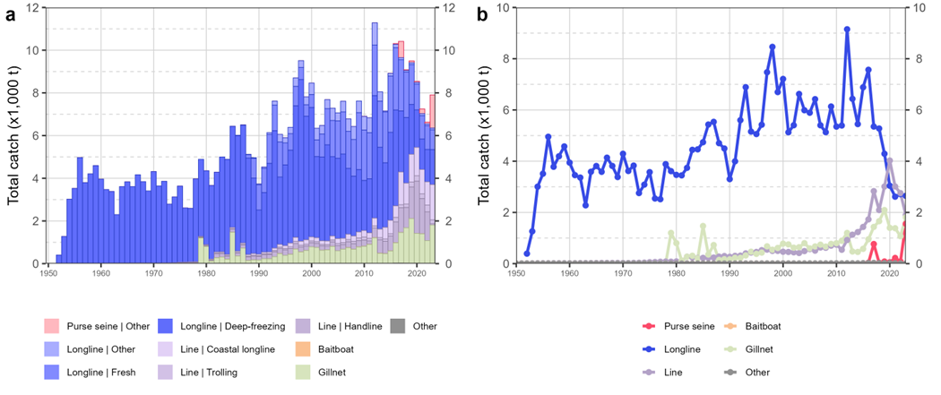

Fig. 1. Annual time series of (a) cumulative nominal catches (metric tons; t) by fishery and (b) individual nominal catches (metric tons; t) by fishery group for blue marlin during 1950-2023. Longline | Other: swordfish and sharks-targeted longlines; Other: all remaining fishing gears

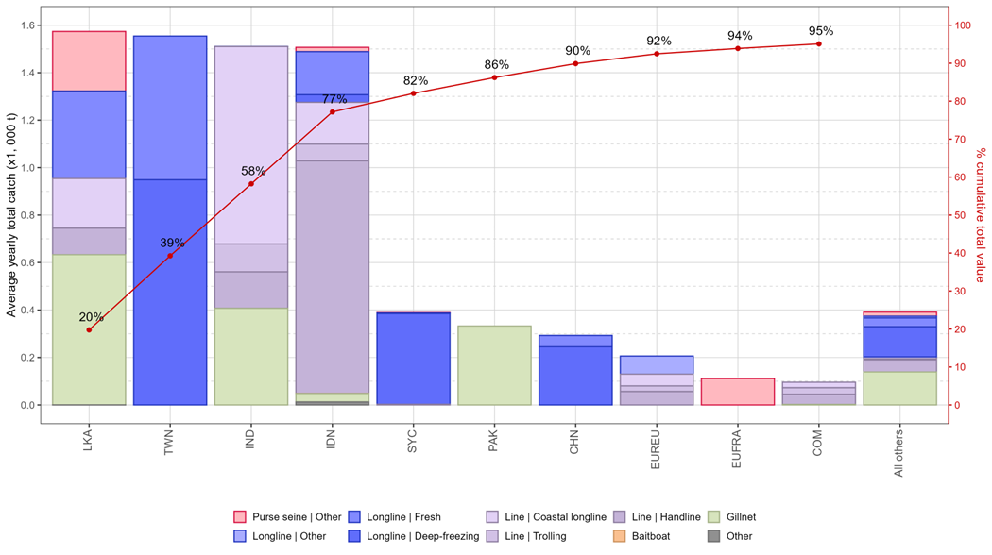
Fig. 2. Mean annual catches (metric tons; t) of blue marlin by fleet and fishery between 2019 and 2023, with indication of cumulative catches by fleet. Longline | Other: swordfish and sharks-targeted longlines; Other: all remaining fishing gears

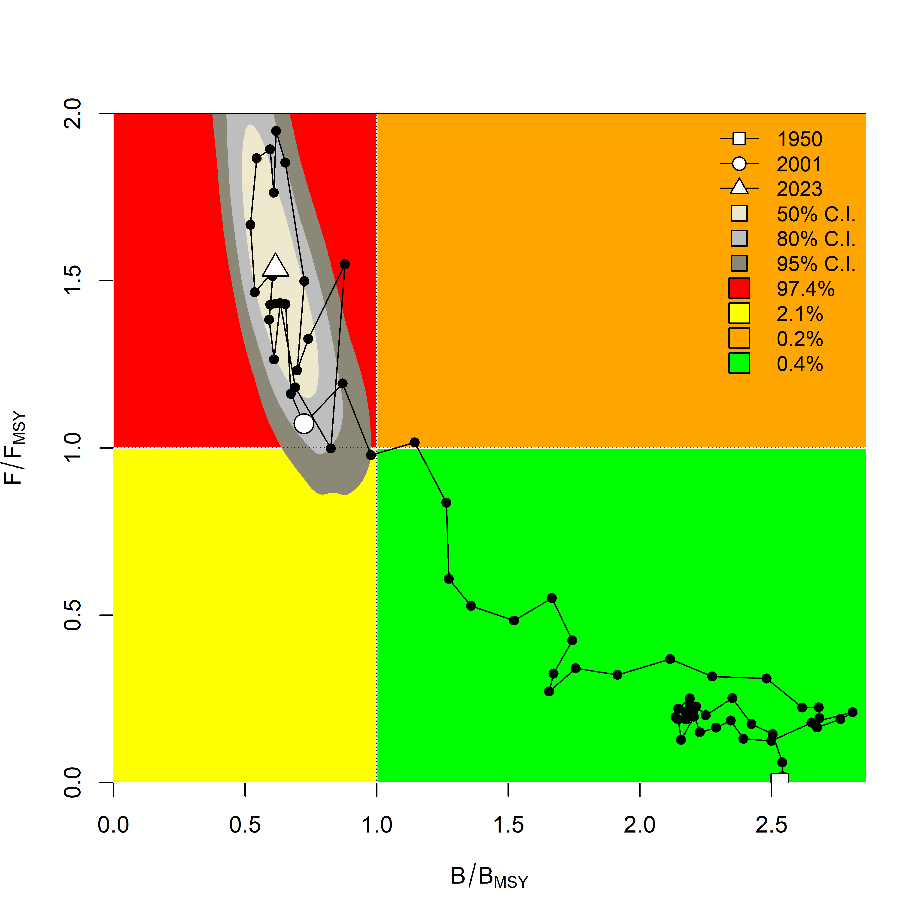
Fig. 3. JABBA Indian Ocean assessment Kobe plots for blue marlin (contours are the 50, 80 and 95 percentiles of the 2023 estimate). Black line indicates the trajectory of the point estimates for the total biomass ratio (B/BMSY) and fishing mortality ratio (F/FMSY) for each year 1950–2023

Table 2. Blue Marlin: Indian Ocean JABBA Kobe II Strategy Matrix. Probability (percentage) of achieving the green quadrant of the KOBE plot, for a range of constant catch projections (JABBA). Catch in 2024 and 2025 are fixed at 7,262 t
Catch (t)\Year | 2026 | 2027 | 2028 | 2029 | 2030 | 2031 | 2032 | 2033 | 2034 | 2035
4,357 (60%) | 10 | 22 | 35 | 48 | 59 | 67 | 74 | 80 | 83 | 86
5,083 (70%) | 10 | 20 | 31 | 41 | 50 | 58 | 64 | 69 | 73 | 77
5,809 (80%) | 10 | 18 | 26 | 34 | 41 | 47 | 53 | 57 | 61 | 64
6,536 (90%) | 10 | 16 | 22 | 27 | 33 | 37 | 41 | 44 | 47 | 50
7,262 (100%) | 10 | 14 | 18 | 22 | 25 | 27 | 30 | 32 | 34 | 35
7,988 (110%) | 10 | 12 | 15 | 16 | 18 | 19 | 20 | 21 | 22 | 22
8,714 (120%) | 8 | 9 | 11 | 11 | 12 | 12 | 12 | 13 | 12 | 12
9,440 (130%) | 6 | 6 | 6 | 7 | 6 | 6 | 6 | 6 | 6 | 6
10,167 (140%) | 4 | 4 | 4 | 4 | 3 | 3 | 3 | 3 | 3 | 2

Table 3. Blue marlin: JABBA Indian Ocean assessment Kobe II Strategy Matrix. Probability (percentage) of violating the MSY-based target reference points for nine constant catch projections relative to the average catch level from 2021 to 2023 (7,262 t)*, ± 10%, ± 20%, ± 30% ± 40%) projected for 3 and 10 years.

Reference point and projection timeframe | Alternative catch projections (relative to the average catch level from 2021 to 2023 of 7,262 t)  and probability (%) of violating MSY-based target reference points (Btarg = B_{MSY}; Ftarg = F_{MSY})
 | 60%  (4,357) | 70%  (5,083) | 80%  (5,809) | 90%  (6,536) | 100%  (7,262) | 110%  (7,988) | 120%  (8,714) | 130%  (9,440) | 140%  (10,167)
B₂₀₂₈ < B_{MSY} | 65 | 69 | 74 | 78 | 82 | 85 | 88 | 90 | 92
F₂₀₂₈ > F_{MSY} | 19 | 31 | 45 | 60 | 72 | 81 | 88 | 93 | 96
B₂₀₃₅ < B_{MSY} | 14 | 23 | 36 | 50 | 64 | 77 | 87 | 93 | 97
F₂₀₃₅ > F_{MSY} | 5 | 12 | 23 | 40 | 58 | 75 | 87 | 94 | 98

Appendix VII - [ Draft ] resource stock status summaries – Striped marlin

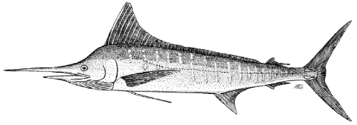

Table 1. Status of striped marlin (Kajikia audax) in the Indian Ocean
Area¹ | Indicators |  | 2024 stock status determination⁵
Indian Ocean | Catch 2023² (t)  Average catch 2019-2023 (t) | 3,556  3,017 | 100%*
Indian Ocean | MSY (1,000 t) (JABBA)  MSY (1,000 t) (SS3)  F_{MSY} (JABBA)  F_{MSY} (SS3)  F_{2022/}F_{MSY} (JABBA)  F_{2022/}F_{MSY} (SS3)  B_{2022/} B_{msy} (JABBA)  SB₂₀₂₂/SB_{MSY} (SS3)⁴  B₂₀₂₂/B₀(JABBA)  SB₂₀₂₂/SB₀ (SS3) | 4.73 (4.22 – 5.24)³  4.89 (4.48-5.30)  0.26 (0.20–0.35)  0.22 (0.21–0.24)  3.95 (2.54 - 6.14)  9.26 (5.38-13.14)  0.17 (0.11 - 0.27)  0.27 (0.19-0.35)  0.06 (0.04 – 0.10)  0.036 (0.03-0.04) | 100%*
¹ Boundaries for the Indian Ocean are defined as IOTC area of competence
² Proportion of 2022 catch estimated or partially estimated by IOTC Secretariat: 15.4%
³ Range estimates in the table are 80% confidence interval
⁴ SS3 is the only model that used SB/SB_{MSY}, all others used B/B_{MSY}
⁵2022 is the final year that data were available for this assessment
* Estimated probability that the stock is in the respective quadrant of the Kobe plot (shown below), derived from the confidence intervals associated with the current stock status

Colour key | Stock overfished (B_{year}/B_{MSY}< 1) | Stock not overfished (B_{year}/B_{MSY}≥ 1)
Stock subject to overfishing (F_{year}/F_{MSY}> 1) | 100% | 0.0%
Stock not subject to overfishing (F_{year}/F_{MSY}≤ 1) | 0.0% | 0.0%
Not assessed/Uncertain/Unknown
The percentages are calculated as the proportion of model terminal values that fall within each quadrant with model weights taken into account
Indian Ocean stock – Management Advice
Stock status. No new stock assessment was carried out for Striped marlin 2025, thus, the stock status estimates are based on two different assessment models carried out in 2024: JABBA, a Bayesian state-space production model (age-aggregated); and SS3, an integrated model (age-structured) (using data up to 2022). Both models were generally consistent with regards to stock status and confirmed the results from 2012, 2013, 2015, 2017, 2018, and 2021 assessments, indicating that the stock is subject to overfishing (F>F_{MSY}) and is overfished, with the biomass being below the level which would produce MSY (B<B_{MSY}) for over a decade. Both SS3 and JABBA assessments rely on CPUE indices from the longline fisheries in which the striped marlin are not the main target species. On the weight-of-evidence available in 2024, the stock status of striped marlin is determined to be overfished and subject to overfishing (Table 1; Fig. 3).

Outlook. Biomass estimates of the Indian Ocean striped marlin stock have likely been below BMSY since the late 90’s – the stock has been severely depleted (B/B₀ = 0.06; JABBA model). The level of depletion has increased since the previous assessment and is currently the worst among IOTC species. There has been a substantial increase of catches of stripe marlin from coastal fleets in recent years. The outlook is very pessimistic, and a substantial decrease in fishing mortality is required to ensure a reasonable chance of stock recovery in the foreseeable future (Table 2). It should be noted that point estimates from SS3 indicate that F_{curr}/F_{MSY} are much higher than those estimated by JABBA.

Management advice. Current or increasing catches have a very high risk of further decline in the stock status. The 2023 catches (3,553 t) were lower than the estimated MSY (4,730 t) but are above the limit set by Resolution 18/05 (3,260 t) which may be a concern if this trend continues. However, the limit is not based on estimates of the most recent stock assessment. Thus, it is recommended that the Commission urgently revise Resolution 18/05 to incorporate limits that reflect the most recent stock assessment and projections, and review, and where necessary, revise the implementation and effectiveness of the measures contained in this Resolution.
The stock has been overfished for more than a decade and is now in a highly depleted state. A 70% reduction in the recent average 2020-22 catch of 2,891 t (i.e. catch of 867 t) would recover the stock to the green quadrant by 2032 with a probability of 78% and a 60% reduction in recent average catch (i.e. catch of 1,157 t) would achieve this with a probability of 58%.

The following key points should also be noted:
- Maximum Sustainable Yield (MSY): estimates for the Indian Ocean stock are uncertain and estimates range between 4,220 - 5,240 t. However, the current biomass is well below the B_{MSY} reference point and fishing mortality is in excess of F_{MSY} at recent catch levels.
- Provisional reference points: although the Commission adopted reference points for swordfish in Resolution 15/10 on target and limit reference points and a decision framework, no such interim reference points have been established for striped marlin.
- Main fisheries (mean annual catch 2019-2023): striped marlin are caught using gillnet (74.1%), followed by longline (14.4%) and line (6.7%). The remaining catches taken with other gears contributed to 4.8% of the total catches in recent years (Fig. 1).
- Main fleets (mean annual catch 2019-2023): the majority of striped marlin catches are attributed to vessels flagged to I. R. Iran (35.1%) followed by Pakistan (26.8%) and Indonesia (16.4%). The 24 other fleets catching striped marlin contributed to 21.6% of the total catch in recent years (Fig. 2).

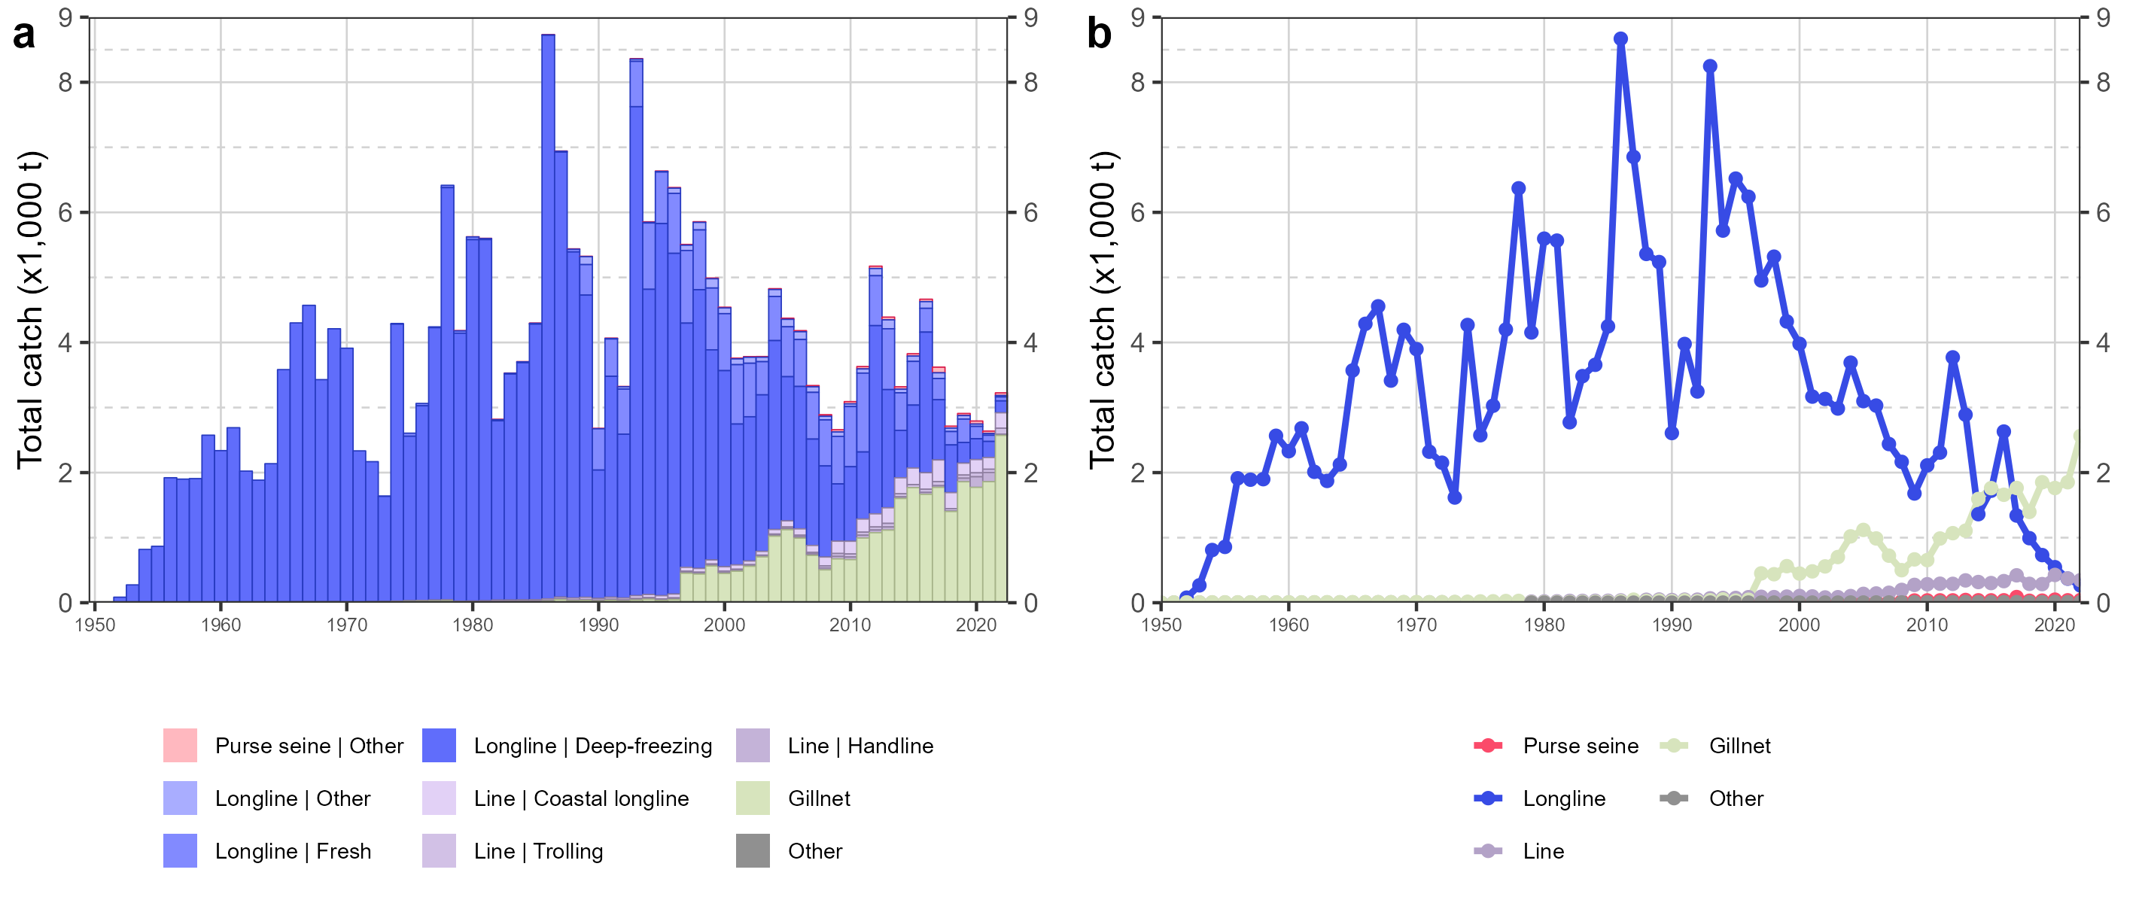
Fig. 1. Annual time series of (a) cumulative nominal catches (metric tons; t) by fishery and (b) individual nominal catches (metric tons; t) by fishery group for striped marlin during 1950-2022. Longline | Other: swordfish and sharks-targeted longlines; Other: all remaining fishing gears

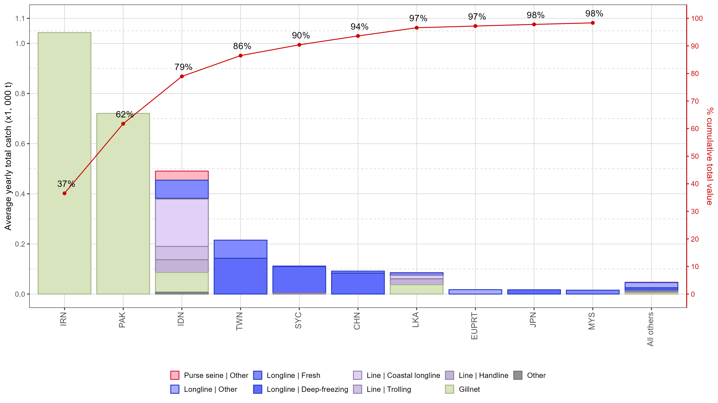

Fig. 2. Mean annual catches (metric tons; t) of striped marlin by fleet and fishery between 2018 and 2022, with indication of cumulative catches by fleet. Longline | Other: swordfish and sharks-targeted longlines; Other: all remaining fishing gears

(a) Stock status (JABBA and SS3 models)  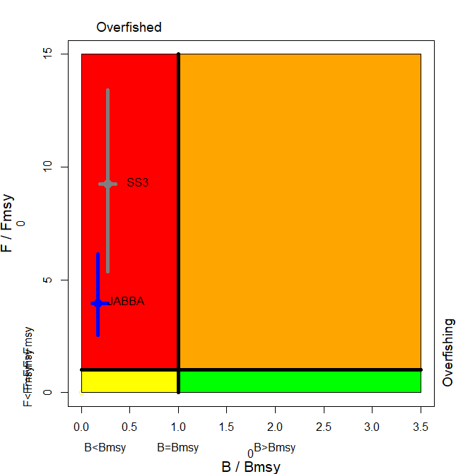 | (b) JABBA B/B_{MSY} and F/F_{MSY} trajectories  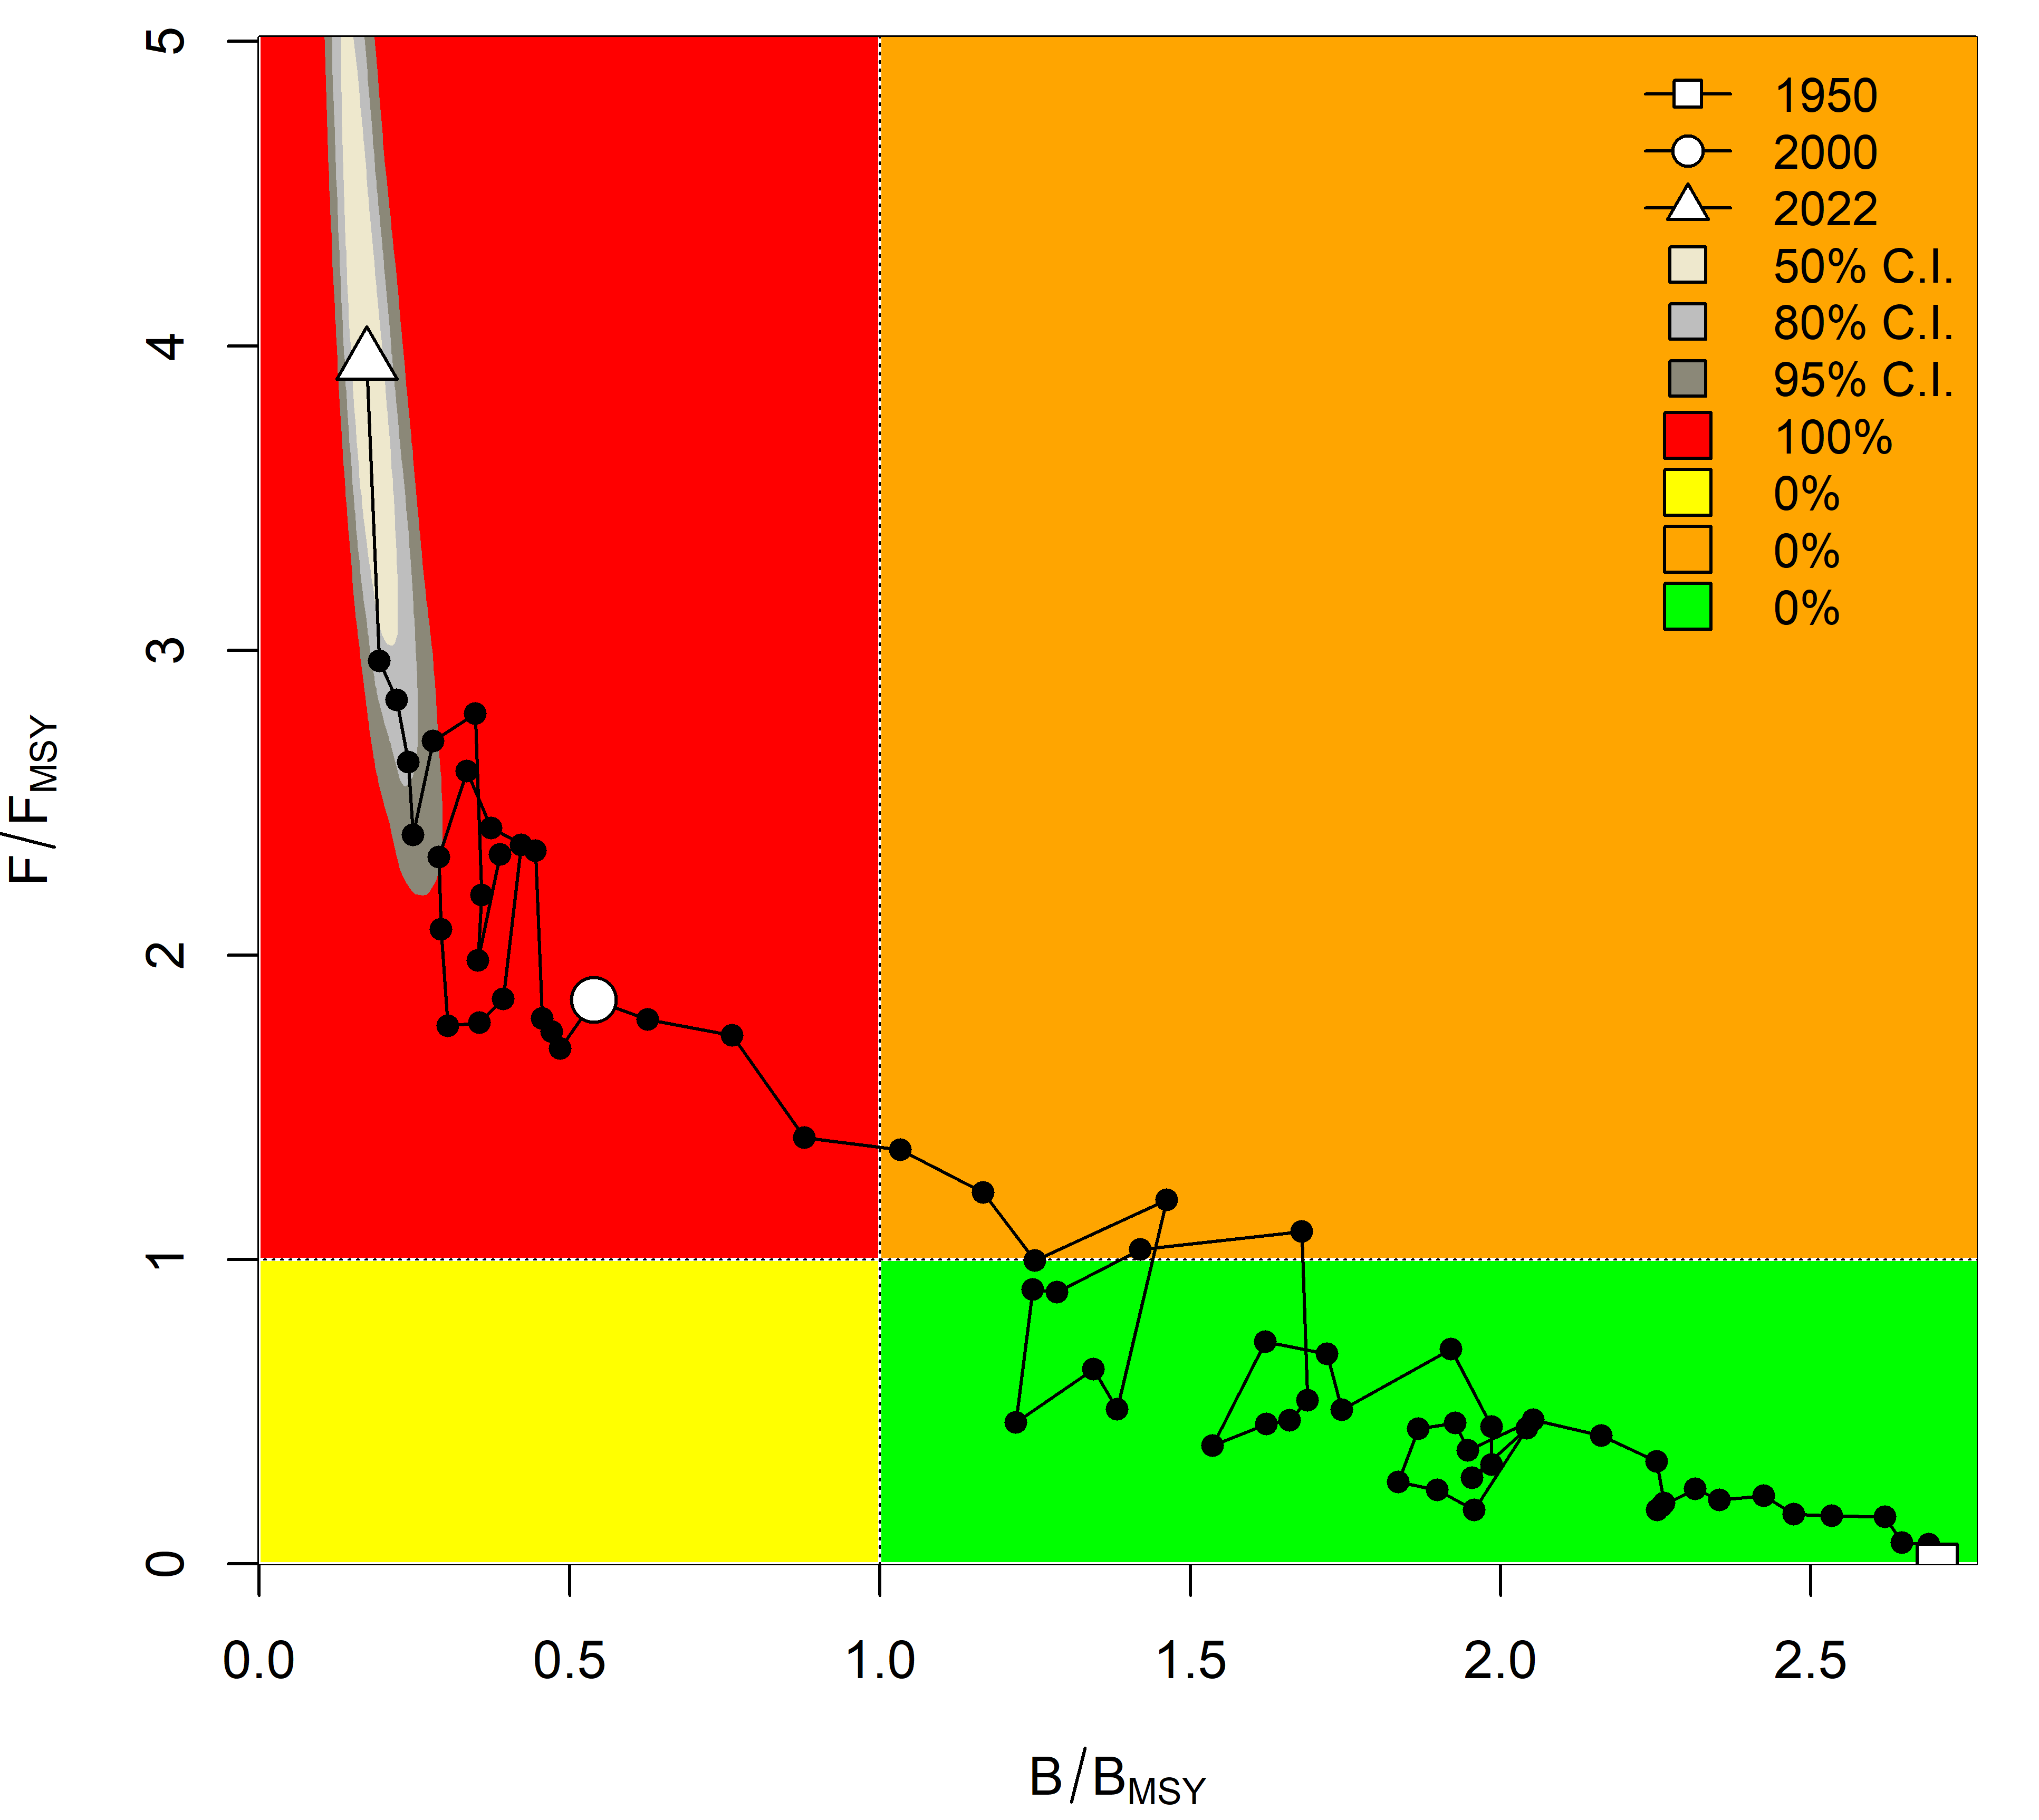
Fig. 3. (a) Striped marlin: Stock status from the Indian Ocean assessment JABBA (Bayesian State Space Surplus Production Model) and SS3 models with the confidence intervals (left); (b) Trajectories (1950-2022) of B/B_{MSY} and F/F_{MSY} from the JABBA model. NB: SS3 refers to SB/SB_{MSY} while the JABBA model’s output refers to B/B_{MSY}

Table 2. Striped marlin: JABBA Indian Ocean assessment Kobe II Strategy Matrix. Probability (percentage) of violating the MSY-based target reference points for nine constant catch projections relative to the average catch level of 2020–2022 (2891 t) (100%, 80%, then 70%–10% in decrement of 10%) projected for 3 and 10 years.
Reference point and projection timeframe | Alternative catch projections (relative to the 2020-2022 catch of 3,001 t)  and probability (%) of violating MSY-based target reference points (Btarg = B_{MSY}; Ftarg = F_{MSY})
 | 10%  (289 t) | 20%  (578 t) | 30%  (867 t) | 40%  (1157 t) | 50%  (1446 t) | 60%  (1735 t) | 70%  (2024 t) | 80%  (2313 t) | 100%  (2891 t)
B₂₀₂₅ < B_{MSY} | 100 | 100 | 100 | 100 | 100 | 100 | 100 | 100 | 100
F₂₀₂₅ > F_{MSY} | 3 | 12 | 35 | 66 | 88 | 97 | 99 | 100 | 100
B₂₀₃₂ < B_{MSY} | 3 | 9 | 22 | 42 | 64 | 83 | 93 | 98 | 100
F₂₀₃₂ > F_{MSY} | 0 | 4 | 8 | 18 | 35 | 57 | 78 | 91 | 99

Table 3. Striped marlin: Probability (percentage) of achieving the KOBE green quadrat from 2023-2032 for a range of constant catch projections (JABBA).

Catch (t)| Year | 2023 | 2024 | 2025 | 2026 | 2027 | 2028 | 2029 | 2030 | 2031 | 2032
289 (10%) | 0 | 0 | 0 | 0 | 7 | 31 | 63 | 84 | 94 | 97
578 (20%) | 0 | 0 | 0 | 0 | 3 | 17 | 44 | 68 | 84 | 91
867 (30%) | 0 | 0 | 0 | 0 | 1 | 8 | 26 | 48 | 66 | 78
1157 (40%) | 0 | 0 | 0 | 0 | 0 | 4 | 13 | 28 | 45 | 58
1446 (50%) | 0 | 0 | 0 | 0 | 0 | 1 | 5 | 13 | 25 | 36
1735 (60%) | 0 | 0 | 0 | 0 | 0 | 0 | 2 | 5 | 11 | 17
2024 (70%) | 0 | 0 | 0 | 0 | 0 | 0 | 1 | 2 | 4 | 7
2313 (80%) | 0 | 0 | 0 | 0 | 0 | 0 | 0 | 0 | 1 | 2
3470 (100%) | 0 | 0 | 0 | 0 | 0 | 0 | 0 | 0 | 0 | 0

Appendix VIII - [ Draft ] resource stock status summary – Indo-Pacific sailfish
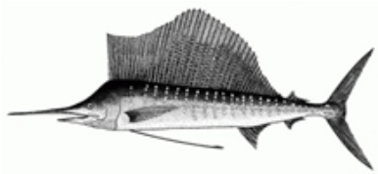

Table 1. Status of Indo-Pacific sailfish (Istiophorus platypterus) in the Indian Ocean
Area¹ | Indicators |  | 2025 stock status determination^{3,4}
Indian Ocean | Catch 2023² (t)  Average catch 2019-2023 (t) | 31,898  33,888 | 92.3 %
Indian Ocean | MSY (1,000 t) (80% CI)⁴  F_{MSY} (80% CI)⁴  SB_{MSY} (1,000 t) (80% CI)⁴  F_{2023/}F_{MSY} (80% CI)⁴  SB_{2023/}SB_{MSY} (80% CI)⁴  SB₂₀₂₃/SB₀ (80% CI)⁴ | 34.3 (28.7 - 42.2)  0.20 (0.17 - 0.23)  174 (145 - 212)  0.69 (0.51 - 0.94)  1.34 (1.15 - 1.53)  0.67 (0.58 - 0.76) | 92.3 %
¹ Boundaries for the Indian Ocean stock assessment are defined as the IOTC area of competence
² Proportion of 2023 catch estimated or partially estimated by IOTC Secretariat: 31 %
³2023 is the final year that data were available for this assessment
⁴These figures are outputs from the 2025 stock assessment and are not endorsed for management advice. Please see the section on management advice for further explanations on these estimates.

Colour key | Stock overfished (B_{year}/B_{MSY}< 1) | Stock not overfished (B_{year}/B_{MSY}≥ 1)
Stock subject to overfishing (F₂₀₂₃/F_{MSY}> 1) | 2 % | 6 %
Stock not subject to overfishing (F₂₀₂₃/F_{MSY}≤ 1) | 0 % | 92 %
Not assessed/Uncertain/Unknown
The percentages are calculated as the proportion of model terminal values that fall within each quadrant with model weights accounted for

Indian Ocean stock – Management Advice
Stock status. A new iteration of a Bayesian state-space production model (age-aggregated) JABBA stock assessment was carried out for Indo-Pacific Sailfish in 2025, using data up to 2023. Prior to this, in 2015 and 2019, data poor methods (Catch-MSY) were utilised to provide stock status for Indo-Pacific sailfish. These methods rely on catch data only, which is highly uncertain for this species, and resulted in an undefined stock status.

To overcome the lack of standardised CPUE indices or alternative abundance indices for this species, this assessment followed the methods of the previous assessment in 2022 where length-frequency data were used to estimate the annual Spawning Potential Ratio (SPR) using the length-based spawning potential ratio (LBSPR) method. Annual estimates of SPR were then normalised in the JARA (Just Another Red List Assessment) model to provide an index that was assumed to be proportional to spawning biomass. This index was then incorporated as an index of relative abundance in a JABBA model.

This is a novel technique applied to overcome the paucity of abundance data for Indo-Pacific sailfish and it had not been thoroughly tested with rigorous simulation-evaluation. This method has key assumptions that raised concerns within members of the WPB23. These three equilibrium assumptions that are likely to be violated are: 1) annual recruitment is assumed to be constant over time without directional trends; 2) length-frequency data used to derive the SPR trends is representative of the population; 3) selectivity is non-varying, and follows a logistic form.

The previous iteration of the Indo-Pacific sailfish assessment also noted the same concerns, and it was agreed by the SC in 2022 that the methodology of converting the length data into an index of relative abundance required further review. At the time of the assessment in 2025, there was uncertainty regarding how much the current assessment results are impacted by the violation of the assumptions listed above. It was discussed that it was possible that if assumptions are violated, the index of abundance could be showing trends that are diametrically opposed to the true population trend. It was recommended by the WPB23 that the extent of the potential bias must be evaluated with a simulation study which will inform whether this index is acceptable for use in the Indo-Pacific sailfish stock assessment.

The results of the LBSPR portion of the assessment indicate that there has been a 45.5 % decline in SPR since 1970. The latest (2023) estimate of B/B_{MSY} was 1.34, while the F/F_{MSY} estimate was 0.69. Additionally, concern was raised regarding the high levels of current catches (31,898 t in 2023), that are above the previous MSY estimate of 25,905 t, and close to the current, higher estimate of MSY of 34,300 t.

On the weight-of-evidence available in 2025, the stock status of Indo-Pacific sailfish is determined to be not overfished nor subject to overfishing (Table 1; Fig. 3).

Outlook. Catches have exceeded the estimated MSY since 2013 and the current catches (average of 33,888 t in the last 5 years, 2019-2023) are substantially higher than the previous MSY estimate of 25,905 t, and close to the current MSY estimate of 34,300 t. This increase in coastal gillnet and longline catches and fishing effort in recent years is a substantial cause for concern for the Indian Ocean stock, however there is not sufficient information to evaluate the effect this will have on the resource. It is also noted that the 2020-2024 catches exceed the catch limit prescribed in Resolution 18/05 (25,000 t).

Management advice. Considerable uncertainty remains in the JABBA assessment conducted in 2025, however the trends in key model outputs align relatively well with the 2022 assessment. For this year, due to the uncertainty in the model outputs, the management advice from 2022 would be carried over for one year (1 year) to allow time to complete the simulation studies and provide updated management advice in 2026. It is anticipated that, once the underlying uncertainty in the JABBA assessment is understood and presented at the proposed WPB meeting next year, management advice can be updated.

The catch limits as stipulated in Resolution 18/05 have been exceeded since 2020, which as per resolution 18/05, requires a review of the resolution. Furthermore, these limits are not based on estimates of most recent stock assessment. It is recommended that the Commission review the implementation and effectiveness of the measures contained in this Resolution and consider the adoption of additional conservation and management measures. The Commission should provide mechanisms to ensure that catch limits are not exceeded by all concerned fisheries. Research emphasis on further developing possible CPUE indicators from coastal gillnet and longline fisheries, and further exploration of stock assessment approaches for data poor fisheries are warranted. Given the limited data being reported for coastal fisheries, and the importance of sports fisheries for this species, efforts must be made to rectify these information gaps.
The following key points should also be noted:
- Maximum Sustainable Yield (MSY): estimate for the Indian Ocean stock is 34,300 t. As mentioned in the paragraph above and in the table at the start of the document (Table 1), MSY and associated stock assessment outputs are not to be used for management advice. This includes the Kobe plot, and these values (including the Kobe plot) may be updated in 2026 after the simulation study has been completed.
- Provisional reference points: although the Commission adopted reference points for swordfish in Resolution 15/10 on target and limit reference points and a decision framework, no such interim reference points have been established for Indo-Pacific sailfish.
- Main fisheries (mean annual catch 2019-2023): Indo-Pacific sailfish are caught using gillnet (69.6%), followed by line (26.4%) and longline (2.4%). The remaining catches taken with other gears contributed to 1.6% of the total catches in recent years (Fig. 1).
- Main fleets (mean annual catch 2019-2023): most Indo-Pacific sailfish catches are attributed to vessels flagged to I. R. Iran (41.7%) followed by India (20.2%) and Indonesia (8.7%). The 33 other fleets catching Indo-Pacific sailfish contributed to 29.1% of the total catch in recent years (Fig. 2).

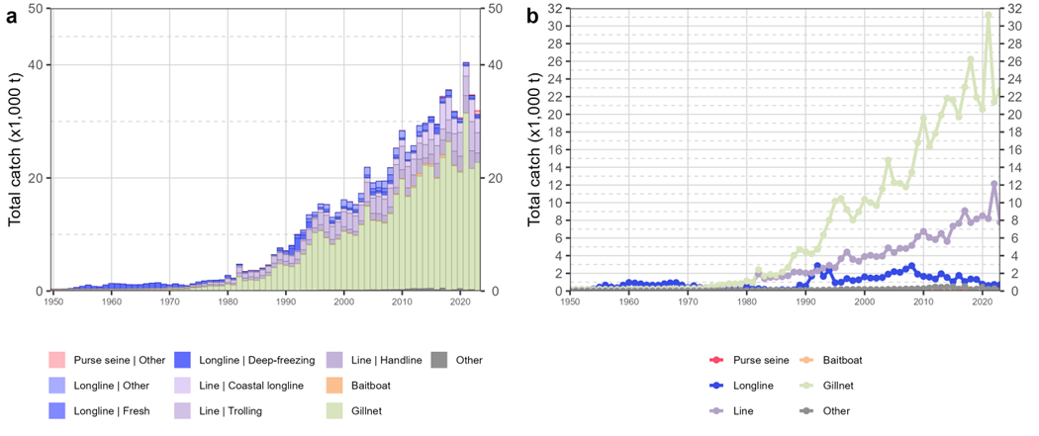

Fig. 1. Annual time series of (a) cumulative nominal catches (metric tons; t) by fishery and (b) individual nominal catches (metric tons; t) by fishery group for Indo-Pacific sailfish during 1950-2023. Longline | Other: swordfish and sharks-targeted longlines; Other: all remaining fishing gears

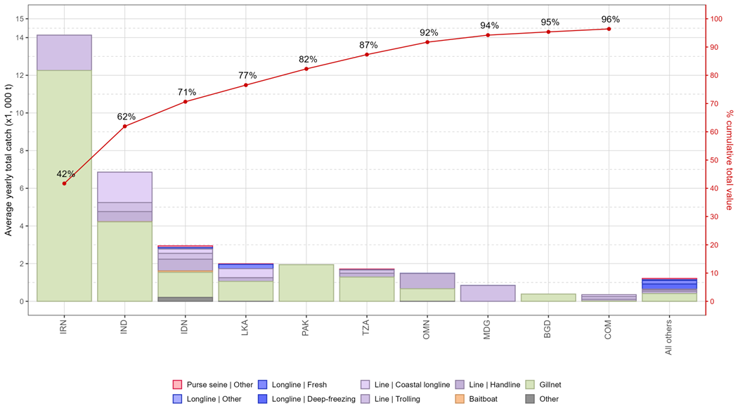
Fig. 2. Mean annual catches (metric tons; t) of Indo-Pacific sailfish by fleet and fishery between 2019 and 2023, with indication of cumulative catches by fleet. Longline | Other: swordfish and sharks-targeted longlines; Other: all remaining fishing gears

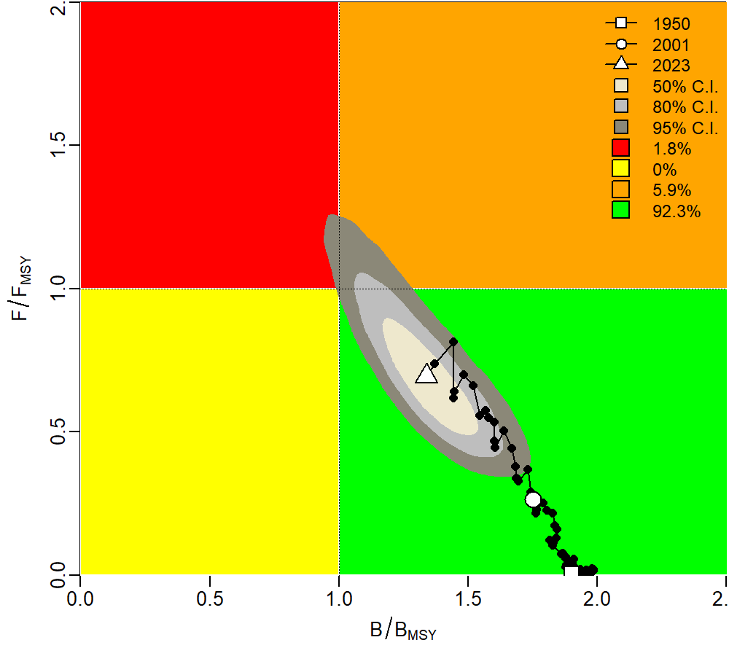
Fig.3: Kobe plot showing estimated trajectories (1950-2023) of B/B_{MSY} and F/F_{MSY} for JABBA model of Indian Ocean IP sailfish. Different grey shaded areas denote the 50%, 80%, and 95% credibility interval for the terminal assessment year. The probability of terminal year points falling within each quadrant is indicated in the figure legend.

Appendix IX drafted Guidelines for Longline CPUE Standardization
1. Data Selection
- Choose appropriate data sources (e.g., logbook data, observer data, or other relevant datasets).

2. Exploratory Data Analysis
Analyze and visualize:
- Catch data (weight and number)
- Effort data (number of hooks, number of operations, number of sets, etc.)
- Nominal CPUE
- Proportion of zero-catch records
2.1 Temporal Variation
- Year, month, season
2.2 Spatio-temporal Variation
- Area, latitude, longitude, spatial resolution (e.g., 1°×1°, 2°×2°, etc.)
2.3 Gear Effects
- Number of hooks between floats (HBF), hook types, leader materials, branch line length, bait type, etc.
2.4 Vessel Effects
- Vessel size, vessel type, etc.
2.5 Environmental Effects
- Sea surface temperature, chlorophyll concentration, depth, El Niño, etc.
2.6 Interaction Effects
- Year × area, year × gear, etc.
2.7 Other Factors
- Lunar phase, changes in target species, etc.
2.8 Multicollinearity Assessment
- Variance Inflation Factor (VIF < 5), correlation coefficients, etc.
2.9 Data Filtering
Remove data that are not relevant to the target species, such as:
- Records from unsuitable sea surface temperature ranges
- Records where the catch of the target species is missing (NA)
- Vessels that did not catch the target species at all during a trip
- When using HBF, include only data within an appropriate range (e.g., 3–25)
2.10 Time-blocking
- Define time blocks to account for changes in data quality or major shifts in fishing patterns.

3. Model Selection Based on Data Quality and Quantity
3.1 When Zero-catch Proportion is High
- Use zero-inflated models, hurdle models, or delta two-step models (e.g., binomial model + continuous model)
3.2 For Catch Weight
- Use continuous distributions (e.g., lognormal, gamma, Tweedie)
3.3 For Catch Count
- Use discrete distributions (e.g., Poisson, negative binomial)
3.4 Estimation Approach
- Choose between frequentist or Bayesian approach
3.5 Model Selection Criteria
- Use information criteria (AIC, BIC, DIC, WAIC) or cross-validation (K-fold, leave-one-out)

4. Model Diagnostics
4.1 Convergence Check
- Frequentist: max gradient, positive definiteness of Hessian matrix
- Bayesian: trace plots, R-hat (Gelman-Rubin statistic)
4.2 Residual Diagnostics
- Residual plots, autocorrelation, normality checks
4.3 Goodness-of-fit
- AIC, BIC, DIC, WAIC, R² or pseudo-R², log-likelihood
4.4 Predictive Performance
- Cross-validation
4.5 Prediction Error
- RMSE (Root Mean Square Error), MAE (Mean Absolute Error)
4.6 Model Robustness and Sensitivity Analysis
- Parameter sensitivity (effect of explanatory variables)
- Subset analysis (e.g., by region)
4.7 Diagnostics for Spatio-temporal Models
- Spatial autocorrelation (e.g., Moran’s I)
- Spatial residual plots
- Visualization of spatial random effects
- Temporal trend analysis

5. Confidence Intervals and Uncertainty Estimation
5.1 Confidence Intervals for Parameter Estimates
- Based on standard errors
5.2 Prediction Intervals
- Use predict() function with standard errors; calculate 95% intervals as ±1.96 × SE
5.3 Bootstrap
- Resample data and re-estimate the model multiple times
5.4 Bayesian Inference
- Use posterior distributions to derive credible intervals

Future Work
- Provide multiple examples using actual data with corresponding R code.

Appendix X Working Party on Billfish Program of Work (2026–2030)
The Program of Work consists of the following, noting that a timeline for implementation would be developed by the SC once it has agreed to the priority projects across all of its Working Parties:
- Table 1: High priority topics for obtaining the information necessary to develop stock status indicators for billfish in the Indian Ocean; and
- Table 2: Stock assessment schedule.
Table 1. Priority topics for obtaining the information necessary to develop stock status indicators for billfish in the Indian Ocean
Topic in order of priority | Sub-topic and project | Timing
Topic in order of priority | Sub-topic and project | 2026 | 2027 | 2028 | 2029 | 2030
CPUE standardization | Develop and/or revise standardized CPUE series for each billfish species and major fisheries/fleets in the Indian Ocean and develop Joint CPUE series where feasible
CPUE standardization | - Swordfish: Priority LL fleets: Taiwan,China, EU(Spain, Portugal, France), Japan, Indonesia, South African
CPUE standardization | - Striped marlin: Priority fleets: Japan, Taiwan,China
CPUE standardization | - Black marlin: Priority fleets: Longline: Taiwan,China; Potential fleets (Gillnet: I.R. Iran, Sri Lanka, Indonesia)
CPUE standardization | - Blue marlin: Priority fleets: Japan, Taiwan,China, Indonesia
CPUE standardization | - I.P. Sailfish: Potential longline fleets: EU(Spain, Portugal, France), Japan, Indonesia; gillnet fleets: I.R. Iran and Sri Lanka;
- Population biology | 1.1 Age and growth research
- Population biology | 1.1.1 CPCs to provide further research on billfish biology, namely age and growth studies including the use of fish otolith or other hard parts, as well as through genetic methods, either from data collected through observer programs, port sampling or other research programs. (Priority: all billfishes: swordfish, marlins and sailfish)
 | 1.2 Spawning time and locations
1.2.1 Collect gonad samples from billfish or utilise any other scientific means to confirm the spawning time and location of the spawning areas that are presently hypothesized for each billfish species. This will also provide advice to the Commission on the request for alternative management measures (Res. 18-05, paragraph 6). Partially supported by EU, on-going support and collaboration from CPCs are required.
1.3 Literature review of biological parameters for billfish
 | 1.3.1. Conduct a literature review of biological parameters for billfish through a consultancy and update the supplementary information that companies with species Executive Summaries.
2 Population dynamics | 2.1 Stock structure (connectivity and diversity)  2.1.1 Continue work on determining stock structure of Billfish species, using complimentary data sources, including genetic and microchemistry information as well as other relevant sources/studies.  2.1.2 Tagging research (PSAT tags) to determine connectivity, movement rates and mortality estimates of billfish (Priority species: swordfish). Similar projects have been partially funded by EU, with a focus on epipelagic species. More tags are needed for swordfish.  2.2 CKMR  2.2.1 Pilot design study to estimate abundance and papulation parameters including larval surveys
3 Billfish bycatch mitigation and management | WPB and CPCs scientists to firstly, review and summarise existing information on billfish bycatch mitigation, including also factors influencing at-haul and post-release mortality of billfish, and secondly to undertake further research to inform gaps in understanding on potential effective mitigation approaches, to provide options for the Commission to reduce fishing mortality for species where that is required (e.g. Black Marlin, Striped Marlin and Sailfish) focusing on gillnet and longline fisheries but also including recreational and sport fishing activities .  For example, implementing tagging data to better understand the issues of post release mortality of marlins  How to provide scientific advice to management on billfish caught as bycatch
Other Future Research Requirements (not in order of priority)
4 Data mining and processing – (Development of subsequent CPUE indices) | Data on gillnet fisheries are available in Pakistan (and potentially other CPCs) and the recovery of this information and the development of gillnet CPUE indices as well as provision of length frequency data would improve species assessments, particularly for:  - Black marlin  - Sailfish
5 Historical data review | 5.1 Changes in fleet dynamics
 | 5.1.1 Continue the work with coastal countries to address recent changes and/or increases of marlins catches especially in some coastal fleets. The historical review should include as much explanatory information as possible regarding changes in fishing areas, species targeting, gear changes and other fleet characteristics to assist the WPB understand the current fluctuations observed in the data and very high increases in some species (e.g., black marlin mainly due to very high catches reported by India in recent years). The possibility of producing alternative catch histories should also be explored. Priority countries: India, Pakistan, Iran, I.R., Indonesia.
 | 5.2 Species identification
 | 5.2.1 The quality of the data available at the IOTC Secretariat on marlins (by species) is likely to be compromised by species miss-identification. Thus, CPCs should review their historical data in order to identify, report and correct (if possible) potential identification problems that are detrimental to any analysis of the status of the stocks. Consider the application of DNA-Barcoding technology for billfish species identification.
6. Climate change | Investigate impact and interaction of climate change on billfish fisheries

Table 2. Assessment schedule for the IOTC Working Party on Billfish

Working Party on Billfish
Species | 2026 | 2027 | 2028 | 2029 | 2030
Black marlin |  | Full assessment |  |  | Full assessment
Blue marlin |  |  | Full assessment
Striped marlin |  | Full assessment |  |  | Full assessment
Swordfish | Full assessment | Run MP |  | Full assessment
Indo-Pacific sailfish |  |  | Full assessment

Appendix XI
Consolidated recommendations of the 23rd Session of the Working Party on Billfish
Review of new information on the status of blue marlin and Indo Pacific sailfish
WPB23.01 (para 90): The WPB NOTED that, for several years, joint analyses combining catch and effort data from major longline fleets have been proposed to improve the CPUE index for billfish species, and that the WPEB recommended investigating methods to compare CPUE indices across fleets and to develop joint CPUE indices for bycatch species. The WPB also NOTED that these suggestions are based on a methodological perspective that such analyses could harmonize standardization methods, reconcile conflicts between indices developed from different fleets, and potentially produce more robust indices with broader spatial and temporal coverage. The WPB further NOTED that it is at the discretion of CPCs to determine the feasibility of such collaboration, considering data confidentiality agreements and other logistical arrangements. The WPB AGREED on the importance of establishing a process to discuss how to move forward. Noting that joint CPUE analysis arrangements already exist for the standardization of tropical and temperate tuna, the WPB RECOMMENDED that the SC advise the Commission to urge CPCs to explore ways to extend joint analyses to bycatch species, such as marlins.
WPB23.02 (para 92): Following these discussions, the author of document IOTC-2025-WPB23-16 tentatively drafted Guidelines for Longline CPUE Standardization (Appendix IX). The WPB RECOMMENDED that the SC review and further develop these guidelines for potential adoption in the future.
WPB23.03 (para 138): NOTING that the methodology was not reviewed prior to the 2025 assessment, and NOTING concern from the WPB, the WPB RECOMMENDED that simulation testing be carried out prior to the next WPB in 2026 to understand whether the SPR index can be used as an abundance index in the JABBA model.
WPB23.04 (para 139): The WPB RECOMMENDED that the stock assessment be revisited at the next WPB after simulation testing has been completed, and an updated stock status be presented to the SC in 2026.
Resolution 18/05 Catch Limits
WPB23.05 (para 166): NOTING the necessity to gather information to enable the development of advice relating to a range of potential management measures to complement the commonly used CPC based catch advice, the WPB RECOMMENDED that the Scientific Committee REQUEST:
- That the IOTC Secretariat (or alternately CPCs, where the Secretariat does not hold a CPCs relevant data or information) provide summaries of observer data (or logbook data or other relevant information) to WPB pertaining to the following data types for the following fishery types:
  - All gear/fishery types – discarding/retention rates and at-haul mortality (%) for each marlin and sailfish species, by fishery/gear type.
  - Longline – proportion of each fleet using different hook types and sizes (Japanese tuna, J hook, Circle hook, other)
  - Gillnet – estimate of the proportion of the gillnet fleet using subsurface setting, and if possible, preferred depths used in fishery, and whether the fishery predominantly sets/soaks the gear overnight or through the day (or other)
- CPCs to consider undertaking analyses (e.g., model-based) of at-haul mortality, at a longline fleet level (and if possible for troll/handline), to help identify key factors driving at-haul mortality and subsequently, possibly help identify additional options to reduce at haul mortality.
- CPCs individually or collaboratively conduct gillnet experimental fishing trials that:
  - Aim to test different setting depths and times of setting/soaking (e.g. day/night), on catch rates and mortality of interacting species
  - Collect data on all interacting species including billfish bycatch, target tuna and vulnerable species (e.g. cetaceans, turtles), in order to provide the Commission a quantified understanding of likely effects and possible trade-offs of various subsurface setting options, on each species.
  - Prioritise accurate species identification.
WPB23.06 (para 167): In addition, the WPB RECOMMENDED that the Scientific Committee advise the Commission to give consideration to how such a trial (point (3) above) might be supported financially and logistically.
Revision of the WPB Program of work (2026–2030)
WPB23.07 (para 171): The WPB RECOMMENDED that the SC consider and endorse the WPB Program of Work (2026–2030), as provided in Appendix X.
Date and place of the 24rd and 25th Sessions of the Working Party on Billfish
WPB23.08 (para 181): The WPB RECOMMENDED the SC consider early September as a preferred time period to hold the WPB24 in 2026. As usual it was also AGREED that this meeting should continue to be held back-to-back with the WPEB and that in 2026 WPB will be held in the week before the WPEB.
Review of the draft, and adoption of the Report of the 23rd Session of the Working Party on Billfish
WPB23.09 (para 183): The WPB RECOMMENDED that the Scientific Committee consider the consolidated set of recommendations arising from WPB22, provided at Appendix XI, as well as the management advice provided in the draft resource stock status summary for each of the five billfish species under the IOTC mandate, and the combined Kobe plot for the five species assigned a stock status in 2024 (Fig. 3):
  - Swordfish (Xiphias gladius)– Appendix IV
  - Black marlin (Istiompax indica) – Appendix V
  - Blue marlin (Makaira nigricans) – Appendix VI
  - Striped marlin (Kajikia audax) – Appendix VII
  - Indo-Pacific sailfish (Istiophorus platypterus) – Appendix VIII
Fig. 3. Combined Kobe plot for swordfish (grey), Indo-pacific sailfish (cyan), black marlin (black), blue marlin (blue) and striped marlin (purple) showing the 2023, 2024, and 2025 estimates of current stock size (SB or B, species assessment dependent) and current fishing mortality (F) in relation to optimal spawning stock size and optimal fishing mortality. Cross bars illustrate the range of uncertainty from the model runs.

