stock Assessment of Indian Ocean SKIPJACK TUNA (Katsuwonus pelamis) using Stock Synthesis (2026)
Genevieve A.C. Phillips
Discussions, Feedback, Recommendations, and Decisions:
This report presents the 2026 integrated stock assessment for Indian Ocean skipjack tuna (Katsuwonus pelamis) for the year 2025, using data up to the end of 2025 (31st December 2025). The stock assessment is based on an update of the 2023 model and is a seasonally structured model that uses catch rate indices, length-compositions, tagging data, and catch data to inform estimates of spawning stock biomass (SSB) and fishing mortality (F), relative to estimated maximum sustainable yield (MSY).
The assessment was completed using Stock Synthesis 3.30.25.1 and incorporates all newly available data since the previous assessment.
This assessment provides information on stock status, but is not used for management advice, as there is a management procedure in place for K. pelamis (Resolution 24/07).
This version of the report (rev1) is the second iteration of the assessment and was finalised with constructive input from the members of the Working Party on Tropical Tunas in October 2026.

Abstract
The Indian Ocean skipjack tuna (Katsuwonus pelamis, SKJ) fishery is one of the largest tuna fisheries in the world, with total catches of ~ 400-600 thousand tonnes over the past decade. This report presents an integrated stock assessment for K. pelamis in the Indian Ocean in 2026, using data up to the end of 2025 (31st December 2025). The stock assessment is based on an update of the 2023 model, and is seasonally, and age-structured using catch rate indices, length compositions, tagging data, and catch data to inform estimates of spawning stock biomass (SSB) and fishing mortality (F), relative to estimated maximum sustainable yield (MSY). Additional metrics of SSB and F relative to a depletion target reference point of 40 % virgin biomass (0.4 B₀) are also provided.
The Stock Synthesis 3.30 (SS3.30.25.1, August 2026) assessment model covers the period 1950-2025 and assumes that the Indian Ocean skipjack tuna consists of a single genetic stock, with seven fishing fleets organised into métiers. Standardised catch per unit effort (CPUE) series from the pole and line fleet of Maldives (1995-2025), and the European Union purse seine fleet (1990-2025) were included in the models as an assumed abundance index relative to the exploitable biomass. Two additional indices were available: one based on the associative dynamics of skipjack tuna to floating objects (ABBI), and one based on echosounder data (BAI). These were tested in sensitivity runs, but neither were included in the base model.
In 2026, the overall stock status for Indian Ocean skipjack is that the stock is not overfished and not subject to overfishing with a likelihood of 92.1 % of being in the green quadrant of the KOBE plot. This was estimated over an ensemble of 47 equally weighted models and using the multivariate lognormal approach to account for uncertainty between models, and within each individual model.
This assessment provides information on stock status, but is not to be used for management advice, as there is a management procedure in place for skipjack tuna (Resolution 24/07).
This version of the assessment (rev1) is the final assessment, after input and constructive comments from the members of the Working Party for Tropical Tunas, in Tenerife, October 2026.

Stock assessment of Indian Ocean skipjack tuna (Katsuwonus pelamis) using Stock Synthesis (2026)

Genevieve A.C. Phillips¹

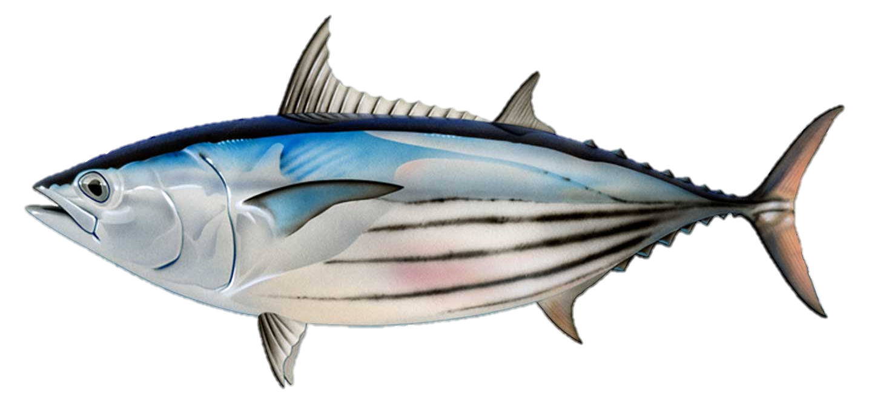

- Indian Ocean Tuna Commission Secretariat, FAO

Contents
1. Abstract 2
Contents 2
List of Figures 4
List of Tables 7
Executive summary 8
Introduction 8
Methods 8
Results 9
Catch 12
Catch rates 13
Key sensitivities 14
Recommendations for future assessments 14
Acknowledgements 16
2. Introduction 17
3. Background 19
3.1. Biology 19
3.2. Stock structure 20
3.3. Indian Ocean skipjack fishery overview 20
4. Data inputs 23
4.1. General notes 23
4.2. Spatial stratification 23
4.3. Temporal stratification 23
4.4. Definition of model fleets 24
4.5. Catch data 24
4.6. Abundance indices 27
4.7. Length frequency data 29
4.8. Tagging data 32
5. Model Description 37
5.1. Population dynamics 37
5.2. Fleet dynamics 40
5.3. Dynamics of tagged fish 40
5.4. Modelling methods, parameters, and likelihood 40
6. Assessment model runs 42
6.1. Updates to the base model for 2026 42
6.2. Model sensitivity testing 45
6.3. Final ensemble models (Grid) 47
7. Modelling Results 48
7.1. Continuity runs from 2023 model 48
7.2. Model fits 52
7.3. Model estimates 58
7.4. Diagnostics 62
8. Sensitivity Runs 69
8.1. Non-biological parameters 69
8.2. Biological parameters 70
8.3. Proposed final model options for grid / ensemble 78
9. Stock Status 80
9.1. Current status and yields 80
10. Discussion 90
10.1. Recommendations for future assessments: 92
11. References 94
12. APPENDIX A 98

List of Figures
Figure i: KOBE plot showing the range of model outputs from the grid ensemble. The blue vertical line represents the median value for SSB₂₀₂₅ / SSBtgt (0.4 B₀), with shaded 90 % confidence intervals. 10
Figure ii: Management outputs from the ensemble of models (grid) used in 2026. Bounds around the main darker line represent the 90% confidence intervals. The red band on the catch graph represents estimated optimal catch at MSY (90 % confidence interval). The horizontal lines indicate limit or reference points for SSB/SSB_{MSY} and SSB/SSB₀ respectively. 11
Figure iii: Estimated raised catches for the Indian Ocean skipjack tuna fishery by model fleet from 1950-2025. The horizontal red lines represent the average catch from 2020-2022, and 2023-2025 (final three years prior to the 2023 assessment, and this assessment). 12
Figure iv: Annual standardised catch rates (CPUE) available for the 2026 model. 13
Figure 1: Spatial distribution of SKJ catches in the Indian Ocean by fleet aggregated for 1980-2025. 20
Figure 2: Total skipjack catch in tonnes by model fleet 1950 – 2025 for the whole Indian Ocean. Red horizontal lines indicate mean catches for the three years prior to the previous, and current stock assessments. 22
Figure 3: Fishery catches (metric tonnes) aggregated by year. Note the y-axes differ between plots. Purple lines are catches used in the 2023 assessment. The differences in catch are mainly due to general improvements in the data quality over time. 26
Figure 4: Standardized CPUE indices available for the model. All series have been rescaled so that they are visually comparable for relevant periods of overlap. 28
Figure 5: The availability of length sampling data from each model fleet by year. The grey circles denote the presence of samples in a specific year (the size indicate number of quarters being sampled). The red horizontal lines indicate the time period over which each fleet has operated. 30
Figure 6: Length compositions of skipjack samples aggregated by model fishery. 31
Figure 7: Size distribution (fork length, cm) of skipjack tuna sampled from the Maldives pole and line fishery by year showing the distinct multimodal distribution of lengths. 32
Figure 8: Location of releases (red) and density of recoveries for the skipjack tuna RTTP-IO and small-scale tag programs 35
Figure 9 : Number of tag releases by quarter and age class for the skipjack tuna from the RTTP-IO and small-scale tag Programs. Ages were assigned based on the length. 35
Figure 10: Number of tag recoveries by year/quarter and fishery for the skipjack tuna from the RTTP-IO and small-scale tag Programs. Purse seine tag recoveries have not been corrected for reporting rate. 36
Figure 11: Fixed growth function for skipjack tuna following Eveson et al. 2012 (left) and length-based maturity ogive following Grande et al. (2014). For the growth function, the red line represents the estimated mean length (FL, cm) at age and the grey area represents the assumed distribution of length at age). 38
Figure 12: Spawning biomass trajectories for IO skipjack from the stepwise model updates. (from the 2023 assessment reference model ‘0_base_2023’). 49
Figure 13: Spawning biomass trajectories (depletion (%)) for IO skipjack from the stepwise model updates. (from the 2023 assessment reference model ‘0_base_2023’). 50
Figure 14: Fits to the CPUE indices for the Maldives PL index and the PSLS long index. 53
Figure 15: Standardised residuals from the fits to the CPUE indices from the base model ‘4_update_L50’. 54
Figure 16: Observed (grey bars) and predicted (red line) length compositions (in 4 cm intervals) for each model fleet and season aggregated over time for the base model ‘4_update_L50’. 55
Figure 17: A comparison of the observed (grey points) and predicted (red points) average fish length (FL, cm) of skipjack by fleet for the main fleets with length data for the base model ‘4_update_L50’. 56
Figure 18: Observed and predicted the number of tag recoveries over time following the mixing period for (a) PSLS and (b) PSFS fleets in the base model. Tag release groups represent the total releases in each quarter (aggregating the age groups that define individual release groups). 57
Figure 19: Estimated length-based selectivity for model fleets within the base model ‘4_update_L50’, with the maturity ogive (purple) plotted over the selectivity curves. 59
Figure 20: Recruitment deviates from the SRR with 90% confidence interval from the reference model ‘4_update_L50’. 60
Figure 21: Annual length frequency histograms for the length data included in the base model from the PL fleet. 60
Figure 22: Annual length frequency histograms for the length data included in the base model from the Other fleet. 61
Figure 23: Estimated absolute spawning biomass (1000 t) for each model configuration. 63
Figure 24: Estimated fishing mortality relative to FMSY, 1950–2025, by model configuration. 63
Figure 25: Observed (points) and predicted (lines) for the MDV PL CPUE index, 1995–2025, with estimated catchability (Q) by model configuration. 64
Figure 26: Observed (points) and predicted (lines) for the PSLS abundance index, 1991–2025, with estimated catchability (Q) by model configuration. 64
Figure 27: Retrospective analysis summary for the base model ‘4_update_L50’. 65
Figure 28: Profile likelihood of log(R0): change in total and component negative log-likelihood relative to the minimum, across a range of fixed log(R0) values. 66
Figure 29: Results of the jittering of the base model. Twenty-five models were run with a random perturbation of starting parameters. All but one of the models found the same negative log likelihood, max gradient, and estimates of SSB₀ suggesting the base model is robust to variation in starting values. 68
Figure 30: Biomass estimates from sensitivity runs relating to the CPUE component. 71
Figure 31: Depletion (% biomass or status) estimates from sensitivity runs relating to the CPUE component. 72
Figure 32: Biomass estimates from sensitivity runs. 73
Figure 33: Depletion (% biomass or status) estimates from sensitivity runs. 74
Figure 34: Biomass estimates from the sensitivity run relating to using the Lorenzen form for M. 75
Figure 35: Depletion (% biomass or status) estimates from the sensitivity run relating to using the Lorenzen form for M. 76
Figure 36: Spawning biomass trajectories from the proposed final model options in the grid 81
Figure 37: Spawning biomass depletion (% SSB₀) from the proposed final model options in the grid 82
Figure 38: Boxplot showing the influence of individual factors varied within models on key management components in the grid run. Red dashed line shows F₂₀₂₅/F_{MSY}. 83
Figure 39: KOBE PLOT FROM GRID RUNS WITH B/B40% (+/- 90% CI) plotted. 88
Figure 40: Management outputs from the ensemble of models (grid) used in 2026. Bounds around the main darker line represent the highest and lowest values from the grid of models. The red band on the catch graph represents estimated catch at MSY (90 % confidence interval). The horizontal red lines indicate limit or reference points for SSB/SSB_{MSY} and F/F_{MSY}. 89
Figure A1: Estimated vs. observed values from the sensitivity model “s1a_MDV_cpue” where the Maldives pole and line index was the sole CPUE index within the model. 98
Figure A2: Estimated vs. observed values from the sensitivity model “s1b_PSLS_cpue” where the European Union purse seine index was the sole CPUE index within the model. 99
Figure A3: Estimated vs. observed values from the sensitivity model “s1c_BAI_cpue” where the BAI CPUE index was the sole CPUE index within the model. 100
Figure A4: Estimated vs. observed values from the sensitivity model “s1d_ABBI_cpue” where the ABBI (behavioural) index was the sole CPUE index within the model. 101
Figure A5: Estimated vs. observed values from the sensitivity model “s1e_all_cpue” where all four CPUE indices were included in the model, with equal weighting (1.0). 102
Figure A6: Estimated vs. observed values from the sensitivity model “s9_catchability” where the Maldives pole and line index and the PSLS index had a 1.25 % discount applied to account for potential increases in catchability over time (‘gear creep’). 103
Figure A7: Model output from the sensitivity run ‘s5_Linf_LL2’ where the L_{inf} parameter was freely estimated, and the LL length samples not down-sampled (e.g. read as-is into the data file). This resulted in far better fits to the LL size data, while not overly affecting fits to other fishery size data. 104

List of Tables
Table i: STOCK STATUS (MSY-based) INDICATORS FROM MODEL ENSEMBLE 9
Table ii: STOCK STATUS INDICATORS FROM MODEL ENSEMBLE RELATIVE TO 40 % B₀ 10
Table 1: Catch model fleet definitions (numbers 1–7) used within the SS3 assessment. 24
Table 2: Recent skipjack catches (metric tonnes, t) aggregated by model fleet that have been included in the stock assessment model. The annual catches are presented for 2021- 2025. 25
Table 3: CPUE series available for the SS3 Assessment. Number is the SS3 index number 28
Table 4: Number of Tag releases by year (of release) and recoveries by year (of recovery) for the skipjack tuna RTTP-IO and small scale tag Programs. 34
Table 5: Description of the sequence of model runs to update the 2026 base model. 43
Table 6: Main structural assumptions of the skipjack base model and details of estimated parameters. Changes to the 2023 reference model are highlighted in red. 44
Table 7: Description of various data inputs and biological parameters varied in sensitivity runs. 46
Table 8: Description of the proposed final model options for the grid for the 2026 assessment. The final models consist of a full combination of options below, making a total of 48 models. The options adopted within the reference (base) model (‘4_update_L50’) are highlighted, although the base model was not included in the grid. 48
Table 9: Estimates of management quantities for the step-wise updates of the 2023 stock assessment reference model (‘0_base_2023’) to the 2026 reference model (‘4_update_L50’) 51
Table 10 (next page): Estimates of management quantities for the sensitivity testing from the base model options. Current catch (2025) is estimated at 729,282 t. 76
Table 11: Description of the proposed final model options for the grid for the 2026 assessment. The final models consist of a full combination of options below, making a total of 48 models. The options adopted within the reference (base) model (‘4_update_L50’) are highlighted. 79
Table 12 Estimates of management quantities for the stock assessment model options. Current yield (t) represents yield in 2025 corresponding to fishing mortality at the FMSY level. 84
Table 13: STOCK STATUS INDICATORS FROM MODEL ENSEMBLE 87
Table 14: STOCK STATUS INDICATORS FROM MODEL ENSEMBLE RELATIVE TO 40 % B₀ 87

Executive summary

Introduction
Skipjack are the smallest of the major commercial tuna species and are found mainly in the tropical areas with geographic limits between 55-60° N and 45-50° S. Skipjack are highly fecund and can spawn year-round over a wide area of the tropical and subtropical waters. Environmental conditions (such as sea surface chlorophyll) are believed to significantly influence recruitment and can produce widely varying recruitment levels between years (Marsac 2023). The historical Japanese surveys of skipjack larvae have identified large quantities of skipjack larvae in the Equatorial Eastern IO (Nishikawa et al 1985), but these surveys have been quite rare in the Western IO. The location of skipjack nurseries remains widely unknown, as well as the biology of skipjack early juveniles, because very small sizes of skipjack have never been exploited significantly in the IO (Fonteneau 2014).
This report presents an integrated stock assessment for Katsuwonus pelamis in the Indian Ocean in 2026, using data up to the end of 2025 (31st December 2025). The stock assessment is based on an update of the 2023 model and is a seasonally, and age-structured integrated model that uses catch rate indices, length-compositions, tagging data, and catch data to inform estimates of spawning stock biomass (SSB) and fishing mortality (F), relative to estimated maximum sustainable yield (MSY). Additional metrics of SSB and F relative to a depletion target reference point of 40 % virgin biomass (0.4 B₀) are also provided.
The assessment was completed using Stock Synthesis 3.30.25.1 and incorporates all newly available data since the previous assessment.
This assessment provides information on stock status, but is not used for management advice, as there is a management procedure in place for K. pelamis (Resolution 24/07).
This version of the assessment incorporates changes from the 28th IOTC Working Party for Tropical Tunas (WPTT) that took place from 20-24 October, 2026 in Tenerife, Spain.

Methods
The Stock Synthesis 3.30 (SS3.30.25.1, August 2026) assessment model covers the period 1950-2025 and assumes that the Indian Ocean skipjack tuna consists of a single genetic stock, with seven fishing fleets organised into métiers. Standardised catch per unit effort (CPUE) series from the pole and line fleet of Maldives (1995-2025), and the European Union purse seine fleet (1991-2025) were included in the models as an assumed abundance index relative to the exploitable biomass. Two additional indices were available: one based on the associative dynamics of skipjack tuna to floating objects (ABBI; 2013-2024), and one based on echosounder data (BAI; 2012-2024). These were tested in sensitivity runs, but neither were included in the base model. Tag release-and-recovery data from the RTTP-IO program were included in the model to inform abundance and fishing mortality rates. The length at 50 % maturity was updated from the previous assessment (38 cm) to a more recent value (39.9 cm), as agreed at the WPTT28(DP) meeting in June 2026.
Several sensitivity scenarios were run to explore the effects of alternative model assumptions with alternative CPUE configurations; an alternative for the instantaneous rate of natural mortality (M), based on the Lorenzen curve, and assuming a maximum age of 8 years; alternative values for the maximum size at age; a different model time period; and a two-area model structure. After sensitivity analyses, and running of diagnostics, including running retrospectives, jitter analyses, and age-structured production models (ASPM) testing the impact of recruitment and length data, a biologically relevant, and internally consistent model was chosen as a base model (“4_update_L50”).
Following discussions at the 28th WPTT(AS), this model is used as the ‘base’ or ‘reference’ model, however, as there was some discrepancy in the rate of change in the Maldive Pole and Line, and PSLS CPUE indices in the final years of the model, it was decided that the grid would be run without the base model (where both the Maldives pole and line index, and the purse seine log school index were included as abundance indices), and instead run with models containing only individual indices.
To account for uncertainty within specific model parameters, several model options were then run using within an ensemble of models using a combination of plausible options for various parameters. This included: three options for the steepness parameter (h = 0.7, 0.8, 0.9); two alternative growth parameter options (L∞ estimated or fixed); two options for the instantaneous rate of natural mortality (fixed, or Lorenzen form M); two options for inclusion of abundance indices (CPUE indices), and two options for catchability (q = 0; q = 1.25 %) to account for potential gear creep. The model ensemble (a total of 48 models) therefore encompasses a reasonable range of uncertainty, and stock trajectories. Estimates of stock status were combined across the 47 models out of 48 that converged and incorporate uncertainty estimates from both within and across the model ensemble using the multivariate lognormal approach.

Results
In 2026, the overall stock status for Indian Ocean skipjack tuna is that the stock is not overfished and not subject to overfishing with a likelihood of 92.1 % (Figure i, Table i) over an ensemble of 47 models that encompass the main uncertainties within the model. Table ii provides reference values with reference to 40 % of B₀.

Table i: STOCK STATUS (MSY-based) INDICATORS FROM MODEL ENSEMBLE
Catch in 2025 (t) | 729,282
Average catch 2021–2025 (t) | 670,136
Catch MSY (1000 t) | 570 (505-683)
F_{MSY} | 0.94 (0.64-1.4)
SSB₀ (1000 t) (90% CI) | 2376 (1816-2865)
SSB₂₀₂₅ (1000 t) (90% CI) | 1099 (805-1522)
SSB_{MSY} | 520 (351-753)
SSB₂₀₂₅/SSB₀ (90% CI) | 0.5 (0.29-0.71)
SSB₂₀₂₅ / SSB_{MSY} | 2.2 (1.28-3.64)
F₂₀₂₅ / F_{MSY} | 0.59 (0.37-1.01)

Table ii: STOCK STATUS INDICATORS FROM MODEL ENSEMBLE RELATIVE TO 40 % B₀
Catch in 2025 (t) | 729282
Average catch 2021-2025 (t) | 670136
Catch B40 % (1000 t) | 506 (461-595)
F_{B40%} | 0.5 (0.41-0.6)
SSB₀ (1000 t) (90% CI) | 2376 (1816-2865)
SSB₂₀₂₅ (1000 t) (90% CI) | 1099 (805-1522)
SSB _{B40%} (1000 t) | 949 (724-1153)
SSB₂₀₂₅/SSB₀ (90% CI) | 0.50 (0.29-0.71)
SSB₂₀₂₅/SSB_{B40%} | 1.25 (0.71-1.77)
F₂₀₂₅/F_{B40%} | 1.09 (0.79-1.82)

Figure i: KOBE plot showing the range of model outputs from the grid ensemble. The blue vertical line represents the median value for SSB₂₀₂₅ / SSBtgt (0.4 B₀), with shaded 90 % confidence intervals.

In the 2023 assessment (using data up to 2022) the model ensemble estimated that the stock was not overfished and not subject to overfishing, and the 2020 assessment also estimated the stock to be not overfished and not subject to overfishing.
The estimated biomass trajectory shows a stock recovering from high exploitation in the mid-2010s to the present year. (Figure ii). Biomass levels appear to be increasing, while catch is above MSY in the final year of the model. Fishing mortality has also been steadily decreasing from a peak around 2005.
Figure ii: Management outputs from the ensemble of models (grid) used in 2026. Bounds around the main darker line represent the 90% confidence intervals. The red band on the catch graph represents estimated optimal catch at MSY (90 % confidence interval). The horizontal lines indicate limit or reference points for SSB/SSB_{MSY} and SSB/SSB₀ respectively.

Catch
In the three years since the previous assessment (2023 - 2025), total catch has averaged 681,350 tonnes per year from all fleets within the fishery (Figure iii).

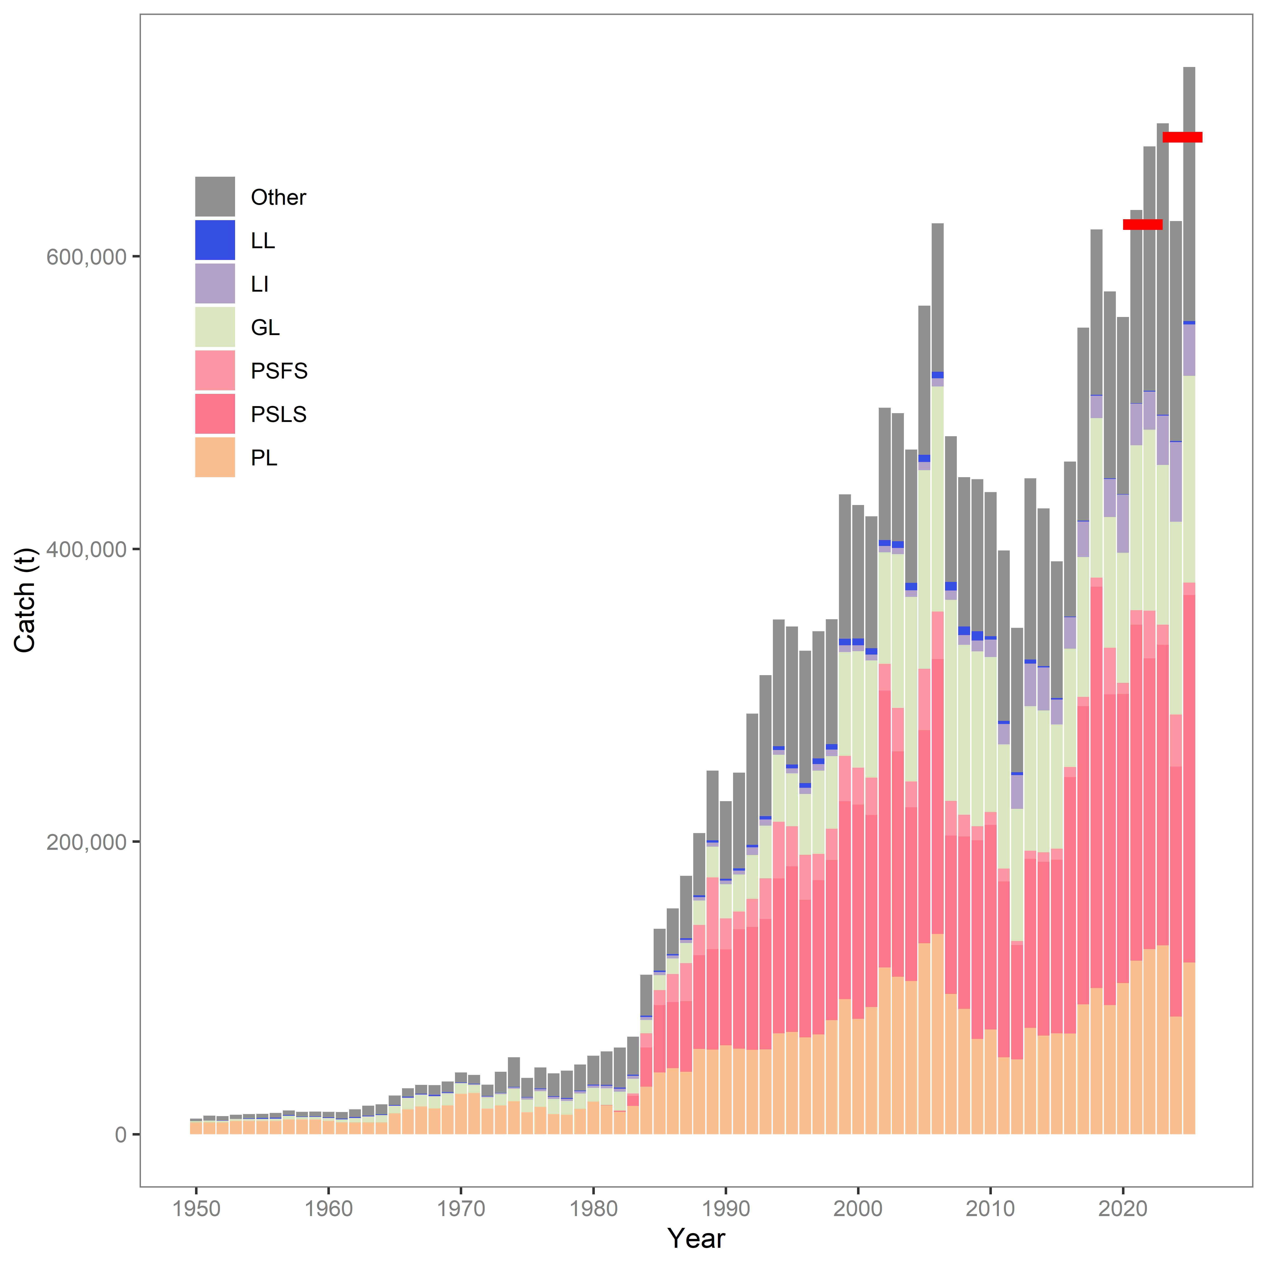
Figure iii: Estimated raised catches for the Indian Ocean skipjack tuna fishery by model fleet from 1950-2025. The horizontal red lines represent the average catch from 2020-2022, and 2023-2025 (final three years prior to the 2023 assessment, and this assessment).

Catch rates
Standardised catch rates available for the assessment. Indices included in the base model are MDV_PL (Maldives pole and line), and PSLS_long (European Union log school associated purse seine index) (Figure iv). Detailed methods for these indices can be found in the documents provided at the 27th Working Party for Tropical Tunas (DP).
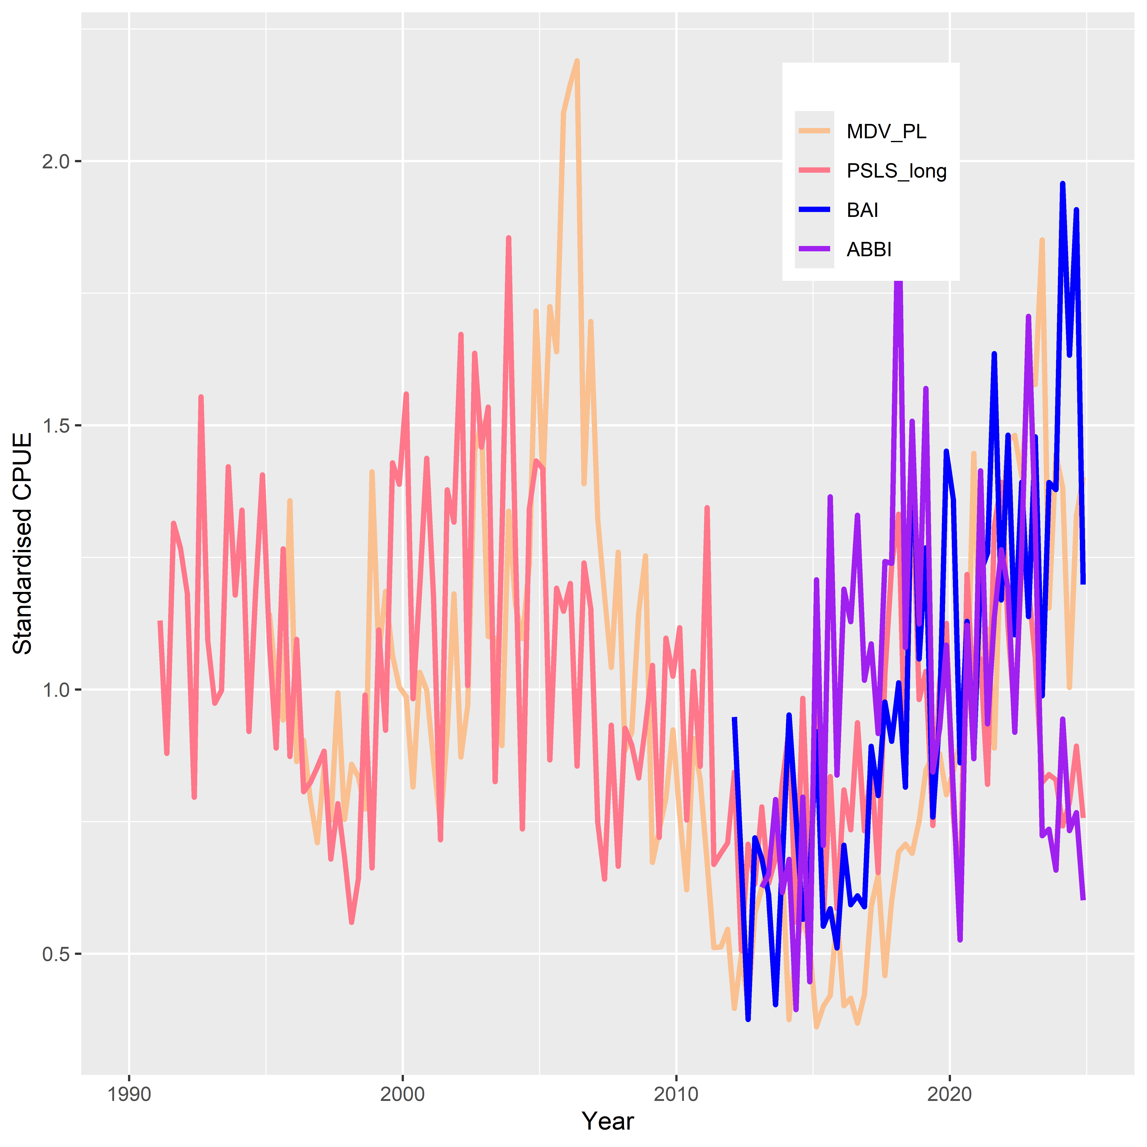
Figure iv: Annual standardised catch rates (CPUE) available for the 2026 model.

Key sensitivities
The model was sensitive to changes to the inclusion of specific CPUE indices. When only one index was used, the trajectory of the stock differed quite considerably, depending on which was used as the main index of abundance. When only the Maldives pole and line index was used, the stock increased to nearly 90 % B₀ in the final year, similarly when the BAI index was included as the only abundance index (in fact the biomass increased to above that of B₀ during the model time period). The European Union PSLS CPUE index provided a more pessimistic (or realistic) stock status. The model was also sensitive to changes to the growth parameter L∞ (or length-at-maximum age) – currently the model uses a fixed value of 70 cm, however this value is too small to account for the largest fish caught in the longline fleet (~ 110 cm). When the L∞ was estimated (and the length data from the longline fleet not down sampled), the model was able to fit better to the longline size data and estimated a more realistic L∞ of 84 cm. The estimates of biomass provided by model appear to be mostly driven by the CPUE indices. This is a key issue for the model, as these are spatially constrained and are unlikely to represent the population dynamics of the entire Indian Ocean stock.
Future research should focus on improving the sparse biological data available for this species – especially with regards to age-at-length data. It is difficult to age skipjack tuna from otolith data (although not impossible), due to the fish remaining in tropical waters for their entire lifecycle, therefore annual rings in otoliths are indistinct. However, a workshop in 2023, provided information on best practice and methods to minimise bias in age estimations of SKJ using fine spines and otoliths (Luque et al., 2024). Ageing more fish, alongside the development of newer techniques such as epigenetic ageing (noting that more otolith readings are still necessary to provide “known ages”) would improve the stock assessment robustness and reliability. Additionally, more length data from fleets that catch larger fish (longline, and line fleets) would go some way to improving the model’s ability to estimate growth parameters in the absence of robust research data, as shown when increasing the sample size of the longline length frequency data. Improving the biological data inputs in the model would reduce the reliance on the CPUE indices as the main driver(s) of biomass estimates in the model.

Recommendations for future assessments
- Improved quality and quantity of length composition data: The model is relatively sensitive to the length-frequency data. It is recommended that improvements in both quantity and quality of length frequency data are provided to the Secretariat prior to the next assessment of skipjack in 2029, and that any length data omitted in this assessment are reassessed for suitability and inclusion in 2029. Of particular interest would more measurements from fleets that catch larger fish (e.g. longline and line fleets).
- Development of independent abundance indices: as with other assessments in the IOTC, there are no fishery-independent abundance indices included in the stock assessment. Inclusion or exclusion of individual CPUE indices changes both the biomass estimates, and the trajectory of the spawning stock biomass. With no independent abundance indices, it is currently not possible to know for certain which of the indices trajectories is biologically accurate. Additionally, as with other IOTC assessments, the CPUE indices are driving the assessment.
- Ageing data: It is strongly recommended that more fish are aged, encompassing (if possible) both male and female fish, from all length-bins across the spatial extent of the fishery, to build a reasonable timeseries of biologically informative data. Age data should be accompanied by detailed information on the source of the fish (e.g. time, date, location, sex, fishing gear, vessel flag etc.) if the data are to be used to either estimate age-at-length within the model (as data need to be allocated to appropriate timesteps, model areas, and model fleets) or to account for changes in age-at-length over time or space (due to population dynamics, environmental factors, such as climate change or high fishing effort). Estimating age within the model allows for more accurate diagnosis of the cause of potential model misspecification. Fish could be aged on a yearly basis, to provide additional information.
- Incorporation of climate variables: As stipulated under Resolution 25/01 the IOTC “Commission should support further research into the relationship between climate change, fisheries for IOTC fisheries…and the ecosystems…”. Currently the assessment does not incorporate any information on potential changes in population distribution due to climate change. This aspect of the assessment could benefit from targeted research from CPCs or research organisations, and feedback from ecosystem models developed within the WPEB. As part of these investigations, it is recommended to research the applicability of dynamic reference points such as dynamic MSY or dynamic B0 on skipjack tuna, in light of the potential that the productivity of the stock may have either been underestimated, or have changed over time with respect to climate change.
- Investigation of tagging data: Tagging data are likely constraining the scale of the population despite limited tag-mixing and coverage. In particular, the four-season mixing assumption excludes about 80% of tag recoveries. It is recommended to run sensitivities with differential tag-weighting, or exclusion of and alternative mixing and reporting scenarios in the next iteration of the assessment model.
- Investigation of CPUE weighting: The low CV for the main CPUE indices likely reduces the potential impact of the length data on the assessment. It is recommended that the next skipjack assessment investigates alternative CV scenarios for the main CPUE indices.
- Improved biological information: This assessment investigated one alternative for the instantaneous rate of natural mortality (M) using the Lorenzen curve, and a maximum age of eight (8) years. It is recommended that more biological studies and / or investigation of tagging data and other data sources or literature reviews are carried out to ensure that values for both maximum age of skipjack, and M are biologically accurate.
- Allow for seasonal variation in q: The abundance indices, and CPUE indices are standardised on a seasonal (quarterly) basis, and yet q (catchability) is constant across all seasons in a year. There are clear differences between the indices in each season, therefore it is recommended that sensitivity runs are completed where q is allowed to vary between seasons in the next assessment model.
- Model structure: One model run was completed where the skipjack population was split into an “east” and “west” region, under several assumptions. This model requires further investigation, as a multi-region model may be able to account for divergences in the main CPUE indices.
- Model fleets: There was discussion around the gear and vessel flags included in the ‘other’ fleet, and whether this was still representative of a single métier. It is recommended that the model fleet definitions are explored fully in the next skipjack assessment.

Acknowledgements
This stock assessment was informed by previous assessments of Indian Ocean skipjack (Katsuwonus pelamis), and from reading reports of recent assessments undertaken by the International Commission for the Conservation of Atlantic Tunas (ICCAT), the Western and Central Pacific Fisheries Commission (WCPFC), and the Inter-American Tropical Tuna Commission (IATTC) in the Atlantic, Western Pacific, and Eastern Pacific Oceans respectively. The previous assessment provided the starting input parameters, and discussions at the data prep meeting (WPTT28(DP)) provided scenarios to test for model sensitivities, alongside possibilities for the final grid of models presented in this report. The assessment was discussed and finalised at the 28th meeting of the Working Party for Tropical Tunas (Assessment meeting) in October 2026, in Tenerife, Spain (European Union).
The assessment benefited greatly from updated abundance indices (CPUE) from the following CPCs: Maldives and European Union.
We thank all the observers who collect and provide biological data for the assessment of skipjack stocks in the IOTC Area of Competence, the IOTC Data Team for providing data to allow for a complete assessment of the stock, and previous stock assessment scientists at the IOTC for their code, and previous models which form the basis of this assessment.
The assessment benefited greatly from the constructive comments at the 28th meeting of the Working Party for Tropical Tunas in October 2026.

Introduction
This paper presents the preliminary 2026 stock assessment of skipjack (Katsuwonus pelamis; SKJ) in the Indian Ocean (IO). As in previous assessments, the objectives of the 2026 skipjack assessment are to estimate population level parameters which indicate the stock status and the impacts of fishing, such as time series of recruitment, spawning stock biomass, biomass depletion, and fishing mortality. The stock status is summarised using reference points that are adopted by the Indian Ocean Tuna Commission (IOTC).
The current assessment is carried out using the stock assessment framework Stock Synthesis 3.30 (Methot, 2013, Methot & Werner, 2013) using a length-based, age- and seasonally structured population model.
The Indian Ocean skipjack tuna (Katsuwonus pelamis, SKJ) fishery is one of the largest tuna fisheries in the world, with total catches of 400-700 thousand tons over the past decade. Some bioeconomic modelling of the fish population and fishery was undertaken in 2007 (Mohamed 2007). Before 2010, management advice relied on data-based indicators, and mortality estimates from analyses of the RTTP-IO tagging data (Edwards et al. 2010). A full integrated model-based assessment was developed in 2011 (Kolody et al 2011), and further updated in 2012, 2014 (Sharma et al. 2012, 2014), 2017, 2020, and 2023 (Fu 2017, 2020, 2023). In 2016, the IOTC commission adopted a Harvest control rule (HCR) for the skipjack tuna through Resolution 16/02 (IOTC 2016). The HCR recommended a total annual catch limit inferred from a relationship between stock status (spawning biomass relative to unfished levels) and fishing intensity (exploitation rate relative to target exploitation rate) estimated from a model-based stock assessment.
The Skipjack HCR was first applied in 2017, resulting in a recommended catch limit of 470,029 t for 2018–2020. It was run again in 2020 to provide a catch limit of 513,572 t for 2021–2023, and in 2023 to recommend a catch limit of 628,606 t for 2024–2026. In 2024, IOTC adopted a Management Procedure (MP) for skipjack tuna (Resolution 24/07). The MP replaces the previously adopted harvest control rule (HCR) for skipjack tuna. The MP was run in 2025 which recommended a TAC of 565,745 t for 2027-2029. In 2025, the Commission also adopted Resolution 25/03, which allocates the TAC to major skipjack harvesting countries according to specified rules and provides provisions for the administration of catch limits.
Previous skipjack tuna assessments investigated the impact of a range of data and model assumptions (e.g., spatial and temporal structure) on estimates of stock status and a systematic approach was taken to evaluate interactions of model assumptions and to develop management advice. In 2017, the WPTT19 agreed to a final ensemble of 37 models to characterize key uncertainties related to steepness, natural mortality, tagging program, tag mixing period and tagging mortality (IOTC 2017); In 2020, WPTT22 adopted a full factorial uncertainty grid that included alternative spatial structure, steepness, tag data weights, and CPUE catchability assumption. The median estimate from each set of stock assessment model ensemble was then used to determine the catch limits to be implemented over the next three years through the HCR (470,029 tonnes for 2021-2020 and 513,572 tonnes for 2021-2023).
In 2023 WPTT25 adopted a full factorial uncertainty grid that included alternative CPUE indices (PL, PSLS, and/or behavioural (ABBI) indices), alternative assumptions on catchability (annual increase of 0 % or 1.25 %), alternative values of steepness (h = 0.7, 0.8, and 0.9), and alternative growth parameter options (L∞ fixed or estimated). The ensemble of 36 models therefore addressed the main uncertainty in key datasets and productivity parameters.
This report provides an update to the 2023 assessment, with further development and testing of the assumptions within the model for skipjack in the Indian Ocean. The model incorporates three additional years of data (2023–2025), improved information on nominal catches from IOTC database, and revised CPUE time series for the Maldives pole and line, European purse seine fleets, and tested the inclusion of two additional FAD-associated indices (BAI, ABBI). The assessment provides estimates of population parameters, stock status and reference quantities, with uncertainties characterised through a model grid on combinations of model settings and parameter values. The assessment builds on the work by Fu (2017, 2020, 2023), Sharma et al. (2012, 2014), and Kolody (2011), and uses a size based, age structured population model, implemented in Stock Synthesis 3 (Methot and Wetzel 2013, Methot et al. 2020, Methot et al., 2026).
New information relating to size at maturity (Grande, 2014) of skipjack in the Indian Ocean were made available for this assessment. The study provided an update to the length at 50 % maturity (L₅₀) used in the previous assessment.
During the assessment meeting, discussions centred around the CPUE indices used within the model, and whether these were representative of abundance trajectories across the Indian Ocean. Members commented on the representativeness of the fishing fleets (métiers) within the model, and that further investigation of gears used within the “Other” fleet needed to happen prior to the 2029 assessment. Additionally, members commented that the next assessment should include different values for sigma R, greater CV on the CPUE indices, and allow for seasonality in catchability (q) – e.g. allow this to vary; and test the impact of estimating these parameters in the model. Additionally, members stressed the importance of model ‘self-testing’ (re-running the model using the estimated parameters from the base model).
In summary, this report documents the 2026 iteration of the stock assessment of the Indian Ocean skipjack stock after discussions at the 28th WPTT(AS) due to be held in Tenerife, in October 2026. The stock assessment is based on the 2023 modelling framework and has incorporated revised and updated data up to the end of 2025, and newly available biological information. The assessment implements a length-based, age-structured and seasonal population model fitted to catch per unit effort (CPUE, abundance indices), and length composition data. The assessment is implemented in Stock Synthesis (v3.30.25.1). Code to prepare the data and run the models will be made available on Github once the assessment is finalised.

Background

Biology
Skipjack are the smallest of the major commercial tuna species and are found mainly in the tropical areas with geographic limits between 55-60° N and 45-50° S. Skipjack are highly fecund and can spawn year-round over a wide area of the tropical and subtropical waters. Environmental conditions (such as sea surface chlorophyll) are believed to significantly influence recruitment and can produce widely varying recruitment levels between years (Marsac 2023). The historical Japanese surveys of skipjack larvae have identified large quantities of skipjack larvae in the Equatorial Eastern IO (Nishikawa et al 1985), but these surveys have been quite rare in the Western IO. The location of skipjack nurseries remains widely unknown, as well as the biology of skipjack early juveniles, because very small sizes of skipjack have never been exploited significantly in the IO (Fonteneau 2014).
Considerable information on skipjack movement is available from tagging programs, which have documented some large-scale movement within the Indian Ocean. The average range of movement during the skipjack lifetime can be estimated at about 1000 miles, with maximum distance of about 2000 miles (Fonteneau 2014). Skipjack movement is highly variable and is thought to be influenced by large-scale oceanographic variability (Mackenzie et al. 2016).
Skipjack growth is rapid compared to yellowfin and bigeye tuna. Young skipjack are approximately between 10–20cm at age of 40–90 days after hatching and immature fish are approximately in a range of 20 cm to 40 cm at age of 90 days to one year after hatching (Kiyofuji et al. 2019). Eveson et al (2012) estimated a fixed growth function for skipjack tuna with the VB-logK curve approximated using a Richards curve in SS3, with $L^{∞}$= 70cm, k=0.34, and the inflexion parameter fixed at 2.96. However, the $L^{∞}$appears to be low compared to the Pacific, where estimates suggest maximum length above 80 cm. In the WCPFC skipjack assessment (2021) the assume a maximum length of 90-100 cm, and in the Eastern Pacific (Teears et al., 2025), $L^{∞}$ or asymptotic length is assumed to be 83 cm.
Maturity was estimated by Grande et al. (2010, 2014) to be invariant over time with 50% maturity at length 38 cm (2010) with an updated figure of 39.9 cm in 2014 (Figure 11–right), corresponding to an age-at-maturity of 0.4 y with the Richard growth curve. This is also very similar to the 40 cm value reported in the Pacific, where the maturity is estimated to follow a knife-edge pattern with all fish two quarters or less being immature and all fish older being fully mature (Vincent et al. 2019). Grande et al. (2010; 2014) studies used the ‘cortical alveolar’ oocyte development stage and above as the threshold indicating a fish was mature. Zudaire et. al (2022) estimated reproductive parameters for skipjack tuna in the Indian Ocean as part of the ‘GERUNDIO’ project. The estimate of L50 (41.3 cm FL) obtained in this study is slightly higher than that obtained by Grande et al. (2010; 2014). probably affected by different maturity thresholds used in both studies.
The estimates for the instantaneous rate of natural mortality for skipjack are available from tagging data (Everson 2011), but estimates were very low compared to assumed or estimated M in other oceans. In this assessment (as in the previous assessment), a constant M of 0.8 for all ages is assumed, equal to a previous value used in ICCAT (now ICCAT use the Lorenzen form for M with a maximum age of 8 years; ICCAT, 2022). In the Eastern Pacific (Bi et al., 2024), M is assumed constant for fish over 65 cm in length, with the Lorenzen form for M also used in the base assessment.

Figure 1: Spatial distribution of SKJ catches in the Indian Ocean by fleet aggregated for 1980-2025.

Stock structure
Genetic analyses by Dammannagado et al. (2011) have suggested that there might be two (or more) skipjack populations in the Indian Ocean. A stock structure study based on analysis of the shape of otolith from four areas south of Java showed that they are not statistically different among regions, suggesting that these skipjack belong to a single stock (Wujdi et al. 2017). However, due to the limited spatial range of the samples, this conclusion cannot be applied to the whole Indian Ocean. Using next generation genetic sequencing, Grewe (2019) suggested a weak genetic population differentiation of skipjack tuna from the central Indian Ocean through to the Eastern Pacific Ocean.

Indian Ocean skipjack fishery overview
The Indian Ocean skipjack catch history is shown in Figure 1 (red horizontal lines indicate mean catches from three years prior to an assessment). Catches increased steadily from the 1980s to a peak at over 600,000 t in 2006, with a decrease in catches in the mid-2000s. Since 2006 total catches declined to around 340,000 t in 2012 although since 2013 catches have increased sharply with a peak in 2018 at ~ 600,000 t mostly driven by the purse seine fisheries. The catches dropped in 2019 and again in 2020 to about 550 000 t but increased to a peak at 655,000 t in 2021 and again increased to the highest catches recorded in 2025 (729, 000 t). The annual catches between 2021 and 2025 have all exceeded the catch limit as set out by the skipjack Harvest Control Rule, and later, the skipjack management procedure (565,745 t). Figure 2 illustrates the spatial distribution of the catches from the main fisheries (purse seine, pole and line, gillnet, line). In 2025, purse seine accounted for about 34 % of the total catches, with the remainder of catches mainly taken by the gillnet (19.4 %), pole and line (16 %) and other (23.8 %) fisheries (IOTC 2025).
The Maldives has sustained a pole and line (PL, bait boat) skipjack fishery for many centuries, with catches increasing dramatically with the uptake of mechanization and deployment of larger vessels (more poles, larger bait and storage capacity, longer range) starting in the 1980s. The Maldives has experienced substantial catch declines since the peak in 2006, for reasons that are not entirely clear. Adam (2010) suggested that this may reflect declining skipjack abundance, limitations to bait availability or changing economic incentives (e.g., high fuel prices). There has been an increasing trend in catch levels from 2018, with a slight drop in 2019 followed by a new increase in catches which peaked at 129,000 t in 2023 (IOTC 2023). Catches dropped in 2024 to 80,000 t, but rebounded in 2025 to 117, 000 t.
There has been a rapid increase in skipjack catches with the introduction of the purse seine fleets in the 1980s, and the development of the fishery in association with Fish Aggregating Devices (FADs) since the 1980s (e.g., Chassot 2010, Delgado de Molina 2010). The European/Seychelles PS catch has fluctuated considerably since around 2000 without a clear trend. Catch declines in the recent years are probably partly attributable to the effects of piracy in the prime fishing area near Somalia. From 2003-06 the decline was due to very good fishing of large yellowfin tuna on free schools. After 2007 piracy or other ‘unknown’ reasons may be the cause of the decline. In recent years, well over 90% of the skipjack tuna caught by purse seine vessels are taken from around FADs. The fraction of catches from FAD associated schools was around 98% of skipjack catches reported in 2018 and around 96% in 2021.
Several fisheries using gillnets have reported large catches of skipjack tuna in the Indian Ocean, including the gillnet/longline fishery of Sri Lanka, driftnet fisheries of I.R. Iran and Pakistan, and gillnet fisheries of Indonesia. In recent years gillnet catches have represented as much as 20% to 30% of the total catches of skipjack tuna in the Indian Ocean. Moderate catches are taken by the line fishery representing a mixture of gears using handlines, trolling, and small longlines, mostly in the eastern Indian Ocean (Figure 2).
A substantial portion of the total catch is taken by a mix of artisanal gears, with minor catches dating back before the pre-industrial period. For the assessment, these fleets have been pooled together, in the heterogeneous Other fleet. The bulk of the recent catch in this fishery is from the small purse seiners fisheries of India, Indonesia, Malaysia, and Mozambique. These fleets were mostly operating in coastal waters. The aggregate catches of these fleets have been increasing recently to a high of 24 % of total catches in 2025 (possibly due to revisions in catch data estimation methods by Indonesia).

Figure 2: Total skipjack catch in tonnes by model fleet 1950 – 2025 for the whole Indian Ocean. Red horizontal lines indicate mean catches for the three years prior to the previous, and current stock assessments.

Data inputs

General notes
Data used in this stock assessment consist of catch, length composition data, tagging data, and CPUE indices, alongside biological parameters such as growth (length at age), natural mortality, and maturity information. Data are continually being improved and as such catch and length composition data may not be identical to those in previous assessments. Where data inputs have substantially changed, it is noted in the sections below, and links to relevant methods papers are provided for further detail.
Model input files along with reproducible code to run the assessment, and all sensitivities are stored by the Secretariat and are available on request.

Spatial stratification
The assessment assumed that the entire Indian Ocean as one homogeneous area, with the different model fleets harvesting different portions of the skipjack population. The tagging data suggest that SKJ migrate quickly but the limited distribution of tag releases, and small number of returns outside of the European/Seychelles purse seine fleets (mainly operating in the western equatorial Indian Ocean) makes it difficult to quantify large-scale movements. It is notable that basin-scale movements into the eastern Indian Ocean were observed from the EU/Seychelles fleet, but proper mixing might never occur at the basin scale. Thus, the inclusion of the tagging data in the aggregated spatial structure may induce bias due to the low mixing rates. Another concern is that Maldives PL CPUE is used as an index of abundance for the broader population in the aggregated model when in fact in it is derived from the relatively small area of the Maldives EEZ.
The 2020 assessment included a two-region spatial structure which assumed discrete populations west and east of 80° (see Figure 2 of Fu 2020). The partition is based on the distribution of major fisheries and appears well fitted with geographical scale of the observed skipjack movements in the western Indian Ocean. The partition allows for spatial heterogeneity in tag mixing and changes in abundance (the mixing rate is probably quite low between the Northern and southern western Indian Ocean, see Fonteneau 2014). However, there is a lack of information on regional scaling (Hoyle and Langley 2018) to estimate the biomass distribution across the two regions because the purse seine and pole and line indices, which are assumed to index regional abundance, are not comparable in relative size. The tagging data contains little information about migration between the east and western Indian Ocean. These factors led to significant variations and uncertainty in estimates of regional abundance and movement rates across an array of model options. The spatial model requires further development and is not used in the current assessment, although it was trialled as a sensitivity.

Temporal stratification
The population was assumed to be in unfished equilibrium in 1950, the start of the catch data series. The model was iterated from 1950 to 2025. The population dynamics were represented with an annual/ season configuration, referred as the SS3 internal year-season (SSYS). The model was iterated on an annual time step which is split into four quarters to represent potentially important seasonal processes. The tag ages are assigned to annual increments, and recruitment is apportioned among four seasons from a single recruitment event. The previous assessments also examined an alternative configuration (Calendar Season as Model Year, CSMY) which is commonly used for species with rapid dynamics such as tropical tuna. The CSMY defined quarterly time periods as years, i.e., each model “year” is a three-month period, and each age class is 3 months (see Fu 2017 for a detailed comparison of the two temporal structure). For this assessment, only the SSYS structure is used for all models, as in the 2023 assessment.

Definition of model fleets
In SS3, data are required to be aggregated or defined in “fleets” within the overall fishery. Individual fleets represent relatively homogenous fishing units, with similar selectivity and catchability characteristics that do not vary significantly over time (métiers). Seven (7) fleets were defined in the model (Table 1), with an additional four “survey” fleets, for which only CPUE indices were assigned. The use of “survey” fleets for the CPUE indices was chosen as these indices are based on aggregated datasets and allow for separate estimation of selectivity and catchability within the model framework. Fishing fleets were defined based on the fishing gear type, fishery type (e.g. fresh vs. frozen longline), and fleet dynamics (e.g. spatial and temporal extent of the fishery).
The definitions of model fleets were the same as those used in the previous iterations of the SS3 stock assessment. In earlier assessments, the “Other” fleet was defined broadly to have aggregated gillnet, line, longline fleets (in total four fleets were defined for the assessment). Consequently, the Other fleet included a heterogeneous mix of fleets which caught different sizes of fish (e.g., the longline generally caught much larger skipjack than other gears). The combined size distribution was unlikely to be representative of this composite fleet if the component fleets had inconsistent size sampling over time. Therefore, it was decided to partition this composite fleet into fleets with distinctive selectivity characteristics, with the aim to improve predicted sizes in the catch and the estimates of the selectivity patterns (Fu 2020). The 2023, and current (2026) assessments keep this same definition for the Other fleet.

Table 1: Catch model fleet definitions (numbers 1–7) used within the SS3 assessment.
Name | Fleet Number | Description
MDV_PL | 1 | Maldives pole and line fleet
PSLS | 2 | FAD / log associated purse seine (PS) sets from the EU / Seychelles fleets
PSFS | 3 | Non-FAD / log associated PS sets from the EU / Seychelles fleets
GL | 4 | Gillnet fleets primarily from Sri Lanka, I.R. Iran, Indonesia, and Pakistan
LI | 5 | Handline and small coastal longline gears from Yemen, Sri Lanka, Maldives, and Madagascar
LL | 6 | Trivial catches from the distant water longline fishing fleets
Other | 7 | All other fleets, primarily non-EU / Seychelles PS fleets, trolling, and small coastal fleets (e.g. ring nets)

Catch data
Catch data were compiled based on the fleet definitions in Table 1. An update of annual catches by fleet was provided by the IOTC Secretariat, including catches since the last assessment (2023–2025; “IOTC-WPTT28-AS-SKJ-CEraised_1950_2025.csv”).
The time series of catches are similar to those included in the 2023 assessment (Figure 3). Total skipjack catches in the years 1987-2018 were impacted by the revisions introduced to the official catch series submitted in late 2019 by Pakistan for its gillnet fisheries, with revised catches in 2023 assessed as being 69,244 t lower (in total) during those years (IOTC 2020). There has also been a substantial decrease in the LL catches since the previous assessment, with an overall decrease throughout the entire time period (Figure 3).
Total annual catches for 2023, 2024 and 2025 included in the updated catch history are 690,776 t, 623,992 t, and 729,282 t respectively (Table 2). The total catch in 2025 is the highest in the history of the fishery (Figure 2, Table 2).
Table 2: Recent skipjack catches (metric tonnes, t) aggregated by model fleet that have been included in the stock assessment model. The annual catches are presented for 2021- 2025.
Fleet | 2021 | 2022 | 2023 | 2024 | 2025
MDV_PL | 118517 | 126362 | 129026 | 80283 | 117219
PSLS | 229699 | 198807 | 205418 | 170853 | 251203
PSFS | 9820 | 32551 | 13751 | 35602 | 8562
Gillnet | 112767 | 123677 | 109086 | 131779 | 141245
Line | 28435 | 26077 | 33749 | 54434 | 35134
LL | 237 | 524 | 565 | 733 | 2337
Other | 132161 | 166994 | 199181 | 150308 | 173582
Total (t) | 631,636 | 674,992 | 690,776 | 623,992 | 729,282

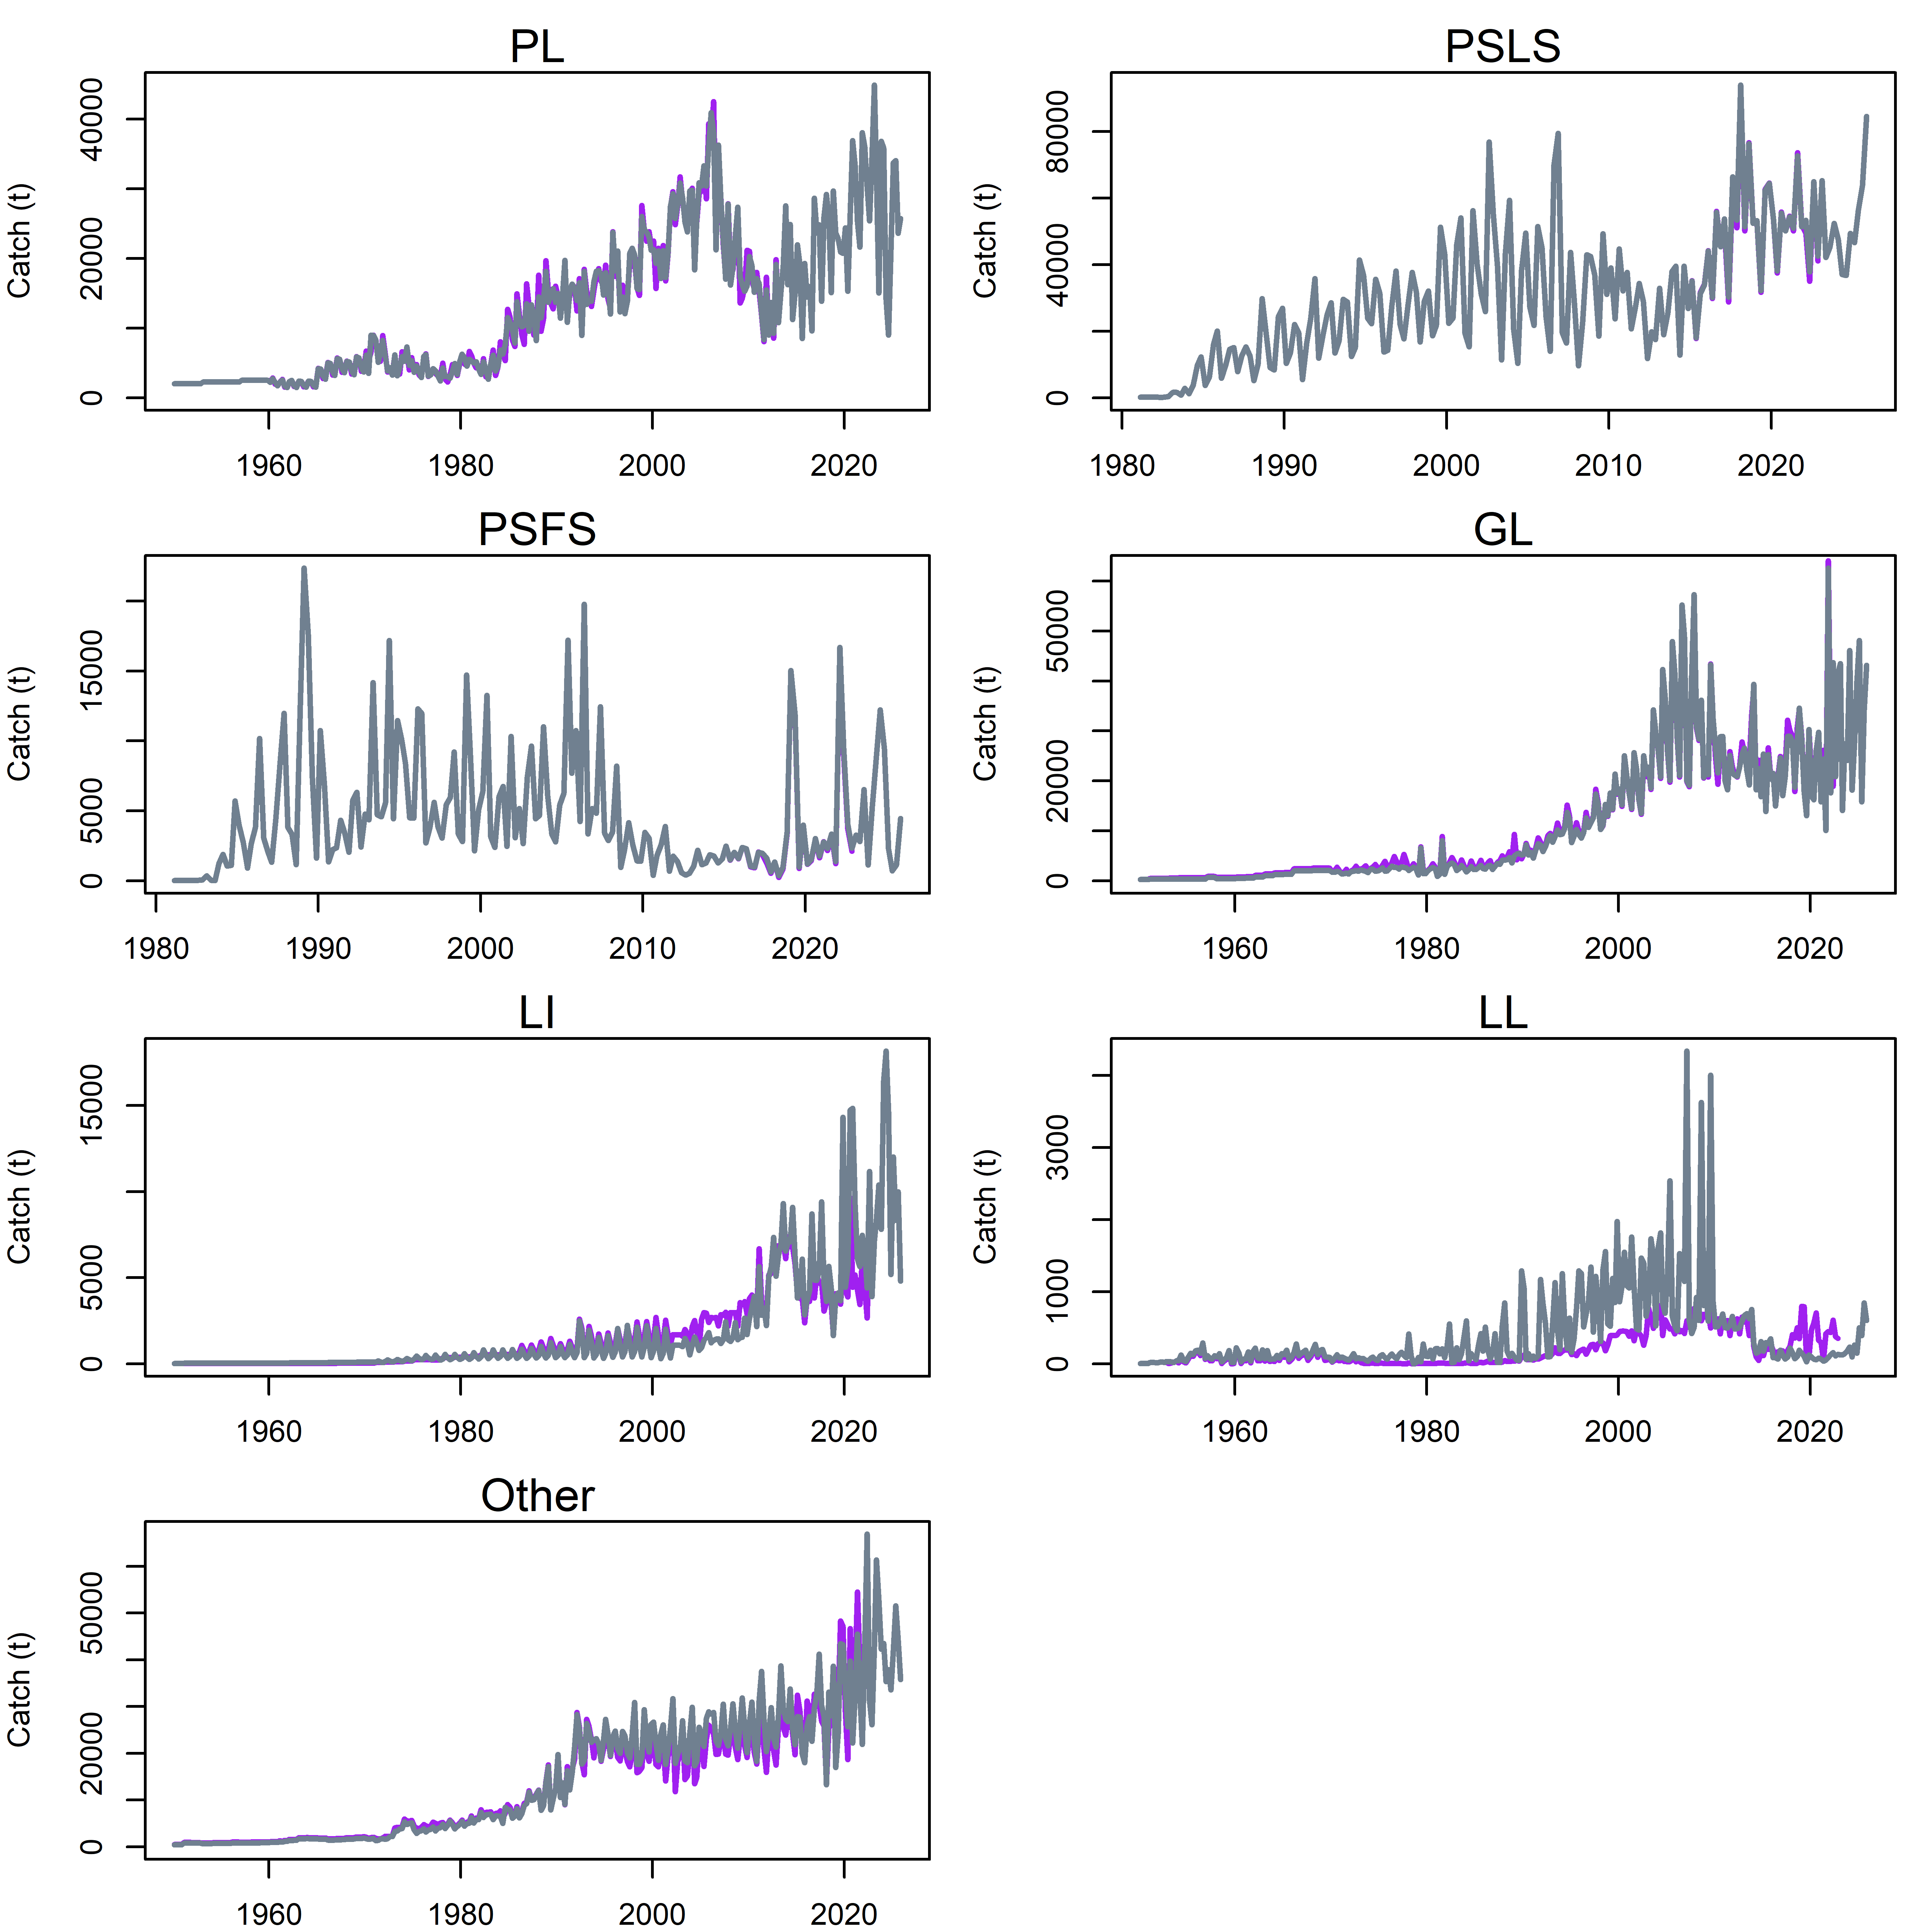
Figure 3: Fishery catches (metric tonnes) aggregated by year. Note the y-axes differ between plots. Purple lines are catches used in the 2023 assessment. The differences in catch are mainly due to general improvements in the data quality over time.

Abundance indices
Four standardised CPUE series (Table 3, Figure 4) were available at the time of the assessment, from the following sources:
- Maldives pole and line index (Shimal et al., 2026)
- European Union PSLS index (long and short versions; Kaplan et al., 2026)
- BAI (echosounder-based index; Uranga, J. 2026)
- ABBI (behavioural association of skipjack with FADs; Baidai et al., 2026)
The CPUE series are included in the assessment as relative abundance indices. Detailed descriptions of the indices and their standardisation processes are available and were discussed at the 28th WPTT(DP). They are briefly discussed here.

Maldives PL CPUE
Shimal et al. (2026) updated the abundance index for skipjack tuna from Maldives pole and line catch and effort data using the same methods as previous standardisations. The index was derived from multiple datasets with differing level of detail over the period 1995–2025 using a Bayesian approach (Figure 4). The main concern on this CPUE is that the spatial area in which the Maldives pole and line fishery operates does not represent the entire Indian Ocean, and thus the index may be more appropriate as a regional abundance index. There has been a significant and sharp increase of the index in the years since the last two assessment.

European Union PSLS CPUE
The European and associated flags purse seine fishing activities in the Indian Ocean during 1981–2025 have been monitored through the collection of logbook and observer sampling. Standardised indices of the abundance of skipjack caught by the European purse seiners (Spain and France) under floating objects (including primarily sets on drifting fishing aggregating devices) were developed and provided to the assessment (Kaplan, et al. 2023; Kaplan et al., 2026). The standardisation was based on the application of a generalized additive mixed model (GAMM) which considered a comprehensive list of candidate covariates, including non-conventional covariates. Both a short time series from 2010 to 2025 and a long time series from 1990 to 2025 were developed (the short time series includes several methodology improvements that make use of newly available information). The short series closely resembles the long series across comparable periods, but it is insufficient to be used as an independent index in the model (using the short series would yield results that are very similar to those of the long series in the model that included both the PL and PSLS index). Consequently, the assessment focuses on the long timeseries, as in the 2023 assessment. The index has seen a significant decrease in the last three years, in contrast to the Maldives index (Figure 4).

Other indices
Baidai et al. (2023) developed a novel approach to construct estimates of tropical tuna population size based on their associative dynamics with floating objects and acoustic data collected from echosounder buoys. The approach was updated in 2026 to provide time series of abundance for skipjack tuna in the western Indian Ocean, over the period 2013 to 2024 (Figure 3; Baidai et al., 2026). This is called the ABBI index (associative behaviour based abundance index) or ‘behaviour’ index in the model.
An additional echosounder-based CPUE index (BAI) was provided to the WPTT28(DP) for consideration on inclusion in the assessment from the years 2012 to 2024 (Uranga, 2026).
The ABBI index closely follows that of the PSLS long series, while the BAI index follows the Maldive PL index. Therefore, two indices are increasing over time, while two show decreasing trends in the final years of the model. The BAI index shows a remarkable decline in CPUE in the final year of the index.

Table 3: CPUE series available for the SS3 Assessment. Number is the SS3 index number
Name | Number | Description
MDV_PL | 8 | Maldive pole and line index (1995-2025)
PSLS_long | 9 | European log-associated PS index (1991-2025)
BAI | 10 | BAI – echosounder index (2012-2024)
ABBI/behaviour | 11 | ABBI – associative-behaviour-based-abundance-index (FAD-associations and echosounder (2013-2024)

Figure 4: Standardized CPUE indices available for the model. All series have been rescaled so that they are visually comparable for relevant periods of overlap.

Length frequency data
Available length-frequency data for each of the defined fisheries were compiled into 20, 4-cm size classes (20−24 cm to 92−96 cm) and were aggregated to provide a composite length composition for each year (Figure 5). Each length frequency observation for purse seine fisheries represents the number of fish sampled raised to the sampling units (sets in the fish compartment) while for fisheries other than purse seine each observation consisted of the actual number of skipjack tuna measured. In the assessment, all length composition strata from all fleets were weighted by dividing the number of fish included in the aggregated sample by a factor of 1000, with a maximum initial sample size of 10. Size data were examined by the Secretariat and problematic data were removed from the database (country-gear-time-area strata for which the size data are removed can be made available upon request) for the 2023 assessment. For example, Maldivian PL from 1987 to 2000 were removed from the database as were considered extremely unreliable. However, on re-evaluation of these data in 2026, it has been noted there is no documentation detailing the reasons behind why these data were excluded, and inspection of the data revealed no inherent differences in the data between 1987 -2000 compared to 2000 – 2025. However, with no detailed analyses of these data, data filtering was kept from the previous assessment, e.g. length data for 2015/2016 were removed as only extremely small fish (less than 1kg on average) were reported, and data earlier than 2000 from the Maldives and MUS fisheries were removed. Aggregated catch-at-length distributions for each fishery are shown in Figure 6.
The inclusion or exclusion of length data in this model requires a more detailed analysis prior to the next assessment, as it is unclear as to why certain data have been removed, and others kept in the assessment.
The Maldives PL fishery length distribution typically has two very distinct modes (about 50 cm and 70 cm) indicating that the fishery appears to be catching two different life stages of skipjack tuna. The multimodal length frequency can introduce a significant amount of uncertainty into the assessment model because changes in the composition of modes imply changes in selectivity. Before 2015, the two modes are highly distinct, but then became less obvious after 2016 (Figure 7). Further investigation was done on the spatial and temporal distribution of the Maldives PL length samples (provided by 1x1⁰ resolution). Prior to 2015, all samples were collected from a few spots along longitudes 72⁰ to 73⁰. The multimodal distribution is mainly driven by samples from one spatial grid cell (0.5⁰ latitude and 73.5⁰ longitude 73.5), which accounted for over 30% of total samples. After 2016, the samples were taken from a considerably wider range of locations and contains mainly smaller fish. The multimodal distribution doesn’t appear to be seasonal.
A recent decline in mean size in the Other fleet probably reflects the erratic sampling from this fleet. It has been noted previously that the length frequency data from Thailand small purse seiners in 2007 and following years were of extremely poor quality. For the ‘Other’ category, size data between 2007 and 2010 were not used.
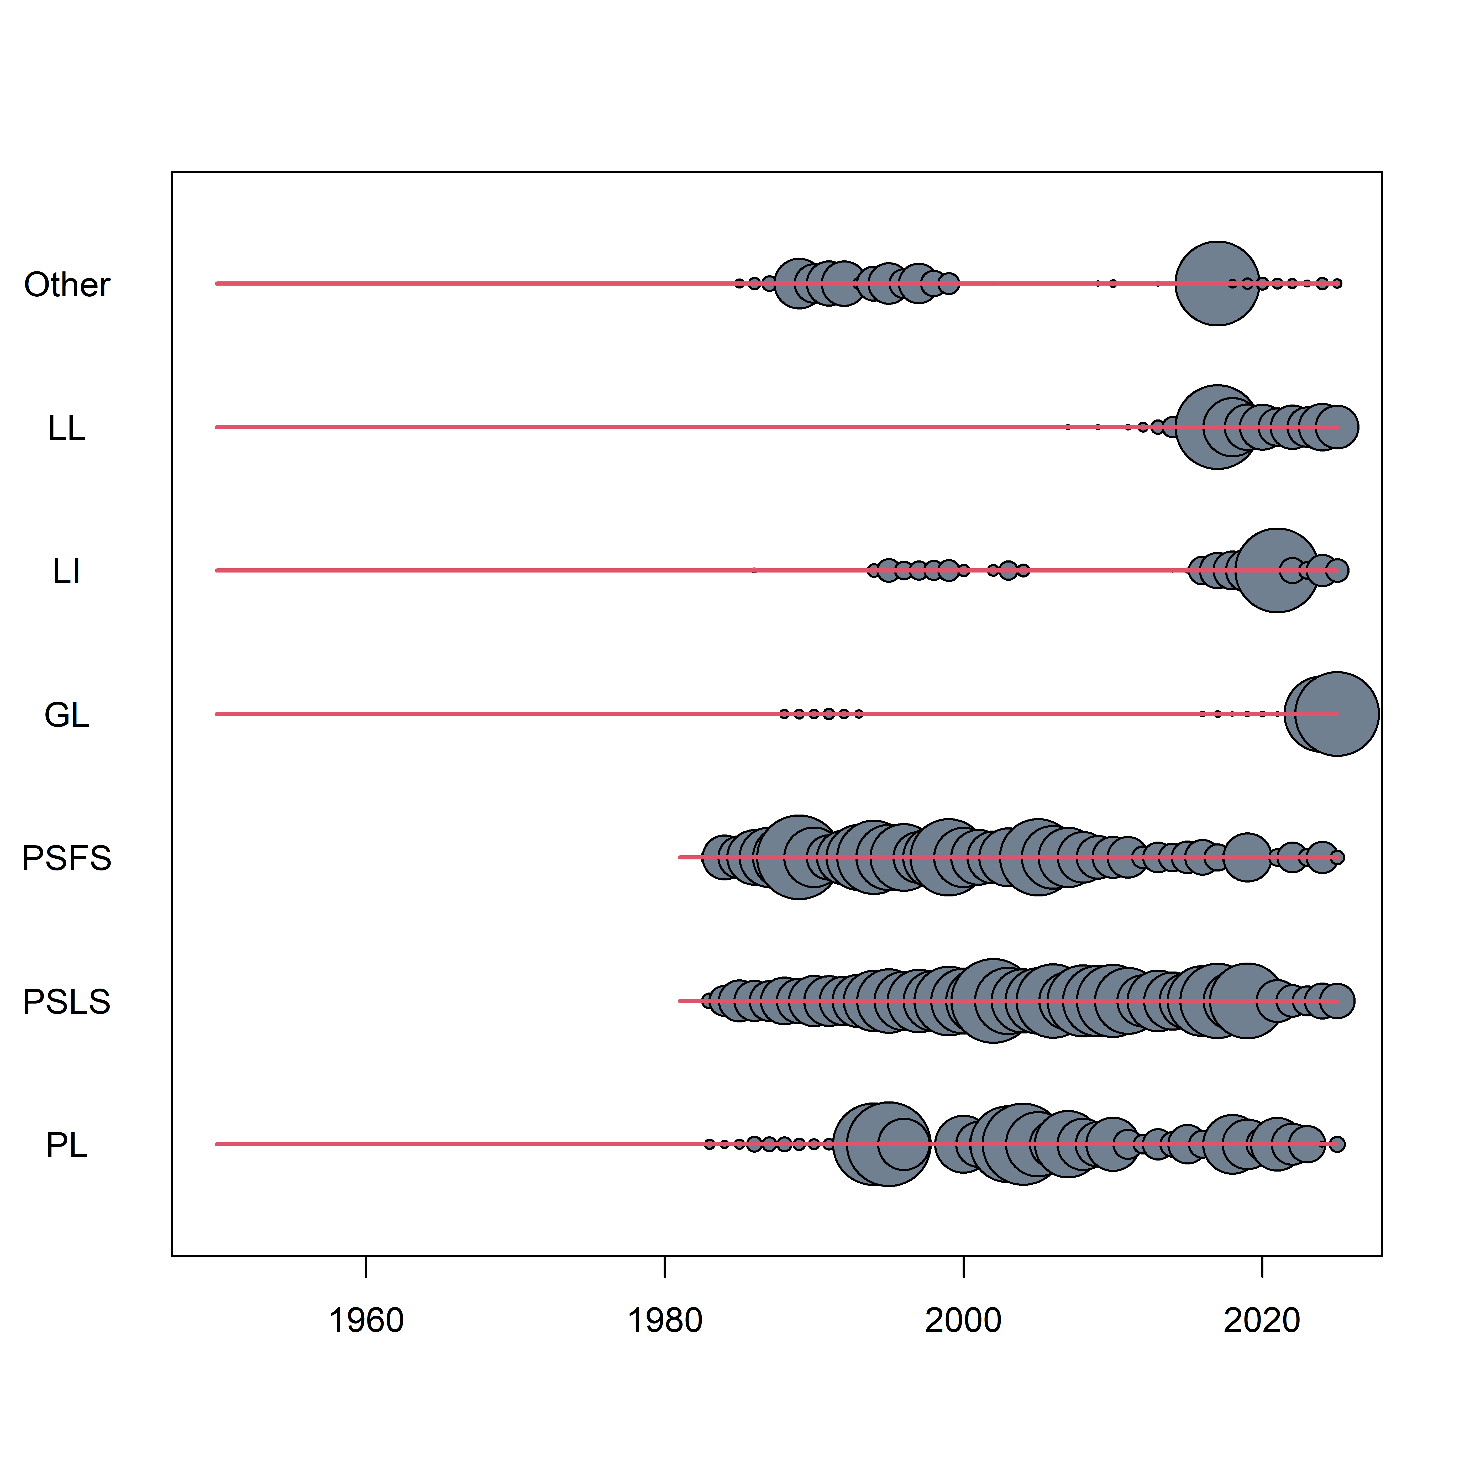
Figure 5: The availability of length sampling data from each model fleet by year. The grey circles denote the presence of samples in a specific year (the size indicate number of quarters being sampled). The red horizontal lines indicate the time period over which each fleet has operated.

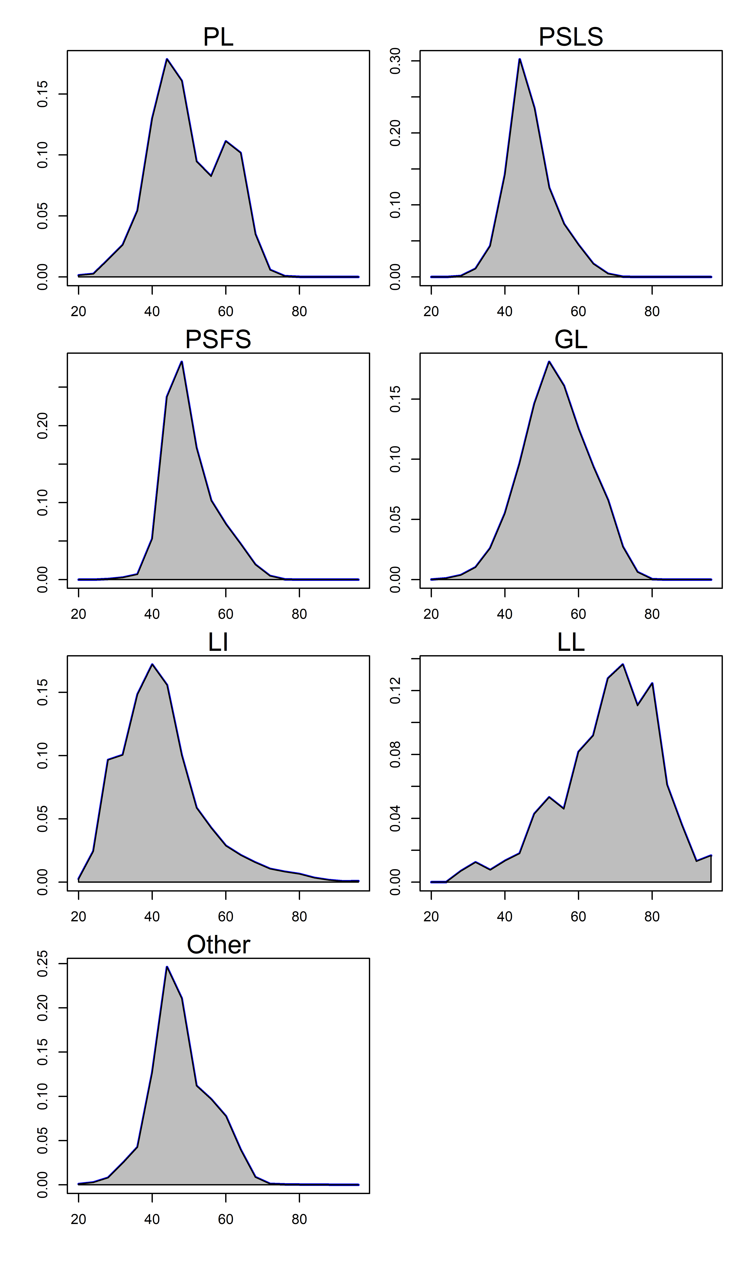
Figure 6: Length compositions of skipjack samples aggregated by model fishery.

Figure 7: Size distribution (fork length, cm) of skipjack tuna sampled from the Maldives pole and line fishery by year showing the distinct multimodal distribution of lengths.

Tagging data
The model includes tagging data from the RTTP-IO project. The data have not changed since the previous assessment, thus this section is taken from the 2023 assessment. A considerable amount of tagging data was available for inclusion in the assessment model (Hallier & Million 2009). Between 2005 and 2007, about 77000 tagged skipjack were released from Tanzania, Seychelles and Mozambique Channel under the RTTP-IO program (Figure 8). Additional tagging (~22000 releases) also occurred in the eastern Indian Ocean as part of small-scale tagging operations in 2004–2009 (Figure 5). The most substantial small-scale project was based in the Maldives (Jauharee & Adam 2009), but tags were also released near Lakshadweep, Mayotte, western Sumatra and the Andaman Islands.
Most skipjack tagged under the RTTP-IO were under 2-year of age (Figure 9) The percent of returns for the RTTP-IO tags is approximately 16% and the returns were primarily from the purse seine fishery in the western Indian Ocean within four years after release (Figure10, Table 4). A significant proportion of the tag returns from purse seiners were not accompanied by information concerning the set type. These tag recoveries were assigned to either the free-school or FAD fishery based on the proportion of catch by each fishing mode. The low number of returns from other fisheries is partly due to lower catch numbers, particularly of the smaller size classes that were tagged, but probably due in most part to non-reporting (Eveson 2012 et al.).
In contrast smaller fish was tagged under the small-scale program and the percent of tag returns is approximately 12% (Table 4). The returns were primarily from the Maldives Pole and line fishery (Figure 10), but the numbers were variable over time. In general release cohorts with higher recovery rates were mostly tagged in Maldives waters 2007 – 2009, whereas releases made further east in the IO waters between 2004 and 2006 tend to have lower recovery rates. The recovery from the purse seine fishery is extremely low (less than 10 recoveries except for those released in the first two quarters of 2009).
The RTTP-IO data is considered more reliable than the small-scale tagging programs, because the RTTP-IO has a much larger number of tags and was released by more experienced taggers. In contrast, there was no tag shedding estimates for the fleets conducting the small-scale tagging programs, and the reporting rates from pole and line fishery were also unknown. The previous assessment included the small-scale data in part of the model grid considering that the small-scale tagging program may provide additional insight into spatial dynamics. However, the inclusion of the small-scale data is likely to introduce bias to the model estimates because (1) the recovery rate of small scale tags from the PS fishery is extremely low (the tag returns from the PS fishery is the primary source of information on abundance), and (2) very few tags (<5%) were recovered with a time of liberty exceeding 2 quarters, whereas it is generally agreed that longer periods are required to achieve sufficient tag mixing. The utility of small-scale tag data was thoroughly investigated in previous assessments and they are not included in the current assessment.
For incorporation into the assessment model, tag releases were stratified by release region, time period of release (quarter) and age class. The returns from each tag release group were classified by recapture fishery and recapture time period (quarter). The tag data were further adjusted for tag losses and reporting rates to minimize the bias on estimates of fishing mortality and abundance in the assessment model. The procedure is described in below.
Age assignment of tag release. The length of release of each tag is recorded in the database but the model dynamics are based on ages. The age of each individual tag was estimated from the mean of the growth curve, assuming a 1 January birthdate. The age estimation occurs external to the model.
Tagging mortality. The number of tags in each release group was reduced by 25% to account for initial tag mortality. Tagging mortality was estimated relative to those for the best tagger (Hoyle et al 2015). Hoyle et al. (2015) did not find any differences in tagging induced mortality between species in the Indian Ocean but tag mortality was estimated to be lower for skipjack in the Pacific Ocean where there are more data.
Reporting rate. The results of the tag seeding experiments conducted during 2005−2008, have revealed considerable temporal variability in tag reporting rates from the IO purse-seine fishery (Hillary et al. 2008a). Reporting rates were lower in 2005 (57%) compared to 2006 and 2007 (89% and 94%). Quarterly estimates were also available and were similar in magnitude (Hillary et al. 2008b). This large increase over time was the result of the development of publicity campaign and tag recovery scheme raising the awareness of the stakeholders, i.e. stevedores and crew. SS3 assumes a constant fishery-specific reporting rate. To account for the temporal change in reporting rate, the number of tag returns from the purse-seine fishery in each stratum (tag group, year/quarter, and length class) were corrected using the respective estimates of the reporting rates. Following Kolody (2011) and Fu (2017), tags recovered at-sea are assumed to have a 100% reporting rate; tags recovered from landings in Seychelles were corrected for the quarterly estimates of reporting rates from Hillary et al (2008b). The tag recoveries were further increased by the proportions of EU PS catches landed outside the Seychelles, to account for purse-seine catches that were not examined for tags. For example, the adjusted number of observed recaptures for a PSLS fishery as input to the model${, R}_{L}^{'}$ was calculated using the following equation:

$$R_{L}^{'}=R_{L}^{sea}+\frac{R_{L}^{sez}}{P^{sez}r^{sez}}$$
where

$R_{L}^{sea}$= the number of observed recaptures recovered at sea for the PSLS fishery.
$R_{L}^{sez}$= the number of observed recaptures recovered in Seychelles for the PSLS fishery.
$r^{sez}$ = the reporting rates for PS tags removed from the Seychelles
$P^{sez}$ = the scaling factor to account for the EU PS recaptures not landed in the Seychelles.

The adjusted number of observed recaptures for a PSFS fishery was calculated similarly. A reporting rate of 94% was assumed for the correction of the 2009−2015 tag recoveries. The numbers of tag recoveries were also adjusted for long-term tag loss (tag shedding) based on an analysis by Gaertner and Hallier (2015). Tag shedding rates for skipjack tuna were estimated to be approximately 3% per annum.
For the RTTP-IO, a total of 58 420 releases were classified into 40 tag release groups. Most of the tag releases were under age 2 (Figure 9) A total of 10,458 actual tag recoveries were included in the tagging data set. The cumulative effect of processing the tag recovery data increased the number of recoveries to 11,640 tags.
Table 4: Number of Tag releases by year (of release) and recoveries by year (of recovery) for the skipjack tuna RTTP-IO and small scale tag Programs.
 |  |  |  |  |  |  |  |  |  | Recovery
RTTP Release |  |  | 2004 | 2005 | 2006 | 2007 | 2008 | 2009 | 2010 | 2011
2005 | 14744 |  |  | 160 | 1592 | 277 | 26 | 2
2006 | 41387 |  |  |  | 2793 | 4277 | 303 | 39 | 5
2007 | 21741 |  |  |  |  | 1901 | 1019 | 167 | 9
SS Release |  |  | 2004 | 2005 | 2006 | 2007 | 2008 | 2009 | 2010 | 2011
2004 | 4339 |  | 254 | 39 | 6 | 3 | 2
2005 | 2208 |  |  | 51 | 35 | 3 |  |  |  | 1
2006 | 2883 |  |  |  | 176 | 19 | 2 |  |  | 3
2007 | 741 |  |  |  |  | 29 | 19 | 8 | 3
2008 | 5029 |  |  |  |  |  | 383 | 180 | 2
2009 | 7233 |  |  |  |  |  |  | 1440 | 39 | 2

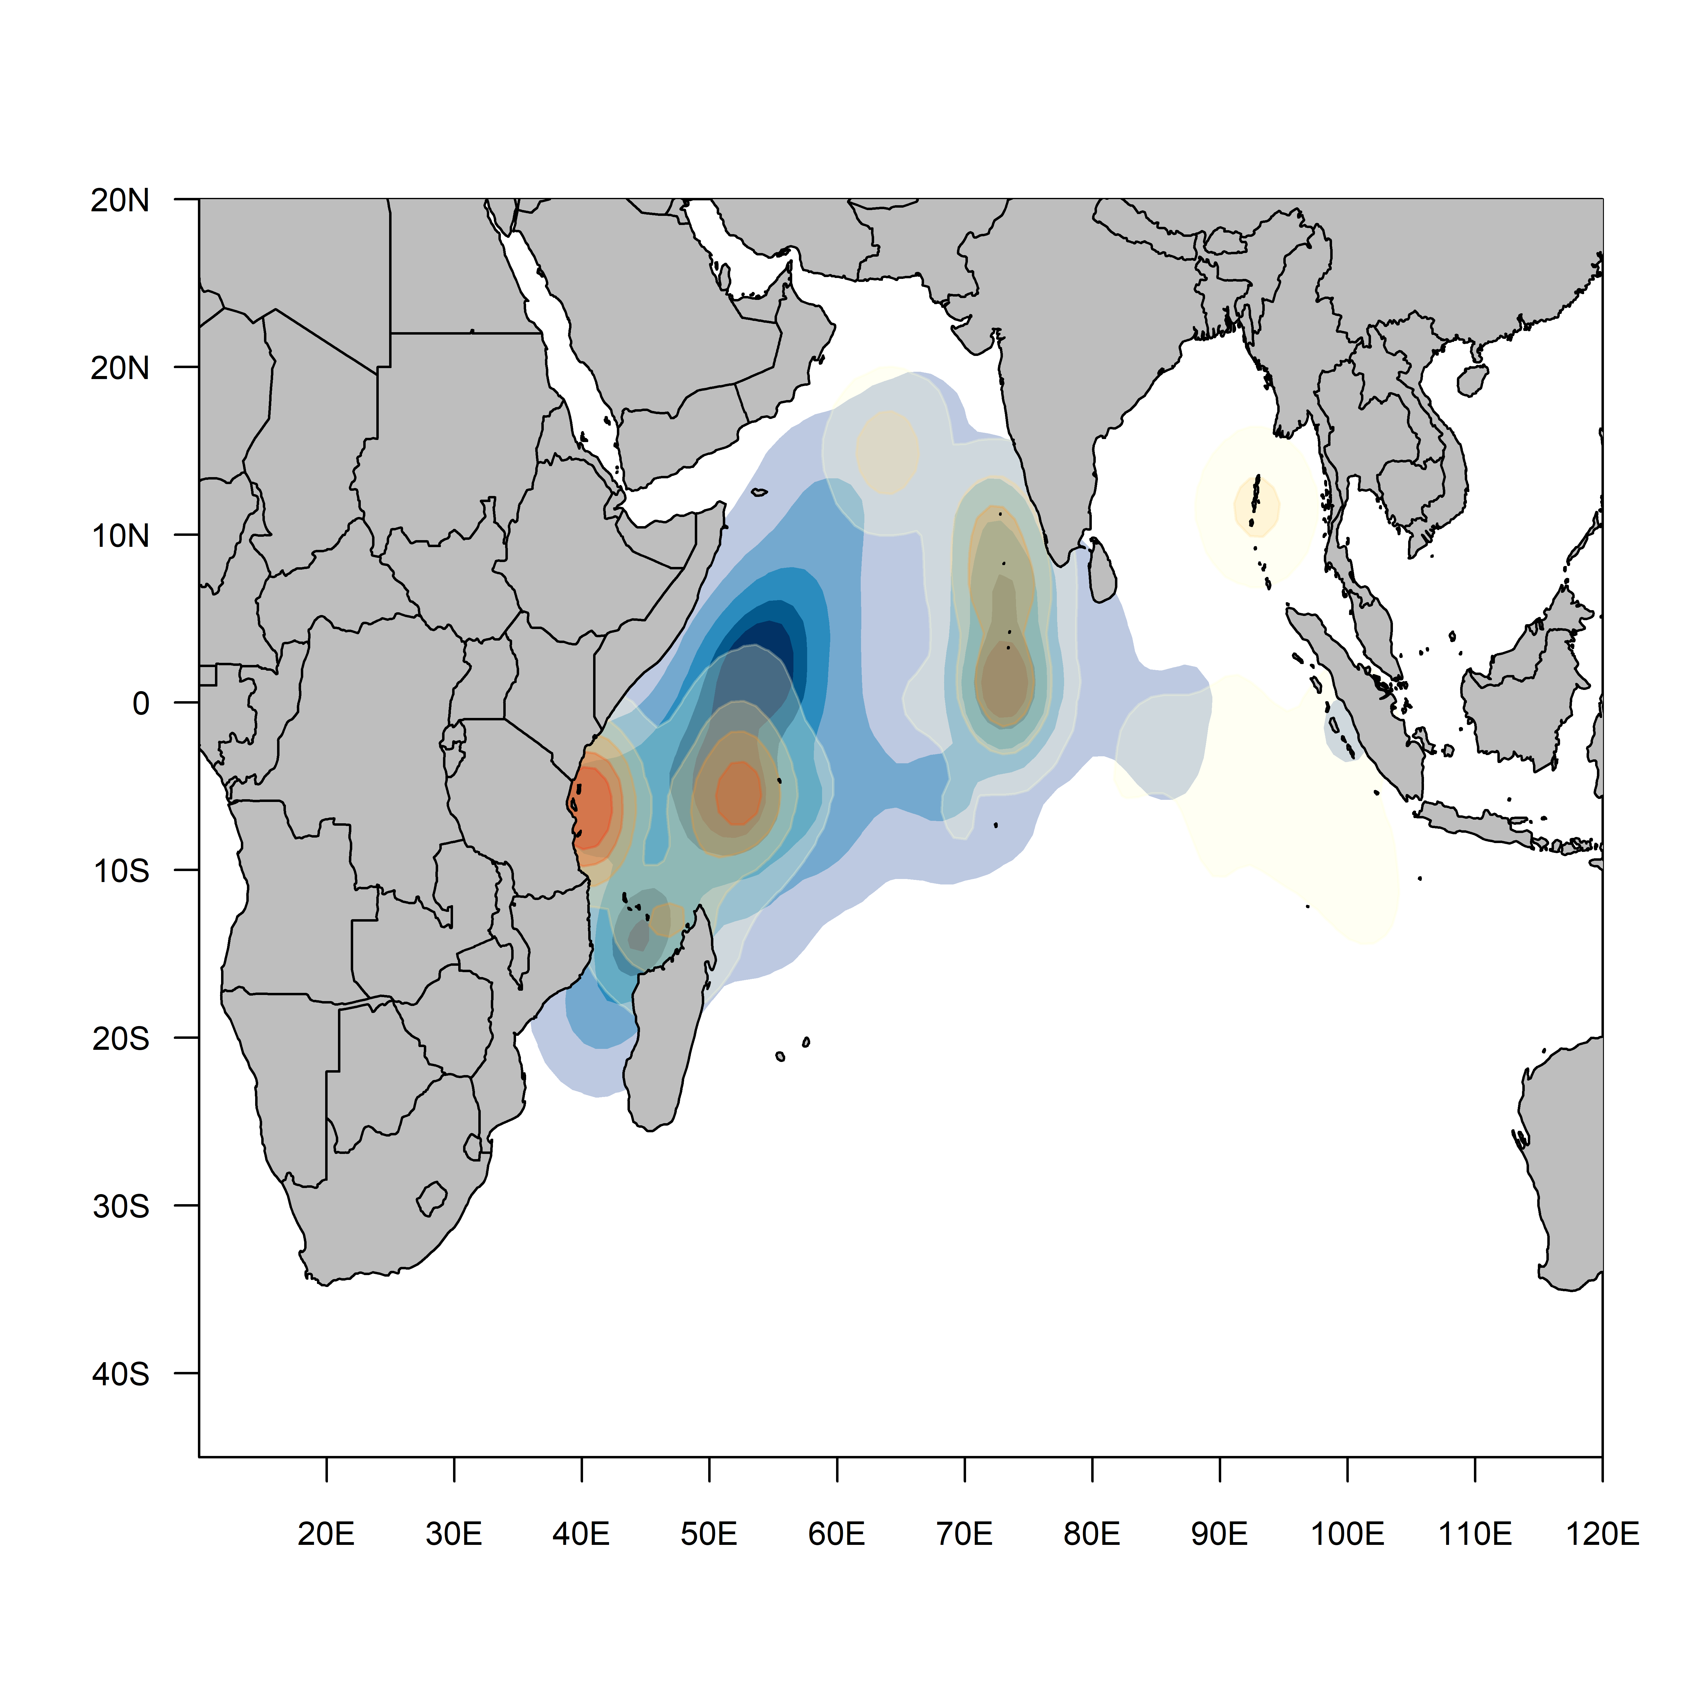
Figure 8: Location of releases (red) and density of recoveries for the skipjack tuna RTTP-IO and small-scale tag programs
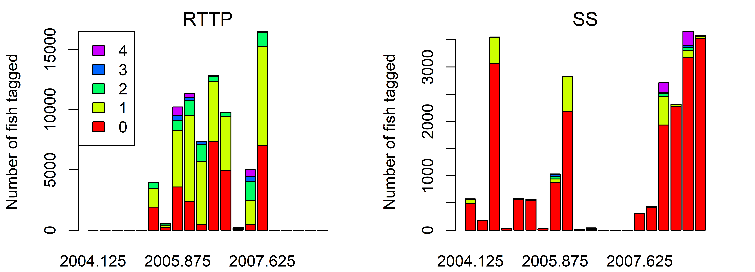

Figure 9 : Number of tag releases by quarter and age class for the skipjack tuna from the RTTP-IO and small-scale tag Programs. Ages were assigned based on the length.

Figure 10: Number of tag recoveries by year/quarter and fishery for the skipjack tuna from the RTTP-IO and small-scale tag Programs. Purse seine tag recoveries have not been corrected for reporting rate.

Model Description
The model was implemented in Stock Synthesis 3.30.25.1 (August 2026). A detailed description of the model and the general assumptions, alongside detailed technical descriptions of various components can be found in the SS3 User Guide, and associated webpage, and publications. Most of the structure of the model has remained the same since the 2023 model, and as such many of the following sections are the same as in the previous stock assessment report. There have been updates in 2026 to the length at 50 % maturity, and the length data included in the assessment.

Population dynamics
The model was sex-aggregated (and reported spawning biomass is the summed mass of all mature fish). The stock assessment model partitioned the Indian Ocean skipjack age groups 0–8 years with the last age a plus group (in unfished equilibrium, <0.25% of the population survives to reach the plus-group with the constant M value considered).
The population was assumed to be in unfished equilibrium in 1950, the start of the catch data series. The model was iterated from 1950-2025 using four seasons per year. The nominal unit of time in the model is one year during which population processes (e.g., recruitment, spawning, and ageing) were applied in sequence according to the dynamics implemented within the Stock Synthesis model (Methot 2013). The observations were fitted to model predictions on the seasonal basis within the year.
An alternative model option commenced in 1983 and assumed an exploited, equilibrium initial state, considering that the main fisheries were developed after 1983 and there is very little submitted data prior to that. Initial fishing mortality parameters were estimated for each of these fisheries, based on early catches. The resulting fishing mortality rates are applied to determine the initial numbers-at-age. This model option is reported on in the sensitivity part of the report.

Recruitment
For some of the tuna species there is an indication of a strong seasonal pattern in recruitment. However, Itano (2000) suggested tropical tuna spawning does not always follow a clear seasonal pattern but occurs sporadically when food supplies are plentiful. SKJ has been assumed to have a continuous spawning season.
Recruitment was assumed to occur annually at the start of the year and SS3 programmed to allocate recruitment to each season (the population will have a collection of seasonal cohorts with different birthdays), with the proportion being estimated as time-varying parameters. New recruits enter the population as age-class 0 fish (averaging approximately 20 cm). A Beverton-Holt stock recruitment relationship was assumed with steepness fixed at a range of options. ISSF (2011) summarises steepness estimates from tuna fisheries, the high values reported seem to be consistent with SKJ life history. The final model options included three (fixed) values of steepness of the BH SRR (h 0.7, 0.8 and 0.9). These values are considered to encompass the plausible range of steepness values for tuna species and are routinely adopted in tuna assessments conducted by all tuna RFMOs.
Annual deviations from the stock-recruitment relationship were estimated for 1983–2024, assuming a lognormal distribution. Assessments of major tropical tuna species using a quarterly model time-step typically assumed the quarterly recruitment events to have a fixed standard deviation (σR) of 0.6 for recruitment deviates (Kolody et al. 2018), corresponding to an annual CV of about 0.3 (assuming quarterly recruits are independent, and the annual recruitment is calculated as the mean of four seasonal events). Season-specific parameters were estimated to distribute the mean recruitment among seasons (quarter). Recruitment anomalies by season were estimated for 1983 – 2024 with a standard deviation of 0.3.

Growth
Skipjack growth is rapid compared to yellowfin and bigeye tuna. Young skipjack are approximately between 10–20 cm at an age of 40–90 days after hatching and immature fish are approximately in a range of 20 cm to 40 cm at an age of 90 days to one year after hatching (Kiyofuji et al. 2019). Earlier assessments have considered length-at-age relationships that followed the standard von Bertalanffy growth function. But there were concerns that the von-B growth curves might not be capturing the rapid initial growth rate for this species (e.g. Kayama et al. 2004). The 2017 assessment adopted a two stanza VB-logK curve of Eveson (2012), derived from the tag-recapture data. The VB-logK curve was approximated using a Richards curve in SS3, with $L^{∞}$= 70cm, k=0.34809, and the inflexion parameter fixed at 2.9096. However, the $L^{∞}$appears to be low compared to the Pacific, where a number of estimates suggested maximum length above 80 cm (Bi et al., 2024). The two-stanza growth is considered to be appropriate for skipjack tuna as it captures the rapid growth of juveniles, and diminished growth from a transfer of energy from somatic growth to gonad development (Grande et al. 2010). A CV of 0.2 and 0.1 is assumed for the length at the initial and maximum age, respectively with linear interpolations for intermediate ages (Figure 11–left), loosely based on evidence from tagging data.
The weight-length relationship was estimated from Chassot et al. (2016), where W = 4.97e-006 L^{3.9292}.

Maturity
Maturity was estimated by Grande et al. (2010, 2014) to be invariant over time with 50% maturity at length 38 cm, corresponding to an age-at-maturity of 0.4 y with the Richard growth curve. The updated data in 2014 estimated an L50 of 39.9 cm FL (Figure 11 – right). This is also very similar to the 40 cm value reported in the Pacific, where the maturity is estimated to follow a knife-edge pattern with all fish two quarters or less being immature and all fish older being fully mature (Vincent et al. 2019). Zudaire et. al (2022) estimated reproductive parameters for skipjack tuna in the Indian Ocean as part of the ‘GERUNDIO’ project. The estimate of L50 (41.3 cm FL) obtained in this study is slightly higher than that obtained by Grande et al. (2010; 2014). probably affected by different maturity thresholds used in both studies.
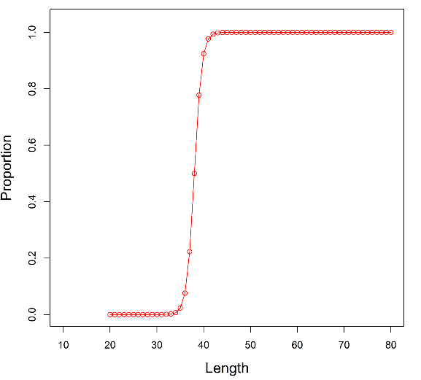
Figure 11: Fixed growth function for skipjack tuna following Eveson et al. 2012 (left) and length-based maturity ogive following Grande et al. (2014). For the growth function, the red line represents the estimated mean length (FL, cm) at age and the grey area represents the assumed distribution of length at age).

Natural mortality
The instantaneous rate of natural mortality (M) varies with age and consists of an average over age classes and age-specific deviations from the overall average M. In many fish stock assessments, M is fixed at a pre-specified value for all ages or sizes and is often not based on data related to the species or fishery being assessed. Incorrectly specifying M within stock assessments (and therefore having a mis-specified model) has been shown to have significant impacts on the relevant estimations of management-relevant indicators (Punt et al., 2021; Maunder et al., 2015).
Independent estimates of natural mortality for skipjack tuna were available from tagging data (Everson 2011), but the estimates appeared to be very low compared to the assumed or estimated M in the other oceans. For the assessment, the natural mortality of 0.8 (constant across all ages) is used, which is equal to the value used by the ICCAT when they used constant M). Previous assessment also considered estimating M within the model when the small-scale tagging data were included, and the estimates were similar in magnitude to the assumed value of 0.8.

Fleet dynamics

Selectivity
Length based selectivity was assumed for all fisheries. Within the model, the length-based selectivity is used to calculate the predicted catch-at-length distribution. Selectivity is internally converted to an age-based selectivity for purposes of removing the appropriate portion of the population in the catch. A non-parametric, cubic spline function was estimated independently for the selectivity of pole and line, and purse seine fleets (both PSLS and PSFS). The function is flexible enough to represent polymodal functions (and was motivated by the clear bimodal distribution of the PL fleet). Seven nodes were estimated for the PL fleet, and 5 nodes for the PSLS, PSFS fleets. The selectivity of the gillnet and line fisheries were estimated using a dome-shaped, double normal functional form, and the selectivity of the longline fisheries was estimated using a monotonically increasing, logistic function.
Fishing mortality was modelled using the hybrid method that estimates the harvest rate using Pope’s approximation and then converts it to an approximation of the corresponding F (Methot & Wetzel 2013).

Dynamics of tagged fish
In the population model, tagged fish are assumed to have identical dynamics to the general population. Therefore, a reasonable period of mixing is required before this assumption would be valid. Tag displacement appears to suggest rapid mixing within the core PS area. However, this would be contingent upon the distribution of fishing effort (i.e., if the gear is deployed a long way from the release site, all recoveries will suggest rapid movement, but they might not represent the movement of the general population). Also, directed seasonal migration can cause large displacements, without necessarily resulting in uniform mixing. The Stock Synthesis model specifies a tag mixing period during which observations do not contribute to the overall likelihood function. Previous analyses examined tag mixing periods ranging from 2 to 6 seasons, with a longer mixing period effectively de-weighting the tagging dataset. The current assessment model used a four-quarter tag mixing period, retaining about 20% recovered tags in the model.

Modelling methods, parameters, and likelihood
The total likelihood is composed of four main components: catch data, the abundance indices (CPUE), length frequency data and tag release/recovery data. There are also contributions to the total likelihood from the recruitment deviates and priors on the individual model parameters. The model was configured to fit the catch almost exactly so the catch component of the likelihood is very small. There are two components of the tag likelihood: the multinomial likelihood for the distribution of tag recoveries by fleets over time and the negative binomial distribution of expected total recaptures across the model region.
Assumed CV of 20% (lognormal observation errors) was applied to standardised CPUE indices. The CV of 20% is probably not realistic for these fisheries, but it allows the model to fit the core features of the relative abundance series.
The individual length frequency observations were assigned a sample size that is proportional to the number of fish measured, with a maximum sample size capped at 10 (except for the ‘Other’ fisheries, where the maximum is capped at 1).
The negative binomial distribution allows for overdispersion relative to the ideal, independent movement, fully mixed, tag recovery distribution (e.g., which might be expected to conform to the Poisson distribution). The overdispersion parameter τ was fixed at 20 and was applied equally across all tag groups. Previous assessments attempted to estimate τ but the estimate was strongly driven by the prior.
The parameters estimated by the model included:
- Catchability for the CPUE series
- Selectivity parameters
- Virgin recruitment
- Annual recruitment deviations from the stock recruitment relationship
- Annual seasonal-specific recruitment deviations

The Hessian matrix computed at the mode of the posterior distribution was used to obtain estimates of the covariance matrix, which was used in combination with the Delta method to compute approximate confidence intervals for parameters of interest.

Assessment model runs
A base model was configured that represents a continuity run from the 2023 assessment with updated data and several revisions of the model. A range of sensitivity or exploratory models were later conducted explore alternative assumptions and parameter configurations. On basis of the analyses, final model options were tentatively proposed that include an ensemble of models running over permutations of plausible parameters and/or model settings, from which the stock status was estimated, and uncertainty was quantified (the Grid). The assessment was conducted using the 3.30.25.1 version of the Stock Synthesis software using R. Most diagnostic plots, and model updates were coded in R and generated using the r4ss and ss3diags packages. Stock status is reported for the terminal year of the model (2025).
When the HCR for skipjack was in place (Resolution 16/02), the assessment was required to estimate required inputs to the HCR which included SSB_{year} / SB₀ (current depletion), SB_{40 %} (40 % of unfished spawning biomass), F _{40%} (fishing mortality corresponding to stock levels at SB_{40%}. These values are also noted in the assessment, however the main stock status reference points are based on MSY reference points, as is the case for all other IOTC species (Resolution 15/10).

Updates to the base model for 2026
In the 2023 assessment, final model options selected to quantify stock status by the WPTT included 36 models with alternative CPUE configurations (three options); alternative assumptions on CPUE catchability (annual increase of 0 or 1 %); alternative steepness parameters (0.7, 0.8, 0.9); and alternative growth parameters (two options).
The 2023 reference model was re-run to ensure continuity, and some revisions were incorporated based on preliminary analyses. These revisions are to improve the assessment model, but they do not represent any major structural changes to the model. The revisions included:
- Updating the SS3 executable to the latest version
- Updating the catch, length-frequency, and CPUE data inputs.
- Updating the recruitment deviations to the appropriate timeframe
- Updating the length at 50 % maturity (L50) from 38 cm to 39.9 cm
A sequential, stepwise approach was taken for the model updates (Table 5). The configuration of the resulting base model is summarised in Table 6. The base model in 2026 included the Maldives pole and line index, and the European purse seine index (long).

Table 5: Description of the sequence of model runs to update the 2026 base model.
Model | Description
0_base_2023 | 2023 reference model
0_base_2023_exe | Updated R and SS3 executable (version – 3.30.25.1)
1-update-catch | Updated and revised catch series, extended the model to 2025
2-update-lf1 | Updated and revised length-frequency data (no filtering of data)
2_update_lf2 | As above, with same filtering of data as previous assessment
2_update_lf3 | Updated and revised length-frequency data, with the same filtering as 2023, plus additional filtering where necessary (exceptionally large fish were removed).
3-update-cpue | Updated and revised CPUE data as 2023 – PL and PSLS_long (weighted evenly)
4-update-L50 | Update length at 50 % maturity to 39.9 cm

Table 6: Main structural assumptions of the skipjack base model and details of estimated parameters. Changes to the 2023 reference model are highlighted in red.
Parameter | Assumptions | Values
Recruitment | Occurs at the start of each season as 0 age fish.  Recruitment is a function of Beverton-Holt stock-recruitment relationship (SRR).  Seasonal apportionment of recruitment with temporal deviates 1983 – 2024  Temporal recruitment deviates from SRR, 1983−2024. | R₀ Norm(10,10); h = 0.80  SigmaR = 0.3.
Initial population | A function of the equilibrium recruitment in each region assuming population in an initial, unexploited state in 1950.
Age and growth | 9 age-classes, (0-8) with the last representing a plus group.  Growth based on a Richard growth model which approximate the two-stanza growth estimated by Eveson et al (2012).  SD of length-at-age based on a coefficient of variation decreasing linearly from 20% at age 0 to 10% at maximum age.  Mean weights (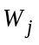 ) from the weight-length relationship 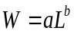. | $L^{∞}$= 70.3509 cm, k = 0.34809, Richard parameter of 2.9096.
Age and growth |  | a = 4.97 e-06, b = 3.39
Instantaneous rate of natural mortality | Constant at 0.8
Maturity | Length specific logistic function from Grande et al. (2014).  Mature population includes both male and female fish (single sex model). | L₅₀ = 39.9 cm  Mat slope -1.25
Selectivity | Cubic spline (7 nodes) selectivity for PL Fishery  Cubic spline (5 nodes) selectivity for PSLS and PSFS Fisheries  Double normal selectivity for Gillnet, Line, and ‘Other’ fisheries  Logistic selectivity for the longline fishery
CPUE indices | PL index 1995 – 2025; PSLS index 1991 – 2025. Temporally invariant catchability
Fishing mortality | Hybrid approach (method 3, see Methot & Wetzel 2013).
Tagging data | Included only tag release from the RTTP program, and EU PS tag recoveries (adjusted for externally estimated reporting rates); tags assumed to be randomly mixed at the model region four quarters following release;

Model sensitivity testing
The base model (“4_update_L50”) was the starting point for further analyses and exploration of potential sensitivities within the model. Within this phase, variations of key data inputs, biological parameters, and model structures were explored. In this year’s assessment, two structural changes were tested (starting the model later (1983) and splitting the assessment into two areas). Additionally, the model’s sensitivity to data inputs and biological parameters was also tested. The aim of doing these runs was to identify any major sources of uncertainty that would impact assessment outputs. If specific data inputs or biological parameters were found to impact the assessment output, the plausible variations in these values were kept in the final ensemble of models used in the ‘grid’ from which stock status is derived.
Sensitivity testing was discussed at the 28th WPTT(DP), and some initial explorations agreed on. Further runs were included as model development continued.
Discussions at the 28th WPTT(AS) expanded on the sensitivity runs so that models with “conflicting” trends in the estimated abundance (CPUE/abundance indices) were included (see Table 7 in bold below). These runs were:
- The Maldives pole and line index (increasing in final years) with the ABBI index (not increasing in final years);
- The PSLS index (not increasing in final years) with the BAI index (increasing through the time period of the index).
Additional sensitivity runs requested at the WPTT28(AS) were:
- Addition of 1.25 % catchability to MDV_PL index (only index in model)
- Addition of 1.25 % catchability to PSLS index (only index in model)
- Value of 0.6 for sigma R
Table 7 provides a brief description of the range of alternative model options explored in sensitivity testing.

Table 7: Description of various data inputs and biological parameters varied in sensitivity runs.
Sensitivity | Description of test
CPUE indices
s1a_MDV_cpue | Inclusion of MDV_PL CPUE only
s1b_PSLS_cpue | Inclusion of PSLS CPUE only
s1c_BAI_cpue | Inclusion of BAI CPUE only
s1d_ABBI_cpue | Inclusion of ABBI (behaviour) CPUE only
s1e_all_cpue | Inclusion of all four CPUE indices (equal weighting)
s1f_PL_ABBI_cpue | Inclusion of MDV_PL and ABBI (“conflicting”)
s1g_PSLS_BAI_cpue | Inclusion of PSLS and BAI (“conflicting”)
s1h_PL_q1_cpue | Addition of 1.25 % catchability on MDV_PL index (only index in model)
s1i_PSLS_q1_cpue | Addition of 1.25 % catchability on PSLS index (only index in model)
Catch data
s2_update_som | Removal of Somalia catch data (only two years of data reported in 2024, and 2025)
Sigma R
s10_sigmaR | Value of 0.6 for sigma R
Growth
s3_Linf_est | Length at age_{max} estimated in the model
s4_Linf_est_LL2 | Length at age_{max} estimated in the model, with longline length samples increased to actual numbers reported
s6_Linf_95 | Length at age_{max} fixed at 95 cm
Natural mortality
s7_natM_lorenzen | Natural mortality estimated using the Lorenzen form, with an assumed age_{max} of 8 years, and reference ages (adults) from 1-7 years.
Model structure
s8_mod_time | Model started in 1983 with population assumed to be at exploited equilibrium.
s10_two_area | Model split into “east” and “west” with MDV_PL, GL, LI, LL, and Other fleets (and MSV_PL CPUE index) in the “east” and PSLS, PSFS fleet in the “west” (with PSLS CPUE index). Tag releases occurred in the “east”. Movement rates estimated between the areas.
Catchability
s9_catchability | Catchability increase (1.25 % compounding discount on the MDV_PL and PSLS CPUE indices)

Final ensemble models (Grid)
From the results of the sensitivity analyses, the model was found to be most sensitive to changes in the inclusion or not of various CPUE indices. With no independent abundance indices, the current abundance could feasibly be either represented by the Maldive pole and line index, or the PSLS index. The two alternative abundance indices showed differing trends and when the BAI index was included as the abundance index, the stock was estimated to go above values for B₀ despite increasing catches over time, suggesting this was not a realistic abundance index for the stock. Additionally, when just the Maldive pole and line index was used in the model, the stock again was estimated to be at very high levels, close to 90 % B₀ which represents a very optimistic outlook for the stock. The opposite scenario was true when the PSLS CPUE index was used as the main abundance index, with values of current stock status much lower than estimated by the Maldives pole and line index. Therefore, the base model includes both the MDV_PL and PSLS indices, as this represents a balanced approach, and accounts for the likelihood that these two fleets are fishing different aspects of the stock (at the very least, spatially).
Discussions during the 28th WPTT suggested that the grid should include models with individual CPUE indices to truly account for the differences in estimated stock status (e.g. have half of the models with the Maldives pole and line index, and the other half with the PSLS CPUE index). Therefore, it was agreed to not include the reference or base model in the grid. Additionally, it was agreed to include the catchability scenario of a discount of 1.5 % annually compounded through time in half of the models. The two behavioural abundance indices, ABBI and BAI were discussed at length, and it was agreed to not include these indices in the grid, especially as these two indices have dramatically different trajectories, despite being derived from similar data sources. It was agreed that these indices should be investigated further, at the 29th WPTT, and invitations extended to the developers of those indices so that they attend the meeting and provide further context for these indices.
Therefore, at the end of discussions, it was agreed that the grid should include CPUE options that span the range of potential scenarios (Maldives pole and line – high stock status; PSLS – lower stock status), variation in catchability, estimated L∞ (with increased longline samples), Lorenzen instantaneous rate of natural mortality (M), and variation in the steepness (h) parameter. The final models included in the ensemble of models were:
- two options for L∞;
- two options for M;
- two options for CPUE;
- three options for h,
- two options for q

Table 8: Description of the proposed final model options for the grid for the 2026 assessment. The final models consist of a full combination of options below, making a total of 48 models. The options adopted within the reference (base) model (‘4_update_L50’) are highlighted, although the base model was not included in the grid.
Model options | Description
Steepness (h) in SRR | - h70: h = 0.70
Steepness (h) in SRR | - h80: h = 0.80
Steepness (h) in SRR | - h90: h = 0.90
Growth | - LinfestLL2: L∞ estimated (with increased sample size from LL fleet)
Growth | - Linf70: L∞ fixed at 70.3509 cm
Natural Mortality | - Lorenzen: – Lorenzen functional form M with reference ages 1-7 yrs, and maximum age of 8 years.
Natural Mortality | - Fixed M of 0.80 for all ages
CPUE | - CPUEmdv: Only MDV_PL index included
CPUE | - CPUEpsls: Only PSLS_long index included
Catchability | - q0: no catchability  - q1: 1.25 % catchability

Modelling Results

Continuity runs from 2023 model
Updating the SS3 executable (“0_base_2023_exe”) and removing several error messages had some impact on the model estimates in the earlier years, however these were negligible when looking at the stock status. Updating the 2023 base model with catch had some impact to estimates of spawning stock biomass (hereafter referred to as biomass), throughout the model time period, however the trend was similar throughout the model time period. These changes are presumably due to re-estimation of catches over time. Biomass estimates in more recent years (1995-2024) were higher, but similar to those of the 2023 model.
Updating the length frequency composition (all data, no filtering “2_update_lf1”) increased the overall estimate of biomass, but not the trajectory. Filtering the length data using previous filters, and updating with additional 2026 filters (mainly removal of extremely large fish) (“2_update_lf2 and 2_update_lf3”) increased the overall estimate of biomass. Not filtering the length data appears to provide more variability in the estimates of biomass throughout the model time period (“2_update_lf1”). Updates to catch, and length frequency data provide model trajectories in the final year that are sharply decreasing in terms of biomass estimates, and stock status (Figure 12, Figure 13).
Updating the CPUE indices resulted in increased estimates of biomass throughout the model time period. The CPUE indices also reversed the decreasing trend in biomass in the final two years of the model, both in absolute values, and in stock status (Figure 12, Figure 13). This is mostly driven by the recent increases in the Maldive pole and line CPUE index.
The increase from 38 cm to 39.9 cm in the length at 50 % maturity (“4_update_L50”) had a modest impact on the estimates of biomass, reducing the overall estimates slightly throughout the time period. Estimates of depletion were not impacted as much. The increasing trajectory of the stock in terms of biomass and depletion was unaffected, with only a minor decrease in both. Bias correction was not applied in the base model, as the current implementation did not suggest this needed to occur (suggested values in SS3 were very similar to those already implemented in the model input files).
The full output of management quantities is found in Table 9. There is ~ 2 % decrease in C_{MSY} estimates from the 2023 base model to the 2026 base model, suggesting excellent continuity in C_{MSY} estimates.
Figure 12: Spawning biomass trajectories for IO skipjack from the stepwise model updates. (from the 2023 assessment reference model ‘0_base_2023’).

Figure 13: Spawning biomass trajectories (depletion (%)) for IO skipjack from the stepwise model updates. (from the 2023 assessment reference model ‘0_base_2023’).

Table 9: Estimates of management quantities for the step-wise updates of the 2023 stock assessment reference model (‘0_base_2023’) to the 2026 reference model (‘4_update_L50’)
 | SSB₁₉₅₀ (t) | SSB_{MSY} (t) | SSB₂₀₂₅ (t) | SSB₂₀₂₅SSB₁₉₅₀ | SSB₁₉₅₀SSB_{MSY} | F_{MSY} | F₂₀₂₅ | F₁₉₅₀F_{MSY} | C_{MSY} (t)
0_base_2023 | 1717570 | 419133 | 1198130 | 0.6975727 | 2.858591 | 1.06852 | 0.455484 | 0.426276 | 542666
0_update_base_2023 | 1642720 | 399935 | 1120190 | 0.6819117 | 2.80093 | 1.09414 | 0.484685 | 0.442983 | 530914
1_update_catch | 1683270 | 394732 | 643274 | 0.3821573 | 1.629647 | 1.09257 | 0.991476 | 0.907471 | 524029
2_update_lf1 | 1863360 | 438598 | 750331 | 0.4026763 | 1.710749 | 1.06647 | 0.841542 | 0.789091 | 567249
2_update_lf2 | 1721100 | 405093 | 658157 | 0.3824049 | 1.624706 | 1.08823 | 0.952057 | 0.874867 | 535707
2_update_lf3 | 1721100 | 405093 | 658157 | 0.3824049 | 1.624706 | 1.08823 | 0.952057 | 0.874867 | 535707
3_update_cpue | 1861880 | 439149 | 1168100 | 0.6273766 | 2.659917 | 1.08335 | 0.535638 | 0.494427 | 576022
4_update_L50 | 1828630 | 426643 | 1116060 | 0.6103258 | 2.615911 | 1.04884 | 0.534414 | 0.509529 | 571553

Model fits

Base model (4_update_L50)
The historical stock estimations from model updates up to 2023 are relatively comparable to the 2023 assessment reference model (Figure 12), demonstrating the assessment model's relative stability. However, there are significant disparities between 2022 and 2025 when the catches, length compositions, and CPUE are sequentially updated. The stock biomass significantly dropped under the recent catches when there was no updated abundance indicator to inform current recruitment. However, the new CPUE index, notably the Maldive PL index, which indicates a strong pulse of recruitment into the fisheries in recent years, is what is driving the substantial increase in biomass between 2022 and 2025 (terminal years of the model). Contrary to the previous model in 2023, recent length compositions indicate below-average recruitment in recent years, as updating the length-frequency data suggested biomass decreased under the current high catches. Only the addition of the CPUE indices reversed the declining biomass trend.
The base model included both the Maldives PL index and EU PSLS index (as in the previous assessment) with equal weighting. The two sets of indices are broadly consistent, in view of their overall trend (the increase from 1995 to 2005, the subsequent decline from 2006 to 2015, and the increase in more recent years). However, the PSLS index has a less contrasting trend over time, and does not display such an increase in CPUE from 2015 to 2025 as the Maldives PL index does. The model fitted the PL and PSLS indices reasonably well, although the recent sharp increase in the Maldives PL index was not able to be fitted well (with the predicted values underestimating the abundance in recent years) while the predicted values were overestimated for the PSLS index. This contrast is probably the model compensating for the contrasting trends in the indices in the last 3 years, with a dramatic increase in the Maldives PL index not reflected in the PSLS index (Figure 14).
As expected from the trends in the CPUE indices, there is a very slight increasing trend in the residuals of the Maldives PL index, and a very slight decreasing trend in the residuals of the PSLS index (Figure 15). As both indices are equally weighted in the model, this should not have too much of an impact on the overall biomass estimates.
The fits to the fleet-aggregated length frequency appear generally satisfactory (Figure 16), and the model has captured the gross features of the length composition data (indicating that there is probably no significant bias in the estimates of fishery selectivity). However, there is a lack of fit to the larger fish in the length samples from the longline fishery, as in the previous assessment. The previous assessment stated that “it is clear that smaller fish were most likely under-sampled” – it is important to note that sample sizes for this fleet are very low compared to other fleets. The model has tracked the mean length in the catches reasonably well: it predicted a moderate declining trend for most fisheries which is consistent with the observations (Figure 17). The model does not adequately account for the large inter-annual variability in the PSFS fishery. The length composition from the PSFS fishery shows some seasonal variation as well, with more large fish (> 50 cm) in quarters 3 and 4, potentially due to seasonal growth or shifts in availability.
The fit to the observed number of tag recoveries was examined for the fisheries which accounted for most of the tag returns (i.e., PSLS). The fit to the number of tag recoveries was examined by recombining the tags into individual release periods (i.e., aggregating the releases by age class) and excluding those recoveries that occurred during the mixing period (Figure 18). The number of tag recoveries varied considerably amongst the release periods and most releases occurred in 2006. Most of the observed tag recoveries in the post mix period were from the PSLS fishery and a high proportion of the total recoveries occurred during the first four quarters following the mixing period. The number of tag recoveries in the first quarter following the mixing period was generally underestimated (Figure 19). This can be an indication that the tags weren't properly mixed with the fish population that was susceptible to the PSLS fishery. Over the longer term, tagged fish were less vulnerable to the purse seine fishery, which resulted in a sharp decline in the number of recoveries. Fits to longer-term recoveries may be also reflecting variable tag reporting or misspecification of natural mortality.
Figure 14: Fits to the CPUE indices for the Maldives PL index and the PSLS long index.

Figure 15: Standardised residuals from the fits to the CPUE indices from the base model ‘4_update_L50’.

Figure 16: Observed (grey bars) and predicted (red line) length compositions (in 4 cm intervals) for each model fleet and season aggregated over time for the base model ‘4_update_L50’.

Figure 17: A comparison of the observed (grey points) and predicted (red points) average fish length (FL, cm) of skipjack by fleet for the main fleets with length data for the base model ‘4_update_L50’.

- PSFS
- PSLS
Figure 18: Observed and predicted the number of tag recoveries over time following the mixing period for (a) PSLS and (b) PSFS fleets in the base model. Tag release groups represent the total releases in each quarter (aggregating the age groups that define individual release groups).

Model estimates

Selectivity
As in the 2023 model, the estimated parameters in the basic model include: the overall population scale parameter R0, the time series of recruitment deviates, the distribution of recruitment among seasons, fleet selectivity parameters, and the catchability parameters for the CPUE indices.
The size-specific selectivity functions are presented in Figure 19 along with the maturity ogive. Full selectivity is reached for the PL fleet at around 70 cm, and 60 cm for the GL (gillnet) fleet. For all other fleets, full selectivity is reached earlier between 40-50 cm, except for the LL fleet where full selectivity is only reached at sizes above 80 cm (Figure 19). Half of the fleets retain high selectivity of very large fish e.g. GL, LI, LL and Other, while the PL, PSFS, and PSLS display a bimodal dome-shaped selectivity or a poisson-shifted dome-shape for selectivity (PSLS). This possibly represents two separate fishing métiers (e.g. different gear types that target different portions of the population, or spatial and/or temporal heterogeneity in fleet dynamics).
Selectivity estimates are very similar to the 2023 model.

Recruitment
Recruitment deviates were estimated from 1983 to 2024 (Figure 20). As in the 2023 model, there is a strong increase in recruitment from 1997 to 2004, followed by a decrease in estimated recruitment the following years (2005, 2006). From 2006 to 2024 there has been an increasing trend in recruitment, with strong yearly fluctuations. The historical estimates of recruitment from 1983 to 1995 have more uncertainty than later years, primarily due to the lack of “abundance” indices (CPUE indices) in the earlier years. This emphasises the influence of the CPUE indices on recruitment trends, certainty in recruitment trends, and in the overall biomass estimates from the model. It could be expected that the recruitment signal might be corroborated by the size data, but there is no strong signal in mean sizes, for the PL fleet (Figure 21). In fact the peak in size frequency in the PL fleet has increased in the years from 2020 to 2024, suggesting the opposite of a recruitment pulse (Figure 21). However the peak size in the ‘Other’ fleet has shown a potential recruitment pulse with smaller fish being caught from 2012 onwards (Figure 22). The geographical distribution of the fisheries within this fleet however are not accounted for in this graphic (meaning these could just be representative of fishing in different areas rather than an increase in small fish being recruited to the fishery).\
The seasonal recruitment distribution estimated by the PL and PSLS models is comparable throughout the four quarters and remarkably constant over time, with season two recruitment estimated to be somewhat higher than season one. Season three and four recruitment were estimated to be lower. It is likely that seasonal recruitment distribution was mainly driven by seasonal pattern in the CPUE indices.

Spawning stock biomass
Estimated biomass showed two steep declines, and very similar patterns to the 2023 model. The first steep decline in biomass is between 1983 to the late 1990s and the other after the mid-2000s (Figure 23), which are explained by a combination of catch removals and recruitment anomalies. The biomass has increased since 2010 from a historical low, to a peak in 2021. The last three years in the model show declines in spawning biomass, although the final year of the model does suggest an upward trajectory in biomass estimates, despite record high catches for 2024. It is clear from the stock biomass that the estimates are strongly driven by recruitment (Figure 23), which in turn is driven by the CPUE indices.
Figure 19: Estimated length-based selectivity for model fleets within the base model ‘4_update_L50’, with the maturity ogive (purple) plotted over the selectivity curves.

Figure 20: Recruitment deviates from the SRR with 90% confidence interval from the reference model ‘4_update_L50’.
Figure 21: Annual length frequency histograms for the length data included in the base model from the PL fleet.

Figure 22: Annual length frequency histograms for the length data included in the base model from the Other fleet.

Diagnostics
Some diagnostic tools were run for the base model, including running an age structured production model (ASPM), likelihood profiling, jittering, and a retrospective analysis.

ASPM analysis
The Age Structured Production Model (ASPM) analysis (Maunder & Piner, 2015) was used to identify the main drivers of the population trend and to assess whether the length composition data or recruitment deviates have an undue influence on estimates of abundance. Two variants of the reference model were run. In ASPM, the length composition data were excluded (selectivity parameters were fixed at the reference model estimates) and recruitment deviates were fixed at zero, so recruitment followed the stock-recruitment relationship. In ASPM_rec, the recruitment deviates estimated in the reference model were fixed in the model, with selectivity again fixed and the length composition data excluded.
The ASPM therefore reflects the information in the catch and CPUE data alone (together with the fixed biological parameters and selectivity), with no recruitment variability. The ASPM_rec adds the recruitment variability estimated by the reference model, but does not fit the length composition data directly. Because the deviates and selectivity were estimated from the reference model, some information from the length data is carried into this run indirectly.
The ASPM without recruitment deviations (ASPM, red lines) was unable to reproduce the observed CPUE indices (Figure 25, Figure 26). The fitted values were nearly flat over 1995-2025 and did not capture any of the variability of the indices. To accommodate this, the ASPM estimated a much larger stock (initial spawning biomass of about 7.2 million t, compared with about 1.8 million t in the base model, Figure 23). Catch is therefore a very small fraction of biomass, giving F/F_{MSY} of around 0.1 or less, compared with a peak of about 0.67 in the base model (Figure 24). Estimated catchability was about eight times lower than in the base model. Catch alone therefore does not explain the variation in the index.
Introducing recruitment deviations (ASPM_rec) recovered nearly all of the base model's behaviour (Figure 23). The fit to the CPUE was almost identical, and the biomass trajectory matched the base in shape, including the decline from the mid-1980s to the late 1990s and the peaks in the mid-2000s and early 2020s in the MDV PL index (Figure 25). The estimated deviations were similar to the base model in sign and magnitude, and variation in the index followed periods of high and low recruitment with a lag of one to two years, which is to be expected for a fast-growing short-lived species like skipjack. ASPM_rec estimated lower absolute biomass (roughly 15-30% below the base, Figure 23) and higher F/Fmsy (about 0.7 versus 0.5 in recent years, Figure 24), indicating that the composition data mainly influence the scale of the population rather than its trend.
These results indicate that population dynamics in the SS3 model are driven primarily by recruitment variability rather than by catch-driven depletion, which is expected for a short-lived, highly productive species such as skipjack under moderate exploitation. The MDV PL CPUE index therefore appears to reflect recruitment pulses rather than catch-driven depletion. No length data are available before the 1980s and the CPUE series begin in the 1990s, so the early biomass trajectory is determined by catch and model structure alone, and the 1980s-1990s decline is informed by length data and recruitment deviations rather than by CPUE.
Stock status conclusions were qualitatively consistent across all three runs, with F/F_{MSY} well below 1 and spawning biomass well above the threshold. However, absolute biomass and productivity estimates are sensitive to the composition data and the recruitment deviation structure. The ASPM-estimated scale is likely poorly determined, given the flat index, small catch relative to biomass and absence of composition data.

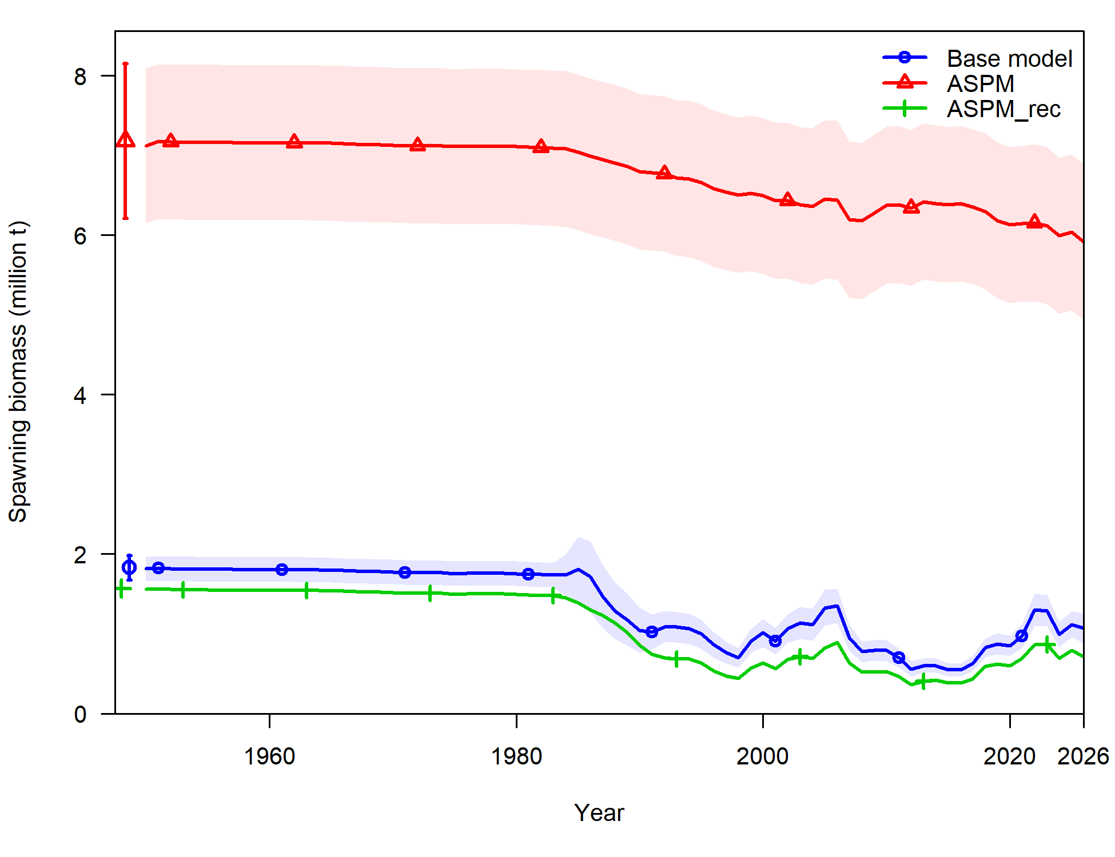
Figure 23: Estimated absolute spawning biomass (1000 t) for each model configuration.

Figure 24: Estimated fishing mortality relative to FMSY, 1950–2025, by model configuration.

Figure 25: Observed (points) and predicted (lines) for the MDV PL CPUE index, 1995–2025, with estimated catchability (Q) by model configuration.

Figure 26: Observed (points) and predicted (lines) for the PSLS abundance index, 1991–2025, with estimated catchability (Q) by model configuration.

Retrospective analysis
Retrospective analysis is a diagnostic approach to evaluate the reliability of parameter and reference point estimates and will allow the revelation of systematic bias in the model estimation. It involves fitting a stock assessment model to the full dataset, and then sequentially removing data from the inputs from the most recent years. The analysis was conducted using the base model, and the last 5 years of data were removed in 1-year increments to evaluate whether there were any notable changes to the model results. The selected period mirrors that of previous assessments. The analysis of the impact of data removal was conducted on the outputs of estimated spawning stock biomass (SSB) and the ratio of SSB_{current} to SSB₀.
There were some retrospective patterns in the historical estimates for SSB for years prior to 1983 when sequential years of the data were removed. There was some fluctuation in the estimates of SSB in more recent years, but when the stock status (SSB/SSB0) was investigated, there is no apparent retrospective pattern in the estimates for SSB₂₀₂₅/SSB₀ (Figure 29). The small shifts in estimates of overall biomass reflect the influence of recent years of both CPUE and catch data in estimating the overall biomass level of skipjack in the Indian Ocean. However, overall biomass estimates likely vary between model years anyway due to improvements in input data over time, and it is encouraging that the stock status remains constant when individual years of data are removed.

Figure 27: Retrospective analysis summary for the base model ‘4_update_L50’.

Likelihood profiling
A likelihood profile over log(R0) – the log of unfished recruitment – is a standard diagnostic used to evaluate how precisely the model estimates this key scaling parameter, and which data sources or model components are driving that estimate. R0 was fixed at a sequence of values spanning the range around its maximum likelihood estimate (MLE), and the model was re-optimised conditional on each fixed value, and the resulting total negative log-likelihood (NLL), together with its components (recruitment, length composition data, index data, priors, F ballpark, and parameter deviations), was estimated. The change in NLL relative to the minimum was plotted for the total and for each contributing component (Figure 28).
The likelihood profile shows a single, well-defined minimum with no evidence of secondary modes, suggesting LN(R0) is approximately 13.3. The lower bound on R0 is informed mainly by the recruitment, length and index data, while the upper bound is informed mainly by the tag recapture data. The tag data and the length, recruitment and index data therefore favour different scales for the population, however this is over a narrows range around the minimum, and there is no strong conflict between them at the base model estimate.
Figure 28: Profile likelihood of log(R0): change in total and component negative log-likelihood relative to the minimum, across a range of fixed log(R0) values.

Jittering
A jitter analysis was run on the base model to test whether the model converges to the same global solution regardless of starting values. Twenty-five jitter runs were performed, in which the initial parameter values were randomly perturbed, and the resulting likelihood, maximum gradient (Maxgrad), and unfished spawning biomass (SSB₀) were compared against the base model estimate (Figure 29, horizontal black line in each panel).
Twenty-four of the 25 runs (96%) converged to the same solution as the base model. These runs returned a total likelihood that was the same as the base model, a maximum gradient close to zero, and a consistent SSB₀ estimate. None of the converged runs found a lower likelihood than the base model, indicating no evidence of a better-fitting solution and supporting the base model as the global minimum.
One run (run 17) failed to converge properly. It returned a very high likelihood (around 250,000), a very large maximum gradient (around 9 × 10⁶), and an SSB₀ well below all other runs. The size of the gradient and the likelihood inflation indicate that the optimiser terminated at a poor local point or failed outright, rather than finding a plausible alternative solution.
Overall, the jitter analysis demonstrates that the base model is stable and robust to starting values, with the SSB₀ estimate showing minimal sensitivity to initial conditions among converged runs. No evidence of multiple local minima or of a better solution was found.
Figure 29: Results of the jittering of the base model. Twenty-five models were run with a random perturbation of starting parameters. All but one of the models found the same negative log likelihood, max gradient, and estimates of SSB₀ suggesting the base model is robust to variation in starting values.

Sensitivity Runs
The exploration of the model’s sensitivity to input parameters aimed to identify potential revisions to the base models, and to guide the assessment group in choosing the most appropriate values for running the grid or ensemble of models that encapsulates the uncertainty within the model. Key results for the sensitivity runs are summarised below. Figures can be found in the Appendix.

Non-biological parameters

CPUE indices
The impact of including individual CPUE indices was investigated as these were identified as key inputs that would affect the biomass estimates at the 28th WPTT(DP). To investigate the impact of individual CPUE indices, they were added as individual indices, and then one model was run with all indices in there, with an equal weighting of 1.0 for each index. The model was able to fit relatively well to the individual CPUE indices (Figure A1, Figure A2, Figure A3, Figure A4). However, when all four CPUE indices were in the model, with equal weighting, the model was unable to fit well to the “behaviour” or ABBI index, and did not capture the downward trend in this index in the latest years (Figure A5). Additionally in this model, the fit to the PL CPUE underestimated the recent apparent increase in biomass, instead fitting a downward, and flat trend in the last 2 years of the model (Figure A5). Biomass estimates were very different depending on which CPUE index was included in the model (Figure 30). The highest estimates of biomass were seen when the BAI index or the MDV PL index were the singular index of abundance (Figure 30), although the BAI index caused the model to estimate biomass above carrying capacity (or above B₀) which seems unrealistic (Figure 31). Conversely, when the PSLS or ABBI indices were the sole abundance indices in the model, the estimates of biomass were considerably lower (Figure 30).
Clearly, the CPUE indices included in the model have a significant impact on estimates of biomass and fishing mortality. The base model therefore represents a good balance between the higher estimated abundance from the Maldives pole and line index, and the much lower estimated abundance from the PSLS index. Neither the ABBI nor BAI indices produced reliable estimates of biomass that were more robust than either of these indices.
The impact of adding an increase in catchability to the base model (‘s9_catchability’) was also tested, with a compounding discount of 1.25 % added to the Maldives pole and line index, and the European purse seine index. This model followed the trends of the base model relatively well, starting with a higher estimate for SSB₀ but ending with a stock that is more depleted than the base model, with lower overall biomass (Figure 30, Figure 31). The model was able to fit well to the adjusted CPUE indices (Figure A6).

Removal of Somalia catches
Somalia has only reported skipjack tuna catches in the final two years of the model time (2024, 2025). These catches are significant (~ 5000 t in 2024; ~ 10,000 t in 2025). It was suggested to run a sensitivity run without these catches, as was done with the 2025 bigeye tuna stock assessment (Phillips et al., 2025) to test the relative impact of these catches in the terminal year of the model. There was little impact to be seen in the estimated biomass (Figure 32), and estimated depletion (Figure 33), therefore these catches were kept in the base model.

Model structure
Two models were run to investigate the impact of changing the structure of the model. The first involved running the assessment from the start of the industrial fishery (1983) as opposed to including data from the early years of the fishery (1950-1983) when catch data is mostly estimated from FAO databases, rather than reported by CPCs. The sensitivity s8_mod_time assumed an exploited population in equilibrium in 1983, and restricted estimated recruitment deviations to 1983-2024.
An additional structural change was tested with the splitting of the model into two areas “east”, and “west” (‘s10_two_area). These two areas were chosen as they appear to represent the two major sources of fishing mortality, and may also represent two potential skipjack stocks, although biological data is scarce. The two areas contained similar fish (e.g. there were no differences in the biological characteristics such as growth, natural mortality, or weight at length), and fish were allowed to move between areas, seasonally. All tags were released in the “east” portion of the fishery. The “east” area of the fishery contained the Maldives pole and line fleet (PL), the gillnet (GI), line (LI), longline (LL) and other (Other) fleets, while the “west” area of the fishery contained the European Union purse seine fleets (PSLS and PSFS). The corresponding CPUE indices were also attributed to the relevant area (“east” = MDV_PL; “west” = PSLS_long).
The model where time was restricted had very low impact on the model estimates of SSB and depletion (Figure 32, Figure 33), while the two-area model had significant impacts on both SSB estimates and depletion estimates (Figure 32, Figure 33). The estimates of depletion for the two-area model are very low (e.g. the stock is estimated to be over 90 % of SSB₀. The trajectory of depletion however is much more variable than in the base model (Figure 33), with high fluctuations. Although, as in the previous assessment, it has been a good exercise to investigate a spatially explicit model, there is insufficient data, especially in the tagging data, to inform the model of appropriate movement rates between areas. Additionally, there is no biological data to inform the model of potential differences in physiological characteristics which would normally be used to inform a spatial split within a stock assessment model (to avoid the model becoming a fleet-dynamics based model, as opposed to a population dynamics model).

Biological parameters

Growth
Allowing the growth parameter L∞ to be estimated within the model (sensitivity models ‘s3, s4, and s5’) changed the estimates of initial SSB, with the model progressively estimating higher SSB with longer estimates of L∞ (Figure 32). Depletion rates also varied, with longer estimates of L∞ producing lower estimates of the depletion % (Figure 33). The model where L∞ was fixed at 95 cm (similar to the WCPFC assessment (Teears et al., 2025), did not converge, and so estimates are not reliable. Indeed, this model was unable to reproduce the upward tick in estimated SSB and depletion % that the other models did (Figure 32, Figure 33).
The longline fishery has extremely low catches of skipjack tuna, but they are included to provide size-based information. The LL fishery catches mostly large skipjack tuna and the right-hand side of the LL length distribution appeared to be poorly fitted in the base model (see Figure 16). The LL catches of skipjack tuna are negligible and any bias in the LL selectivity is not expected to have any noticeable impact on the model. However, the lack of fits to the larger size classes may indicate that the assumed growth is probably biased. Models s4_Linf_LL’ and ‘s5_Linf_LL2’ estimated the $L^{∞}$ as a free parameter (to do that the sample size of the longline length composition data was increased 10 x (model s4_Linf_LL) and 100 x (model s5_Linf_LL2). Essentially model s5_Linf_LL2 contains the LL size data without any downsampling. The $L^{∞}$parameter was estimated to be 76 cm and 84 cm respectively (up to 14 cm longer than the estimate of Eveson et al. 2012), which allowed the model to better explain the larger fish in the LL length samples (Figure A7). The model estimated a more depleted current stock status (52 % B0) as a higher $L^{∞}$ implies that there had been more large fish in the unfished population.

Natural mortality
Changing the instantaneous rate of natural mortality (M) in the model (‘s7_natM_lorenzen’) had only a small impact on the estimates of biomass, and the scale of the biomass estimates (Figure 34, Figure 35, Table 11). The Lorenzen M estimated almost the same biomass in the final years of the model, while starting from a higher SSB₀ estimate. Using the Lorenzen M in the model produced slightly lower estimates of depletion % (Figure 35). As such, this does not represent a major uncertainty in the model structure, possibly due to the high M in the base model for all ages.

Figure 30: Biomass estimates from sensitivity runs relating to the CPUE component.

Figure 31: Depletion (% biomass or status) estimates from sensitivity runs relating to the CPUE component.

Figure 32: Biomass estimates from sensitivity runs.

Figure 33: Depletion (% biomass or status) estimates from sensitivity runs.

Figure 34: Biomass estimates from the sensitivity run relating to using the Lorenzen form for M.

Figure 35: Depletion (% biomass or status) estimates from the sensitivity run relating to using the Lorenzen form for M.

Table 10 (next page): Estimates of management quantities for the sensitivity testing from the base model options. Current catch (2025) is estimated at 729,282 t.

 | SSB₀ | SSB_{MSY} | SSB₂₀₂₅ | SSB₂₀₂₅SSB₀ | SSB₂₀₂₅SSB_{MSY} | F_{MSY} | F₂₀₂₅ | F₂₀₂₅F_{MSY} | C_{MSY}
4_update_L50 | 1828630 | 426643 | 1116060 | 0.6103258 | 2.615911 | 1.04884 | 0.5344144 | 0.509529 | 571553
s1a_MDV_cpue | 1750500 | 410856 | 1350570 | 0.7715338 | 3.28721 | 1.04214 | 0.428528 | 0.4112 | 552156
s1b_PSLS_cpue | 2101600 | 488338 | 1029690 | 0.4899553 | 2.10856 | 1.03514 | 0.5797012 | 0.560022 | 647982
s1c_BAI_cpue | 2681930 | 612702 | 2944420 | 1.0978735 | 4.805631 | 1.01994 | 0.2221123 | 0.21777 | 806978
s1d_ABBI_cpue | 2386350 | 548503 | 1227990 | 0.5145892 | 2.238803 | 1.01991 | 0.5124344 | 0.502431 | 723381
s1e_all_cpue | 1927550 | 448335 | 1184530 | 0.6145262 | 2.642065 | 1.04956 | 0.5133052 | 0.489067 | 598330
s1f_PL_ABBI_cpue | 1756060 | 420277 | 1170220 | 0.6663895 | 2.784402 | 1.03729 | 0.4746203 | 0.457558 | 561916
s1g_PSLS_BAI_cpue | 2078110 | 482935 | 1196740 | 0.575879 | 2.478056 | 1.03997 | 0.5293395 | 0.508995 | 641893
s1h_PL_q1_cpue | 1776410 | 421608 | 1147250 | 0.645825 | 2.72113 | 1.04212 | 0.4989181 | 0.478753 | 566338
s1i_PSLS_q1_cpue | 2228810 | 523112 | 862272 | 0.3868755 | 1.648351 | 1.03422 | 0.6835284 | 0.660912 | 693300
s2_update_som | 1824480 | 425328 | 1109900 | 0.6083377 | 2.609516 | 1.04814 | 0.5297038 | 0.505375 | 569436
s3_Linf_est | 1929560 | 458131 | 1028140 | 0.5328365 | 2.244205 | 1.00793 | 0.6118054 | 0.606992 | 537327
s4_Linf_est_LL | 1969520 | 468663 | 1031060 | 0.5235083 | 2.200003 | 0.991589 | 0.6169359 | 0.622169 | 533256
s5_Linf_est_LL2 | 2311500 | 553104 | 1051630 | 0.4549557 | 1.901324 | 0.861503 | 0.6368489 | 0.73923 | 513063
s6_Linf_95 | 2580540 | 629041 | 1181730 | 0.457939 | 1.878622 | 0.704828 | 0.5857966 | 0.83112 | 460669
s7_natM_lorenzen | 2003730 | 444700 | 1092980 | 0.5454727 | 2.457792 | 0.967002 | 0.5412175 | 0.559686 | 546520
s8_mod_time | 1815510 | 427966 | 1077420 | 0.5934531 | 2.517536 | 1.04946 | 0.5504481 | 0.524506 | 573506
s9_catchability | 2021670 | 474976 | 1037160 | 0.5130214 | 2.183605 | 1.04404 | 0.5712642 | 0.547167 | 633490
s10_sigmaR | 2137970 | 504136 | 1108780 | 0.5186135 | 2.199367 | 1.04696 | 0.5364539 | 0.512392 | 674215
s10_two_area | 2852140 | 644065 | 2712850 | 0.951163 | 4.212075 | 1.06755 | 0.2217301 | 0.2077 | 881286

Proposed final model options for grid / ensemble
On basis of the sensitivity analyses, model options were configured to capture the main uncertainties in the model (Table 11). From the results of the sensitivity analyses, the model was most sensitive to changes in the inclusion or not of various CPUE indices. Indeed, the model is mainly driven by the estimated recruitment (which in turn is driven by the CPUE indices).
Despite of the overall consistency between the PL and PSLS index, they differed in the extent of implied stock productivity (e.g., B0) and depletion, with the PL index representing a larger decline in vulnerable abundance since mid-2000 but a more significant increase from 2016 – 2025 The index based on the associative dynamics with floating objects (ABBI / behaviour) corroborate the increasing trend in the PSLS index from 2015 to 2018, but showed an opposite trend from 2018 – 2025, with a large decline in the latter years. The BAI index shows the opposite trend in recent years to the ABBI index, and corroborates the PL index, in estimating a significant increase in abundance in the later years of the fishery. There has been some concern about the reliability of abundance indices produced from the purse seine fishery, it is important to account for these alternate abundance trend scenarios in the model ensemble.
The WPTT22 in 2020 suggested including catchability trends of 0 and/or 1.25% per year in the final model grid for the PSLS index, based on a proof-of-concept analysis that assessed PS catchability changes using bigeye and yellowfin tuna assessments (IOTC 2020). Given the technological advancements that are well known to have happened in the fisheries and the resulting increased fishing efficiency, it is suggested to include this increase in catchability on both the main indices (MDV PL and PSLS) in the model ensemble.
It is also suggested to include a scenario where the $L^{∞}$parameter is freely estimated within the model (and increasing the sample size of the LL length composition data) given the uncertainty associated with growth parameters as evident in the poor model fits to the longline length composition.
The proposed model options also included three alternative values of steepness of the BH SRR (h 0.7, 0.8 and 0.9). These values are considered to encompass the plausible range of steepness values for skipjack tuna.
Synthesizing above, the proposed model ensemble corresponds to a full combination of two CPUE options, two catchability trend scenarios, three steepness values, two growth parameter options, and two natural mortality scenarios, with a total of 48 models (see Table 11). These models encompass a wide range of stock trajectories (Figure 32, Figure 33). Across the model ensemble, initial spawning biomass (SB₀) ranged from 1,657,920 t to 3,163,960 t, current depletion ranged from 29% to 60% of SSB₀ (SSB₂₀₂₅/SSB₀) (Table 11 and Figure 33). In general, high steepness, the PL index, and fixed $L^{∞}$ are associated with lower SB₀ and higher current stock status (depletion), whereas low steepness, the behaviours and the PSLS index, free $L^{∞}$ option, are typically associated with high SB₀ and lower current stock status (Table 11, Figure 38). As expected, the assumption of increasing catchability overtime also resulted in lower estimates of the current stock depletion.
These results presented below are the final results from the grid, after constructive discussions at the 28th WPTT.

Table 11: Description of the proposed final model options for the grid for the 2026 assessment. The final models consist of a full combination of options below, making a total of 48 models. The options adopted within the reference (base) model (‘4_update_L50’) are highlighted.
Model options | Description
Steepness (h) in SRR | - h70: h = 0.70
Steepness (h) in SRR | - h80: h = 0.80
Steepness (h) in SRR | - h90: h = 0.90
Growth | - LinfestLL2: L∞ estimated (with increased sample size from LL fleet)
Growth | - Linf70: L∞ fixed at 70.3509 cm
Natural Mortality | - Lorenzen: – Lorenzen functional form M with reference ages 1-7 yrs, and maximum age of 8 years.
Natural Mortality | - Fixed M of 0.80 for all ages
CPUE | - CPUEmdv: Only MDV_PL index included
CPUE | - CPUEpsls: Only PSLS_long index included
Catchability | - q0: no catchability  - q1: 1.25 % catchability

Stock Status

Current status and yields
MSY based estimates of stock status were determined for the final model options, including alternative assumptions on abundance indices, alternative values of SRR steepness, growth parameters, and natural mortality. Stock status was determined for individual models (Table 13), as well as for all (48) models combined incorporating uncertainty from individual models based on estimated variance-covariance matrix of parameters (Table 13). Table 14 contains management quantities based on the depletion target of 40 % B₀ (as requested at 28th WPTT(DP)).
For the selected model options, point estimates of Catch at MSY ranged from 490,039 t to 768,707 t (Table 11, blue and pink highlights respectively) which are with the range of average catches for the last five years (Table 2 & Table 13). Model options with higher steepness generally yielded comparatively higher estimates of MSY. On average fishing mortality rates have been well below the F_{MSY} throughout the model time period (Figure 34). Biomass was estimated to have declined considerably from 1983 to 2000 before a steady increase to 2010, another decrease before another recovery from 2020 to 2025 (Figure 36). The increased biomass coincides with in increasing abundance index from the Maldives pole and line fishery, alongside higher catches in 2025, suggesting the fishery may be experiencing a high in productivity following a recruitment pulse (at least within the Maldives fleet fishing area).
Current fishing mortality (F₂₀₂₅) was estimated to be lower than F_{MSY} for 46 out of 48 models. The model that estimated F₂₀₂₅ / F_{MSY} > 1 were skj_h70_LinfestLL2_fixed_q1_CPUEpsls and skj_h70_LinfestLL2_lorenzen_q1_CPUEpsls (Table 12, green highlight). Current biomass (SSB₂₀₂₅) was estimated to be between 107 % and 334 % of SSB_{MSY} (Table 11).
Estimates were combined across from 47 out of 48 models to generate the final KOBE stock status plot (Figure 40). For individual models, the uncertainty is characterised using the multivariate lognormal Monte-Carlo approach (Walter et al. 2019, Walter & Winker 2019, Winker et al. 2019), based on the maximum likelihood estimates and variance-covariance of the untransformed quantities F/F_{MSY} and SSB/SSB_{MSY}. Thus, estimates of stock status included both within and across model uncertainty. Combined across the model ensemble, SSB₂₀₂₅ was estimated to be 2.22 times SSB_{MSY} (1.28–3.64), and F₂₀₂₅ was estimated 0.59 F_{MSY} (0.37 – 1.01) (Table 13). Critically, the current catch (729,282 t) is above two estimates of C_{MSY}. Taking all the available information into account, the stock is considered to be not overfished, and not subject to overfishing in 2025.
Figure 36: Spawning biomass trajectories from the proposed final model options in the grid

Figure 37: Spawning biomass depletion (% SSB₀) from the proposed final model options in the grid

Figure 38: Boxplot showing the influence of individual factors varied within models on key management components in the grid run. Red dashed line shows F₂₀₂₅/F_{MSY}.

Table 12 Estimates of management quantities for the stock assessment model options. Current yield (t) represents yield in 2025 corresponding to fishing mortality at the FMSY level.
 | SSB₀ | SSB_{MSY} | SSB₂₀₂₅ | SSB₂₀₂₅SSB₀ | SSB₂₀₂₅SSB_{MSY} | F_{MSY} | F₂₀₂₄ | F₂₀₂₅F_{MSY} | C_{MSY}
skj_h70_Linf70_fixed_q0_CPUEmdv | 1887930 | 521881 | 1096410 | 0.5807472 | 2.100881 | 0.798146 | 0.4961212 | 0.621592 | 515877
skj_h70_Linf70_fixed_q0_CPUEpsls | 2204360 | 605097 | 1005450 | 0.4561188 | 1.661634 | 0.789289 | 0.5394001 | 0.6834 | 588410
skj_h70_Linf70_fixed_q1_CPUEmdv | 1931690 | 534012 | 998539 | 0.5169251 | 1.869881 | 0.797594 | 0.5420584 | 0.679617 | 527445
skj_h70_Linf70_fixed_q1_CPUEpsls | 2357290 | 647235 | 899941 | 0.3817693 | 1.390439 | 0.788138 | 0.5981116 | 0.758892 | 628403
skj_h70_Linf70_lorenzen_q0_CPUEmdv | 2098820 | 556692 | 1137750 | 0.5420903 | 2.043769 | 0.715822 | 0.4801734 | 0.6708 | 490039
skj_h70_Linf70_lorenzen_q0_CPUEpsls | 2436720 | 642026 | 1045230 | 0.4289496 | 1.628018 | 0.708178 | 0.5208231 | 0.735441 | 555895
skj_h70_Linf70_lorenzen_q1_CPUEmdv | 2141520 | 568124 | 1039300 | 0.4853095 | 1.829354 | 0.715324 | 0.5229698 | 0.731095 | 499693
skj_h70_Linf70_lorenzen_q1_CPUEpsls | 2625640 | 691777 | 948683 | 0.3613150 | 1.371371 | 0.70655 | 0.5700693 | 0.806835 | 597528
skj_h70_LinfestLL2_fixed_q0_CPUEmdv | 2515410 | 700610 | 1333000 | 0.5299335 | 1.902628 | 0.656196 | 0.445601 | 0.679067 | 496833
skj_h70_LinfestLL2_fixed_q0_CPUEpsls | 2672020 | 746756 | 992677 | 0.3715081 | 1.329319 | 0.652892 | 0.5951626 | 0.911579 | 519640
skj_h70_LinfestLL2_fixed_q1_CPUEmdv | 2594200 | 723230 | 1172920 | 0.4521317 | 1.62178 | 0.655345 | 0.5049781 | 0.770553 | 511697
skj_h70_LinfestLL2_fixed_q1_CPUEpsls | 2860550 | 800456 | 867344 | 0.3032088 | 1.083562 | 0.65198 | 0.6783265 | 1.04041 | 555628
skj_h70_LinfestLL2_lorenzen_q0_CPUEmdv | 2823480 | 759389 | 1431400 | 0.506963 | 1.884936 | 0.598993 | 0.4147805 | 0.692463 | 491592
skj_h70_LinfestLL2_lorenzen_q0_CPUEpsls | 2954770 | 796809 | 1053970 | 0.3567012 | 1.322739 | 0.603492 | 0.559667 | 0.927381 | 513675
skj_h70_LinfestLL2_lorenzen_q1_CPUEmdv | 2910260 | 783419 | 1252320 | 0.4303121 | 1.598532 | 0.598353 | 0.4726971 | 0.789997 | 506081
skj_h70_LinfestLL2_lorenzen_q1_CPUEpsls | 3163960 | 854257 | 918823 | 0.2904028 | 1.075581 | 0.602686 | 0.639263 | 1.06069 | 549356
skj_h80_Linf70_fixed_q0_CPUEmdv | 1750500 | 410856 | 1034060 | 0.5907227 | 2.516843 | 1.04214 | 0.5236649 | 0.50249 | 552156
skj_h80_Linf70_fixed_q0_CPUEpsls | 2101600 | 488338 | 980686 | 0.4666378 | 2.008211 | 1.03514 | 0.5520515 | 0.533311 | 647982
skj_h80_Linf70_fixed_q1_CPUEmdv | 1790870 | 420438 | 933402 | 0.5212003 | 2.22007 | 1.04155 | 0.5766406 | 0.553637 | 564627
skj_h80_Linf70_fixed_q1_CPUEpsls | 2246980 | 522505 | 874356 | 0.389125 | 1.673393 | 1.0335 | 0.6141873 | 0.594279 | 692099
skj_h80_Linf70_lorenzen_q0_CPUEmdv | 1922220 | 425356 | 1046100 | 0.5442145 | 2.459352 | 0.958481 | 0.5186791 | 0.541147 | 523580
skj_h80_Linf70_lorenzen_q0_CPUEpsls | 2302640 | 504320 | 1008030 | 0.4377714 | 1.99879 | 0.952891 | 0.5385997 | 0.565227 | 612974
skj_h80_Linf70_lorenzen_q1_CPUEmdv | 1961790 | 434288 | 945132 | 0.4817702 | 2.176279 | 0.957919 | 0.5703287 | 0.595383 | 534163
skj_h80_Linf70_lorenzen_q1_CPUEpsls | 2484610 | 544268 | 912466 | 0.3672472 | 1.676501 | 0.950815 | 0.5908089 | 0.621371 | 659981
skj_h80_LinfestLL2_fixed_q0_CPUEmdv | 2295550 | 545223 | 1244380 | 0.5420836 | 2.282332 | 0.870477 | 0.4765513 | 0.54746 | 521856
skj_h80_LinfestLL2_fixed_q0_CPUEpsls | 2502280 | 597924 | 952312 | 0.3805777 | 1.592697 | 0.865164 | 0.6197464 | 0.716334 | 558999
skj_h80_LinfestLL2_fixed_q1_CPUEmdv | 2366170 | 562933 | 1077320 | 0.4553012 | 1.913762 | 0.868675 | 0.5484918 | 0.631412 | 536890
skj_h80_LinfestLL2_fixed_q1_CPUEpsls | 2672800 | 640563 | 821346 | 0.307298 | 1.282225 | 0.862752 | 0.7151205 | 0.828883 | 596230
skj_h80_LinfestLL2_lorenzen_q0_CPUEmdv | 2565240 | 579050 | 1330130 | 0.5185207 | 2.29709 | 0.812956 | 0.4455584 | 0.548072 | 518408
skj_h80_LinfestLL2_lorenzen_q0_CPUEpsls | 2756040 | 625139 | 1006280 | 0.3651181 | 1.60969 | 0.81886 | 0.585403 | 0.7149 | 555422
skj_h80_LinfestLL2_lorenzen_q1_CPUEmdv | 2642850 | 597504 | 1147560 | 0.4342131 | 1.92059 | 0.811584 | 0.5145767 | 0.63404 | 533206
skj_h80_LinfestLL2_lorenzen_q1_CPUEpsls | 2946560 | 670150 | 866933 | 0.2942187 | 1.29364 | 0.816949 | 0.6761576 | 0.827662 | 593066
skj_h90_Linf70_fixed_q0_CPUEmdv | 1657920 | 302522 | 1000520 | 0.6034791 | 3.307264 | 1.43932 | 0.5398429 | 0.375068 | 600324
skj_h90_Linf70_fixed_q0_CPUEpsls | 2031340 | 365296 | 964905 | 0.4750091 | 2.641433 | 1.4398 | 0.560422 | 0.389236 | 720140
skj_h90_Linf70_fixed_q1_CPUEmdv | 1695130 | 309484 | 898586 | 0.5300986 | 2.903497 | 1.43841 | 0.597038 | 0.415068 | 613594
skj_h90_Linf70_fixed_q1_CPUEpsls | 2170380 | 391049 | 857872 | 0.3952635 | 2.193771 | 1.43628 | 0.6249872 | 0.435143 | 768707
skj_h90_Linf70_lorenzen_q0_CPUEmdv | 1803750 | 298977 | 998653 | 0.5536538 | 3.340234 | 1.38075 | 0.5412015 | 0.391962 | 571911
skj_h90_Linf70_lorenzen_q0_CPUEpsls | 2210740 | 360722 | 984310 | 0.4452401 | 2.728722 | 1.38445 | 0.5505778 | 0.397687 | 686227
skj_h90_Linf70_lorenzen_q1_CPUEmdv | 1840160 | 305250 | 896609 | 0.4872451 | 2.937294 | 1.37978 | 0.5982712 | 0.433599 | 583315
skj_h90_Linf70_lorenzen_q1_CPUEpsls | 2386460 | 389731 | 889023 | 0.3725279 | 2.281119 | 1.38092 | 0.6050294 | 0.438135 | 739291
skj_h90_LinfestLL2_fixed_q0_CPUEmdv | 2146610 | 402634 | 1202490 | 0.5601809 | 2.986559 | 1.22427 | 0.4927736 | 0.402504 | 558508
skj_h90_LinfestLL2_fixed_q0_CPUEpsls | 2384610 | 452573 | 926046 | 0.3883427 | 2.04618 | 1.2139 | 0.6368799 | 0.524656 | 607939
skj_h90_LinfestLL2_fixed_q1_CPUEmdv | 2209410 | 415764 | 1033640 | 0.4678353 | 2.486122 | 1.22001 | 0.571033 | 0.468056 | 573410
skj_h90_LinfestLL2_fixed_q1_CPUEpsls | 2538580 | 485191 | 790698 | 0.3114726 | 1.629663 | 1.20593 | 0.7419159 | 0.615223 | 645825
skj_h90_LinfestLL2_lorenzen_q0_CPUEmdv | 2390170 | 412259 | 1280070 | 0.535556 | 3.105014 | 1.19005 | 0.4625677 | 0.388696 | 559194
skj_h90_LinfestLL2_lorenzen_q0_CPUEpsls | 2618680 | 456150 | 975331 | 0.3724514 | 2.13818 | 1.19737 | 0.603417 | 0.503952 | 609685
skj_h90_LinfestLL2_lorenzen_q1_CPUEmdv | 2458940 | 425447 | 1097010 | 0.4461313 | 2.578488 | 1.18656 | 0.5376066 | 0.45308 | 574022

Table 13: STOCK STATUS INDICATORS FROM MODEL ENSEMBLE
Catch in 2025 (t) | 729282
Average catch 2021–2025 (t) | 670136
Catch MSY (1000 t) | 570 (505-683)
F_{MSY} | 0.94 (0.64-1.4)
SSB₀ (1000 t) (90% CI) | 2376 (1816-2865)
SSB₂₀₂₅ (1000 t) (90% CI) | 1099 (805-1522)
SSB_{MSY} | 520 (351-753)
SSB₂₀₂₅/SSB₀ (90% CI) | 0.5 (0.29-0.71)
SSB₂₀₂₅ / SSB_{MSY} | 2.2 (1.28-3.64)
F₂₀₂₅ / F_{MSY} | 0.59 (0.37-1.01)

Table 14: STOCK STATUS INDICATORS FROM MODEL ENSEMBLE RELATIVE TO 40 % B₀
Catch in 2025 (t) | 729282
Average catch 2021-2025 (t) | 670136
Catch B40 % (1000 t) | 506 (461-595)
F_{B40%} | 0.5 (0.41-0.6)
SSB₀ (1000 t) (90% CI) | 2376 (1816-2865)
SSB₂₀₂₅ (1000 t) (90% CI) | 1099 (805-1522)
SSB _{B40%} (1000 t) | 949 (724-1153)
SSB₂₀₂₅/SSB₀ (90% CI) | 0.5 (0.29-0.71)
SSB₂₀₂₅/SSB_{B40%} | 1.25 (0.71-1.77)
F₂₀₂₅/F_{B40%} | 1.09 (0.79-1.82)

Figure 39: KOBE PLOT FROM GRID RUNS WITH B/B40% (+/- 90% CI) plotted.
In the 2023 assessment (using data up to 2022) the model ensemble estimated that the stock was not overfished and not subject to overfishing in 2022, this was the same in the 2020 assessment when the stock was estimated to be not overfished and not subject to overfishing in 2019.
In this current assessment (using data up to 2025) the model ensemble estimates that the stock is not overfished and not subject to overfishing in 2025 with a likelihood of the stock being in the green quadrant of the KOBE plot of 92.1 % (Figure 39).
The estimated biomass trajectory shows a decline from exploited but equilibrium spawning stock biomass levels in 1950 to the late 1990s when there was a brief increase in biomass until the mid-2000s before a decline to historic lows in the 2010s (Figure 40). Biomass levels appear to be increasing in the final years of the model, providing a more positive outlook for the stock, despite several years of increased catches that are estimated to be at or above MSY. However, a period of lower catches in the prior 10 years has helped to continue to rebuild the stock. Fishing mortality has been consistently below that of F/F_{MSY} (Figure 35). As there is a significant lack of representative biological data (length data, and representative ages), the model is forced to fit closely to the main abundance indices from the pole and line and purse seine fleets. As there have been increases in one of the main indices (Maldives pole and line) in the three most recent years (2023-2025 inclusive), alongside stable and increasing catches, it is likely that the CPUE indices are driving the increase in estimated biomass in the model, rather than biological parameters. However, for a short-lived fast-growing species, CPUE trends are likely reflective of changes in primary productivity, which drive recruitment in these species.
Figure 40: Management outputs from the ensemble of models (grid) used in 2026. Bounds around the main darker line represent the highest and lowest values from the grid of models. The red band on the catch graph represents estimated catch at MSY (90 % confidence interval). The horizontal red lines indicate limit or reference points for SSB/SSB_{MSY} and F/F_{MSY}.

Discussion
This report presents a preliminary stock assessment for Indian Ocean skipjack using a seasonally, and age structured model. It represents an update and revision of the 2023 assessment model with newly available information. There are no fundamental changes in the structure of the current assessment models compared to the previous assessment, with most revisions concerning observational data, e.g., the inclusion of specific CPUE indices, and the incorporation newly available biological information including length at 50 % maturity. A range of exploratory models are also presented to explore the impact of key data sets and model assumptions.
The overall stock status estimates obtained from a range of model options is similar to the previous assessment: current spawning biomass remains above SSB_{MSY} (SSB₂₀₂₅/SSB_{MSY} = 2.24), and fishing mortality is estimated to be below F_{MSY} (F₂₀₂₅/F_{MSY} = 0.60).
The Indian Ocean skipjack fisheries present a number of unique problems in the development of a stock population model: there is a lack of good information on recruitment; there is considerable uncertainty on growth, maturity, and natural mortality; there are good time series of CPUE, but their reliability to track abundance is highly uncertain, given the conflicts between these time series; there is also a large amount of data on size structure, but the sampling may be not random. As with earlier assessments, the models presented here, while fairly representing some of the data (e.g., the biomass indices), also show some signs of poor fit. The assessment tested various combinations of assumptions to explore the sensitivity and describe the uncertainty in stock status. It is unlikely the estimates of historical stock size are accurate, given assumptions about annual recruitment and the reliance on the historical catch-effort indices of abundance. Current stock status as estimated here should thus be treated with some caution.
There has been a substantial increase in the Maldives pole and line CPUE (fishery dependent abundance index) in recent years. As the overall catches for skipjack have been remaining high, the increase in estimated abundance in the model outputs is likely driven by an increase in recruitment which was estimated to be much above the long-term average. Environmental conditions (such as sea surface chlorophyll) are believed to significantly influence recruitment of skipjack tuna and can produce widely varying recruitment levels between years. Druon et al. (2016) showed that there is significant correlation between the size of favourable feeding habitat, catch rates and total catches of skipjack in the Indian Ocean, and that SKJ populations respond rapidly to annual changes in the occurrence of productive surface fronts. Marsac (2023) discovered a high correlation between the annual recruitment deviations predicted by the assessment model and the sea surface chlorophyll (as a proxy for ocean productivity). The high recruitment anomaly estimated in 2022 appears to be supported by the strong positive phase of sea surface chlorophyll.
Growth is an important source of uncertainty. As the change in mean size of a fished population relative to the unfished state is interpreted by the model as being linked to fishery-induced depletion, the lack of large fish in the catch, relative to a higher asymptotic length in the model would imply a higher level of fishing mortality and, hence a large fishery depletion effect. There is high degree of uncertainty in the growth estimates used for skipjack assessment. The $L^{∞}$ parameter estimated by Eveson et al. 2012 was ~ 70 cm, which was based on tagging data where only a few tags were recovered above 70 cm. An earlier study (Evenson 2011) fixed the $L^{∞}$at 75 or 83 cm when estimating the growth curve, in recognition of the mode of large SKJ observed in the (poorly sampled) longline fishery. Based on the similar RTTP-IO data, Gartner et al. (2011) estimated $L^{∞}$ to be 76.9 cm (the study used Fabens’s method as opposed to the LEP approach as in Eveson et al. 2012). A collation of growth parameter estimates from a vast array of regional studies for skipjack in the world’s oceans shows an average/median $L^{∞}$ of 81 cm (Murua et al. 2017). Higher $L^{∞}$ values were used in previous skipjack assessments in the Atlantic (67, 76, and 87 cm, ICCAT 2009) and the Eastern Pacific 2024 assessment assumes asymptotic length of (83 cm Bi et al., 2024). The Western Pacific 2025 skipjack assessment assumed a maximum size of 90-100 cm (Teears et al., 2025). Rapid-growing, individual skipjack with a fork length of 80 cm are common, while maximum fork length is thought to be about 110 cm (WWF 2015). Given the above by having the option of estimating $L^{∞}$ within the model allowed some of the uncertainty associated with growth parameters to be incorporated into the assessment to a certain extent.
Alongside growth, age-at-length is a key uncertainty in the model. An IOTC workshop in 2023 provided information on best practice and methods to minimise bias in age estimations of SKJ using fine spines and otoliths (IOTC-2024-WPTT26-14rev1). Ageing more fish, alongside the development of newer techniques such as epigenetic ageing (noting that more otolith readings are still necessary to provide “known ages”) would improve the stock assessment robustness and reliability.
Based on these preliminary results, the stock is considered to be not overfished and not subject to overfishing in 2025. The high productivity and life history characteristics of skipjack tuna (fast growing, early maturation, and high fecundity) suggest that this species is resilient and not easily subjected to overfishing (ISSF 2012). However, some of the early analysis of fishery trend based on indictors of PS fishery up until mid-2010s, including declining SKJ catches for purse seiners, declining percentages and catch rates of SKJ in FAD schools, decline of SKJ catch per FAD sets, reduced average weight of SKJ during this period, suggested symptoms of overfishing in the Western Indian Ocean (Marsac et al. 2017, Fonteneau 2014). The analysis of the correlation between the annual size of favourable feeding habitat and the catch rates and the total catches of skipjack using an ecological niche model agrees with the near full exploitation of skipjack in the IO since the 2000s and the subsequent decline in population productivity as regulated by habitat size (Druon, et al. 2016). The recent increase in PS FAD CPUE associated with declining catch rate in the free schools could be a result of school fragmentation (Fonteneau and Marsac 2016), which hypothesized that the growing number of drifting FADs could have partitioned biomass from free schools. There could also be environmental changes or fluctuations (e.g., reduced feeding habitats) that resulted in a geographical contraction in SKJ populations and therefore higher fishing accessibility (Druon, et al. 2016).
The assessment of Indian Ocean skipjack is due to be revisited in 2029. We strongly encourage CPCs to provide additional data, and research to support an updated stock assessment in 2029.

Recommendations for future assessments:
- Improved quality and quantity of length composition data: The model is relatively sensitive to the length-frequency data. It is recommended that improvements in both quantity and quality of length frequency data are provided to the Secretariat prior to the next assessment of skipjack in 2029, and that any length data omitted in this assessment are reassessed for suitability and inclusion in 2029. Of particular interest would more measurements from fleets that catch larger fish (e.g. longline and line fleets).
- Development of independent abundance indices: as with other assessments in the IOTC, there are no fishery-independent abundance indices included in the stock assessment. Inclusion or exclusion of individual CPUE indices changes both the biomass estimates, and the trajectory of the spawning stock biomass. With no independent abundance indices, it is currently not possible to know for certain which of the indices trajectories is biologically accurate. Additionally, as with other IOTC assessments, the CPUE indices are driving the assessment.
- Ageing data: It is strongly recommended that more fish are aged, encompassing (if possible) both male and female fish, from all length-bins across the spatial extent of the fishery, to build a reasonable timeseries of biologically informative data. Age data should be accompanied by detailed information on the source of the fish (e.g. time, date, location, sex, fishing gear, vessel flag etc.) if the data are to be used to either estimate age-at-length within the model (as data need to be allocated to appropriate timesteps, model areas, and model fleets) or to account for changes in age-at-length over time or space (due to population dynamics, environmental factors, such as climate change or high fishing effort). Estimating age within the model allows for more accurate diagnosis of the cause of potential model misspecification. Fish could be aged on a yearly basis, to provide additional information.
- Incorporation of climate variables: As stipulated under Resolution 25/01 the IOTC “Commission should support further research into the relationship between climate change, fisheries for IOTC fisheries…and the ecosystems…”. Currently the assessment does not incorporate any information on potential changes in population distribution due to climate change. This aspect of the assessment could benefit from targeted research from CPCs or research organisations, and feedback from ecosystem models developed within the WPEB. As part of these investigations, it is recommended to research the applicability of dynamic reference points such as dynamic MSY or dynamic B0 on skipjack tuna, in light of the potential that the productivity of the stock may have either been underestimated, or have changed over time with respect to climate change.
- Investigation of tagging data: Tagging data are likely constraining the scale of the population despite limited tag-mixing and coverage. In particular, the four-season mixing assumption excludes about 80% of tag recoveries. It is recommended to run sensitivities with differential tag-weighting, or exclusion of and alternative mixing and reporting scenarios in the next iteration of the assessment model.
- Investigation of CPUE weighting: The low CV for the main CPUE indices likely reduces the potential impact of the length data on the assessment. It is recommended that the next skipjack assessment investigates alternative CV scenarios for the main CPUE indices.
- Improved biological information: This assessment investigated one alternative for the instantaneous rate of natural mortality (M) using the Lorenzen curve, and a maximum age of eight (8) years. It is recommended that more biological studies and / or investigation of tagging data and other data sources or literature reviews are carried out to ensure that values for both maximum age of skipjack, and M are biologically accurate.
- Allow for seasonal variation in q: The abundance indices, and CPUE indices are standardised on a seasonal (quarterly) basis, and yet q (catchability) is constant across all seasons in a year. There are clear differences between the indices in each season, therefore it is recommended that sensitivity runs are completed where q is allowed to vary between seasons in the next assessment model.
- Model structure: One model run was completed where the skipjack population was split into an “east” and “west” region, under several assumptions. This model requires further investigation, as a multi-region model may be able to account for divergences in the main CPUE indices.
- Model fleets: There was discussion around the gear and vessel flags included in the ‘other’ fleet, and whether this was still representative of a single métier. It is recommended that the model fleet definitions are explored fully in the next skipjack assessment.

References
Adam, M.S. 2010. Declining catches of skipjack in the Indian Ocean – observations from the Maldives. IOTC‐2010‐WPTT‐09.
Baidai, Y., Dupaix, A., Duparc, A., Dagorn, L., Deneubourg, J.L., Capello, M. 2023. Associative Behavior-Based abundance Index (ABBI) for western Indian Ocean skipjack tuna (Katsuwonus pelamis) obtained from echosounder buoys data. IOTC-2023-WPTT25(DP)-12.
Bi, R., Maunder, M.N., Xu, H., Minte-Vera, C., Valero, J., Aires-da-Silva, A. 2024. Stock assessment of skipjack tuna in the Eastern Pacific Ocean: 2024 Benchmark Assessment. SAC-15-04 Skipjack tuna benchmark assessment 2024.
Chassot, E, Assan, C, Esparon, J., Tirant, A., Delgado d, Molina, A., Dewals, P., Augustin, E., Bodin, N. 2016. Length-weight relationships for tropical tunas caught with purse seine in the Indian Ocean: Update and lessons learned. IOTC-2016-WPDCS12-INF05.
Chassot, E., Floch, P., Dewals, V., Fonteneauc, R., Pianet. 2010. Statistics of the main purse seine fleets fishing in the Indian Ocean, 1981-2009. IOTC-2010-WPTT-13.
Dammannagoda, S.T., Hurwood, D.A., Mather, P.B. 2011. Genetic analysis reveals two stocks of skipjack tuna (Katsuwonas pelamis) in the northwestern Indian Ocean. Can. J. Fish. Aquat. Sci. 68: 210-223.
Delgado de Molina, A., Areso, J.J., Ariz, J. 2010. Statistics of the purse seine Spanish fleet in the Indian Ocean (1984-2009). IOTC-2010- WPTT-19.
Druon, J.N., Chassot, E., Murua, H., Soto, M. 2016. Preferred feeding habitat of skipjack tuna in the eastern central Atlantic and western Indian Oceans: relations with carrying capacity and vulnerability to purse seine fishing. IOTC–2016–WPTT18–31.
Eveson, J.P. 2011. Preliminary application of the Brownie-Petersen method to skipjack tag-recapture data. IOTC-2011-WPTT-13-31Rev_1
Eveson, J.P., Million, J., Sardenne, F., Le Croizier, G. 2012. Updated Growth estimates for Skipjack, Yellowin and Bigeye Tuna in the Indian Ocean using the most recent Tag-Recapture and Otolith data. IOTC-2012-WPTT-14-23Rev_1
Fontenea. A. 2014. On the movements and stock structure of skipjack (Katsuwonus pelamis) in the Indian ocean. IOTC–2014–WPTT16–36.
Fu. 2017. Indian Ocean skipjack tuna stock assessment 1950-2016 (Stock synthesis). IOTC–2017–WPTT19–47.
Fu .2020. Preliminary Indian Ocean skipjack tuna stock assessment 1950-2019 (Stock synthesis). IOTC–2020–WPTT22–10.
Fonteneau, A., Marsac, F. 2016. Fishery indicators suggest symptoms of overfishing for the Indian Ocean skipjack stock. IOTC-2016-WPTT18-INF02, 15p.
Gaertner, D., Hallier, J.P., Dortel, E., Chassot, E., Fonteneau, A. 2011. An update of the Indian Ocean skipjack growth curve parameters with tagging data. Some new evidences on area-specific growth rates. IOTC-2011-WPTT13-INF14.
Gaertner, D., Katara, I., Billet, N., Fonteneau, A., Lopez, J., Murua, H., Daniel, P. 2017. Workshop for the development of Skipjack indices of abundance for the EU tropical tuna purse seine fishery operating in the Indian Ocean. 17-21 July 2017. AZTI, Spain.
Gaertner, D., Hallier, J.P. 2014. Tag shedding by tropical tunas in the Indian Ocean and other factors affecting the shedding rate. Fish. Res. (2014).
Grande, M., Murua, H., Zudaire, I., Korta, M. 2010. Spawning activity and batch fecundity of skipjack, Katsuwonus pelamis, in the Western Indian Ocean. IOTC-2010-WPTT-47.
Grande, M., Murua, H., Zudaire, I., Goni, N., & Bodin, N. (2014). Reproductive timing and reproductive capacity of the Skipjack Tuna (Katsuwonus pelamis) in the western Indian Ocean. Fisheries Research, 156, 14-22.
Grewe, P.M., Wudianto, C.H., Proctor, M.S., Adam, A.R., Jauhary, K., Schafer, D., Itano, K., Evans, A., Killian, S., Foster, T., Gosselin, P., Feutry, J., Aulich, R., Gunasekera, M., Lansdell C.R. Davies. 2019. Population Structure and Connectivity of Tropical Tuna Species across the Indo Pacific Ocean Region. WCPFC-SC15-2019/SA-IP-15.
Hallier, J.P., Million. J. 2009. The contribution of the regional tuna tagging project – Indian Ocean
to IOTC stock assessment. IOTC-2010-WPTT-24.
Hillary, R.M., Million, J., Anganuzzi, A., Areso, J.J. 2008a. Tag shedding and reporting rate estimates for Indian Ocean tuna using double-tagging and tag-seeding experiments. IOTC-2008-WPTDA-04.
Hillary, R.M., Million, J., Anganuzzi, A., Areso, J.J. 2008b. Reporting rate analyses for recaptures from Seychelles port for yellowfin, bigeye and skipjack tuna. IOTC-2008-WPTT-18.
Hoyle, S.D., Leroy, B.M., Nicol, S.J., Hampton, J. 2015. Covariates of release mortality and tag loss in large-scale tuna tagging experiments. Fisheries Research 163, 106-118.
Hoyle, S.D., Langley, A. 2018. Indian Ocean tropical tuna regional scaling factors that allow for seasonality and cell areas. IOTC-2018-WPM09-13.
ICCAT 2022. Report of the 2022 skipjack stock assessment meeting. https://www.iccat.int/Documents/Meetings/Docs/2022/REPORTS/2022_SKJ_SA_ENG.pdf
IOTC 2016. Resolution 16/02. On Harvest Control Rules for skipjack tuna in the IOTC Area of Competence. IOTC Resolution 16/02.
IOTC 2017. Report of the 19th Session of the IOTC Working Party on Tropical Tunas. Seychelles, 17–22 October 2017. IOTC–2017–WPTT19–R: 118 pp.
IOTC 2020. Report of the 22nd Session of the IOTC Working Party on Tropical Tunas. Online, 22 - 24 June 2020. IOTC–2020–WPTT22(DP)–R: 35 pp
IOTC 2023. Review of Indian ocean skipjack tuna statistical data. IOTC-2023-WPTT25(DP)-07.2_Rev1.
ISSF 2011. Report of the 2011 ISSF stock assessment workshop. Technical Report ISSF Technical Report 2011-02, Rome, Italy, March 14-17, 2011.
ISSF 2012. Stock Status Ratings, 2012: Status of the world fisheries for tuna. ISSF Technical Report 2012-04B. International Seafood Sustainability Foundation, Washington, D.C., USA.
Itano, D. 2000. The reproductive biology of yellowfin tuna (Thunnus albacares) in Hawaiian waters and the western tropical Pacific Ocean: Project summary. JIMAR Contribution 00-328 SOEST 00-01.
Jauharee, A.R., Adam, M.S. 2009. Small Scale Tuna Tagging Project – Maldives 2007 Project Final Report ‐ October 2009. Marine Research Centre, Malé 20‐025, Republic of Maldives. Unpublished report, 17p.
Jordan, C.C., et al. 2022. Stock assessment of skipjack tuna in the western and central Pacific Ocean: 2022. WCPFC-SC18-2022/SA-WP-01 (REV5)
Kaplan, D.M., Grande, M., Alonso, M., Báez, J.C., Duparc. A., Imzilen, T., Floch, L., Santiago. J. 2023. Long time series CPUE standardization for skipjack tuna (Katsuwonus pelamis) of the EU purse-seine fishery on floating objects (FOB) in the Indian Ocean. IOTC-2023-WPTT25(DP)-INF05.
Kayama,S., Tanabe, T., Ogura, M., Okamoto, H. and Y. Watanabe. 2004. Daily age of skipjack tuna, Katsuwonus pelamis (Linnaeus), in the eastern Indian Ocean. IOTC-2004-WPTT-03.
Kiyofuji, H., Aoki, Y., Kinoshita, J., Ohashi, S., Fujioka, K. 2019. A conceptual model of skipjack tuna in the Western and Central Pacific Ocean (WCPO) for the spatial structure configuration. WCPFC-SC15-2019/SA-WP-11.
Kolody, D., Herrera, M., Million, J. 2011. Indian Ocean Skipjack Tuna Stock Assessment 1950-2009 (Stock Synthesis). IOTC-2011-WPTT13-31_Rev1.
Kolody, D., Eveson, J.P., Preece, A.L., Davies, C.R., Hillary, R.M. 2018. Recruitment in tuna RFMO stock assessment and management: A review of current approaches and challenges. Fisheries Research Volume 217, 217-234.
Luque, P.L., Krusic-Golub, K., da Silva, G., Artetxe-Arrate, I., Fraile, I., Farley, J., Clear, N., Eveson, P., Zudaire, I. 2024. Enhancing precision in age estimation of skipjack tuna (Katsuwonus pelamis) of the western Indian Ocean using otolith and fin spine revised ageing criteria. IOTC-2024-WPTT26-14.
Maunder, M.N., Piner, K.R., 2015. Contemporary fisheries stock assessment: many issues still remain. ICES J. Mar. Sci. 72, 7–18.
McKechnie, S. Hampton, J., Pilling, G. M., Davies N. 2016. Stock assessment of skipjack tuna in the western and central Pacic Ocean. WCPFC-SC12-2016/SA-WP-04.
Marsac, F. 2023. Environmental signal in skipjack tuna recruitment in the Indian Ocean. IOTC-2023-WPTT25(DP)-09.
Mohamed, S. 2007. A bioeconomic analysis of Maldivian skipjack tuna fishery. M.Sc. thesis, University of Tromso. 39 pp.
Marsac, F., Fonteneau, A., Lucas, J., Báez, J., Floch, L. 2017. Data-derived fishery and stocks status indicators for skipjack tuna in the Indian Ocean Floch. IOTC-2017-WPTT19-09.
Murua, H., Kitakado, T., Mosqueira, I., Adam, S., Merino, G., Fu, D., Bentley, N. 2017. Calculation of Skipjack Catch Limit for the Period 2018-2020 Using the Harvest Control Rule Adopted in Resolution 16/02. IOTC–2017–SC20-12 Rev_1.
Murua, H., Rodriguez-Marin, E., Neilson, J.D. et al. Fast versus slow growing tuna species: age, growth, and implications for population dynamics and fisheries management. Rev Fish Biol Fisheries 27, 733–773 (2017). https://doi.org/10.1007/s11160-017-9474-1
Medley, P., Ahusan, M., Adam, M.S. 2023. Bayesian Skipjack and Yellowfin Tuna CPUE Standardisation Model for Maldives Pole and Line 1995-2022. IOTC-2023-WPTT25(DP)-13
Methot Jr, R.D., Wetzel, C.R. (2013) Stock synthesis: A biological and statistical framework for fish stock assessment and fishery management. Fisheries Research, 142(0): 86-99.
Methot Jr, R.D., Taylor, I.G., Doering, K. 2020. 2020. Stock Synthesis User Manual Version 3.30.15. U.S. Department of Commerce, NOAA Processed Report NMFS-NWFSC-PR-2020-05.
Nishikawa, Y., Honma, M., Ueyanagi, S., Kikawa, S. 1985. Average distribution of larvae of oceanic species of scombrid fishes, 1956–1981. Far Seas Fisheries Research Laboratory, Shimizu. S Series 12. WPTT-04-06.
Sharma, R., Herrera, M., Million, J. 2012. Indian Ocean Skipjack Tuna Stock Assessment 1950-2011 (Stock Synthesis). IOTC–2012–WPTT14–29 Rev–1.
Sharma, R., Herrera, M., Million, J. 2014. Indian Ocean Skipjack Tuna Stock Assessment 1950-2013 (Stock Synthesis). IOTC–2014–WPTT16–43 Rev_3.
Teears, T., Davies, N., Hamer, P., Magnusson, A., Peatman, T., Scutt Phillips, J., Pilling, G., Scott, R., Vidal, T., Hampton, J. 2025. Stock assessment of skipjack tuna in the western and central Pacific Ocean: 2025. WCPFC-SC21-2025/SA-WP-02 (REV3).
Wujdi, A., Setyadji, Bram., Nugroho, S. C. 2017. Preliminary stock structure study of skipjack tuna (katsuwonus pelamis) from south java using otolith shape analysis. IOTC-2017-WPTT19-xx.
Walter, J., Winker, H., 2019. Projections to create Kobe 2 Strategy Matrices using the multivariate log-normal approximation for Atlantic yellowfin tuna. ICCAT-SCRS/2019/145 1–12.
Winker, H., Walter, J., Cardinale, M., Fu, D. 2019. A multivariate lognormal Monte-Carlo approach for estimating structural uncertainty about the stock status and future projections for Indian Ocean Yellowfin tuna. IOTC–2019–WPTT21–51.
WWF 2015. WWF Fact Sheet: skipjack tuna (Katsuwonus pelamis).
Vincent, M. T., Pilling, G.M., J Hampton, J. 2019. Stock assessment of skipjack tuna in the western and central Pacific Ocean. WCPFC-SC15-2019/SA-WP-05-Rev2.
Zudaire, I. 2022. Preliminary estimates of sex ratio, spawning season, batch fecundity and length at maturity for Indian Ocean skipjack tuna. IOTC-2021-SC24-INF02

APPENDIX A
Figure A1: Estimated vs. observed values from the sensitivity model “s1a_MDV_cpue” where the Maldives pole and line index was the sole CPUE index within the model.

Figure A2: Estimated vs. observed values from the sensitivity model “s1b_PSLS_cpue” where the European Union purse seine index was the sole CPUE index within the model.

Figure A3: Estimated vs. observed values from the sensitivity model “s1c_BAI_cpue” where the BAI CPUE index was the sole CPUE index within the model.

Figure A4: Estimated vs. observed values from the sensitivity model “s1d_ABBI_cpue” where the ABBI (behavioural) index was the sole CPUE index within the model.

Figure A5: Estimated vs. observed values from the sensitivity model “s1e_all_cpue” where all four CPUE indices were included in the model, with equal weighting (1.0).

Figure A6: Estimated vs. observed values from the sensitivity model “s9_catchability” where the Maldives pole and line index and the PSLS index had a 1.25 % discount applied to account for potential increases in catchability over time (‘gear creep’).

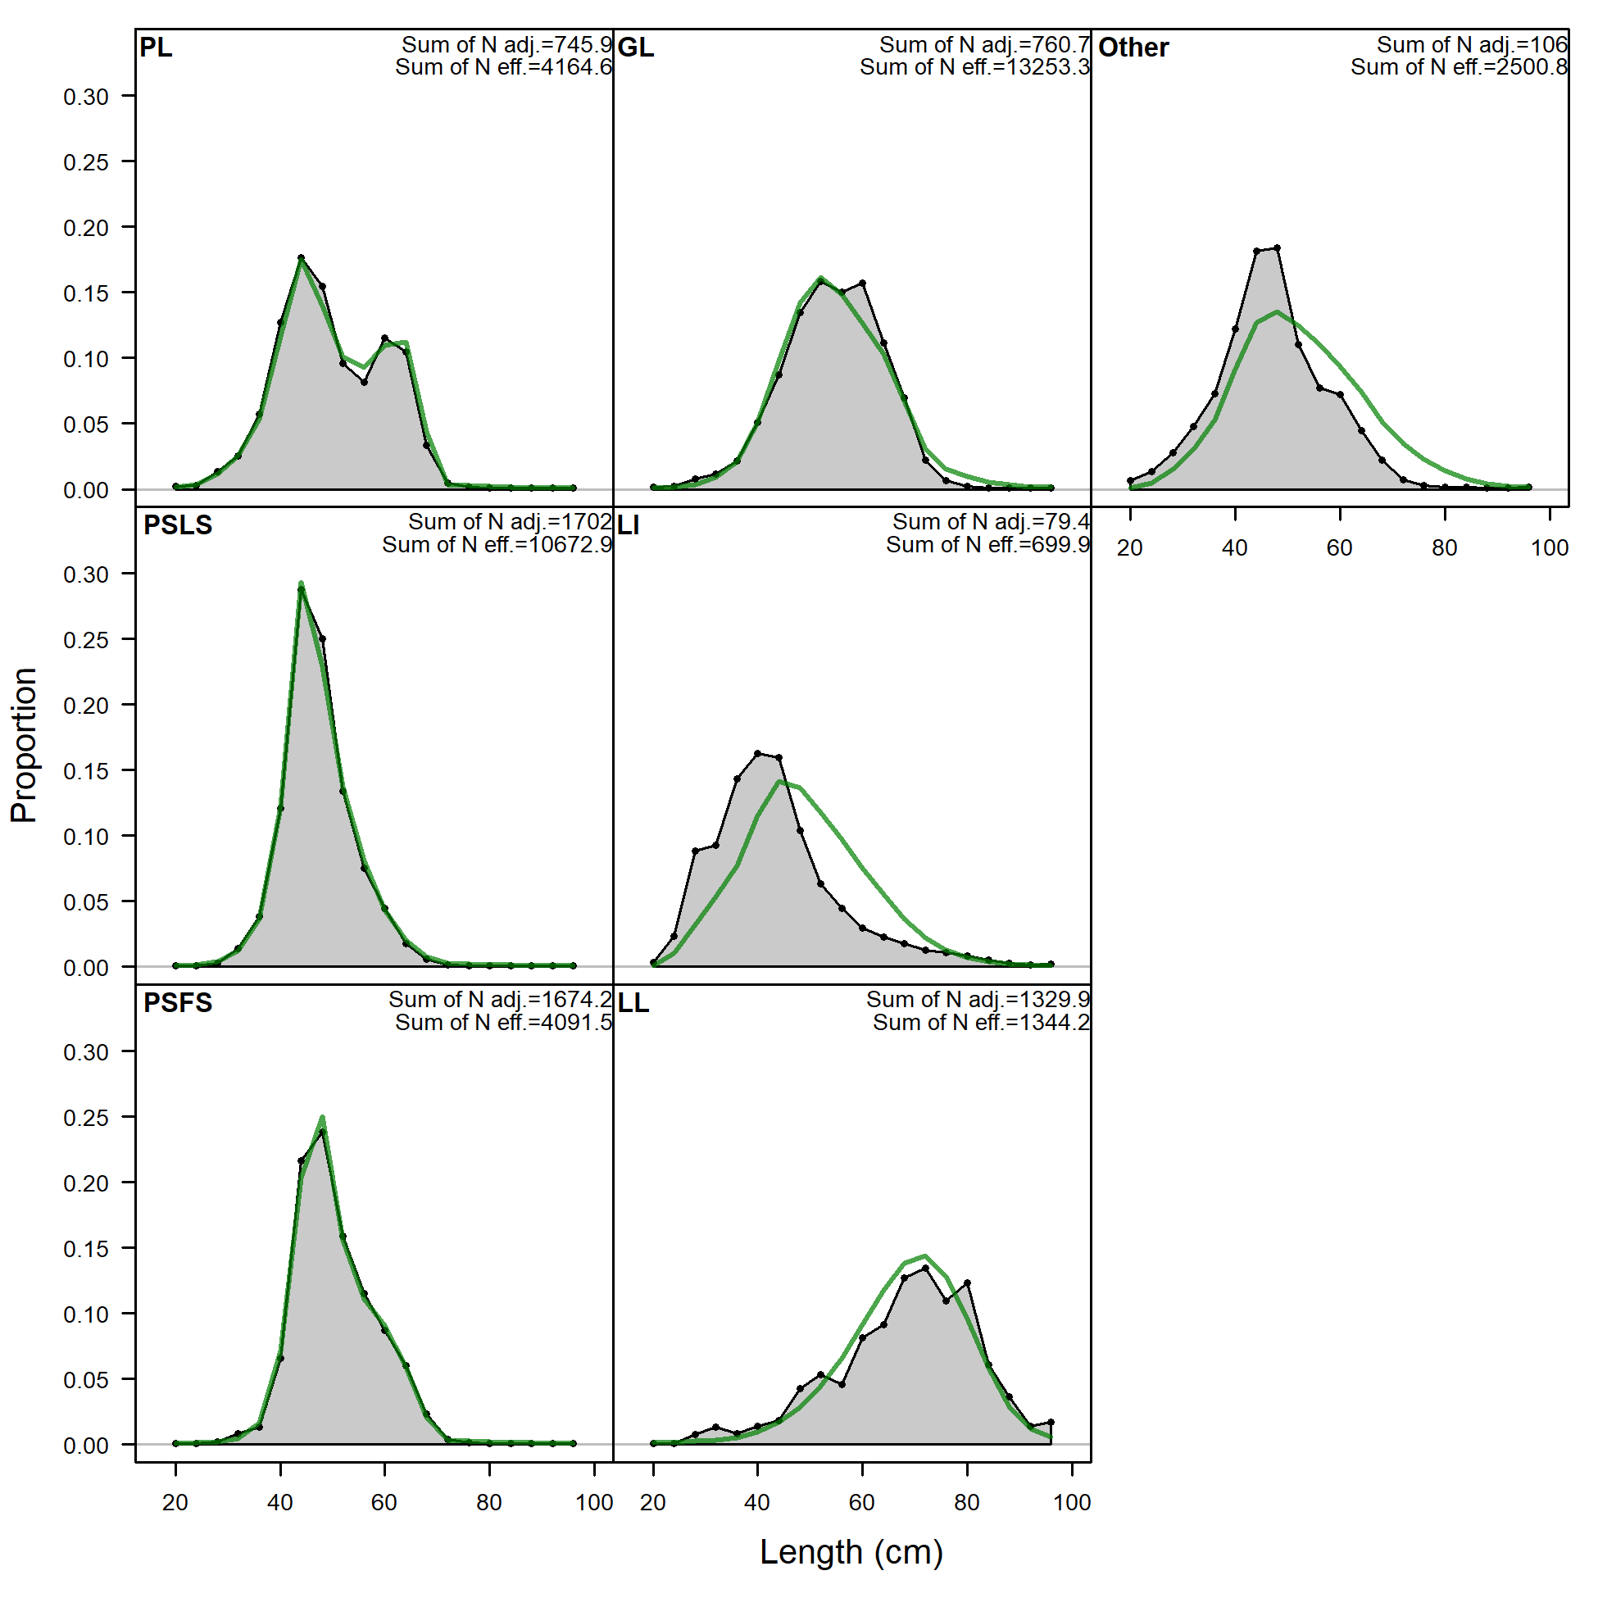
Figure A7: Model output from the sensitivity run ‘s5_Linf_LL2’ where the L_{inf} parameter was freely estimated, and the LL length samples not down-sampled (e.g. read as-is into the data file). This resulted in far better fits to the LL size data, while not overly affecting fits to other fishery size data.

